- Aim and objectives:

The aim of this experiment is to find out how different types and amounts of reinforcement can affect the behavior of beams under loading. This report will explain the reason for this behavior.

- Data and calculations:

The following four tables summarize the data obtained for the four beams as well as the calculations performed:
- Group “A” beam:

Reinforcement:
- Steel bars: 2 ф12 at the bottom.
- Stirrups every 6 cm except in the middle.

Initial gauge reading: 16mm

Failure: under bending (flexural)

Table (1): results for group “A” beam
Corrected deflection (mm) | Deflection (mm) | Force (pound)
0.37 | 15.63 | 500
0.59 | 15.41 | 1000
0.86 | 15.14 | 1500
1.22 | 14.78 | 2000
1.52 | 14.48 | 2500
1.87 | 14.13 | 3000
2.57 | 13.43 | 4000
3.26 | 12.74 | 5000
4.00 | 12.00 | 6000
4.71 | 11.29 | 7000
5.46 | 10.54 | 8000
6.19 | 9.81 | 9000
7.03 | 8.97 | 10000

- Group “B” beam:

Reinforcement:
- Steel bars: 3 ф14 at the bottom.
- Stirrups every 6 cm except in the middle.

Initial gauge reading: 18.76mm

Failure: under shear
Table (2): results for group “B” beam
Corrected deflection (mm) | Deflection (mm) | Force (pound)
1.32 | 17.44 | 500
1.58 | 17.18 | 1000
1.79 | 16.97 | 1500
1.95 | 16.81 | 2000
2.13 | 16.63 | 2500
2.35 | 16.41 | 3000
2.58 | 16.18 | 4000
3.08 | 15.68 | 5000
3.59 | 15.17 | 6000
4.04 | 14.72 | 7000
4.55 | 14.21 | 8000
5.09 | 13.67 | 9000
5.70 | 13.06 | 10000

- Group “C” beam:

Reinforcement:
- Steel bars: 2 ф6 at the bottom.

Initial gauge reading: 16.84 mm

Failure: under bending (flexural)

Table (3): results for group “C” beam
Corrected deflection (mm) | Deflection (mm) | Force (pound)
0.33 | 16.51 | 500
1.21 | 15.63 | 1000
2.63 | 14.21 | 1500
3.54 | 13.30 | 2000
7.72 | 9.12 | 2500

- Group “D” beam:

Reinforcement:
- Steel bars: 2 ф12 at the bottom.

Initial gauge reading: 18.55mm

Failure: under shear
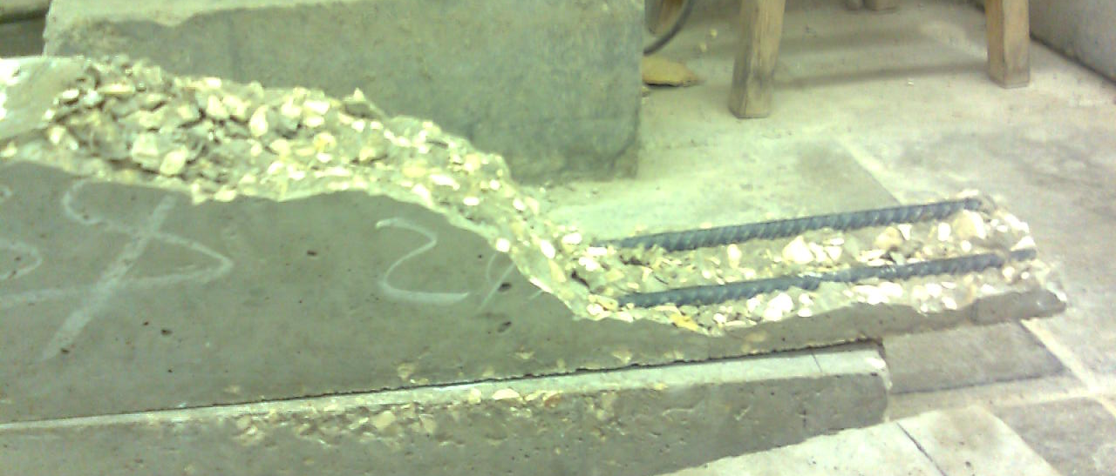

Fig (1): failure under shear for group “D” beam
Table (4): results for group “D” beam
Corrected deflection (mm) | Deflection (mm) | Force (pound)
0.63 | 17.92 | 500
0.84 | 17.71 | 1000
1.16 | 17.39 | 1500
1.57 | 16.98 | 2000
1.95 | 16.60 | 2500
2.27 | 16.28 | 3000
2.99 | 15.56 | 4000
3.85 | 14.70 | 5000
4.63 | 13.92 | 6000

The following table summarizes the results for the beam cubes for group “D”:

Table (5): Cubes results for group “D” beam
Stress (MPa) | Density | Force (kN) | W_{ssd} (g) | W_{sub} (g) | Cube #
24.4 | 2.37 | 244 | 2378 | 1374 | 1
29.6 | 2.39 | 296 | 2427 | 1411 | 2
27.0 | 2.38 | Average

* Sample calculations (Group “D” beam):

For beam:
Corrected deflection (500 lb) = initial reading – deflection
= 18.55-17.92 = 0.63 mm

Compressive strength (concrete in the middle) = Mc/I
Where M = (6000/2)*4.75*(1400/3) =6.65 ^6 N.mm
C = 75 mm
I = (1/12) bh³= (1/12) * 100*150³= 28.125^6 mm⁴
By direct substitution, compressive strength= 17.74 MPa

For beam cube #1:

Density = g/cm${}^{3}$

- Results and Conclusion:

The graph on the next page is a plot for the relationship between the load applied on the beam and the deflection for the four beams.

The results for the deflection values for each beam is shown in tables 1-4 in the data and calculations section

The average compressive strength for the beam cubes for beam D is 24.4 MPa.

The maximum compressive strength for the beam for beam D is 35.47 MPa.

The two types of reinforcement used are reinforcement with steel bars in tension areas in the concrete and reinforcement with stirrups along the concrete for shear resistance. Steel bars are inserted in the bottom because those areas are subjected to tension and concrete tensile strength is much lower than its compressive strength (approximately 10% of its compressive strength). The steel bars resist bending moments. Stirrups on the other hand are used to resist shear forces that are developed in concrete. From the way the beams were loaded in this experiment, bending moment is maximum in the middle region of the bar (and is constant their). Shear force however has it lowest values towards the middle of the bar and has its maximum values toward the supports (at the end of the bar). For this reason stirrups are not inserted in the middle to save money because they are not needed there. From the above it is concluded that flexural failure occur in the middle of the bar either due to the yielding of steel bars under tension or due to failure in the concrete under compression at the top of the bar. Shear failure on the other hand occurs near the end of the bar at an angle 45° to the horizontal.

Beam “A” was reinforced for both bending and shear, from observing this beam, it was obvious that flexural failure occurred not only by the yielding of the steel reinforcement at the bottom, but also by the failure in the concrete under compression in the upper region of the bar to the extent that it was powdered into small pieces. The shape of the load versus deflection graph indicates an almost linear relationship between load and deflection for this beam. This beam also was able to handle high forces before failure (especially when compared with beams C and D) because it is more reinforced.

Beam “B” was also reinforced for bending and shear, but this time 3 steel bars were inserted in the bottom and they were thicker too. Initially it was expected that this beam will fail under shear and this expectation came out to be true. Sudden shear failure occurred first because the presence of three bars ф14 of steel at the bottom means that the steel can resist high values of bending moments before it starts yielding. For this reason shear failure occurred first despite the presence of stirrups. From the shape of the load versus deflection graph, the relationship between loading and deflection is linear after 4000lb load. Off all four bars, this bar contains the highest amount of reinforcement steel, and this may be the reason for its sudden failure since over reinforcement of concrete with steel bars lead to hair cracks inside the concrete that grinds it from the inside so that it fails suddenly. It is also worth mentioning that the results of this beam are not accurate because concrete suffered from segregation and the stirrups weren’t fastened properly. This also might have lead to the occurrence of shear failure. This beam also sustained the highest load before failure because it has the most reinforcement.

Beam “C” was expected to fail under shear because it is reinforced with steal bars in the bottom so that it can resist bending, but it didn’t have any stirrups to resist shear. However this expectation was wrong and the beam failed under bending. The reason for this is that 2ф6 bars is very little reinforcement to resist bending and the effect of bending moment is huge so that the steel started yielding at a lower loading compared with the other three beams and failure occurred soon. The results for this bar also indicate that the effect of bending is much higher than the effect of shear because the bar could resist shear forces until a load of 2500 lb even though no stirrups were present but it failed under bending ( from the middle area) under the same load even thought it was reinforced to resist bending. Additionally, this bar was the least reinforced bar, and the deflection that occurred in it in the middle was the highest of all bars. This indicates that proper reinforcement is vital to reduce deflection but of course it should not exceed the accepted limits. In addition, the relationship between load and deflection is not linear for this beam due to the early yielding of steel.

Beam “D” was also expected to fail under shear because it is reinforced from the bottom by two steel bars. This time however, the beam contains almost four times as much steel reinforcement as that found in beam “C” and the expectation turned out to be true. The beam broke suddenly by shear at an inclination 45° from the horizontal. This inclination is expected from mechanics of materials since the principal axis lie at 45° to the horizontal and the largest shear stress will be developed along these axes. This beam didn’t fail by bending because the amount of reinforcement was enough to resist the internal moments that developed in the beam without the yielding of steel, and thus failure by shear occurred first. Shear failure is sudden, and here the sudden failure was more obvious than in beam “B” because the later contained stirrups that held the concrete together preventing it from breaking abruptly at once. It is good to mention here that design should always be made for flexural failure and not shear failure because it gives a warning and thus people lives can be saved.

