**Influence Lines**

* The internal and support forces in structural systems are functions of the **magnitude and location** of external loads applied to the structural system. The purpose of the influence line is to characterize the effect of loading location on the forces generated in the structure and at its supports.
* Influence lines are important in the design of structures that resist large live (moving) loads.
* In our work up to this point, we have discussed analysis techniques for structures subjected to dead or fixed loads.
* We learned that shear and moment diagrams are important in determining the maximum internal force in a structure.
* If a structure is subjected to a live or moving load, the variation in shear and moment is best described using influence lines.
* Consider a transport truck moving over a simply-support bridge beam.

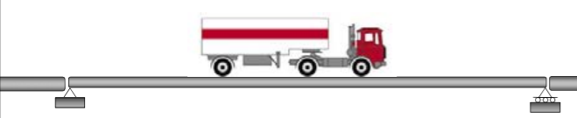

**Definition of an influence line:**

An influence line represents the variation of the reaction, shear, moment, or deflection at a specific point in a member as a concentrated unit force moves over the member.

* Once the influence line is drawn, the location of the live load which will cause the greatest influence on the structure can be found very quickly.
* Therefore, influence lines are important in the design of a structure where the loads move along the span (bridges, cranes, conveyors, etc.).

**Influence line versus shear force and bending moment diagrams:**

* Influence lines represent the effect of a moving load only at a specified point on a member.
* Whereas shear and moment diagrams represent the effect of fixed loads at all points along the member.

**Procedure for constructing an influence line (Equilibrium method)**

* Tabular Procedure for determining the influence line at a point P for any function (reaction, shear, or moment):

1. Place a unit load (a load whose magnitude is equal to one) at a point, x, along the member.
2. Use the equations of equilibrium to find the value of the function (reaction, shear, or moment) at a specific point P due the concentrated load at x.
3. Repeat Steps 1 and 2 for various values of x over the whole beam.
4. Plot the values of the reaction, shear, or moment for the member.

* Influence-Line Equations Procedure for determining the influence line at a point P for any function (reaction, shear, or moment).
  1. Place a unit load (a load whose magnitude is equal to one) at a point, x, along the member.
  2. Use the equations of equilibrium to find the value of the reaction, shear, or moment at a specific point P due the concentrated load as a function of x.
  3. Plot the values of the reaction, shear, or moment for the member.

