**Assessing the Determinacy of a Planar Structure**

**Beams / frames**

Assume:

r=number of reactions

n = total number of “pieces” associated with the entire structure

* r = 3n (just stiff / statically determinate)
* r < 3n (under stiff / forms a mechanism/unstable)
* r > 3n (over stiff / statically indeterminate), and the number of redundancy = r – 3n

3*n = total number of independent equations of equilibrium available to solve for unknowns since there are 3 equations of equilibrium available for the FBD of each “piece”

**Trusses**

Assume:

j=total number of joints

b=total number of members

r= number of reactions

* If b + r = 2j stable and internally determinate
* If b+ r > 2j stable and internally indeterminate
* If b + r < 2j unstable

**It should be noted that the structure is said to have determinacy and indeterminacy ONLY if the structure is stable.**

**Examples**

**Check the determinacy and number of redundancy for the following structures**

**Beams:**

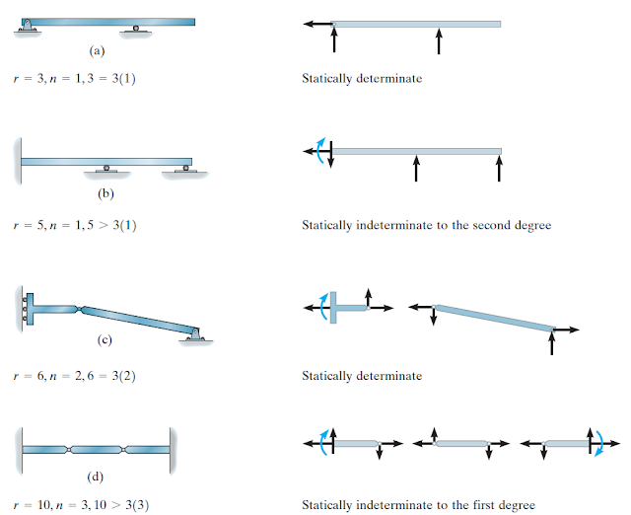

**Frames:**

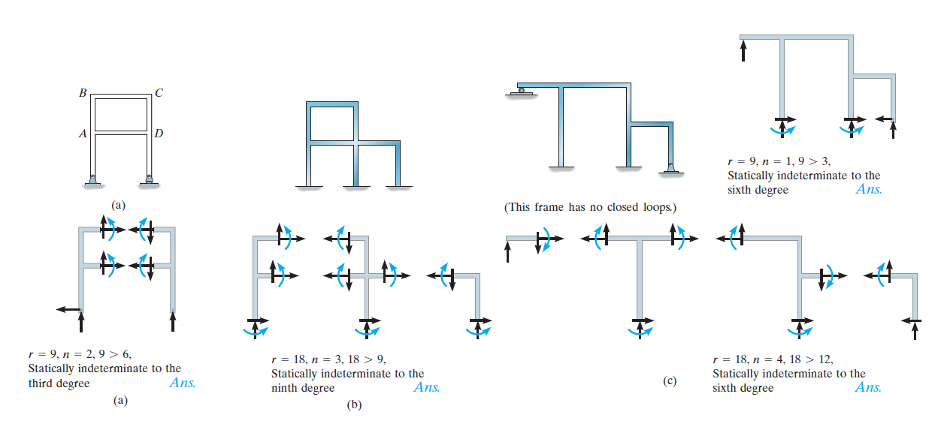

**Trusses:**

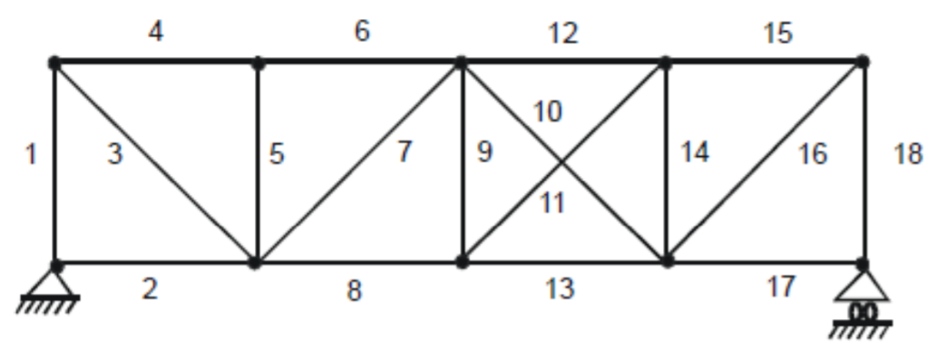

b = 18,

r = 3,

j = 10,

b + r = 18+3 = 21,

2j = 2x10 = 20.

21>20

The truss is stable and internally indeterminate.

**Stability**

* **External stability** - a structure (truss) is externally unstable if its reactions are concurrent or parallel.

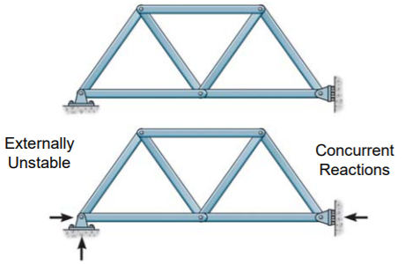 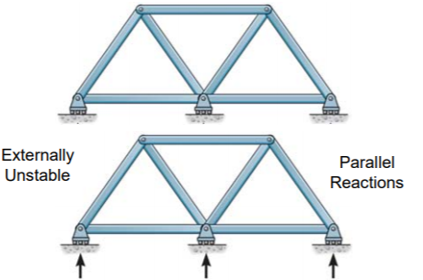

* **Internal stability** - may be determined by inspection of the arrangement of the truss members.
* A simple truss will always be internally stable
* The stability of a compound truss is determined by examining how the simple trusses are connected
* The stability of a complex truss can often be difficult to determine by inspection.
* In general, the stability of any truss may be checked by performing a complete analysis of the structure. If a unique solution can be found for the set of equilibrium equations, then the truss is stable

