 | Birzeit University  Civil Engineering department  P. O. Box 14, Birzeit / West Bank / Palestine
ENCE 435 Hydrology and Hydraulics Dr. Omar Zimmo
Dept. of Civil engineering and Environmental Eng.
Final Exam Thursday, Jan 28, 2021
Closed Book Time: 08:00-10:00

Q1. (20 marks)

True or false

Hydraulic jump is a rapidly varied flow.

The specific energy is the energy at a cross-section of an open channel flow with respect to any arbitrary datum.

At critical depth, the specific energy is maximum.

A 2 m wide concrete rectangular channel with a roughness (n) of 0.012, a slope of 0.2 % and with water depth of 1 m, the estimated flow rate in the channel is 950 m³/s.

Specific Force curve is the relationship between the specific force and the conjugate water depths

The critical flow condition corresponds to the maximum specific discharge in a channel for a fixed specific energy.

Open-channel flows are characterized by the presence of a liquid-gas interface called the free surface.

In open-channel flow, the depth of flow, discharge and the slopes of channel bottom and of the free surface are dependent variables.

A channel built with the same cross section and bottom slope is called a PRISMATIC CHANNEL.

Channel section, which is composed, of different roughness along the wetted perimeter is called a compound channel.

Q2) (20 marks)

Draw the water profile for the below longitudinal channel reach

Gate

So < Sc
So > Sc
Weir

Critical depth

Q3) (20 marks)

A uniform flow of 24 m³/sec occurs in a rectangular channel of 5.5 m width and 2.9 m water depth. A smooth hump of height 0.5 m is placed in the channel bottom (neglect head losses over the hump), determine:

a. the difference in water levels before and at the hump

b. the height of hump to produce critical depth on it.

c. draw the relationship between y₁ and y₂ versus $Δz$

d. what is the effect of increasing the height of hump to 1.3 m on the water levels?

Sketch both specific energy and specific discharge curves showing the main hydraulic characteristics.

Q4) (20 marks)

A trapezoidal channel with bottom width b = 5.0 m and side slopes H:V (2:1) has two reaches of different bottom slopes and Manning roughness. The first reach has S₀1=0.005 and n₁ = 0.015 with y₀1 = 1.5 m, while the second reach has S₀2 = 0.0045 and n₂ = 0.032.

- Compute the critical depths of the two reaches and y₀2.
- Draw the water surface profiles.

S_{o2} = 0.0005
n₂ = 0.015

S_{o1} = 0.045
n₁ = 0.032

Q5) (20 marks)

A trapezoidal channel with bottom width b=4.5 m and side slopes of 1:1 carries a discharge of 22 m³/sec. A venture-flume is installed in this channel having a streamlined (انسيابي) hump 0.5 high. Estimate the constriction width to produce critical depth downstream. Sketch both specific energy and specific discharge curves showing the main hydraulic characteristics through the flume. The water depth up flow the flume is 2.5 m.
Water Surface

y₁ = 2.5 m

∆ Z = 0.5 m

Longitudinal section

Plan

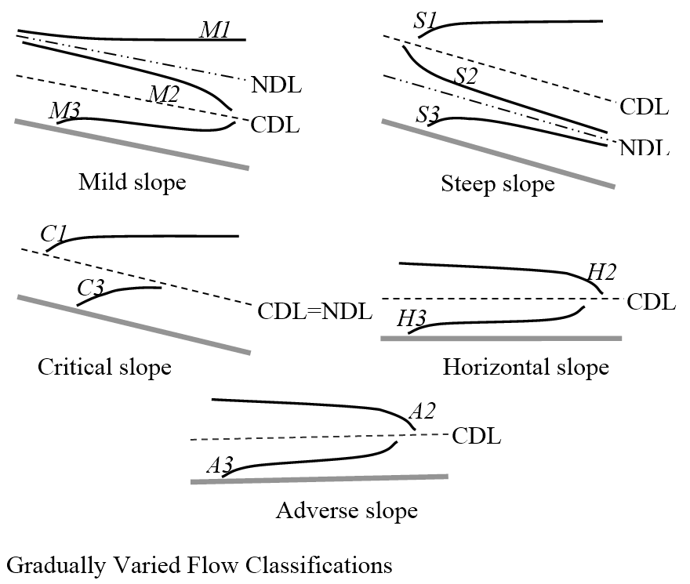

Good Luck

