| Dr. Omar Zimmo  Civil engineering dept.  Tuesday: 17 June 2020  Time: 10:00-11:30 | Midterm Exam CE439  Water Supply and Sanitation  Assume any missing data |
| --- | --- |

Question 1: (80 points)

**Design and prepare the BOQ** for VCP gravity flow sewer main **starting** at the intersection of 4th and G Streets and ending at the intersection of 2nd and B Streets (Figure below). **Prepare a sewer design table and a profile drawing**. Use the following assumptions: minimum invert depth is 3.0 m, the invert of the sewer entering the main from G Street (east and west) is at an elevation of 102.13 m. Contributing flows, including I/I, from mains are given below.

**Peak hour lateral flow rates including I/I**

Street Flow rate, m3/s

G St. 0.0143

F St. 0.0115

E St. 0.0095

D St. via 3rd St. 0.0083

C St. 0.0053

Jefferson Blvd. 0.0052

Washington St. 0.0065



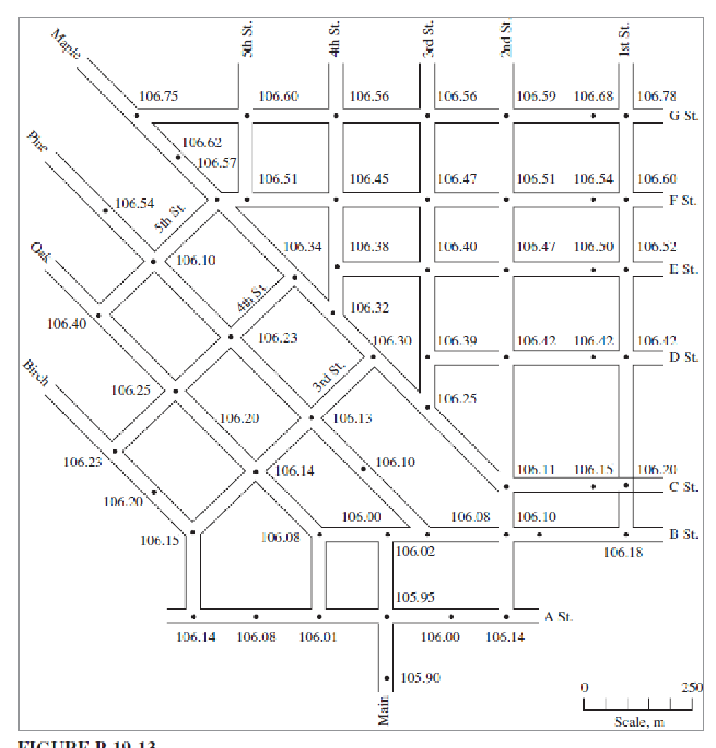

Question 2: 10 points)

Where inverted siphon in a sewer system is commonly used and what is its principal design.

Question 3: 10 points)

What are the main inspection activities in the sewer network.