**Lab 1: Program Structure in Java**

**Objectives**

* To understand the layout and the structure of a simple Java program
* To be able to write simple Java application using output stream.
* To be able to create, compile and execute a simple Java program

**Simple Java Program**

This program will allow you to understand the layout to Java Programs. In addition , to the meaning of the following expressions in Java:

***Package, Class, Method, Modifier***

// Text printing program – First lab   
public class Welcome {  
 // main method begins execution of Java application

public static void main(String argv[]){

System.out.println("Welcome to comp231 – Object oriented programming course ");

} // end method

} // end class Welcome

**Compiling, and Executing a Java Program**

Sun releases each version of J2SE with a **Java Development Toolkit** (JDK). For J2SE 5.0, the Java Development Toolkit is called JDK 5.0. JDK 5.0 was formerly known as JDK 1.5.

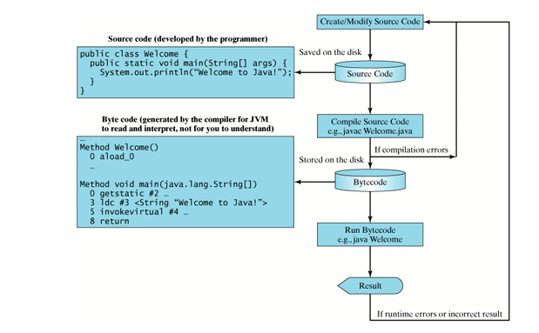

**Welcome.class**

Save the file as:

**Welcome.java**

**Exercises**

1. Write an application that produces a cover sheet for your laboratory assignments. It should have the laboratory number, the tasks that have been assigned, your instructor’s name, your name, the date, and any other information that your instructor has requested.
2. Write an application that writes a birthday message to your mother. Surround the message with asterisks.