**Lab 2: Structure Programming - Revision**

**Objectives**

* To be introduced to the Eclipse debugger - an important tool for finding and fixing run-time errors.
* To be able to write simple Java application using output and input streams.
* To become familiar with primitive data types.
* To become familiar with the conditional statements in Java (i.e. **if, if else, switch**).
* To become familiar with the control structures in Java ( i.e. **while, for, do while**).

**Eclipse Debugger**

This lab will introduce you to Eclipse, a full-featured and very versatile Integrated Development Environment. During the assignments and labs in this course you will be using Eclipse extensively to develop Java programs. All of your work done in each lab and assignment throughout the course should be stored in your account.

* Create the directory /comp231. This will be the root directory for everything done in this course.
* Create the subdirectory /comp231/lab number, which will store all of you work for the current lab.

**Running the Program**

1. In the Package Explorer, select HelloWorldClass.
2. Select Run -> Run..., or right-click on HelloWorldClass and select Run -> Run.... This will allow you to create a launch configuration, which tells Eclipse how to run your application.
3. Choose the type of launch configuration to create. HelloWorld is a standard Java Application, so double click on Java Application.
4. The Project field should contain HellowWorldProject, while the Main Class field should contain HelloWorldClass. If not, enter either one in.
5. Click Run to execute this new launch configuration. 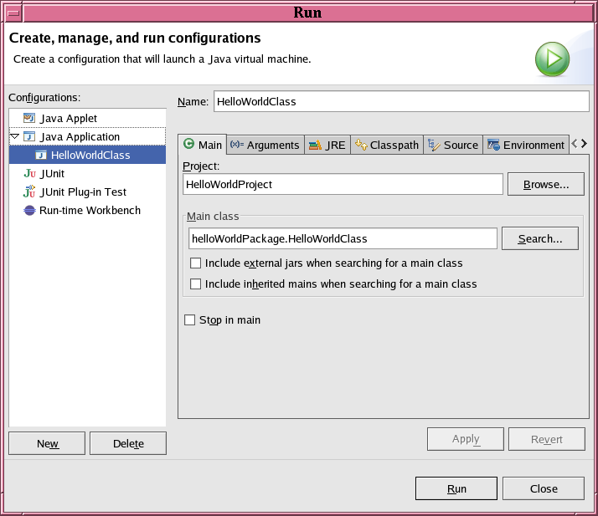
6. The Console view handles the Standard I/O, so after running the program, Hello World, appears in the Console window.
7. Add the line System.out.println(args[0]); after the line System.out.println("Hello World");.  Our program will now print out the first command line argument after Hello World.  Your code should look something like this:

public class HelloWorldClass

{

public static void main(String[] args)

{

System.out.println("Hello World!");

System.out.println(args[0]);

}

}

1. To run our program with command line arguments:
   1. Click Run -> Run... to bring up the launch configuration window.
   2. Under Java Application, select HelloWorldClass.
   3. Click the Arguments tab, in the Program Arguments field enter Goodbye and click Run.  This is equivalent to typing java HelloWorldClass Goodbye in the command prompt.

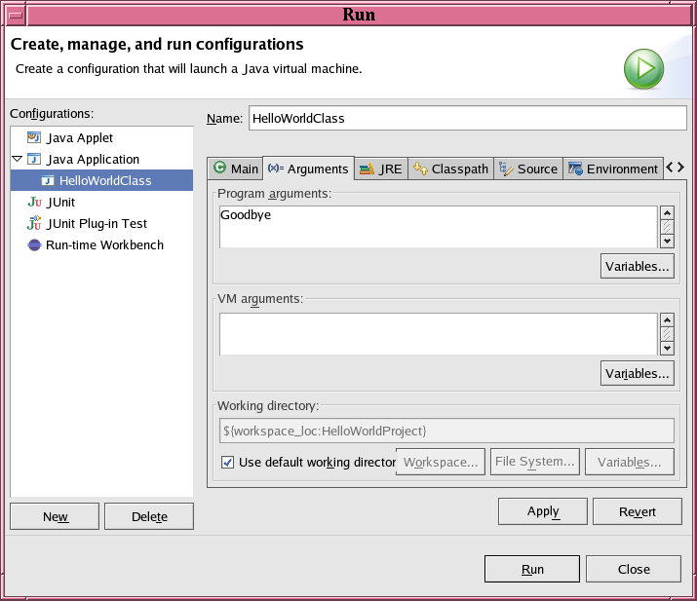

* 1. The console should display:

**Hello World  
Goodbye**

**Exercises**

1. Write an application that reads in a person name and writes a birthday message to the person.
2. The body mass index (BMI) is a ratio of person’s weight and height. The index can be used to determine if a weight is unhealthy for certain height. Here is the non-metric formula:  
     
     
    BMI = weight * 703/ height*height

Write an application that reads in values for weight and height and prints out the BMI index. Your application should prints on the screen an interpretation of the BMI. Use the following scale.

|  |  |
| --- | --- |
| BMI | Interpretation |
| Under 16 | Emaciated |
| 16-19 | Underweight |
| 20-25 | Normal |
| 26-30 | Overweight |
| Over 30 | Obese |

1. Write a class that contains the following two methods:

/** Converts from Celsius to Fahrenheit */

public static double celsiusToFahrenheit(double celsius)

/** Converts from Fahrenheit to Celsius */

public static double fahrenheitToCelsius(double fahrenheit)

The formula for the conversion is:

Fahrenheit = (9.0 / 5) * Celsius + 32

Write a test program that invokes these methods to display the following tables:

Celsius Fahrenheit Fahrenheit Celsius

40.0 105.0 120.0 48.89

39.0 102.2 110.0 43.33

...

32.0 89.6 40.0 5.44

31.0 87.8 30.0 -1.11