

Faculty of Engineering and Technology

Computer Science Department

Advanced Programming (COMP 231)

Quiz #1

**Prepared by**

**Yazan Yousef – 1170249**

**Section No. 3**

Instructor

Dr. Farid Mohammad

BIRZEITbTop of Form

March 2021

Part 1:

Code:

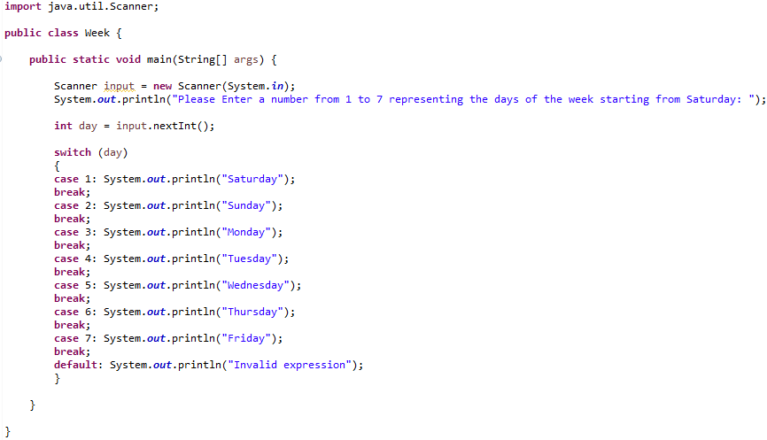

Output Examples:

1. The entered number is ‘7’:



1. The entered number is ‘3’:



Part 2: The Enhanced Code

The code:

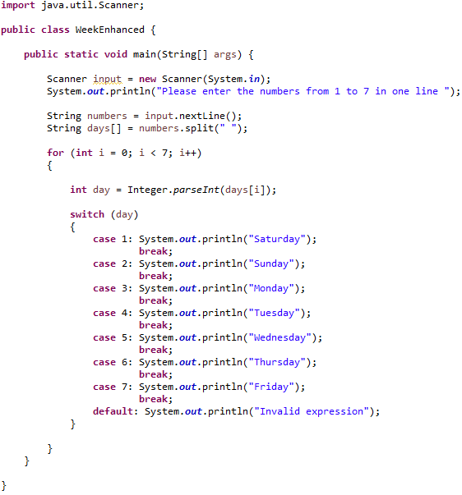

Output:

