

# **Computer Science Department**

**Database Systems 333**

**Midterm Nov. 23, 2021**

**Name: ____________________________________________**

**ID: ____________________________________________________**

**Circle your instructor:**

* **Bassem Sayrafi (Section 1 – T R 11:25)**
* **Bassem Sayrafi (Section 2 M W 10:00)**
* **Diaeddin Rimawi (Section 3 – T R 12:50)**
* **Abed Othman (Section 4 – S W 10:00)**

|  |  |
| --- | --- |
| Question | Mark |
| Q1 Relational Model |  |
| Q2 Relational Algebra |  |
| Q3 SQL |  |
| Q4 ER Diagram |  |
|  |  |
| Total: |  |

* Write your name and ID on each page.
* Use blue ink only.
* This exam is composed of 6 pages numbered from 1 to 6. Make sure you have 6 pages. The last page is blank.

### (25%) Question 1 – Relational Model

For the following ER diagram. Write the necessary create table students (only write what is necessary. Any extra tables will lose you points).

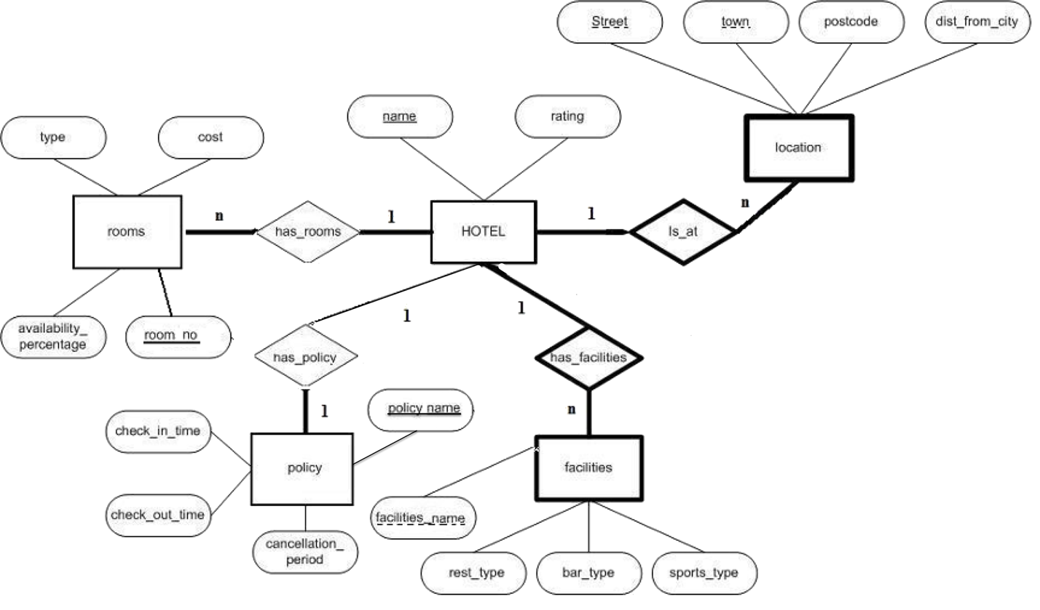

5 points each

CREATE TABLE Hotel (name varchar(16) primary key, rating int);

CREATE TABLE Location(name varchar(16), Street varchar(16), town varchar(16), postcode varchar(16), dist_from_city real, primary key (name, street, town), foreign key name references hotel(name) on delete cascade);

CREATE TABLE Facilities(facilities_name varchar(16), name varchar(16), rest_type varchar(16), bar_type varchar(16), sports_type varchar(16), primary key (name, facilities_name), foreign key name references hotel(name) on delete cascade);

CREATE TABLE Rooms (room_no int primary key, type varchar(16), cost real, availability_percentage real, name varchar(16), foreign key name references hotel(name));

CREATE TABLE policy(policy_id int primary key, check_in_time int, check_out_time int, cancellation period int, name varchar(16), foreign key name references hotel(name));

### (20%) Question 2 – Relational Algebra

Every year, students get warnings (انذارات) for various violations (مخالفات) of university laws. A student who has a warning will get dismissed if he/she gets another warning.

Consider the following relations

Student(sid:int, sname: string, birthdate: date, gender: string)

Warnings(warning_id int, warning_name string, warning_dismiss_period date, warning_type: string)

Warned_students(sid int, warning_id int, issue_year: int, issue_semester: String)

Warning type: takes values “Academic”, “non-Academic”, “Violent”

Issue_year: takes values such as 2020, 2021, etc..

Issue_semester: takes values such as “Spring”, “Fall”, “Summer”

Write the following queries in Relational Algebra:

* 1. Find the names and ids of all students who have been warned.
  2. Find the student names who got dismissed a for an academic warning.
  3. Find the student names and ids of students who did not get any warning in 2020.
  4. Find the female student names who got two warnings in the same year (and thus got dismissed!).

5 points each

$$ρ(S,Student)$$

$$ρ(V,Warned_students)$$

$$ρ(W,Warnings)$$

a)

$$\begin{matrix}π \\ S.sname\end{matrix}\left(S∞V\right)$$

b)

$$ρ(V1,Warned_students:V1.warning_id→V1.warning_id1)$$

$$ρ(V2,Warned_students:V2.warning_id→V2.warning_id2)$$

$$ρ\left[T1, \begin{matrix}σ \\ V1.sid=V2.sid∧ \\ V1.warning_id>V2.warning_id2 \end{matrix}\left(V1×V2\right)\right]$$

$$\begin{matrix}π \\ S.sname\end{matrix} [S∞\left(T1\begin{matrix}∞ \\ T1.warning_id2=W.warning_id\end{matrix}\left[\begin{matrix}σ \\ W.warning_type=^{'}academic^{'}\end{matrix}\left(W\right)\right]\right)]$$

c)

$$\left[\begin{matrix}π \\ S.sid,S.sname\end{matrix}\left(S\right)\right]-\left[\begin{matrix}π \\ S.sid,S.sname\end{matrix}\left(S∞\begin{matrix}σ \\ V.issue_year=2020\end{matrix}(V)\right)\right]$$

d)

$$ρ(V1,Warned_students)$$

$$ρ(V2,Warned_students)$$

$$ρ\left[T1, \begin{matrix}σ \\ V1.sid=V2.sid∧ \\ V1.Year=V2.Year⋀ V1.warning_id>V2.warning_id \end{matrix}\left(V1×V2\right)\right]$$

$$\begin{matrix}π \\ S.sname\end{matrix}\left(T1∞\left[\begin{matrix}σ \\ S.gender='female'\end{matrix}(S)\right]\right)$$

### (25%) Question 3 – SQL

Every year, students get warnings (انذارات) for various violations (مخالفات) of university laws. A student who has a warning will get dismissed if he/she gets another warning.

Consider the following relations

Student(sid:int, sname: string, birthdate: date, gender: string)

Warnings(warning_id int, warning_name string, warning_dismiss_period: date, warning_type: string)

Warned_students (sid int, warning_id int, issue_year: int, issue semester: String)

Gender: takes values “female” or “male”

Warning type: takes values “Academic”, “non-Academic”, “Violent”

Issue_year: takes values such as 2020, 2021, etc..

Issue_semester: takes values such as “Spring”, “Fall”, “Summer”

Write the following queries in SQL

1. The name of female students who were born after “21/1/2002”. Order by name descending.
2. The name of male students who have been warned in the fall semester of 2021.
3. Print the count of “Academic” warnings issued in the fall of semester of 2020.
4. Print the names of students who got all warning types.
5. Print the names of students who got two warnings in the same year.

**5 points each**

SELECT S.sname  
FROM Student S  
WHERE S.birthdate>”21/01/2002” AND S.gender=”female” order by S.sname desc;

SELECT Distinct S.sname  
FROM Student S, Warned_students V  
WHERE S.sid = V.sid AND S.gender=”male” and V.issue_year=”2021” and V.issue_semester=”Fall”;

SELECT count(*) As warning_count  
FROM Warnings W, Warned_students V  
WHERE W.warning_id = V.warning_id AND V.issue_year=”2020” AND W.warning_type=”Academic”;

Select S.sname from Students WHERE NOT EXISTS (

SELECT W1.warning_type FROM Warnings W1   
WHERE W1.warning_type NOT IN  
(SELECT DISTINCT W2.warning_type FROM Warnings W2, Warned_students V  
WHERE W2.warning_id=V.warning_id AND V.sid = S.sid)  
)

SELECT distinct S.sname  
FROM warned_students v1, warned_students v2, student S  
WHERE v1.sid=v2.sid and v1.warning_id>v2.warning_id and v1.issue_year=v2.issue_year and v1.sid = S.sid

### (30%) Question 4 – ER Diagram

PalAir airlines is an airline that operates four airports at Jericho (JER), GAZA (GAZ), Jenin (JEN) and Hebron (HEB). Its entire fleet (اسطول) has more than 15 aircrafts and each aircraft is assigned an airport as its home base. Each aircraft has an aircraft id, make, model and description, engine type. The aircrafts must have maintenance every 10,000 flight hours. Each maintenance is composed of several checks. Each check performs a test on a specific technical item. A check is identified by the check name, status and the maintenance id the check belongs to.

If an aircraft fails a check (status=fail), additional tasks must be performed, which involves replacing or repairing some items (task type = replace or type = repair). Each task has a type, description and cost. A task is uniquely identified by the task id and the check to which it belongs. These additional tasks are performed from a repair branch which belongs to a repair company. Each repair branch specializes on only one particular task and is identified by the branch id and the repair company it belongs too. Each repair company has a number of repair branches throughout the middle east. Each repair company has a name and id. The airline has to pay extra costs for those tasks. Each airport has a number of these repair branches.

Design an ER diagram for the aircraft maintenance tracking system described above. Draw the ER diagram with all its components (entities, relationships, class hierarchies, weak entities, total participation and participation constraints (1-n, m-n, 1-1)).

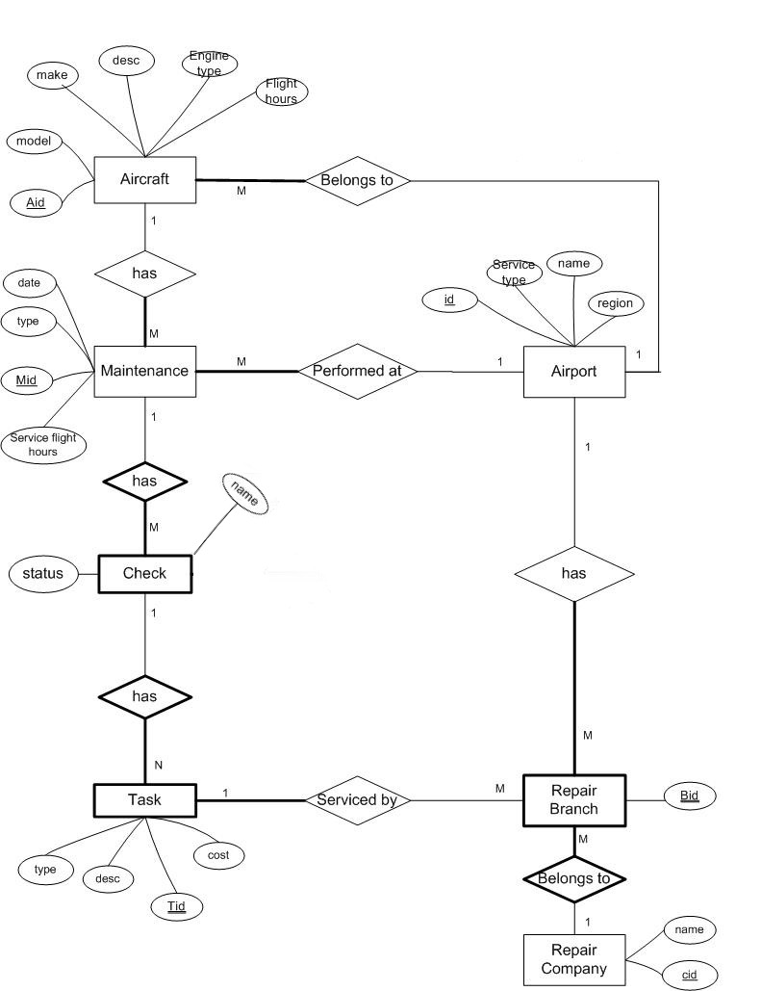

**Suggested Grade distribution:**

**Weak entities with their relationships and keys 3 points each = 9 points**

**Remaining 4 entities with keys and relationships 2 points each = 8 points**

**Participation constraints (1-n, total part.) 16 * 0.5 = 8 points**

**Attributes = 5 points**