 **Faculty of Information Technology  
Computer Systems Engineering Department  
First Semester 2015/2016  
Software Engineering COMP433**

**G6-S1(TL) Final Project-SRSD**

**“ Meat Shop Online ”**

**Tamer Jaber Id: 1120759**

**Tawfiq Lahlouh Id: 1110061**

**Helwa Ahmad Id: 1111864**

**Dana Barghouthi Id: 1120091**

**Instructor : Adel Taweel**

**Project Planning and Management**

**Group Name:** G6-S1(TL)

**Both Name and the role of each student/member:**

|  |  |  |
| --- | --- | --- |
| Student Name | Student Role | Student ID |
| Tawfiq Lahlouh | project manager | 1110061 |
| Tamer Jaber | secretary | 1120759 |
| Helwa Ahmad | technical architect | 1111864 |
| Dana Barghouthi | Programmer | 1120091 |

**Project management strategy:**

Our team have been conducting its meetings both at university and through Facebook, we have created a Facebook group to ease the discussion process , we have altogether negotiate all aspects of the problem and each member has to give his/her opinion on the situation and the project manager has to take the final decision upon our decision ,we were using water fall model , since we ensure there were no changing in the requirement and the project requirement was specified from the beginning .

**Project manager report**

As project manager the table below reflects the work and the tasks each member has undertaken.  
Also I have conducted :  
Cancel order scenario - Cancel demanded meat use case -Cancel order activity Diagram Cancel an order Sequence - Make an order Sequence Diagram - Deployment diagram Overall architecture diagram- State Diagram

|  |  |  |  |
| --- | --- | --- | --- |
| Section | Contributed by | Done By | draw by |
| System CLASSES and their description | Tawfiq + Tamer | Tawfiq + Tamer | Tamer |
| Class analysis | Tamer | Tamer | Tamer |
| CLASS diagram | Tawfiq + Tamer | Tawfiq + Tamer | Tamer |
| OBJECT diagram | Tawfiq + Tamer | Tawfiq + Tamer | Tamer |
| “Make an order” Sequence Diagram | Tawfiq + Tamer | Tawfiq + Tamer | Tawfiq |
| “Cancel an order” Sequence Diagram | Tawfiq + Tamer | Tawfiq + Tamer | Tawfiq |
| “view List Sequence” Sequence Diagram | Dana + Helwa | Dana + Helwa | Dana |
| “Login”  Sequence Diagram | Dana + Helwa | Dana + Helwa | Dana |
| State Diagram | Tawfiq + Tamer +Helwa | Tawfiq + Tamer +Helwa | Tamer |
| Cost | Tamer | Tamer | ----- |
| integrate the whole phase |  |  | Tamer |

All other stuff have been contributed equally by all members such : User requirements, identifying actors , identifying their use cases ,,,

|  |  |
| --- | --- |
| Name | Contributation |
| Tawfiq Lahlouh | **30%** |
| Tamer Jaber | **37%** |
| Helwa Ahmad | **15%** |
| Dana Barghouthi | **18%** |

**Group Member report :**

**Tamer Jaber “secretary”:**  
> During the course I’ve tried my best to sharpening my communication skills through playing the role of a liaison “secretary ”, firstly I have negotiate with my teammates their course schedule and their free time and ask them to provide me with their schedules to ease our meeting process ,and finally I summarize it with this table “as shown below ”.   
> I have created the Facebook groups which ease our communication within our team and with the others “ customer and developer group”.  
> Each and every message on Ritaj board I have summarize it to my team right away   
> Also I ensured to remind my team about the due date .  
> For each phase due date I have organized all the work into one single document and deliver it through Ritaj  
> I have conducted : the Effort/Time estimation calculation , class analysis model ,  
login scenario ,Login activity Diagram ,Login Use Case ,Cancel an order Sequence Diagram , meeting tables ,two assessment forms “User requirement approval”

|  |  |  |  |  |  |
| --- | --- | --- | --- | --- | --- |
| **Names ==>** | **Dana "Programmer"** | **Tawfeek "manager"** | **Helwa "technical architect"** | **Tamer "secretary"** | **suitable for :** |
|  |  |  |  |  |  |
| **SAT** | **12:00-1:00 + 2:00-5:00** | **8:00-1:00** | **Holiday** | **11:00-1:00 + 2:00-5:00** | **12:00-1:00  Dana-tawfeek-tamer** |
| **MON** | **11:00-1:00 + 2:00-5:00** | **8:00-1:00** | **10:00-11:30 + --> 5:00** | **11:00-1:00 + 2:00-5:00** | **11:00-1:00 ALL** |
| **TUE** | **12:30-1:00 + 2:00-5:00** | **11:00-12:30 + 2:00-5:00** | **2:00-5:00** | **11:00-12:30 +2:00-5:00** | **2:00-5:00 ALL +  [ 11:00-12:30 Tawfeek+tamer]** |
| **WED** | **11:00-1:00 +2:00-5:00** | **8:00-1:00 + 2:00-5:00** | **10:00 -2:00** | **11:00-1:00 + 2:00-5:00** | **11:00-1:00 ALL** |
| **THU** | **12:30-1:00 + 2:00-5:00** | **11:00-12:30 + 2:00-5:00** | **Full** | **11:00-12:30 +2:00-5:00** | **2:00-5:00 + [ 11:00-12:30 Tawfeek+tamer]** |

**Dana “Programmer” :**

I have conducted :  
the make order scenario   
, Demand meat online Use case  
, make order activity Diagram  
, view List Sequence Diagram,  
 Login Sequence Diagram

Also I have worked on the presentation

**Helwa “technical architect”:**

I have conducted :

View demand list scenario

View Demand meat list Use case

View meat list Activity Diagram

Also I have worked on the presentation

**Requirement Elicitation and Analysis**

**Requirement Business description -supplied by the customer group**

Our business is a meat shop, we have several kinds of meat to sell and our work is mainly to deliver the kind of meat that someone asks for.

We want a software that can help us to make his process easier by offering the available meat in a website that serve at most 50 person concurrently. In this way, anyone can see the available kinds of meat and we can deliver to him upon his request.

The website should be able to provide the following services:

1. Show the menu and the prices of the available kinds of meat.

2. Let the customer make an order.

3. Let the customer see the invoice for meat he/she requested.

4. Make a secure payment system via visa card.

5. Ask the customer for location to deliver the order.

6. Once the usermakesan order,hecan deleteit justwithin 10 minute after submission.

7. If the customer doesn't have a visa card, there will be an option to pay when the meet is delivered, but there mustbe a confirmation on the order.

The customer cannotmake an order between 12:00 AM and 9:00 AM because the shops will be closed. In addition,the website must show all the information of the shop (phone number,address,and name).

Another important point, which is the caseifthe website is down for any reason, itwill show an apology and a list of numbersthatcanbeusedto make anordervia phone.

**User & system requirements:**

**User Requirements:**

1. The system shall provide online meat shop services that deliver what customers request using the website, the website should offer a friendly, simple graphical user interface.

2. The system shall be able to serve a large number of users at least 100 person concurrently.

3. The payment method shall be via visa card.

4. The system shall permit users to make accounts using the website to start making orders, and take some required information. The customer should be notified by the status of the order by the account.

5. The customer could use the service through surfing the web or through a mobile application.

6. The website should be in Arabic and English languages.

**System Requirements:**

**R1:1:** The system shall provide an efficient user interface, "to do what is required by the least time and steps " also fits many frames such "mobile" aslo the needed time for a user to learn how to use it not exceeds 5 minutes.

**R1:2:** The system shall show the user all types of meats available and provide their prices, and if there is a discount on purchasing so the user can select which type he/she wants.

**R1:3:** To ease the ordering process and make it catchy the system should provide photos of the available meats.

**R2:1:** The system shall be able to allow a hundred users concurrently to use it through allocating a special server, and ensuring that it will not go down, also it shouldn't letting the customers to wait (waiting time at most 3 minute).

**R3:1:** The payment method vi visa card shall be ensured that is a secured payment.

**R4:1:** The system shall permit the user to provide the size and amount of his / her order of meat.

**R4:2:** The system shall notify the customers that the shop is closed through the website interface and show them the latest ads, discount,,,,

**R4:3:** The system shall be able to determine the total cost of the order that calculated using the price of the order itself that depends on the type, size and quantity of the order, the cost of delivering that depends on the customer destination address.

**R5:1:** The system shall be supported by a mobile application that provide the same functionality as the website.

**Scenarios section :**  
**General scenario :**Antonia, Brad, Angelina accessed Meat shop online, Antonia and Brad have accounts on the system, Antonia and Brad have logged in successfully to the system while Angelina has not an account since it’s her first visit to the website and so she has to sign up first, Antonia search for lamb meat and choose 2 kg amount as an order, and so she has 10 minutes to pay for her order and the opportunity to update her order, the 10 minutes finished and she didn’t change her order and so, the order will be prepared by the employee and she will receive her order ASAP. Brad search for lamb meat and choose 5 kg amount as an order, after the 10 minutes finished he didn’t pay for his order and so the system has notify him that he didn’t paid for his order yet and so the system ask if he wants to make a new order or not, he decide not to make a new order and so the system cancelled his order. After Angelina signed up, she search for cow meat and choose 4 kg as an order, after she made her order and during the 10 minutes, she has changed her mind and wants to change the amount to be 2.5 kg of lamb meat and so she has paid for her order, the order will be prepared by the employee and she will receive her order ASAP.

**Tawfiq -Cancel order scenario :**   
**Normal:**  
Antonia, Brad, accessed meat shop online, they have accounts on the system and logged in successfully to the system, Brad search for Hurry meat and choose 6 kg amount as an order, and so he has 10 minutes to pay for his order and the opportunity to update his order, after 6 minutes he has changed his mind and wants to cancel his order by clicking on cancel order button and the system ask him that you want to cancel the order or make new one, he decide to choose cancel, after that the employee will approve the cancellation.

**Alternative:**Antonia, Brad, accessed meat shop online; they have accounts on the system and logged in successfully to the system, Antonia search for lamb meat and choose 3 kg amount as an order, and so she has 10 minutes to pay for her order and the opportunity to update her order, the 10 minutes finished and she doesn't pay for her order, there is an alternative way such that the system asked her for make a new order before the cancellation.

**Error:**Antonia, Brad, accessed meat shop online, they have accounts on the system and logged in successfully to the system, Antonia search for lamb meat and choose 3 kg amount as an order, and so she has 10 minutes to pay for her order and the opportunity to update her order, the 10 minutes finished and she pay for her order, after that she has changed her mind and wants to cancel her order, so the cancellation will be denied and the order process will be continue.

**Tamer - login scenario:**

**Normal:** Adel access the website of Meat shop online to buy meat ,as the welcoming interface asks him to enter his username and password to login ,Adel has already signed up and so he has a valid account and so he enters his username and password , the information he provided has a successful validation and so the system logged him successfully and displayed his specific interface as customer .

**Alternative:** Ali access the website of Meat shop online to buy meat , as the welcoming interface asks him to enter his username and password to login ,Ali has already signed up and so he has a valid account and so he enters his username and password , the system notify him by an error message that he has entered an incorrect username and/or password , and so the system asks him if he forget his password or username and so a verification code will be sent to his email to continue the login process ,,

**Error 1:** Abed as employee has entered incorrect username and password , so an error message will be displayed by the system ,,

**Error 2:** Majd as customer has entered incorrect username and password for five times consecutively and so an error message that inform her that she will be denied to access the website for the coming half hour so she has to wait half hour to try again ,,

**Helwa - View demand list scenario**

**Normal scenario:** Bilal an employee in meat shop. He access the meat shop online and He make an employee account by enter his information and employee number that get it from administer of shop. Then login for his account by enter his name and password. He is viewing demand list and check for ready meat orders and confirm it, and approve other that cancelled.

**Alternative scenario:**

Bilal an employee in meat shop. He access the meat shop online using his account by entering his name and password but he denied from the system because an error in system. The system get for him the password or user name that entered is false, retry enter them. After this error, he go to the administrator for shop and talk him about an error that occurred, so the administrator get bilal new employee number, so bilal take it and make another account and enter his information and login to the system without any error.

**Error scenario:**Bilal an employee in meat shop. He access the meat shop online using his account by entering his name and password but he denied from the system because an error in system. The system get for him the password or user name that entered is false, retry enter them.

**Dana - make order scenario:**

**Normal scenario:**

Amira open her account in meat shop .Check the available items .she want a kilo of sheep meat and one chicken. Amira select sheep meat then choose sheep leg then enter the quantity 1-kilo .she want the order in 12 pm then add her demand to carte. After that, she goes back to home and select chicken. Then choose a white chicken then select completely one. She want the order in same time then she add it to carte. Finally she press to button buy and the system will discount the price from it account in bank by using visa card number.

**Alternative scenario:**

Sami access the website of meat shop. He open his account then search about his favorite fish meat. He used to require it from the site but he didn’t found it. Therefore, he call the company to ask about this kind of meat. Fortunately he find it’s require arrived soon then he demand by phone.

**Error scenario:**

Nadia access the website of meat shop. She open her account then search about some meat for weekend lunch. She find some lovely chicken legs. She add her order to carte then she remember she invite her friends to the lunch so she need more legs. Then she removed it order and back to demand more but she didn’t find enough of this stuff.

**ACTORS analysis and their description.**

|  |  |  |
| --- | --- | --- |
| ACTORS | Description | USE-CASE |
| Customer | This actor represents someone who is a customer of the meat shop, that can search and order meat online. | 1. Login 2. search 3. demand meat online 4. cancel demanded meat   5. pay for his/her order |
| Employee | This actor represents someone who takes the customer order, check if any customer delete its order or not to prepare it and update the order list. | 1. Update the demand list 2. view demanding meat 3. approve the cancellation |
| Owner | This actor represents someone who owns the meat shop, manage the shop and access the personal data of the employee and customer | 1. access to personnel data and administrative matters relating to the shop |

**Note : a bank don’t directly intervene with our system ,but our system rely on it with the payment process and so we have shown it below on the overall use case diagram**

**Overall use case diagram:**

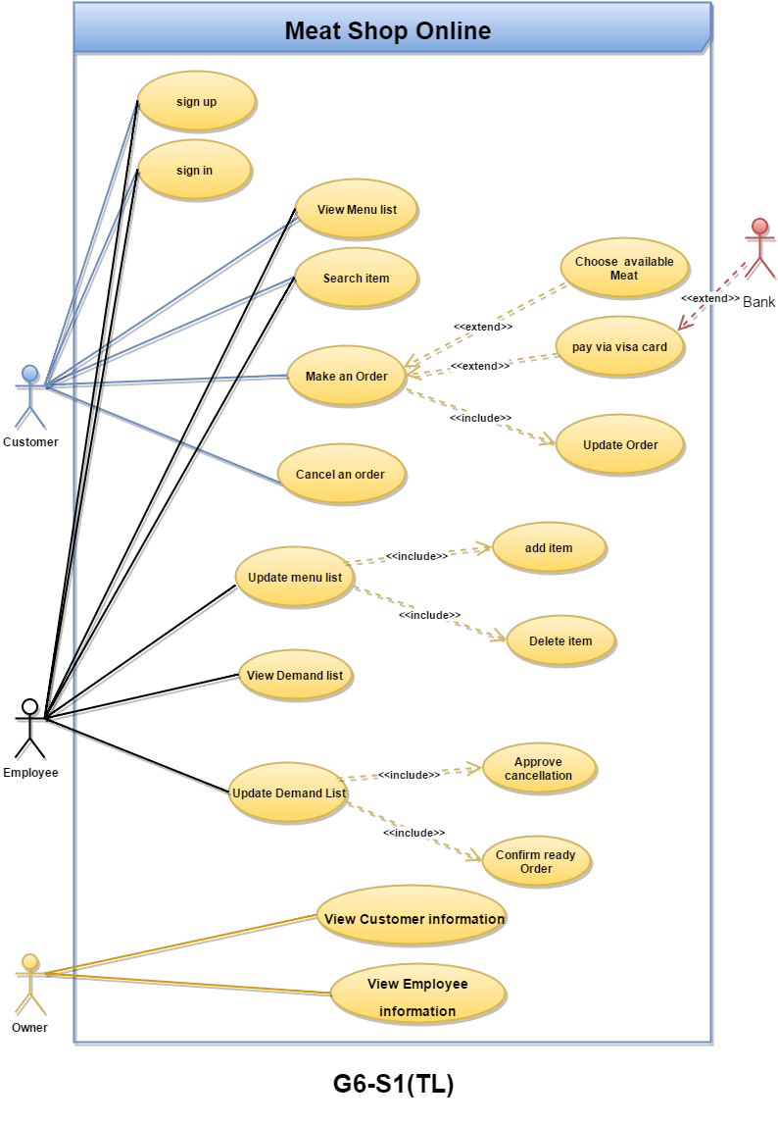

**Detailed description of key USE-CASES:**

**Tawfiq - Cancel demanded meat use case :**

|  |  |
| --- | --- |
| Actors | Customers |
| Description | Customers may cancel their demand. The order can be deleted or canceled if the ordered meat is not ready and the timer less than 10 min . Cancellation can be approved by the employee. |
| Pre-conditions | 1. The customer sign in 2. The customer order meat 3. The order is not ready |
| Sequence/Flow of  Events | 1. The customer make an order  2. Cancel order  3. employee should approve the cancellation after checking if the timer equal 10 min, and the customer not pay.  4. If the oreder ready ( timer >= 10 min and pay ) and the customer make cancel the order, the cancellation will be denied |
| Data | Customer info, order info, meat status(ready or not) |
| Stimulus/Trigger | Customer can use the meat shop to cancel the order. |
| Post-conditions/  Response | 1. Cancel the order, if successful. 2. continue the order, if failed. |
| Comments | There is no limits in the number of cancellation. |

**Tamer -Login Use Case:**

|  |  |
| --- | --- |
| Actors | Owner , Employee , Customer |
| Description | For each actor there will be a special interface with its appropriate functionality that fits each actor specifically |
| Pre-conditions | To use the system actors must be signed in  that is (actor has a valid account “signed up has achieved” and enters both username & password successfully ) |
| Sequence/flow of event | 1. The system shows a welcoming interface that requests the actor to enters both username and password. 2. The actor provide the system with both username and password 3. The system validates the entered username and password , upon a successful validation the actor logs into the system to the appropriate interface . 4. if validation was not successfully achieved that is incorrect username or password entered ,  the system displays an error message and let the user choose to cancel or forget password option “changing the password via email and sending a verification code “ |
| Data | Username, password, verification code (if was an error gain via email ). |
| Trigger | An actor access the website and wants to login |
| Post-conditions | 1. Display the actor interface 2. Store the data “latest login time ,,” |

**Helwa – View Demand meat list Use case**

|  |  |
| --- | --- |
| Actors | Employees |
| Description | The employees that work in customer service can view the demanded meat list with its full description |
| Pre-conditions | Have an employee account |
| Sequence/Flow of Events | 1. open employee account 2. click on demand list to view |
| Data | Employee sign in his/her information |
| Stimulus/Trigger | Employee can view demanding list |
| Post-conditions/ Response | View full demanding list |

|  |  |
| --- | --- |
| Actors | Customer |
| Description | A customer can demand his\her meat order online, determine the type, quantity and when delivered. |
| Pre-conditions | has customer account on meat shop |
| Sequence/Flow of Events | 1. open customer account 2. select type ,quantity of meat and when delivered , and add to carte 3. pay for your order meat online 4. when the payment is authorized then demand is confirmed |
| Data | meat information, payment information |
| Stimulus/Trigger | Order confirmed |
| Post-conditions/ Response | meat demand was successful |
| Comments | Customer must be sure the address added when made account it’s true  because the order will arrive to it. |

**Dana -Demand meat online Use case :**

**ACTIVITY diagrams:  
Main Activity diagram:**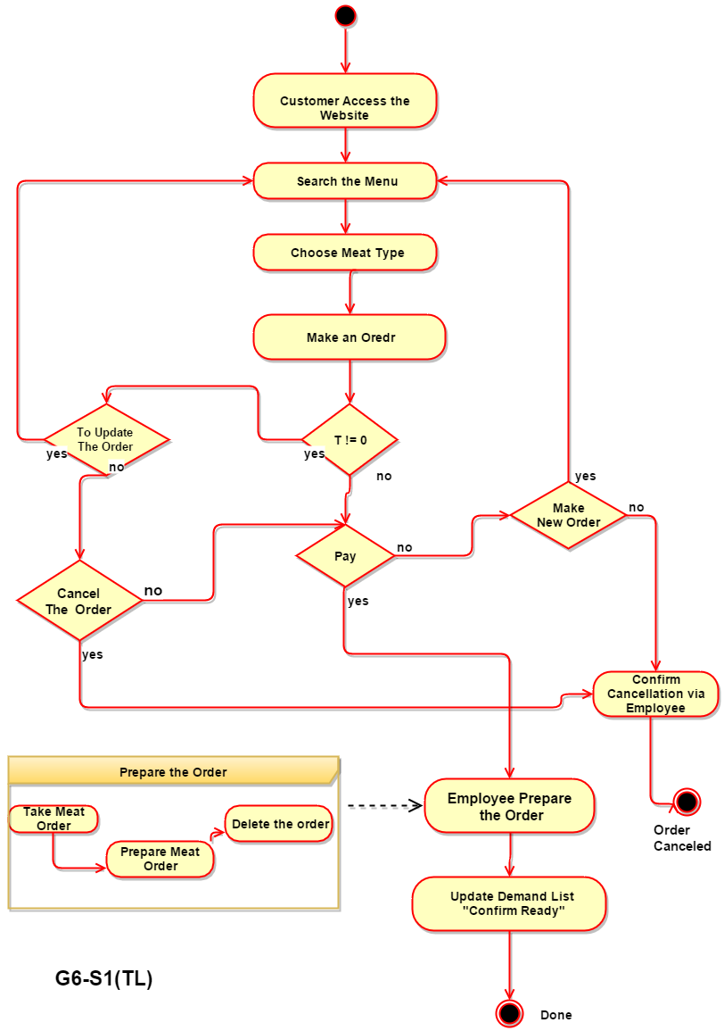

**Tawfiq- Cancel order activity Diagram :**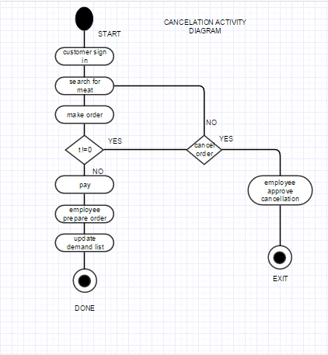

` **Tamer- Login activity Diagram :**

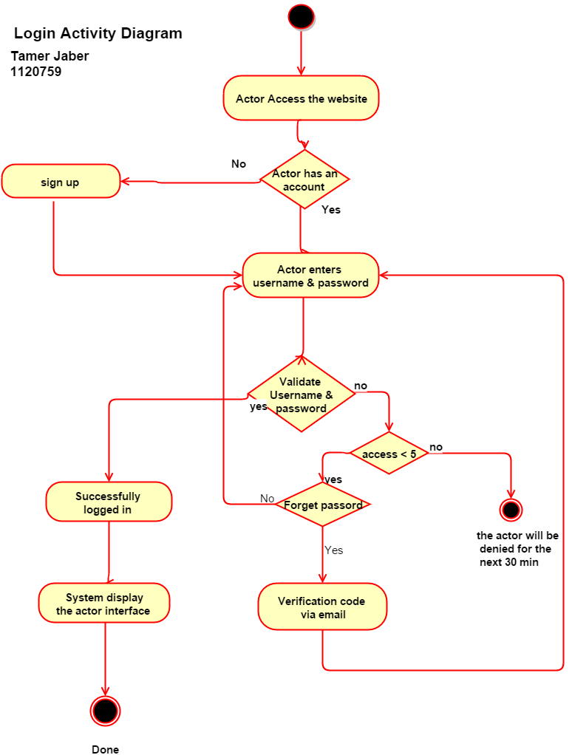

**Helwa -View meat list Activity Diagram:**

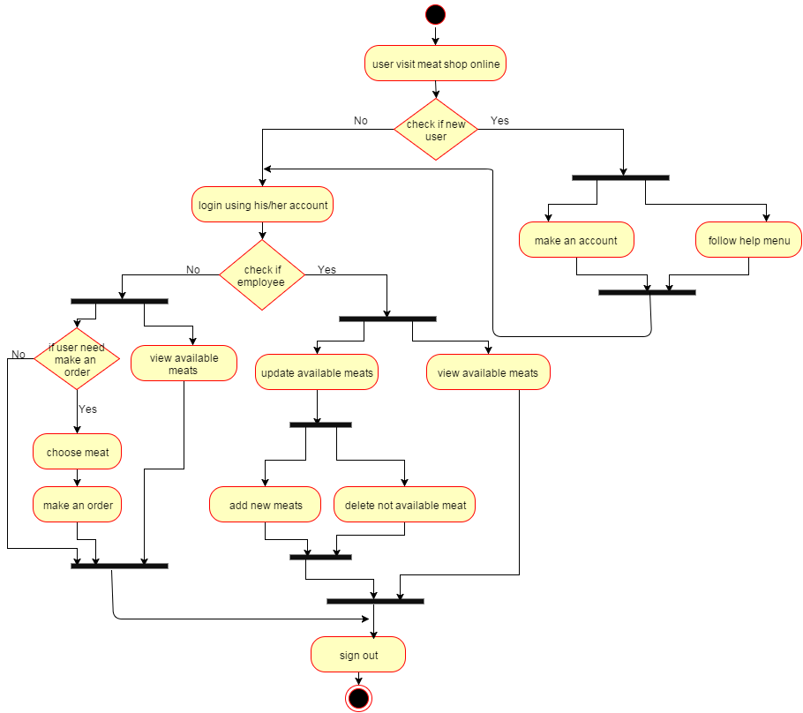

**Dana-make order activity Diagram :** 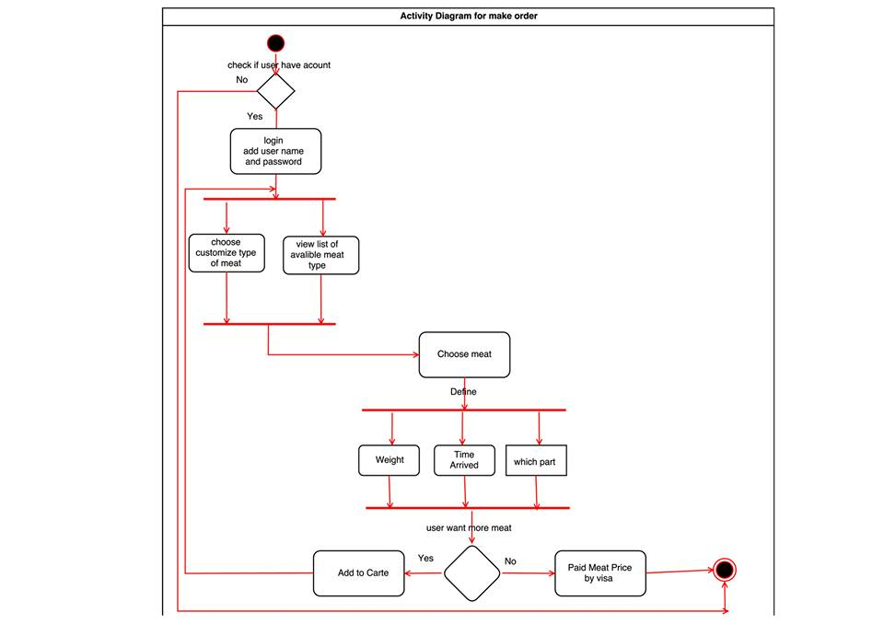

**System Modelling and Design**

**Analysis model –Done By Tamer**



**Detailed CLASS Diagram:**

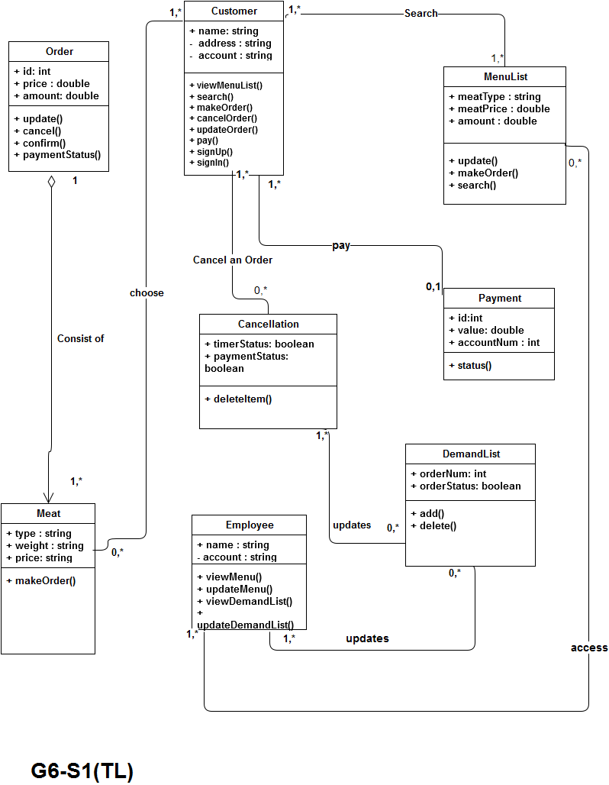

**CLASSES and their description :**

|  |  |
| --- | --- |
| Class | Description |
| Customer | **Store name and address of the customer,  customer can order meat and search for items in the menu .** |
| Payment | **Contain details about customer account and the order value** |
| Menu list | **Contain types of available meat and price for each, it is ordered by customer** |
| Meat | **It’s a meat that has type and amount and price  that the customer can choose among and make order** |
| Order | **Customer can choose and pay for his/her order  mainly consist of meat items** |
| Delete | **Customer can delete order if he/she not paid within the 10 minutes period** |
| Demand list | **Contains list of ordered meat,**  **That can be cancelation “approve” or ready “confirm”** |
| Employee | **Person who can update meat demand list if any change occurs in the list** |

**Object Diagram Done by Tamer:**

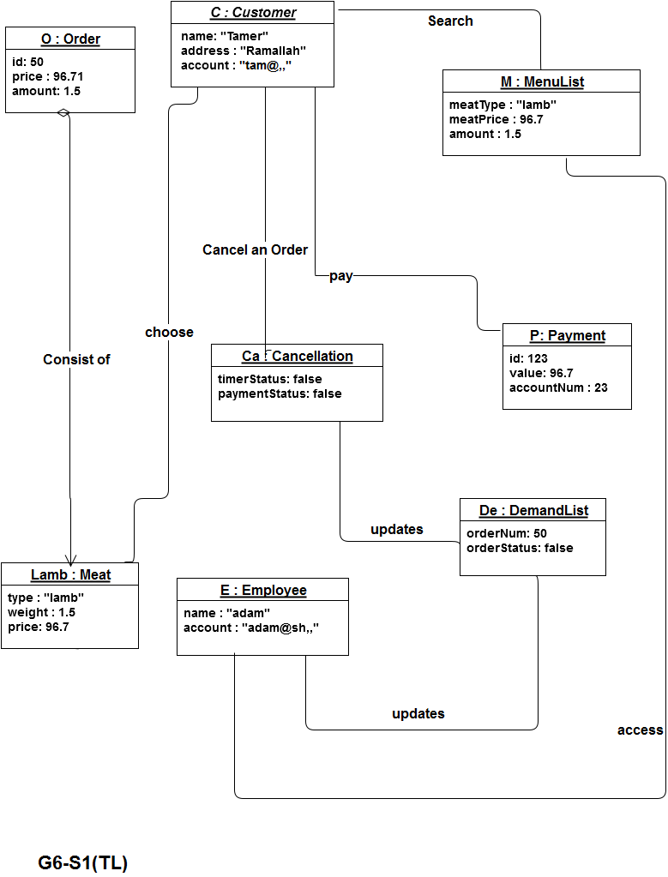

**SEQUENCE diagrams   
  
Cancel an order Sequence Diagram :Done by ”Tamer + Tawfik”**

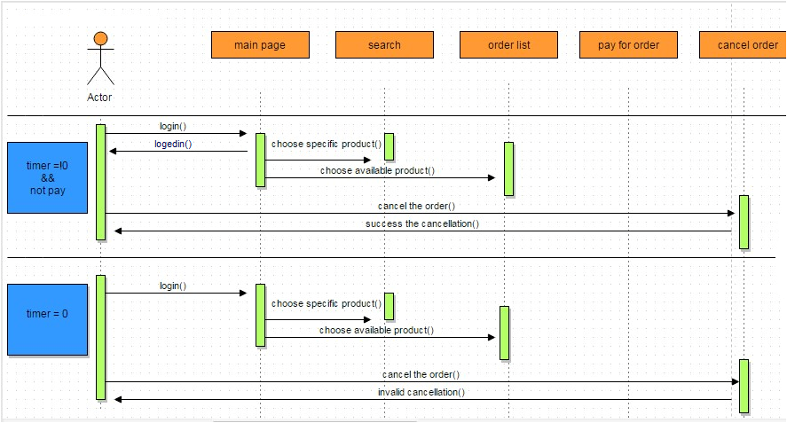  
**Make an order Sequence Diagram : Done by ” Tawfik”**

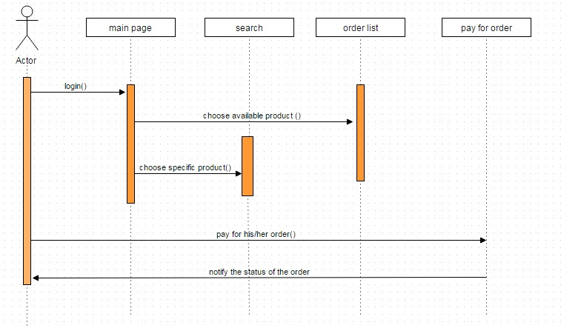

**view List Sequence Diagram Done by “Dana”:**

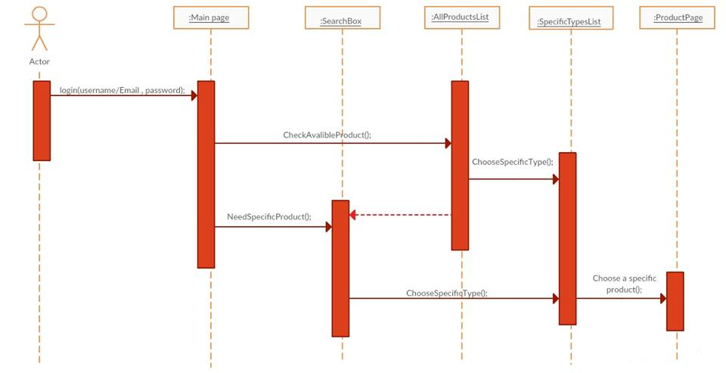

**Login Sequence Diagram Done by Dana:**

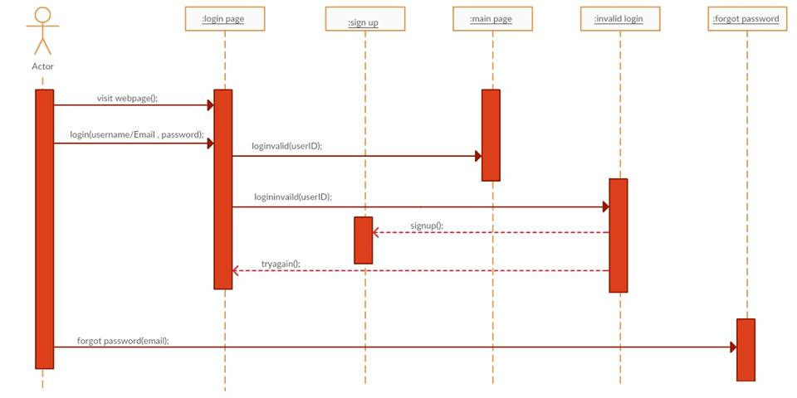

**State Diagram “Done Tawfik” :**

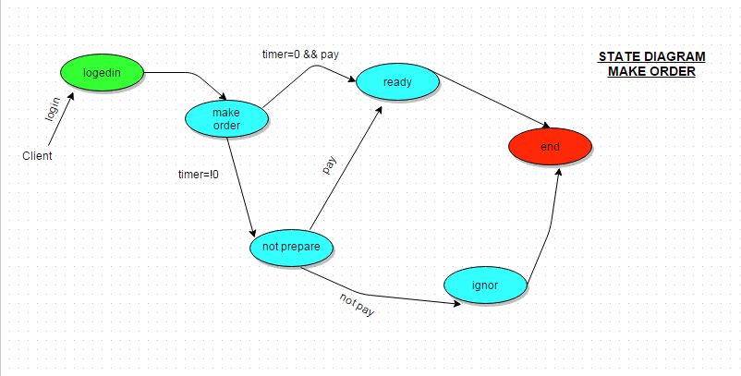

**System Design**

**General design goal:**

**Low coupling:** couple between two classes means that these cases collaborate frequently. Customer, Meat and order list classes are collaborate frequently which mean that they should be in the same domain class, so we grouped these classes in the same component (order Database). We can see other coupled classes and their component diagram in the component diagram below.

**high cohesion:** to make components diagram less complex, and every component serves one functionality. that is each component we have designed in our system does a well defined job , i.e we define tow components : “Customer” ,“Employee” that will leads to high cohesion since we separate each component to serve only one functionality. Instead of having only one component called “USER” that contains both employee and customer that will leads to low cohesion system, as we can see from our component diagram the connation between components is simple and not complex.

**Specific system goal:**

**Performance in terms of processing speed:** the system response time for every instruction conducted by the user must not exceed more than a minimum of 10 second The system have high performance rate when executing user's input and provide system response with in short time usually 50 second for highly complicated task and 20 to 25 seconds for less a span complicated task.

**user-friendliness in terms of training days:** the system provides an easy to use GUI ,that has simple layout which serves each function separately ,that is our GUI information density does not exceeds the 31% of the interface which is a good design term in “HCI”, our system need maximum one day of training to be familiar with all functionality and services .

**Component Design**

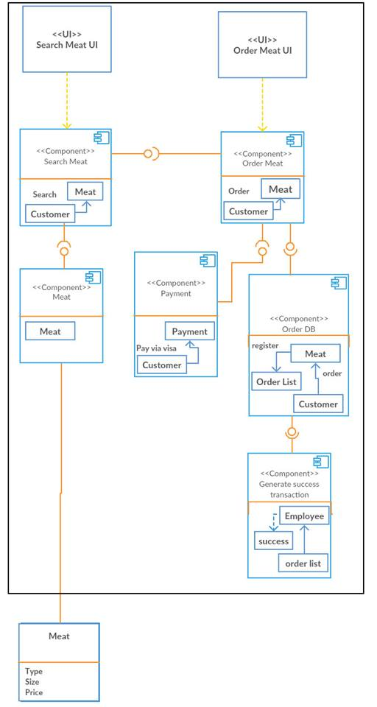

**Overall architecture diagram –Done by Tawfiq**

As we can see the diagram has 3-layers, one for the GUI, one for Application, and infrastructure,

The User interface classes assigned as application components, and we assign common technical classes to infrastructure components.   
> couple between two classes means that these cases collaborate frequently.

> To make components diagram less complex, and every component serves one functionality

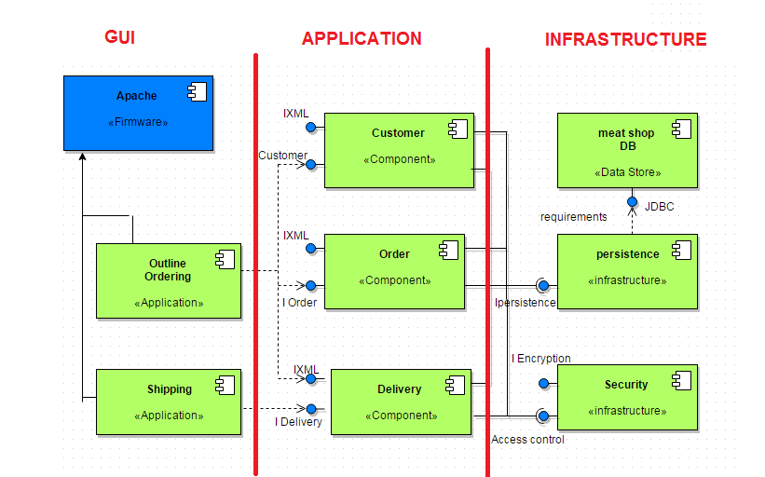

**Deployment diagram –Done by Tamer & Tawfik**

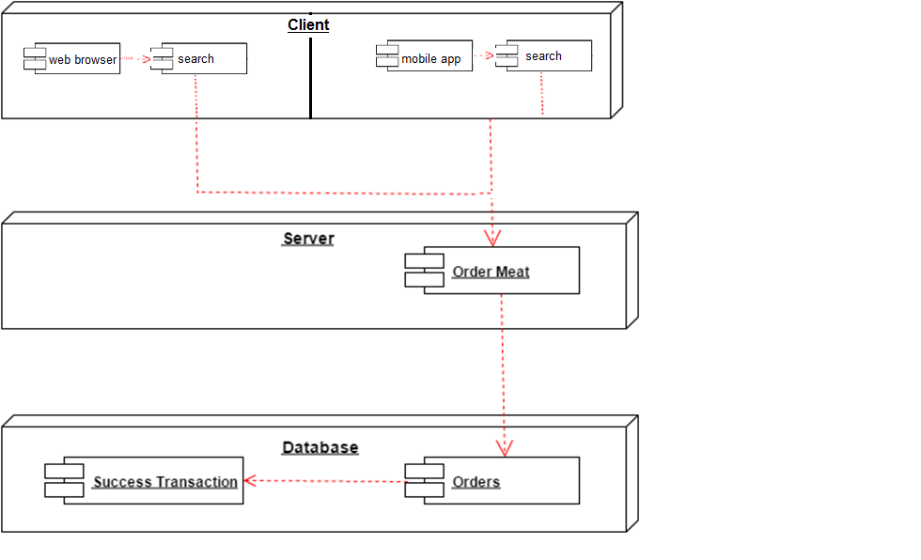

**Assessment and Effort Estimation**

***Note:  
Mr.Adel would you please excuse us as our 6 assessment forms will be attached in separate .rar file that’s because each time I paste it here, the whole document dissolve and ive tried several time ,, Moreover it will appear as one document in the hard copy   
Thanks ^_^***

**Done by Tamer**

|  |  |  |  |
| --- | --- | --- | --- |
| UR | Estimated Effort | Estimation # of developer | Total Effort |
| UR1 - GUI | 1 pw | 1 | 1 |
| UR2 - Code </> | 1 pw | 2 | 2 |
| UR3- VISA | 1 pw | 2 | 2 |
| UR4 - Design | 2 pw | 2 | 4 |
| UR5 - Mobile | 2 pw | 2 | 4 |
| UR6 - Translate | 1 pw | 1 | 1 |
| Total effort/avg | 8 pw | 10/6= 1.67 | 14 pw |
| Schedualed time 30% | 8*1.30=10.4 pw |  | 14*1.30= 18.2 |
| Cost |  | Avg salary=$250 | 250*18.2=4550 |
| Profit Margin(min=10%, max=30%) |  | Min cost 🡺  Max cost 🡺 | 4550*1.10=5005  4550*1.30=5915 |

**Appendix  
Our Team Meetings –Done by Tamer:**

|  |  |  |  |  |
| --- | --- | --- | --- | --- |
| Date | Duration Time | Subject | Attendance | taken actions |
| 17-Oct-2015 Sat | 20 min | >Ice breaking | ALL | -create FB group |
| 20-oct-2015  Tue | 15 min | >Time table | ALL | -making time table to ease meeting process |
| 21-oct-2015 Thu | 10 min | >Understanding the Business | ALL | -start making business document |
| 24--oct-2015 Sat | 15 min | >Understanding the Business &USER REQUIREMENTS | ALL | -setting question to be asked for our Customer |
| 27-oct-2015 Tue | 25 min | >USER REQUIREMENTS | ALL - Tawfik | -understanding the business Req and write document |
| 3-Nov-2015 Tue | 30 min | >Requirement Analysis | ALL | -setting question to be asked for the customer |
| 5-Nov-2015 Thu | 10 min | >Requirement Analysis | ALL - Dana | -ensure our understanding for the business |
| 11-Nov-2015 Wed | 10 min | >Requirement Analysis | ALL | Make some changes on the req |
| 14-Nov-2015 Sat | 20 min | >Modifying Requirement Analysis  >,USER REQUIREMENTS, | ALL | Ensure our changes and set up meeting with our customer |
| 19-Nov-2015 Thu | 10 min | >Modifying Requirement Analysis , >USER REQUIREMENTS, >Understanding the Business | ALL-tamer | Negotiate actors role |
| 25-Nov-2015 Wed | 10 min | Discuss all the previous works | ALL | Ensure every things alright with our customer |
| 8 Dec-2015 Tue | 10 min | Getting ready to the up coming  phase | ALL | -recap all the work |
| 10 Dec-2015 Thu | 15 min | System Modelling and Design :  use case | ALL-dana | Negotiate the business functionality |
| 15 Dec-2015 Tue | 20 min | System Modelling and Design : use case | ALL | Just drawing draft together and suggest changes |
| 17 Dec-2015 Thu | 20 min | System Modelling and Design :  Overall Activity Diagram | ALL | Changes have been made ,payment problem |
| 19 Dec-2015 Sat | 30 min | System Modelling and Design :  Overall Activity Diagram | ALL -Helwa | Changes have been made |
| 22 Dec-2015 Tue | 25 min | System Modelling and Design : use case ,  Overall Activity Diagram | ALL | ensure the timer and the payment are correct |
| 2 Jan-2016 Sat | 30 min | architectural Design | ALL | -draw draft and understand |
| 4 Jan-2016-Mon | 20 min | component design | ALL | Make changes and ensure the previous work and their goals |
| 6 Jan-2016 Wed | 25 min | deployment diagram | ALL | Finalizing the deployment |

**Our Team Meetings with Customer –Done by Tamer:**

|  |  |  |  |  |
| --- | --- | --- | --- | --- |
| Date | Duration Time | Meeting Subject | Attendance | Taken action |
| 21 Oct Wed | 30 min | >Ice breaking  >understanding the business | All | - Taking notes about the   business |
| 27 Oct Tue | 10 min | >Work on business description and requirement | All | -summerize the business requ |
| 4 Nov  Wed | 20 min | >Ensure the requirement meets the business needs | All | * Our work has been approved |
| 25 Nov Wed | 15 min | >Discuss the actors role  and their > use cases and | All | -payment method to be approved next meeting “visa” |
| 28 Nov  Sat | 10 min | >Discuss the scenario | All | -payment method approved |
| 1 Dec Tue | 25 min | >Discuss All activity diagram | Ahmad KH , Ehab A , Tamer & Tawfik | -To work on timer within the diagrams |
| 2 Dec  Wed | 5 min | >To approve the activity diagram changes | Ahmad KH Tamer Tawfik | -changes on the activity diagram approved |
| 15 Dec  Tue | 15 min | >Discussed system classes , | All | --start working on class diagram |
| 17 Dec  Thu | 20 min | >Discuses object diagram. | All | -class diagram approved |
| 5Jan Tue | 15 min | > architectural Design >component design and >deployment diagram | All | * All works have been approved |

**The End**