**System CLASS Diagram, and brief description of classes**

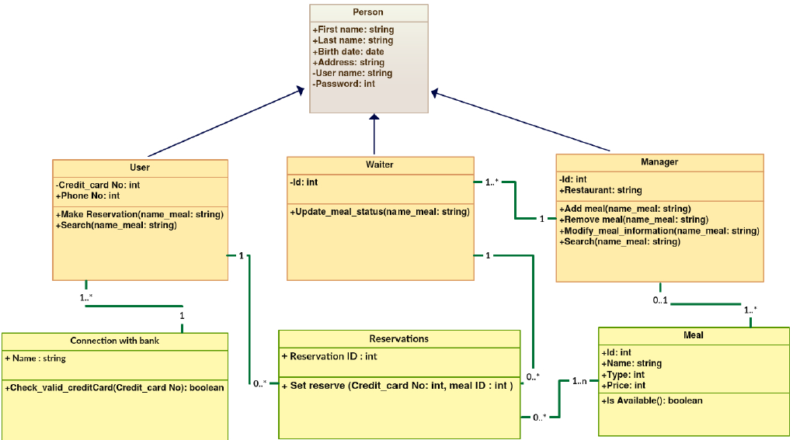

(( Drawn using Creately ( <http://creately.com>) ))

**Classes Description:**

**Person** : identifies an entity that generalizes all users of the system.

**user :**  identifies the user of the system that want to reserve a meal.

**Waiter**: identifies the person who will check the meals demand and change the status.

**Manager**: identifies the person who will organize all system activites.

**Meal** : identifies the meals that users want.

**Connection with bank**: identifies the credit card of user is valid or not.

**Reservations**: identifies the Meals reserved by the user.

OBJECT Diagram - one example

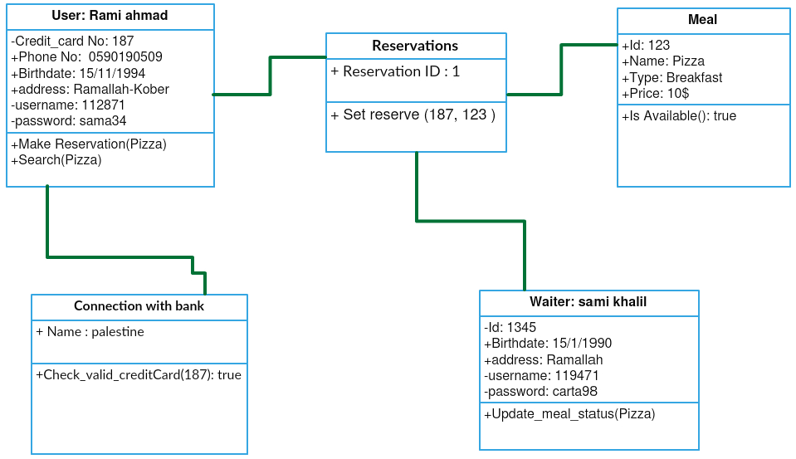

(( Drawn using Creately ( <http://creately.com>) ))

SEQUENCE Diagram; four sequence diagrams for four different use cases

**Sequence Diagram for Reserve A Room Use Case: < Ahmad Dar Khalil>**

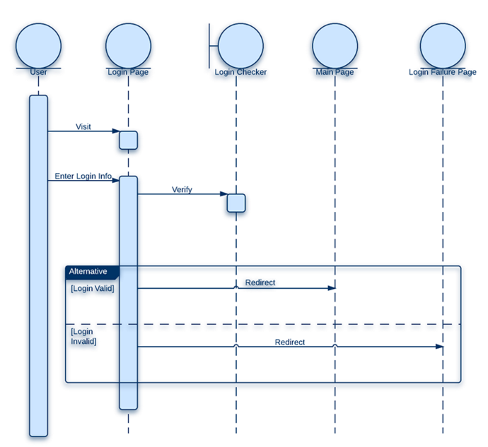

(( Drawn using draw.io ( <https://www.draw.io> ) ))

**Sequence Diagram for Add meal Use Case: < Rinad Lahlooh>**

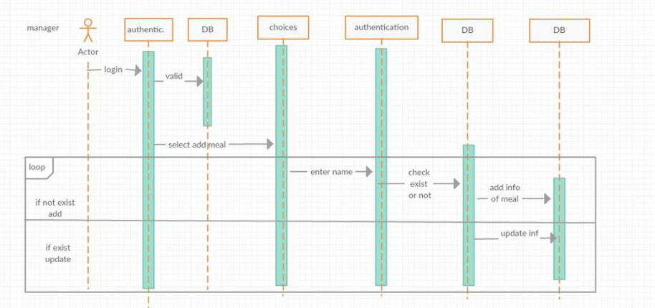

(( Drawn using Creately ( <http://creately.com>) ))

**Sequence Diagram for Make reservation Use Case: < Ahmad Salameh>**

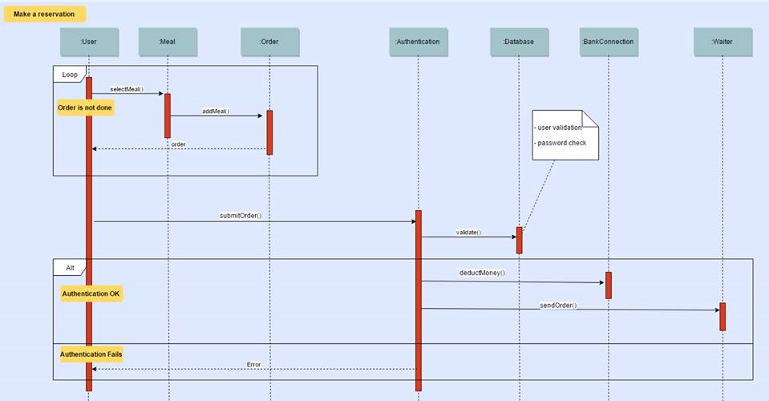

(( Drawn using draw.io ( <https://www.draw.io> ) ))

**Sequence Diagram for Modify meal information Use Case: < Ehab Amriah>**

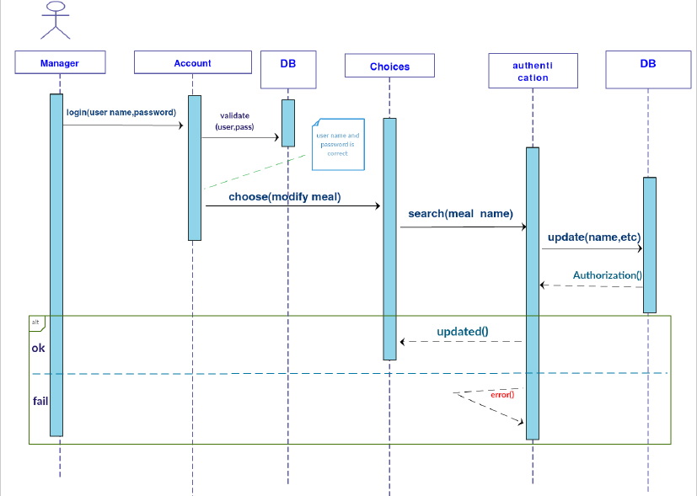

(( Drawn using Creately ( <http://creately.com>) ))

**STATE diagram: one state diagram, of an object that has a state**

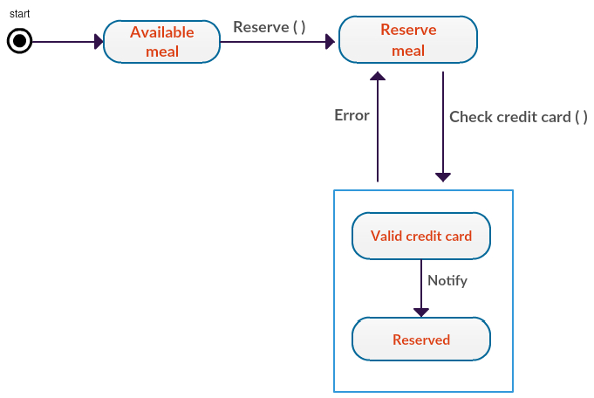

(( Drawn using Creately ( <http://creately.com>) ))