

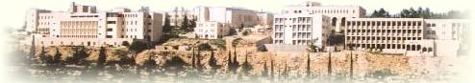

Faculty of Engineering and Technology

Electrical and Computer Engineering Department

Meals Online System

Developer Group: S1_G5 (EA) ,, Customer Group: S1_G4 (AK)

**Student’s Name :** Ehab Amriah **ID:** 1120871

**Student’s Name :** Ahmad Dar Khalil **ID:** 1120443

**Student’s Name :** Ahmad Salameh **ID:** 1110217

**Student’s Name :** Rinad Lahloh **ID:** 1120465

**Instructor Name: Dr. Adel Taweel Sec: 01**

**Date : 5/12/2015**

**Role of each member:**

* Ehab Amriah – Project Manager
* Ahmad Dar Khalil – Technical Architect
* Ahmad Salameh- Programmer
* Rinad Lahloh – Secretary

**Contribution of each member:**

* Project Manager (Ehab Amriah) : Distribute of tasks to each member , draw USE- CASE diagram on computer , typed the Description,Scenario and Activity diagram for use-case **(Modify meal information)** , and made sure each member did his part and participated in the design also.
* Technical Architect (Ahmad Dar Khalil): typed the Description,Scenario and Activity diagram for use-case **(Login)** and lead the team to design overall/main ACTIVTY diagram and draw it on computer.
* Programmer (Ahmad Salameh): typed the Description,Scenario and Activity diagram for use-case **(Make a reservation)** and he was effective member especially in the design stage.
* Secretary (Rinad Lahloh): typed the Description,Scenario and Activity diagram for use-cases **(Add meal , Remove meal)** and she participate with the team in the phases we made**.**
* All members participated in the user requirements and system requirements and the USE-CASE diagram .

**User Requirements**

**1.** Website shall has four categories that are for :

A. Breakfast meals.

B. Lunch meals.

C. Dinner meals.

D. All other dishes we have including sandwiches with Drinks, dessert and snacks.

**2.** The site shall give the user search field to search about any meal easily.

**3.** Each meal in each category shall be with its price, a brief description and offers it may has (for school, employee etc.).

**4.** The website shall ask people who will use it to sign up before starting their visit.

**5.** The payment methods are A. When we deliver their orders to them not before that. B. Pay online.

**6.** The order form will ask user to enter his name, phone number, his identity and the address the user wants us to deliver meals. In the home page, we want a brief description about us and some contacts details.

**SYSTEM REQUIERMENTS**

* 1. The main meal will be displayed based on the time of the day.
  2. From 8-12 Am breakfast meals will be shown on the main page, from 12-5 pm lunch meals will be shown on the main page, from 5-9 pm dinner meals will be shown on the main page and the other time the drinks shall be shown in the main page.
  3. User can choose any category and then the system shall suggest all available meals in that category.

2.1 The system shall contain autocomplete property for the search field.

2.2 The system shall provide the user with past search queries.

2.3 The system should support searching for categories.

3.1 The user can suggest a modification for the description shown.

3.2 The user can make a review on any meal in the site.

4.1 The system shall provide a form includes username, password, email and phone to complete the registration of the user.

4.2 The system should verify the entered information by sending a verification email for the entered email.

5.1 The system shall accept the payment via (visa card) or (internet shopping card).

5.2 If the payment was not using online card, the system shall send verification code to the phone number and user shall enter it into a specific field to complete the order.

6.1 Once someone wants to order some meal, he should provide his phone, name and address to submit the order.

6.2 For users who are registered on the site, the information related the phone, name and address should be filled automatically for that order.

6.3 If any user has a problem with the order submission, system shall provide contact information to fix the problem by the IT stuff.

**Actors:**

**Manager**: This actor represents someone who can access the whole system with user name and password, add meal , remove meal, and modify meal information.

**User**: This actor represents someone who can access the whole system with user name and password, view available meals, search for meal , and reserve any meal .

**Waiter** : this actor represents someone who is added to the system by the manager , displays all his reservations, every meal is sent, it puts it received, update status for any meal (This meal reserved or not), and he also deal with any reported problems related with the system and redirect them to IT stuff.

**Bank**: if the user choose payment through Visa Card,, this actor validate vise card .

**Use Case Diagram:**

Use Case Diagram of the Overall System:

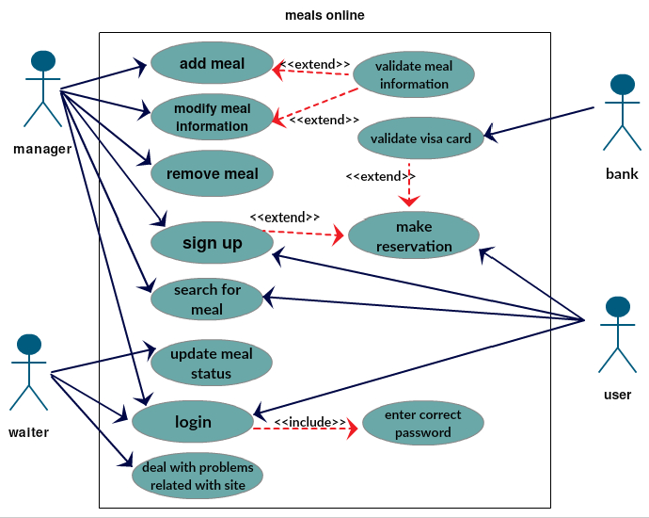

* Drawn using Creately ( <http://creately.com/diagram-type/use-case> ).

**Use-case (LOGIN):**

**DESCRIPTION:**

|  |  |
| --- | --- |
| Actors | Manager , user , waiter |
| Description | A manager, user or waiter may login to the system, each one of them will enter to different profile, that depends on it’s position on the company . |
| Pre-conditions | Manager, user and waiter must be signed up on the system to be able to enter into his profile. |
| Sequence/flow of event | **1.** Once one of the Actors above enter the site of the business, the system will show an interface to enter.  **2.** if the username and password matches then the system shall automatically allow the user to see his profile .  **3.** if there is a mistake in the password system shall show the option of changing the password via his email by sending a verification code and display a window to enter it . |
| Data | Username, password, verification code (if was an error ). |
| Trigger | User, manager or waiter want to enter to his profile. |
| Post-conditions | Display his profile interface.  Store the date of entrance. |
| Comments | manager must have appropriate security permissions to access  meals and waiter information |

**Scenario:**

* **Normal:**

Someone access the website of the business and enter his username and password(‘ahmad’,’123123’) in username, password boxes, this person ‘Ahmad’ was already signed up in the site, and the information that entered ware correct so it enter to his account and show things belong to Ahmad (main meals in the website).

* **Alternative:**

1. Person (either manager, waiter or user) enters username and password and his username does not in the database(does not signed up ), then the system will show message to sign up as a customer user (not manager or waiter) then he can enter as a new user.
2. User ‘Ahmad’ enters incorrect password, then the system will ask him if he forget the password and will send a verification code to his email , then he password will appear to him to login successfully.

* **Error:**

1. user ‘Ahmad’ makes a 10 consecutive wrong passwords , the system will prevent the browser to enter the system for 1 day and send message to the account to say that someone try to access your account ‘please change the password’.
2. User enter more than 32 digit username and password. (The system hold until 32).
3. Username or password are ‘< or > or any html tag’ the system will discard them and send a message to the IT stuff to make a security verification.

**Activity Diagram:**

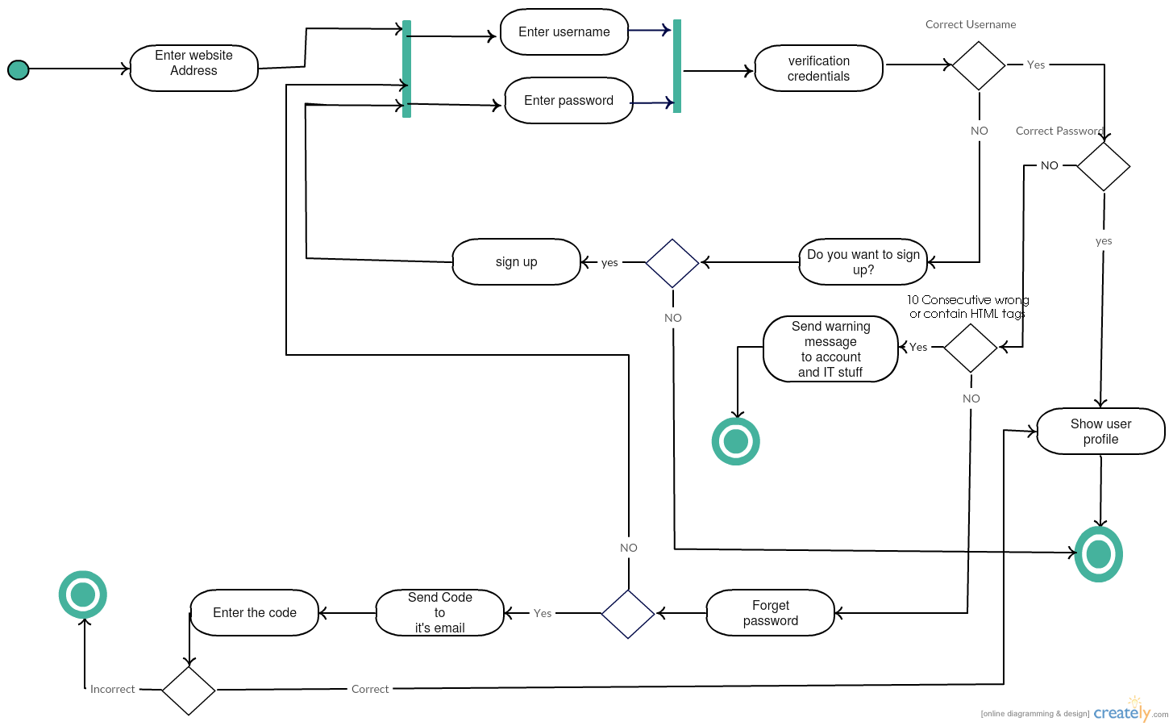

* Drawn using Creately ( <http://creately.com/> )

**Use case: ( Make a reservation):**

**DESCRIPTION:**

|  |  |
| --- | --- |
| Actors | User, waiter. |
| Description | The user surfs the website in order to find a meal to order, the meal must be available before being added to the reservation list. If the order is ready and submitted, then the waiter takes the order and the process of getting the order done starts. |
| Pre-conditions | 1. The user is registered on the system. 2. The user must be logged in the system. 3. The user must have a sufficient amount of money in his account if the payment is online. |
| Sequence/Flow of events | 1. The user chooses the meals to be listed in the order. 2. The user presses the submit button. 3. The system checks if the user is logged in. 4. If he/she is not logged in, the system asks him/her to log in if he/she is registered on the system. 5. If he/she isn’t registered on the system, he/she must fill the registration form. 6. The system checks if the user has a sufficient amount of money in his/her account. 7. If yes, it places the order and it reaches the waiter. 8. If no, it asks the user if he wants to pay when the order is delivered to him/her or to deposit the needed amount of money in his/her account. |
| Data | The order details, The user information. |
| Stimulus/Trigger | The pressing of the submit order button. |
| Post-conditions/Response | 1. The order’s cost will be deducted from the user’s account (if the payment was online). 2. The order will be delivered once it’s ready. |

**Scenario:**

**Normal:**

Ahmad chooses chicken breast in white sauce in addition to Greek salad, with total price 50$. Then he submits the order by pressing the submit order button. The system asks Ahmad to log in since he has an account, in order to check the type of payment Ahmad is used. Ahmad is using VISA to pay online, so the system deducts 50$ from Ahmad’s account. The waiter then takes the online submitted order to the chief to get it done and deliver it to Ahmad.

**Alternative:**

1. Ahmad chooses chicken breast in white sauce in addition to Greek salad, with total price 50$. Then he submits the order by pressing the submit order button. The system asks Ahmad to log in since he has an account, in order to check the type of payment Ahmad is used. Ahmad pays when the order is delivered to him, so the delivery worker will take the 50$ in cash from Ahmad. The waiter then takes the online submitted order to the chief to get it done and deliver it to Ahmad.

2. Ahmad chooses chicken breast in white sauce in addition to Greek salad, with total price 50$. Then he submits the order by pressing the submit order button. The system asks Ahmad to register since he doesn’t have an account, in order to check the type of payment Ahmad is used. Ahmad then registered on the system and chooses to pay online using VISA, so the system deducts 50$ from Ahmad’s account. The waiter then takes the online submitted order to the chief to get it done and deliver it to Ahmad.

**Error:**

1. Ahmad chooses chicken breast in white sauce in addition to Greek salad, with total price 50$. Then he submits the order by pressing the submit order button. The system asks Ahmad to log in since he has an account, in order to check the type of payment Ahmad is used. Ahmad is using VISA to pay online, so the system tries to deduct 50$ from Ahmad’s account. But Ahmad doesn’t have that amount of money in his VISA, so the system asks him to deposit a sufficient amount of money in his VISA and then try to submit the order again.

2. Ahmad chooses chicken breast in white sauce in addition to Greek salad, with total price 50$. Then he submits the order by pressing the submit order button. The system asks Ahmad to log in since he has an account, in order to check the type of payment Ahmad is used. Ahmad pays when the order is delivered to him. But Ahmad doesn’t verify his mobile number using the verification code generator that’s used by the system. So the order will not be submitted to prevent fraudulence.

**Activity Diagram:**

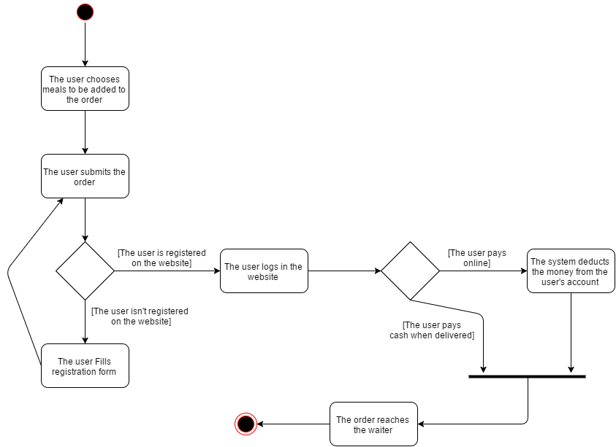

* Drawn using draw.io ( <https://www.draw.io/> )

**Use case: ( Modify meal information):**

**DESCRIPTION:**

|  |  |
| --- | --- |
| Actors | Manager |
| Description | Manager enter username and password and see categories on his restaurant and adjusts the information of any meal he wants. |
| Pre-conditions | Manager must enter his username and password correctly. |
| Sequence/flow of event | 1. Manager tries to get into system by entering his user name and password.  2. Check if these are valid, if not then try again, and if yes then he gets into the system and he views categories of his restaurant.  3. Choose meal that he wanted to update information of it and update this information.  4. Check whether they are valid or not. If they are valid, then information is updated ,and if not then try to enter another information. |
| Data | Meal type , picture of this meal and old meal information. |
| Stimulus / Trigger | Manager wants to update information. |
| Post-conditions | Information updated successfully. |
|  |  |

**Scenario:**

**Normal:**

manager enters username and password correctly ,then enters into your account .first, he shows modified option, when pressed it, he views all categories of his restaurant , he enters the category which contains the meal he wants to edit their information, then modifying information of this meal, and shows a message that has been modified successfully.

**Alternative:**

manager enters username and password correctly ,then enters into your account .first, he shows modified option, when pressed it, he views all categories of his restaurant , he enters the category which contains the meal he wants to edit their information, he did not find a meal in this category, so the system provides the option to search the public for meals by its name, if misspelled happened enter your name in for the meal, the system displays the names of meals near the entrance of the name in the search box, then modifying information of this meal, and shows a message that has been modified successfully.

**Error:**

manager enters username and password correctly ,then enters into your account .first, he shows modified option, when pressed it, he views all categories of his restaurant , he enters the category which contains the meal he wants to edit their information, then modifying information of this meal, waits to the system to validate it, The system shows a message that the information to not be modified and that there is an error, this is caused by that the manager did not put a logical price in box price (the price is negative), or that the name of the meal was very long (more than 50 characters), or leave one of the boxes empty.

**Activity Diagram:**

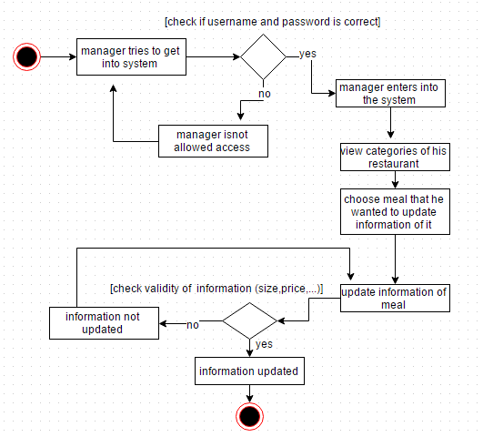

* Drawn using draw.io ( <https://www.draw.io/> )

**Use case: (Add meal):**

**DESCRIPTION:**

|  |  |
| --- | --- |
| Actors | Manager |
| Description | The manager want to add new meal to the system list , this meal should not allocated before in the system . When the administrator add new meal it should also contain the complete information like the price , quantity of meal and the description . |
| Pre conditions | The meal that is wanted to add should not be exist before in the system |
| Sequence /flow of events | 1. Manager put the user and password to the own account 2. Manager have access to add new meal 3. Manager have new meal to add it . 4. Checks if the meal I exist or not . 5. If the meal I exist then the manager can not add it , but if the meal isn’t exist then add it to the system list . |
| Data | New meal information , all meals information in the system in the system |
| Trigger | Manager wants to add new meals to the system . |
| Post conditions/ response | Store the date of entrance and Confirmation that meal has been added or not . |
| Comments | The managers have appropriate security permissions to access the meal information |

**Scenario:**

**Normal :**

The manager Ali wants to add new meal ( lasagna ) to the system which it checks that is no same meal before in it . After this , the administrators add the meal and the system is updated accordingly .

**Alternative :**

The manager Ali wants to add new meal to the system but the meal is exist before so the system point to it and if the administrators have new information , it have a choice to update it

**Error :**

1. The manager Ali want to add new meal( lasagna) to the system but this meal is exist before . so the manager is refused because the meal is found in the system .
2. The manager Ali want to add new meal (lasagna ) , but he didn’t put enough information for the meal like the price or the description . so the manager is refused because the meal is not have enough information .

**Activity Diagram:**

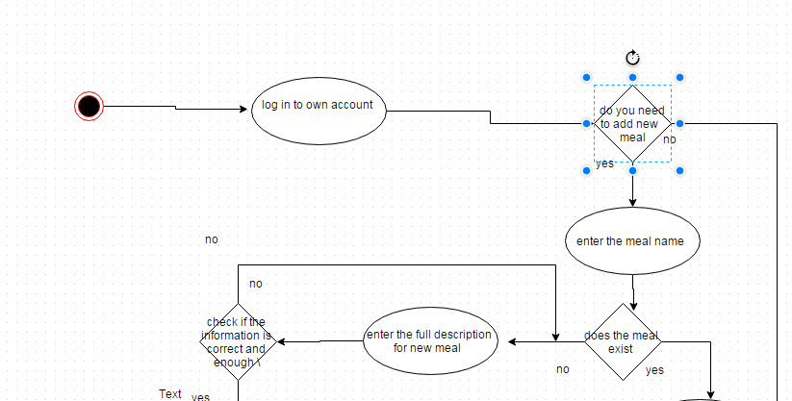

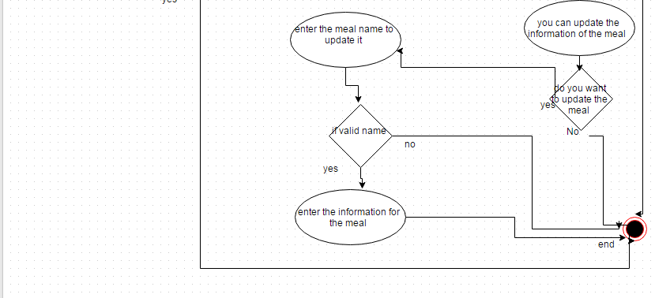

* Drawn using draw.io ( <https://www.draw.io/> )

**Use case: (Remove meal):**

**DESCRIPTION:**

|  |  |
| --- | --- |
| Actors | Manager |
| Description | The manager may want to remove the meal , so the meals should exist in the system . managers use the name of the meal then remove it with all information about it . |
| Pre conditions | The meal should exist in the system so it can removed |
| Sequence /flow of events | 1. Manager put own correct user name and password to account in system 2. Manager have access to delete the meal 3. The manager decide what is the meal 4. Checks the system if this meal is allocated or not 5. If the meal I exist then remove it and also all information is related then update the system , if the meal I not exist then it gives error |
| Data | All meals in the system , the meal that I wanted to remove |
| Trigger | Manager wants to remove new meals to the system |
| Post conditions | Store the date of entrance and Confirmation that the meal is removed |
| Comments | The managers have appropriate security permissions to access the meal information |

**Scenario:**

**Normal :**

The manager Ali wants to remove (lasagna) from the system , so the system check if the lasagna meal is exit in the system then after confirm that it exist , so here remove the meal from the list . After this , the manager add the meal and the system is updated accordingly .

**Alternative :**

* No alternative

**Error :**

The manager Ali wants to remove the lasagna from the system , and this meal is not found in the system so here it gives an error “ you can not remove the meal you don’t have it “

**Activity Diagram:**

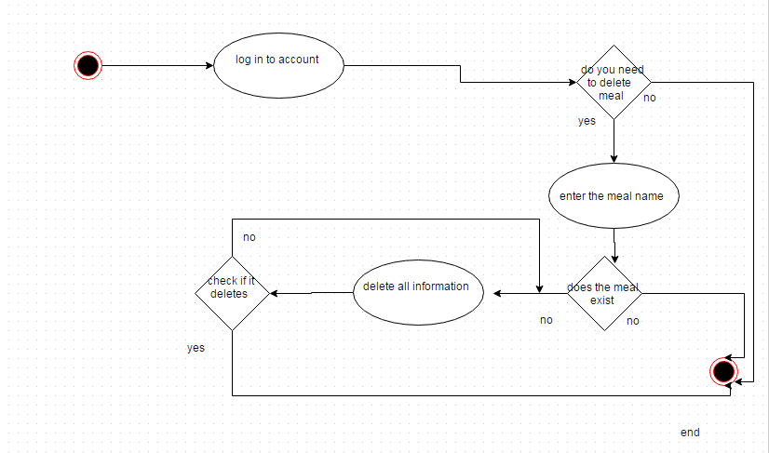

* Drawn using draw.io ( <https://www.draw.io/> )

**Overall\main activity diagram**

**For user:**

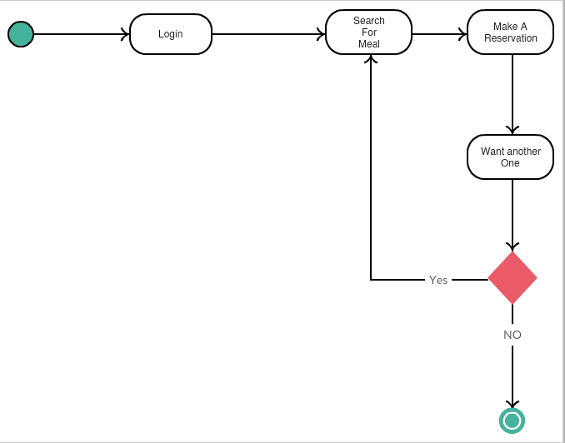

* Drawn using Creately ( <http://creately.com/> )

**For manager**

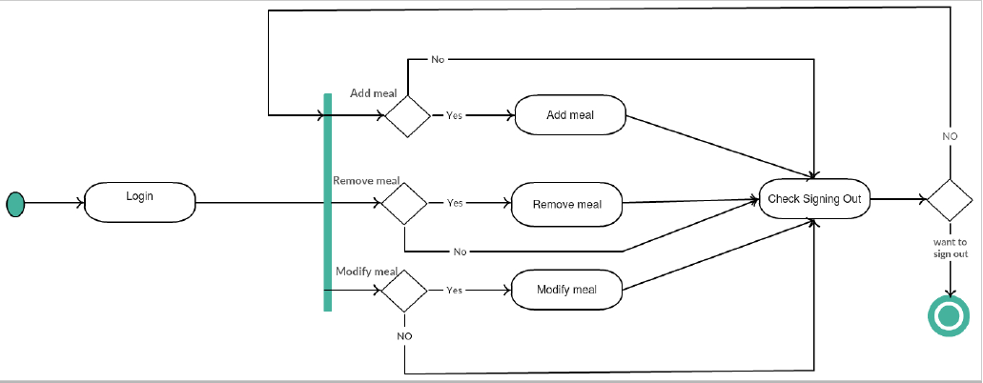

* Drawn using Creately ( <http://creately.com/> )