

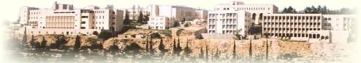

**Birzeit University**

**Computer Science Department**

**Software Engineering**

**COMP433**

**Phase 2**

**Section 1 – Instructor: Dr.Yousef Hassouneh**

Team members:

Yousef Madia 1100211

Shadi Ghabin 1100713

Saeed Suboh

**28/5/2014**

**1.Class Diagram:**

#### Driving and buying from the nearest Mall Class Diagram

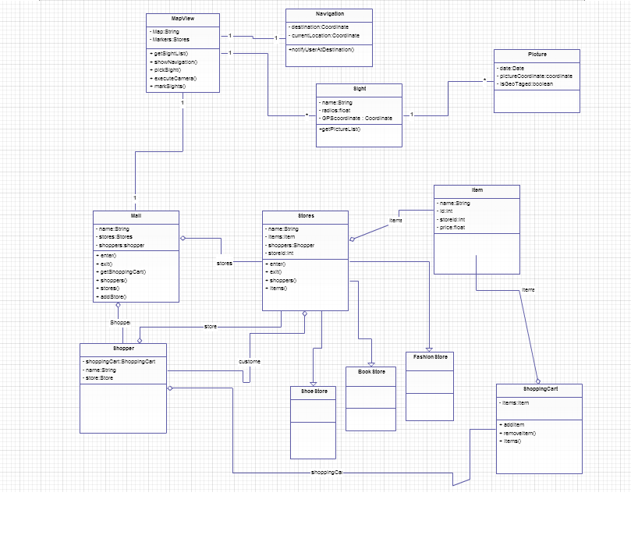

**2. Sequence Diagrams:**

**\*First sequence diagram :Selecting Store** (By team member: Yousef Madia)

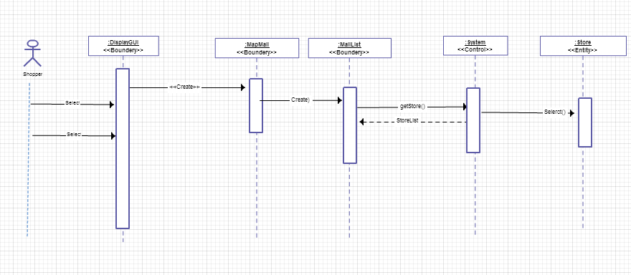

**\*** **second sequence diagram:** Waiting queue handling (By team member: Shadi Ghabin)

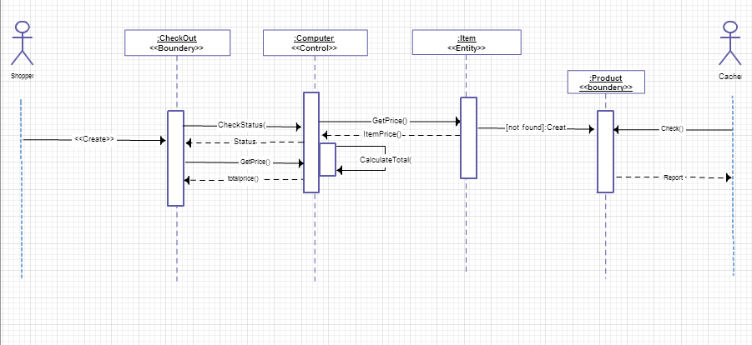

**\* third sequence diagram: PublishAnnouncement** (By team member: Saeed Subbah)

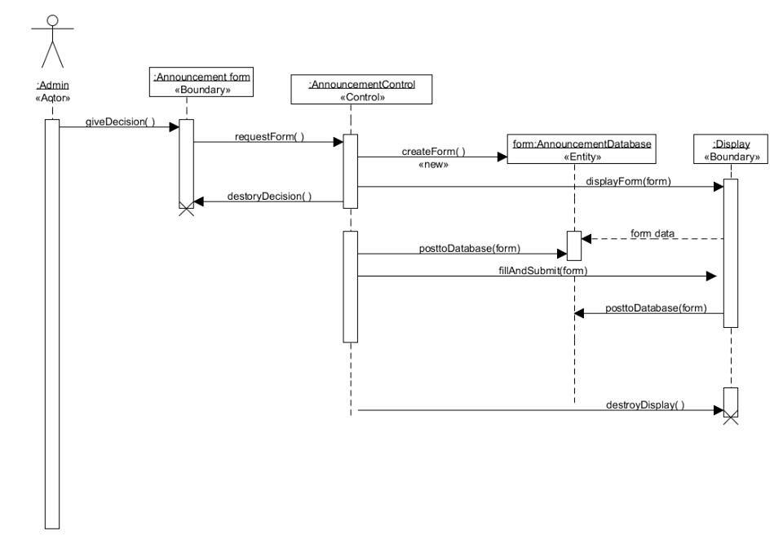

**3. State Diagrams:**

**\*First State diagram :Selecting Store** (By team member: Yousef Madia)

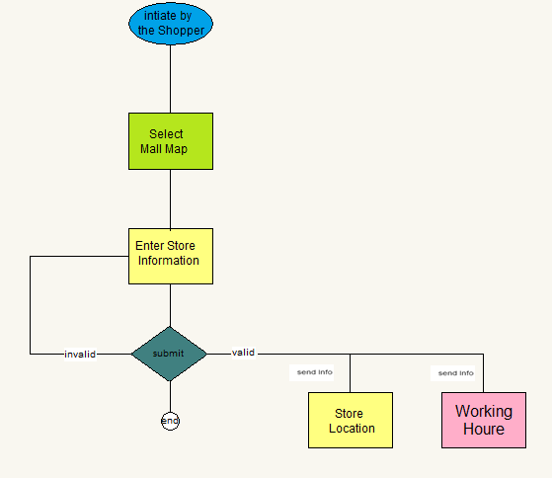

**\*** **second satate diagram:** Selecting Item(By team member: Shadi Ghabin)

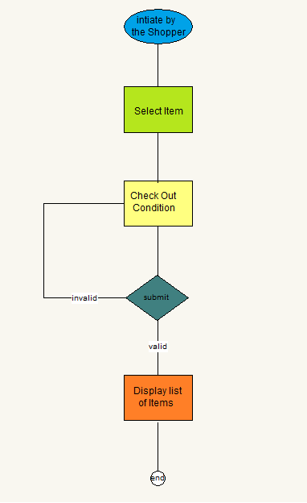

**\* third state diagram: PublishAnnouncement** (By team member: Saeed Subbah)

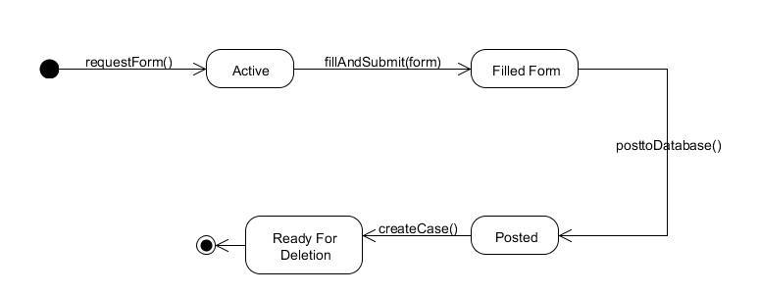

**4. Activity Diagrams:**

**The following graph is activity diagram :**

**\*First activity diagram : Ordering Product** (By team member: Yousef Madia)

