

**Computer Science Department**

**Second Semester 2017/2018**

**Instructor: Adel Taweel**

**Comp433 – Software Engineering**

**Project-Phase Three – Task 3**

**G1- Developer Group**

**3.1- Scenario Analysis**

**3.2- Actors and Use case Model Analysis**

**3.3- Activity Model/Diagram Analysis**

**Students:**

**Maryam Shaheen #1140427: Manager**

**Nourhan Abu Sharbak #1150640: Secretary**

**Eman Ghazawneh #1152278: Technical architect**

**Ahmad Thabet #1150312: Programmer**

**Sanaa Bader #1151763: Tester**

***3.1 Scenarios***

**Scenario#1 (Admin)   
By Ahmad Thabet**

**Initial assumption:** Samer enters the website, he wanted to check insurance company and their information, then viewed customers list, after that he wanted to manage enquiry, he was able to receive profits sent by System Profits Manager, last thing he managed policies by editing some of them.

**Normal**: the admin can enter the system and view companies and customers data, also manage enquiries and policies.  
  
**Alternative:** monthly profit is sent to the Administrator, but due to the System profit manager, the profit can be sent by each insurance applied to any customer, at any time.  
  
**Error:** can’t edit customers or companies information.

**Scenario#2 ( Insurance Company)  
By Maryam Shaheen**

**Initial Assumption:** The Insurance Company wanted to manage insurances, where it can create/ review/ edit insurances, view customers; also it can receive profit for each insurance.

**Normal:** the insurance Company can enter the system review customers, and insurances.

**Alternative:** monthly profit is sent to the insurance company, but due to the System profit manager, the profit can be sent by each insurance applied to any customer, at any time.

**Error:** can’t review the broker’s policies.

**Scenario#3 (System Reminder )  
By Eman Ghazawneh**

**Initial Assumption:** whileAbbas was playing games in his phone , he get a notification from insurance system that tell him , there’s still three days to pay so he should pay before the payment end , so he open the website and pay for the insurance.

**Normal:** The customer gets a notification that tells him to pay before the payment end.

**Alternative:** if his mobile phone not in range ، he also received a telephone call from the company.

**Error:** if his phone and telephone was out of service he also can get email .

**Scenario#4 (Customer )**

**By Nourhan Abu Sharbak**

**Initial Assumption:** Abbass heard that he can make insurance to his new car online by a website, so he searched for that website, and he found it, Now  he wants to register a new account, so he enter his username, password and another information , then it send a verification message to his email or phone, after that he fill the insurance enquiry and apply it ,and he choose the method of payment that he wants, then he read the policies of the company, after 9 month he try to login to his account he lost his password , but he ask the guidance for help and they help him to restore his password by email or phone, then he restore his password and login to his account to view all insurances.

**Normal:** The customer register in the website, so he can fill the insurance enquiry, then he can pay in the time of the payments by the method of pay that he chooses.

**Alternative:** When the customer faced any problem or want to ask any question about payments for example or ask to help he can ask for guidance.

**Error:** If SMS system down and the customer can’t connect with the internet, he can’t receive any email from the website.

**Scenario#5 (System Assistance)  
By Sanaa Bader**

**Initial Assumption:** Abbas wanted to make insurance for his car, he choose our insurance car system to do that, so he visited the website . It took him 5 minutes to recognize how it works , but at the end he asked for help from the system assistance of how the system works to achieve his goal from this operation and give him some tips.

**Normal:** The customer visits the website , he had misunderstanding of how to use the system , so they asked the system assistance for help.

**Alternative:** How the customer/ user will reach the assistance or communicate with it . The system provides a help manual includes all tips & information of how to use the site . Also there's a chat bar provided to make the operation of communicating more flexible & easy.

**Error:** Not applicable for people who can't read

**Error:** Not provided in multiple languages

**3.2- Actors and Use case Model Analysis**

***3.2.1 - Actors’ analysis and description***

***Admin:*** This actor represents someone who works in the Broker System, who can register and login to the system, and after that can manage policies, manage insurances, also can manage enquiry, View customers, view insurance companies, receive profit, change his/her password, and update his/her profile settings.

***Insurance Company:*** This actor represents someone who works in the insurance company, who can register and login to the system, manage insurances (Create/ View/ Update), view customers, and receive profit, also he/she can change his/ her password and update his/her profile settings.

***Customer:*** This actor represents someone who can register and login to the system, view policies, view insurances, fill insurance inquiry and Apply for car Insurances, make payments (cash of online), also can communicate with the assurance company. And he/she can ask for guidance for how to use the system, change his/ her password and update his/her profile settings.

***System Assistance:*** This actor represents system actor who helps and guide the customer how to use the system.

***System Reminder:*** This actor represents system actor who reminds the customer of the deadline for payments Two weeks before.

***System Profits Manager:*** This actor represents system actor who calculates the broker profit percentage, and sends it to the broker, and calculates the insurance company profit percentage, and sends it to the insurance company.

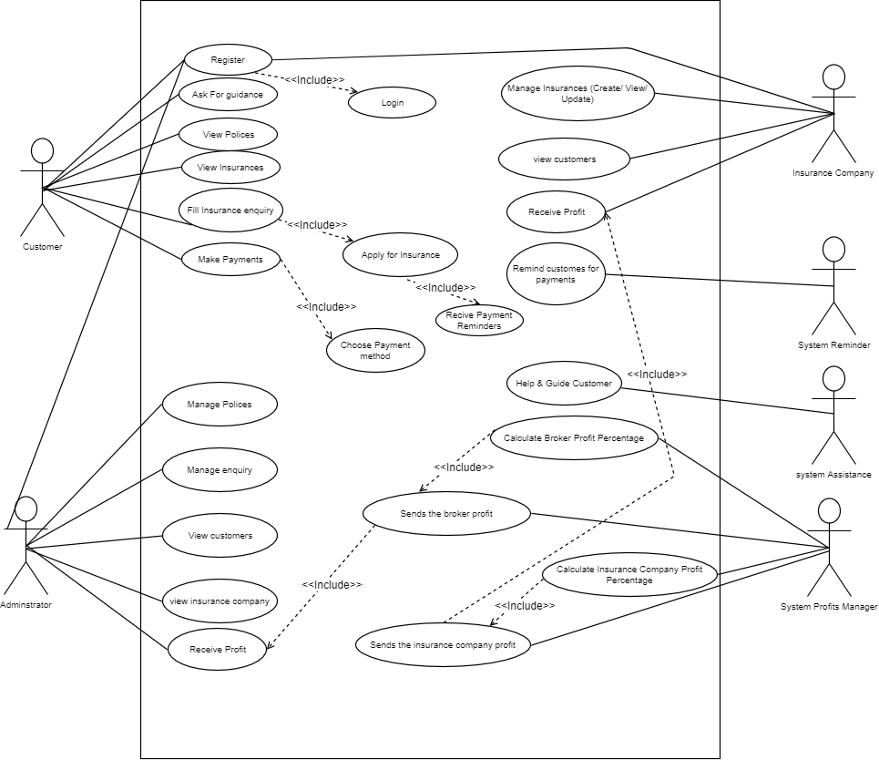***3.2.2 - Overall use-case diagram***

***Use-case diagram Analysis***

1. ***Administrator detailed description:  
    (Ahmad Thabet)***

|  |  |
| --- | --- |
| ***Actor*** | ***Administrator*** |
| ***Description*** | *The Administrator could manage inquires and policies*  *and could also check his profits amount "profits calculated by System profits manager".* |
| ***Pre-conditions*** | *The Administrator could login to system and receive profits or mange system* |
| ***Sequence/Flow of Events*** | 1. *Log-in to system* 2. *check inquires list* 3. *edit inquires [if needed]* 4. *push edited inquire to system database* 5. *log-out* |
| ***Data*** | *Name, Email, phone number, visa card/bank account* |
| ***Stimulus/Trigger*** | *The Administrator could manage inquires* |
| ***Post-conditions/***  ***Response*** | *The Administrator must have admin-type access, and all his information stored in database.* |
| ***Comments*** | *No comments* |

***2- Ask for guide/help detailed description:  
(*Sanaa Bader**)

|  |  |
| --- | --- |
| ***Actor*** | ***Customer*** |
| ***Description*** | *The customer asks for help/guide when he find some trouble using the system by sending a request to the assistance of the system  asking about his issue* |
| ***Pre-conditions*** | *The customer log in to the website and ask for a help/guide.* |
| ***Sequence/Flow of Events*** | *1.Customer ask/request for help/guide by sending a message*  *2.Assistance response immediately to the request*  *3.Assistance sends a message for the customer to choose type of help the customer is looking for.* |
| ***Data*** | *Name , type of help* |
| ***Stimulus/Trigger*** | *The customer send a message* |
| ***Post-conditions/***  ***Response*** | *The system stores the question in a database.* |
| ***Comments*** | *No comments* |

***3- Apply for insurance detailed description:  
(*Maryam Shaheen**)

|  |  |
| --- | --- |
| ***Actor*** | ***Customer*** |
| ***Description*** | *The customer fills the insurance enquiry when he wants to apply for insurance by filling his information.* |
| ***Pre-conditions*** | *The customer shall login to the website and view the insurances available, click on the insurance that he wants, and fill his information.* |
| ***Sequence/Flow of Events*** | *1.Customer logs in*  *2.customer views the insurances*  *3.customer chooses the best insurance*  *4. Customer fills his info.*  *5. and Apply for the insurance by clicking on submit*  *6. chose the type of payment*  *7. pay, or pay later (system reminder will remind him to pay two weeks before its finished)* |
| ***Data*** | *Name, Email, phone number, car type, visa card/bank account, address.* |
| ***Stimulus/Trigger*** | *The Customer may click insure car button.* |
| ***Post-conditions/***  ***Response*** | *The system stores customer’s info and payment status in a database.* |
| ***Comments*** | *No comments* |

***4- Receive notifications/ email/ sms detailed description:  
(*Eman Ghazawneh**)

|  |  |
| --- | --- |
| ***Actor*** | ***Customer*** |
| ***Description*** | *The customer gets a notification/ email/ sms that tells him to pay before the payment end date.* |
| ***Pre-conditions*** | *Have account on the system, and apply for insurance.* |
| ***Sequence/Flow of Events*** | *1-The system send a notification/Email/ sms for the customer on his phone to remind him to pay*  *2-the customer open the website and log in.*  *3- He pays for the insurance.* |
| ***Data*** | *Email, Phone number, Visa card number, amount of payment, payment status, type of insurance.* |
| ***Stimulus/Trigger*** | *Customer press confirm payment button* |
| ***Post-conditions/***  ***Response*** | *The system updates customer’s payment status in the database.* |
| ***Comments*** | *Have account on the system* |

***5- Receive Profit detailed description:  
(*Nour Abu Sharbak**)

|  |  |
| --- | --- |
| ***Actor*** | ***Insurance Company*** |
| ***Description*** | *The insurance company, that has an account in the system, receives the company profit, from the system profit manager* |
| ***Pre-conditions*** | *Have account on the system, provide insurances for customers, and have at least one customer applied for one of its insurances.* |
| ***Sequence/Flow of Events*** | 1. *the customer pays his insurance payments* 2. *the system profit manager calculates the company profit* 3. *The system profit manager sends a notification/ Email/ Sms for the insurance company of the customer current payment status and the amount of profit it gained.* |
| ***Data*** | *Name, Email, phone number, visa card/bank account* |
| ***Stimulus/Trigger*** | *System profit manager should calculate and send the profit* |
| ***Post-conditions/***  ***Response*** | *The system profit manager updates company profits status in the database.* |
| ***Comments*** | *No comments* |

***3.3 - Activity Model and Analysis***

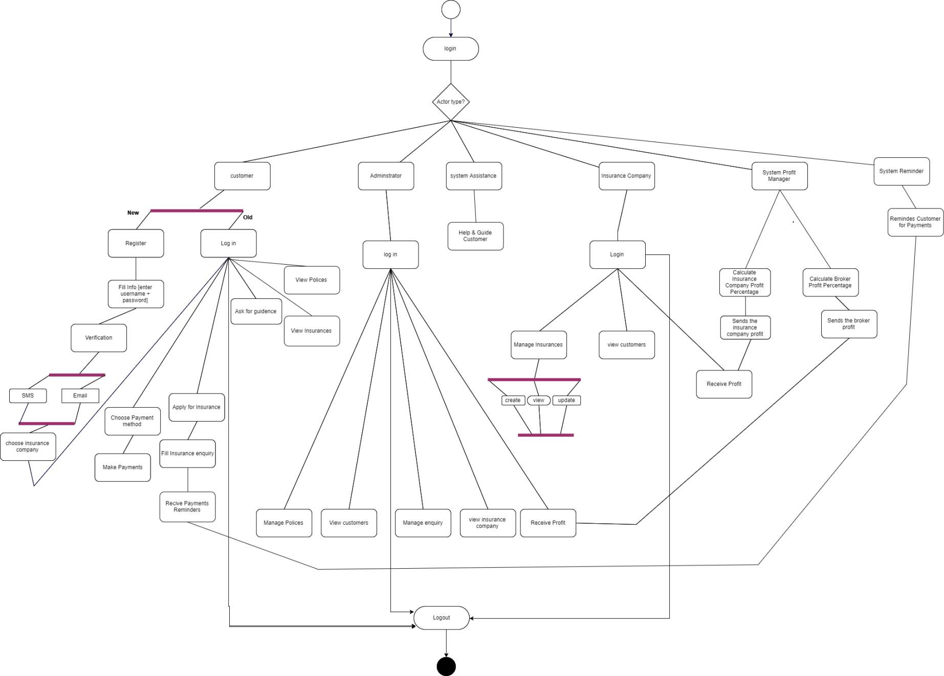

***Activity diagram Analysis***

1. 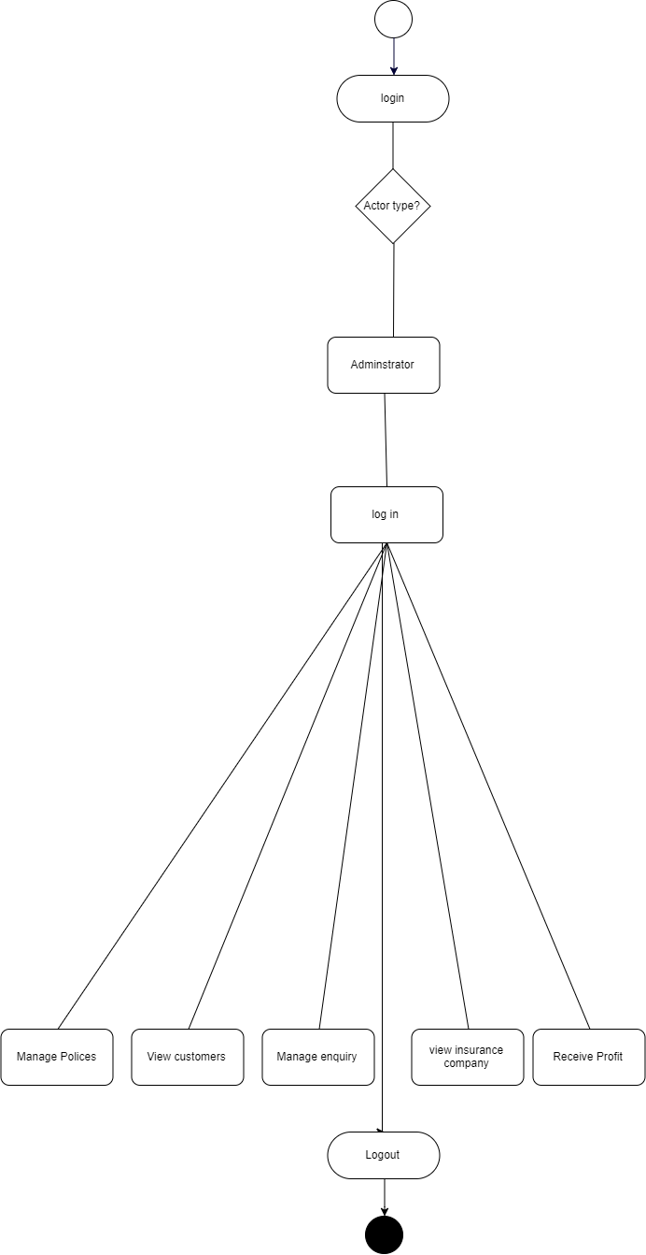***Administrator Activity Diagram:   
   (Ahmad Thabet)***
2. ***Customer Activity Diagram:  
   (*Nourhan Abu Sharbak)**

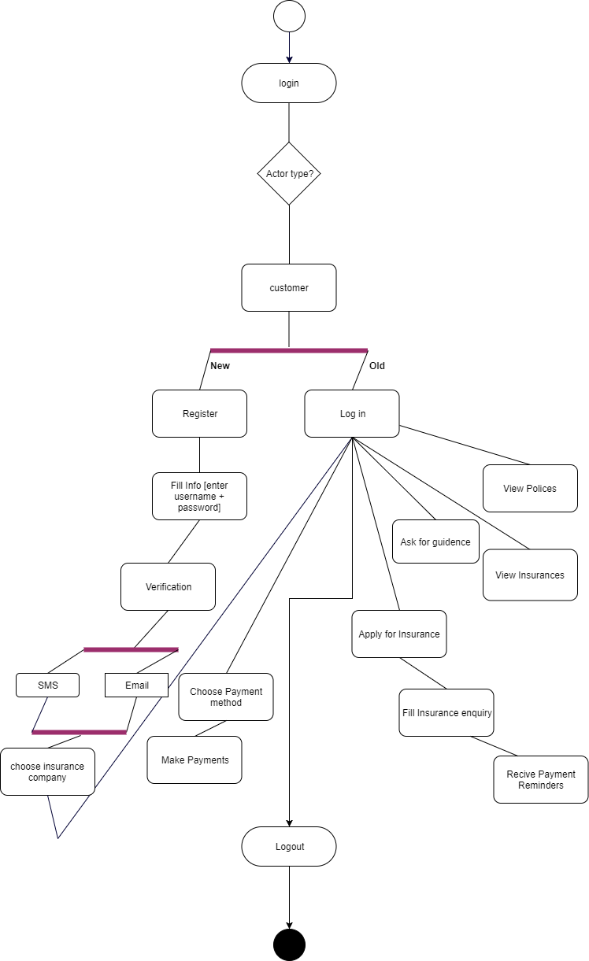

1. 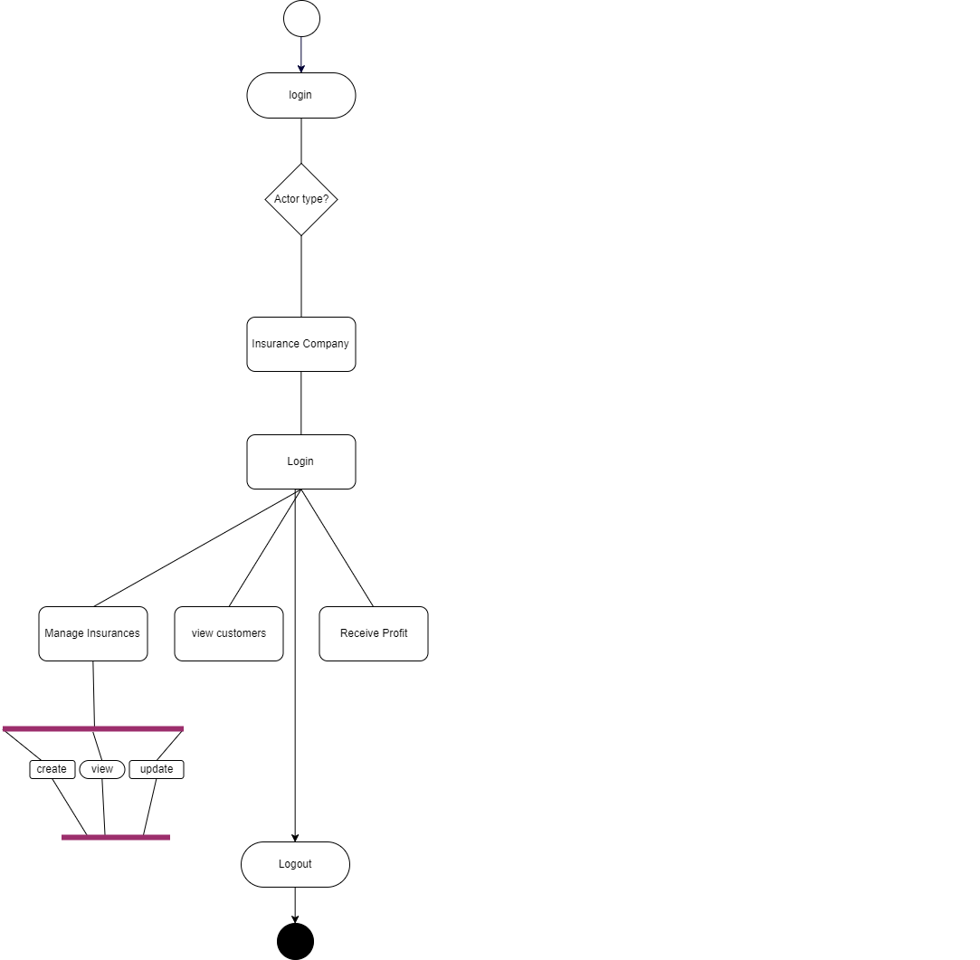***Insurance company Activity Diagram:  
   (Maryam Shaheen)***
2. ***System Reminder Activity Diagram:  
   (Eman Ghazawneh)***

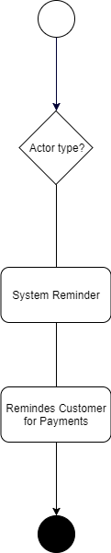

1. ***System Assistance Activity Diagram:  
   (Sanaa Bader)***

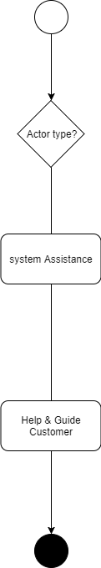

1. 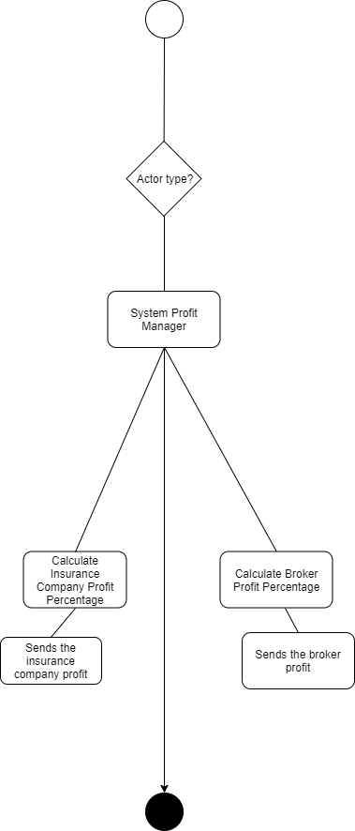***System Profits Manager Activity Diagram:  
   (Maryam Shaheen)***