

**Computer Science Department**

**Second Semester 2017/2018**

**Instructor: Adel Taweel**

**Comp433 – Software Engineering**

**Project-Phase Four**

**Task 4.1 - System Class modelling and Analysis**

**Task4.2- System Sequence & State modelling and Analysis**

**Task4.3- System and architectural Design**

**G1- Developer Group**

**Students:**

**Maryam Shaheen #1140427: Manager**

**Nourhan Abu Sharbak #1150640: Secretary**

**Eman Ghazawneh #1152278: Technical architect**

**Ahmad Thabet #1150312: Programmer**

**Sanaa Bader #1151763: Tester**

***Task 4.1 - System Class modelling and Analysis***

***4.1.1-system analysis CLASSES and description***

* ***System Assistance****: assistance responsible for help and guide the user/customer of the system in any issue.*
* ***System Reminder****: This class represents someone who reminds the customer of the deadline for payments.*
* ***User****: this class represents each user can register and use the system, where has 3 types of users ( Customer/ administrator/ insurance Company)*
* ***Insurance Company****: This class represents someone who registers on the system, manage customers, manage payments, also he/she can manage policies, and change his password and profile settings after logging in.*
* ***Insurance****: is an object obtained from the insurance company, and can be managed by the insurance company and the administrator.*
* ***Administrator****: This class represents the Administrator of the system, it has all of his information, and he is allowed to manage stuff such as, enquiries and policies in addition to receive profits.*
* ***Customer****: This class represents someone who registers on the system, see and ask for car assurance, search for policies and view them, also he/she can ask for guidance for how to use the system, change his password and profile settings after logging in. And after choosing assurance, he can pay cash or by visa card, also he can communicate with the assurance company.*
* ***Profits Manager****: this class represents a system profits manager who calculates the profit for each insurance Company and the administrator, and then sends the profits to their bank accounts, that are stored in the database.*
* ***Database****: this class represents the database that stores each user information (customer/ administrator/ and the insurance company) also can be updated or edited by the administrator or the profits manager only.*
* ***Bank Account****: this class represents each user bank information (customer/ administrator/ and the insurance company), where each one have a bank account id number.*

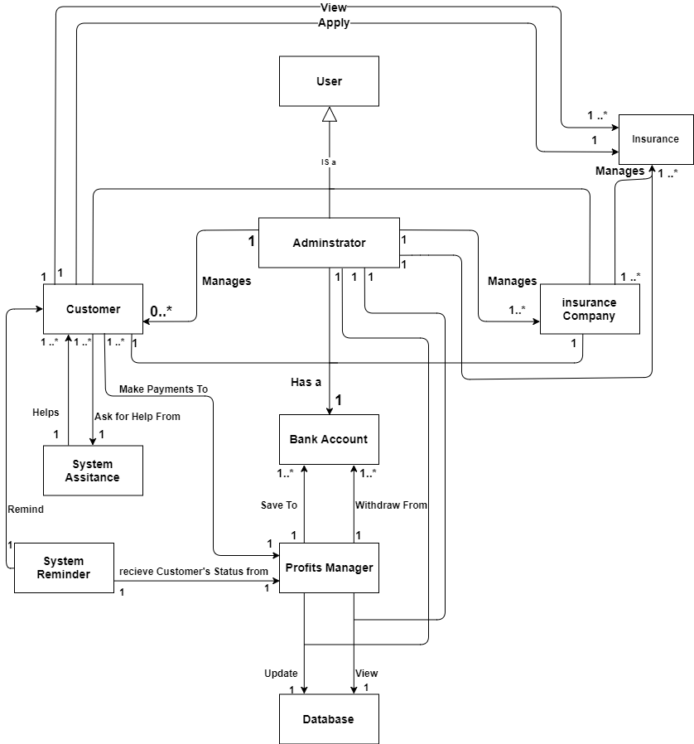***4.1.2- ANALYSIS CLASS model/Diagram.***

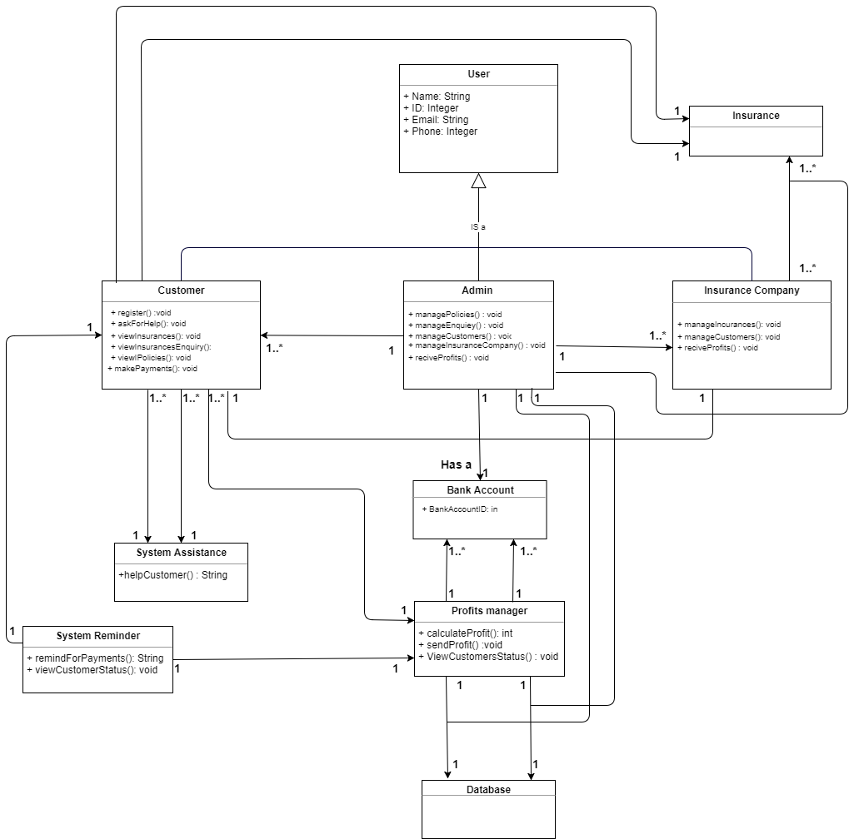***4.1.3- DETAILED CLASS model/Diagram***

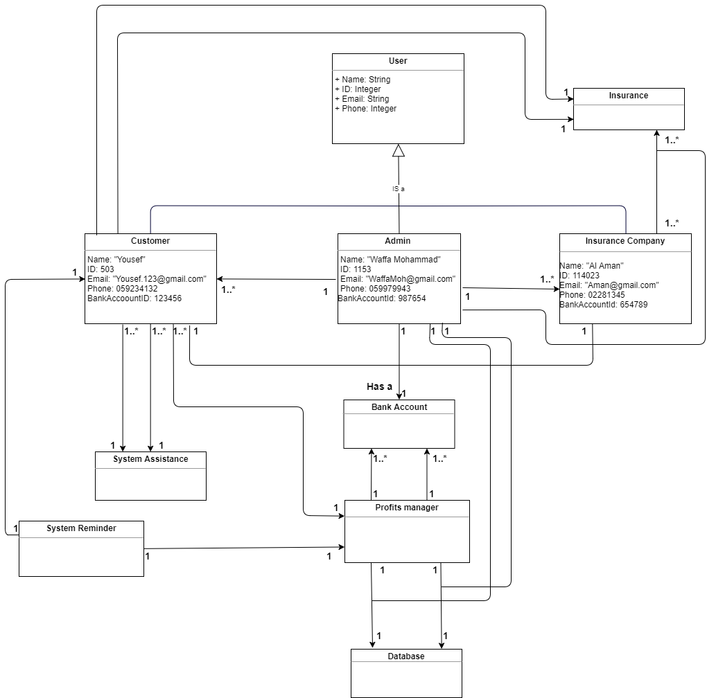***4.1.4- OBJECT diagram***

***Task4.2- System Sequence & State modelling and Analysis***

***4.2.1- SEQUENCE diagrams***

***1- Admin view and edit inquiries sequence diagram (by Ahamad)***

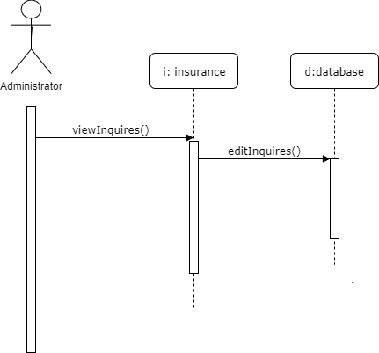

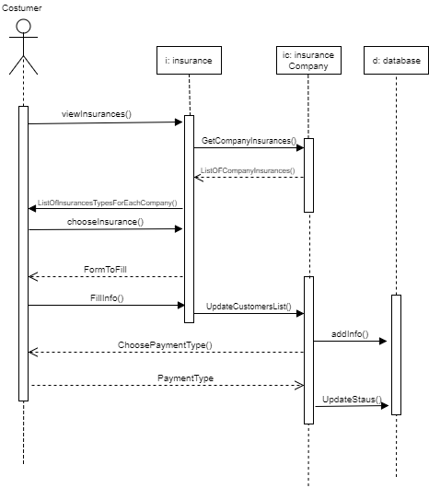***2- Customer applying for insurance sequence diagram (By Maryam)***

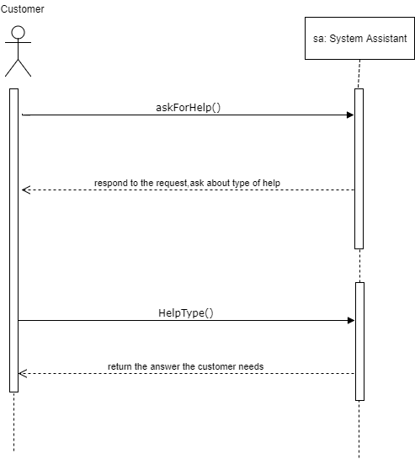***3- Customer asking for assistance sequence diagram (By Sanaa)***

***4- Profit manager for insurance company sequence diagram (By Nourhan)***

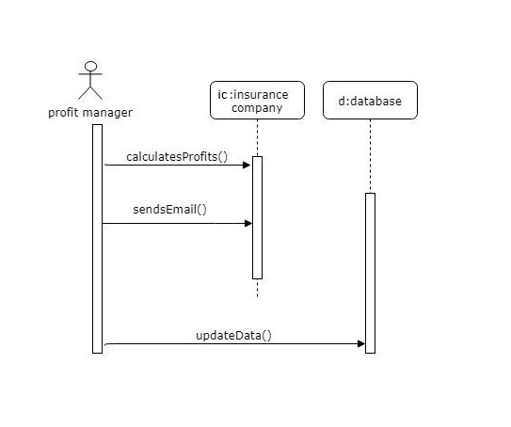

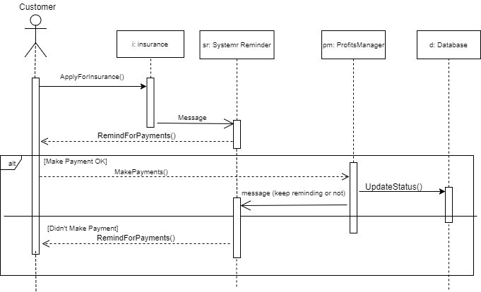***5- System reminder sequence diagram (By Eman)***

***Task 4.2.2- One STATE diagram (By Ahmad)***

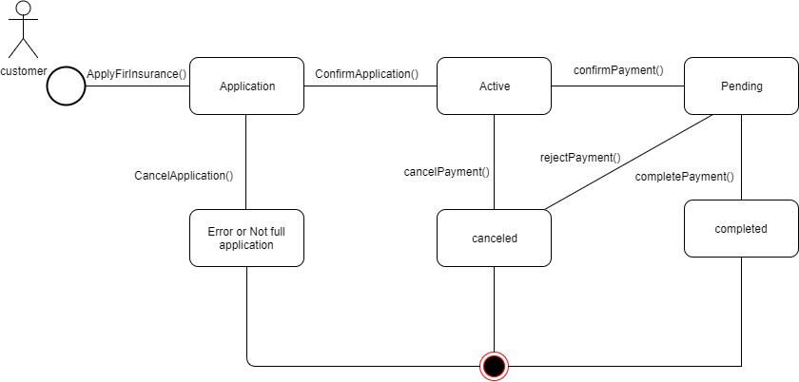

***Task 4.3- System and architectural Design***

***4.3.1- Description of design goals (By Eman)***

***General Goals:***

1. *High cohesion: Classes that interact to perform a certain function are placed together in one component that provides the service of said function.*
2. *Low coupling: If a class has interactions that relate to different components, copies of that class are made and distributed among the components so as to lower the rate of interaction between them*

***Specific Goals:***

1. *User friendliness: Achieved by providing the customer with several user interfaces.*

***4.3.2- Architecture diagram (By Nourhan)***

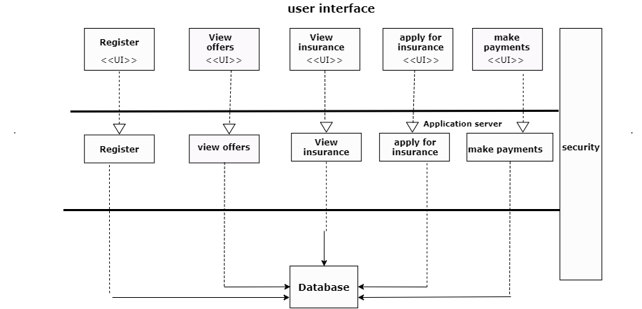

***4.3.3- Component diagram (By Maryam)***

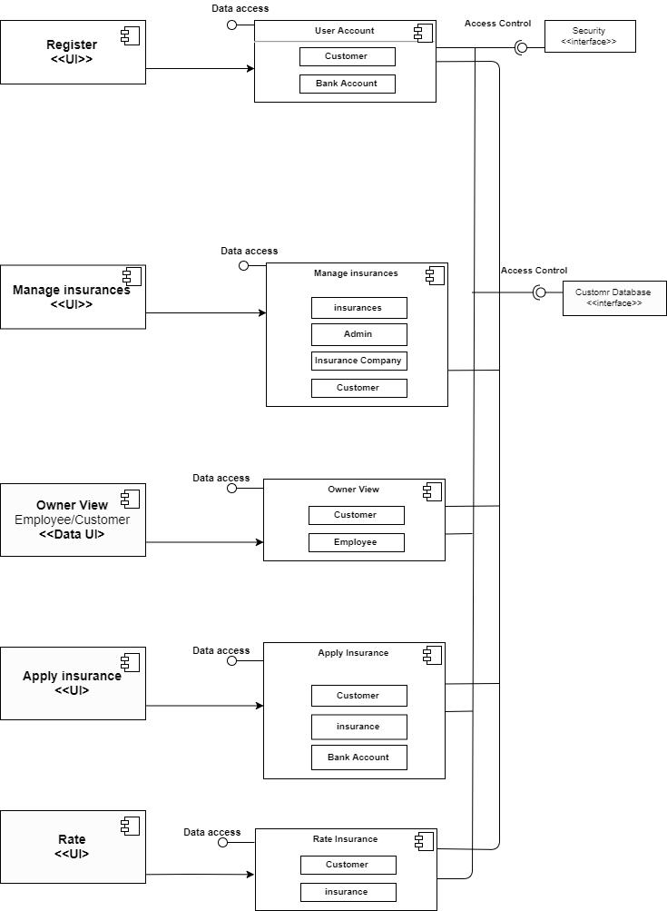

***4.3.4- deployment diagram (By Sanaa)***

