

**Computer Science Department**

**Second Semester 2017/2018**

**Instructor: Adel Taweel**

**Comp433 – Software Engineering**

**Project-Phase Four**

**Task 4.1 - System Modelling and Design**

**G1- Developer Group**

**Students:**

**Maryam Shaheen #1140427: Manager**

**Nourhan Abu Sharbak #1150640: Secretary**

**Eman Ghazawneh #1152278: Technical architect**

**Ahmad Thabet #1150312: Programmer**

**Sanaa Bader #1151763: Tester**

1. ***system analysis CLASSES and description***

* ***Assistance****: assistance responsible for help and guide the user/customer of the system in any issue.*
* ***Employee*** *: This class represents a person who can register to the system, create insurance, review insurance, view customers, and he/she can change his/her password and profile settings after logging in.*
* ***Reminder****: This class represents someone who reminds the customer of the deadline for payments.*
* ***Insurance Company****: This class represents someone who registers on the system, manage customers, manage payments, also he/she can manage policies, and change his password and profile settings after logging in.*
* ***Admin****: This class represents the Administrator of the system, it has all of his information, and he is allowed to manage stuff such as, enquiries and policies in addition to receive profits.*
* ***Customer****: This class represents someone who registers on the system, see and ask for car assurance, search for policies and view them, also he/she can ask for guidance for how to use the system, change his password and profile settings after logging in. And after choosing assurance, he can pay cash or by visa card, also he can communicate with the assurance company.*

1. ***ANALYSIS CLASS model/Diagram.***

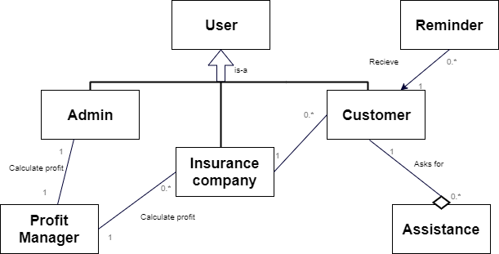

1. 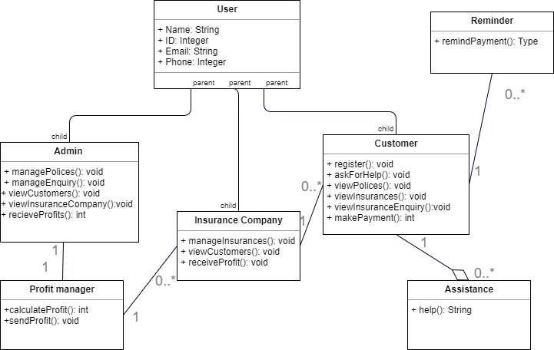***DETAILED CLASS model/Diagram***
2. 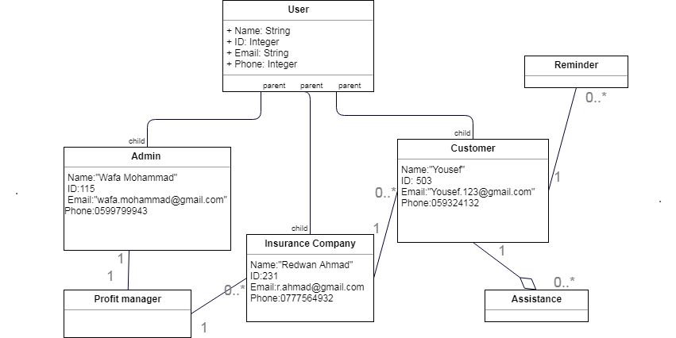***OBJECT diagram***