

**Computer Science Department**

**Second Semester 2017/2018**

**Comp433 – Software Engineering**

**Instructor: Adel Taweel**

***FINAL PROJECT REPORT***

**Developer Group – G1**

**Students:**

**Maryam Shaheen #1140427: Manager**

**Nourhan Abu Sharbak #1150640: Secretary**

**Eman Ghazawneh #1152278: Technical architect**

**Ahmad Thabet #1150312: Programmer**

**Sanaa Bader #1151763: Tester**

***Table of Contents***

***Chapter 1***  *................................................................................................................................... 3*

***Project Planning & Management****........................................................................................ 3*

***1.1 Group Name.............................................................................................*** *4*

***1.2 Members Names & Roles ………*** *............................................................................ 4*

***1.3 Project Management Strategy*** *............................................................................. 4*

***1.4 Project Manager’s Report.......................................................................*** *5*

***1.5 Project Members Report*** *........................................................................................ 7*

***Chapter 2*** *.................................................................................................................................. 9*

***Requirement Elicitation & Analysis*** *................................................................................ 9*

***2.1 Business Description*** *.............................................................................................. 10*

***2.2 User Requirements*** *................................................................................................ 10*

***2.3 System Requirements*** *.......................................................................................... 11*

***2.4 Scenarios*** *................................................................................................................. 13*

***2.5 Actors Analysis & Descriptions*** *........................................................................ 15*

***2.6 Overall Use-Case Diagram*** *................................................................................ 16*

***2.7 Detailed Use Cases*** *............................................................................................... 17*

***2.8 Activity Diagrams*** *............................................................................................... 20*

***Chapter 3*** *............................................................................................................................. 27*

***System Modeling & Analysis*** *......................................................................................... 27*

***3.1 Class Model Analysis****.......................................................................................... 28*

***3.2 Detailed Class Model*** *......................................................................................... 29*

***3.3 Classes Descriptions ..****....................................................................................... 30*

***3.4******Object Diagram …………………****......................................................................... 31*

***3.5 Sequence Diagrams .****......................................................................................... 32*

***3.6 State Diagram ………………****............................................................................... 37*

***Chapter 4*** *............................................................................................................................ 38*

***System Design*** *.................................................................................................................. 38*

***4.1 Design Goals Descriptions*** *.............................................................................. 39*

***4.2 Component Diagram****........................................................................................ 40*

***4.3******Overall Architecture Diagram ……………****.................................................... 41*

***4.4 Deployment Diagram*** *...................................................................................... 41*

***Chapter 5*** *........................................................................................................................... 42*

***Assessment & Effort Estimation*** *................................................................................. 42*

**5.1 Assessment** ......................................................................................................... 43

**5.1.1 User Requirement Approval Phase……..**............................................. 43

**5.1.2 Requirements Analysis Phase…**............................................................ 45

**5.1.3 System Modeling and Design Phase**……………..…………………….…….... 46

***5.2 Effort/Time Estimation & Calculation*** *...................................................... 48*

***Appendix*** *......................................................................................................................... 49*

***A1. Group Meetings*** *.............................................................................................. 50*

***A2. Meetings with Customer Group*** *................................................................ 51*

***Chapter 1***

***[Project Planning  
 &   
Management](#TableOfContents)***

* 1. ***Group Name***

We are group, ***G1***

* 1. ***Members Names & Roles***

***Manager:*** *Maryam Shaheen ……………………….#1140427*

***Secretary****: Nourhan Abu Sharbak ………………#1150640*

***Technical architect:*** *Eman Ghazawneh ……..#1152278*

***Programmer:*** *Ahmad Thabet ……………………..#1150312*

***Tester:*** *Sanaa Bader ……………………………………#1151763*

* 1. ***Project Management Strategy***

Most of the team meetings were conducted online via Facebook Messenger, WhatsApp, UberConference (When Document/Screen Sharing is needed), or Skype.

However, every two weeks, the team met on Wednesday afternoons in many places made for group working such as (Umake Center and Avenue) or on Tuesdays or Thursdays following the lecture in the Campus. The decision to meet twice a week was due to conflicting schedules and was taken to ensure the participation of every team member. When it came to decision making, a team member or two would propose an idea or solution and the team would vote on whether or not to adopt this decision.

The software process model adapted to complete this project was the agile development model.

* 1. ***Project Manager’s Report***

The team members did most of the work together. The task has been discussed among ourselves, the feedback from all team members was assembled into a final draft/solution agreed upon by all of us and the documentation/digitalization of the solution was assigned to one of the team members. During phases, our approach to dividing the tasks was more individual-based; each member was assigned a certain task to work on. Nevertheless, we still discussed the tasks together beforehand so as to have a preconceived idea about how to accomplish the task.

I would say we did a relatively great job with the project. It was a bit difficult at first since we were still trying to understand the whole concept and we still had to work out some communication issues. But over the course of the semester or understanding of the project became more clear and the communication between our team members vastly improved. In addition, feedback from the team members, customers, and lecturer were all taken into consideration and we always strove to improve on our work as much as possible.

**My tasks:**

* *Participate in requirements Analysis.*
* *Participate in USER and SYSTEM requirements.*
* *Write scenario for my use case (Insurance Company).*
* *Write Actors analysis and descriptions.*
* *Participate in overall Use-case diagram.*
* *Detailed description of Customer Applying for insurance.*
* *ACTIVITY Diagram for (Insurance Company).*
* *ACTIVITY Diagram for (System Profits Manager).*
* *Participate in overall Activity Diagram*
* *Participate in Analysis class model.*
* *Participate in Detailed class model.*
* *Participate in Classes Description.*
* *SEQUENCE Diagram for Customer Applying for insurance.*
* *Made the Component Diagram.*
* *Participate in Cost and Effort Estimations.*
* *Main role was to gather all work into each phase and deliver it to the customer group and the doctor. Also giving tasks for each member. After that viewing and making sure everything is correct to deliver.*

|  |  |  |  |  |  |
| --- | --- | --- | --- | --- | --- |
|  | ***Maryam Shaheen***  ***(Group manager)*** | ***Eman Ghazawneh (Technical***  ***Architect)*** | ***Nourhan Abu Sharbak (Secretary)*** | ***Ahmad Thabet (Programmer)*** | ***Sanaa Bader (Tester)*** |
|  | *Requirement Analysis* | *Requirement*  *Analysis* | *Requirement*  *Analysis* | *Requirement*  *Analysis* | *Requirement*  *Analysis* |
|  | *USER & SYSTEM Requirements.* | *USER & SYSTEM Requirements.* | *USER & SYSTEM Requirements.* | *USER & SYSTEM Requirements.* | *USER & SYSTEM Requirements.* |
|  | *Insurance Company Scenario* | *System Reminder Scenario* | *Customer Scenario* | *Admin Scenario* | *System Assistance Scenario* |
|  | *Actors analysis and descriptions* | *---* | *---* | *---* | *---* |
|  | *Overall use-case Diagram* | *Overall use-case Diagram* | *Overall use-case Diagram* | *---* | *Overall use-case Diagram* |
|  | *Detailed description of Customer*  *Applying for insurance* | *Detailed description of Customer Receiving notifications/ email* | *Detailed description of Insurance Company*  *Receiving Profits* | *Detailed description of Administrator* | *Detailed description of Customer Asking for guide/help* |
|  | *Insurance company Activity Diagram/ System Profits Manager Activity Diagram* | *System Reminder Activity Diagram* | *Customer Activity Diagram* | *Administrator Activity Diagram* | *System Assistance Activity Diagram* |
|  | *Overall Activity diagram* | *Overall Activity diagram* | *Overall Activity diagram* | *Overall Activity diagram* | *Overall Activity diagram* |
|  | *ANALYSIS CLASS model/ DETAILED CLASS model* | *---* | *OBJECT diagram* | *---* | *ANALYSIS CLASS model/ DETAILED CLASS model* |
|  | Description of CLASSES | Description of System Reminder Class | Description of Customer Class | Description of Admin Class | Description of CLASSES |
|  | *Customer applying for insurance sequence diagram* | *System reminder sequence diagram* | *Profit manager for insurance company sequence diagram* | *Admin view and edit inquiries sequence diagram* | *Customer asking for assistance sequence diagram* |
|  | *Component diagram* | *Description of design goals* | *Architecture diagram* | *State diagram* | *deployment diagram* |
|  | *---* | *All Assessments* | *All Assessments* | *All Assessments* | *All Assessments* |
|  | Effort/Time estimation calculation | Effort/Time estimation calculation | Effort/Time estimation calculation | Effort/Time estimation calculation | Effort/Time estimation calculation |
|  | *All phases reports and final report* | *PowerPoint for both presentations* | *Meeting minutes + meetings scheduling* | *Contact with our customer and developer groups* | *Meetings reminder* |

* 1. ***Project Members Reports***

1. ***Nourhan Abu Sharbak:****In my opinion this was a good experience for making such a project in* *this course, our group did really a good team work with the requirements* *and diagrams, and we continuously used to be in touch on social media* *to work on this project, using chat messages and voice notes.*

**My tasks:**

* *Participate in requirements Analysis.*
* *Participate in USER and SYSTEM requirements.*
* *Write scenario for my use case (Customer).*
* *Participate in overall Use-case diagram.*
* *Detailed description of Insurance Company receiving profits.*
* *ACTIVITY Diagram for the use case (Customer).*
* *Participate in overall Activity Diagram*
* *Entry data in the OBJECT diagram.*
* *Customer Class Description.*
* *SEQUENCE Diagram for the profit manager for insurance company.*
* *Participate in Cost and Effort Estimations.*
* *Conducted meeting tables, and write meeting minutes.*
* *Participate in All Assessments.*

1. ***Eman Ghazawneh:****As what I’ve seen, my team was cooperative and helpful, we all worked together and learnt from our fault , we always used to be in touch by using different social media even if we can't see each other.*

**My tasks:**

* *Participate in requirements Analysis.*
* *Participate in USER and SYSTEM requirements.*
* *Write scenario for my use case (System Reminder).*
* *Participate in overall Use-case diagram.*
* *Detailed description of Customer receiving notifications/ email.*
* *ACTIVITY Diagram for the use case (System Reminder).*
* *Participate in overall Activity Diagram*
* *Reminder Class Description.*
* *SEQUENCE Diagram for the System Reminder.*
* *Participate in Cost and Effort Estimations.*
* *Prepared PowerPoint slides for both Presentations.*
* *Participate in All Assessments.*

1. ***Ahmad Thabet:****I think this project is a perfect practice of software engineering development; we worked most of the drafts together, some tasks assigned to members via manager and each one done it separately, we communicated together through Facebook and real-time meetings, we helped each other in all tasks. And My role was “developer”.*

**My tasks:**

* *Participate in requirements Analysis.*
* *Participate in USER and SYSTEM requirements.*
* *Write scenario for my use case (Administrator).*
* *Detailed description of Administrator.*
* *ACTIVITY Diagram for the use case (Administrator).*
* *Participate in overall Activity Diagram*
* *Administrator Class Description.*
* *SEQUENCE Diagram for the Admin viewing and editing inquiries*
* *Made the State Diagram.*
* *Participate in Cost and Effort Estimations.*
* *Contacted our customer and developer Groups.*
* *Participate in All Assessments.*

1. ***Sanaa Bader:****I think that most of the work was very collective and cooperative* *between the group members. Most of the time we divided the work* *between us but at the end we reviewed it together .We often tried to* *build the drafts for the diagrams together, later one of us draw the final* *version .*

**My tasks:**

* *Participate in requirements Analysis.*
* *Participate in USER and SYSTEM requirements.*
* *Write scenario for my use case (System Assistance).*
* *Participate in overall Use-case diagram.*
* *Detailed description of Customer Asking for guide/ help.*
* *ACTIVITY Diagram for the use case (System Assistance).*
* *Participate in overall Activity Diagram*
* *Made the Analysis class model.*
* *Made the Detailed class model.*
* *Participate in Classes Description.*
* *SEQUENCE Diagram for Customer asking for assistance.*
* *Made the deployment Diagram.*
* *Participate in Cost and Effort Estimations.*
* *Main role was to remind the team of each meeting we have.*
* *Participate in All Assessments.*

***Chapter 2***

***Requirement Elicitation & Analysis***

1. ***Business Description***

Insurance Broker is an online website, which helps the user to:

1. Ask for guidance to how to use the system
2. View different types of insurances, their prices, and the insurance company that provides each.
3. Apply for insurances and fill inquiries.
4. Be provided with many offers on the insurances from the website and the insurance companies.
5. Pay using credit card or by cash.
6. Receive reminders for payments, if no payments are completed.
7. Rate the insurances/ insurance Companies/ and the Broker online Services.
8. Contact the Broker or the Insurance Company.

1. ***User Requirements***
2. The website with a database and all must be highly secure to prevent from any attacks.
3. The system should be friendly to use.
4. The company should provide the available offers to the customers (car types and models, type of insurance e.g. partially or fully).
5. The customer can register to the web site by a username and password then to choose between the offers after having an account (specified earlier), as the costumer register he should view the financial record including all his payments with the date of each payment, any future fees and discounts.
6. If the customer is already registered, then he must have the option to sign in.
7. Option for the customer to pay online and to record the date and how much the payment was
8. Payments must have a specific time (payments have a due date), so the customer should be notified two weeks earlier before the insurance end and 3 days before the end of this date
9. Add an option to the customer to communicate with the company(broker) as soon as possible (Email, Phone call).
10. Assistance or guides should be available to help customer using the site.
11. Admin of the system should have several options to do

1. ***System Requirements***

**A. The website with a database and all must be highly secure to prevent from any attacks.**

**A.1.**The Data base of the website will be located on a server with all data, while the website will be located on another server.  
**A.2.** A firewall will be generated to avoid attacks and unusual log in’s.  
**A.3.** A Backup will be done every week automatically.

**B. The system should be friendly to use.**

**B.1.** The website will be responsive for any advice (PC’s, Smartphones, iPads, Tablets...).  
**B.2.** Elements on the website will be divided into Categories based on the type of the elements and its topic which will make it easy for the user to reach and it won’t take him so much time.  
**B.3.** A search bar and a list of All Categories will be included also in the header of the website to guarantee the user comfort while using the website.

**C. The company should provide the available offers to the customers (car types and models, type of insurance e.g. partially or fully).**

**C.1.**The customer will have an option to sort/filter out the offers based on his preference (cost/duration/specifications).  
**C.2.**The customer should be able to add any offer to a watch list.  
**C.3.**The offers will have a star rating system shown on them given from the community that tried the offer

**D. The customer can register to the web site by a username and password then to choose between the offers after having an account (specified earlier), as the costumer register he should view the financial record including all his payments with the date of each payment, any future fees and discounts.**

**D.1.**The customer password must not match the username or email address **D.2.**The customer must include a recovery email for his account to recover or reset his password if needed  
**D.3.**The system should send the customer and activation email to his recovery email to activate his account before being able to use it  
**D.4.**The verification of the account will be by a code sent as a phone message or email according to the email and phone number entered in the sign up form .

**E. If the customer is already registered, then he must have the option to sign in.**

**E.1.**A Signup system will be included to create an account on the website, which includes a form contains the user information (name, email, date of birth, id,..) , then an account is created for the customer he/she can reach it any time and can join any service provided on the page.  
**E.2.** If the customer don’t have an account he/she can only see the services the page provides but he/she can’t join it until he/she have an account.

**F. Option for the customer to pay online and to record the date and how much the payment was.**

**F.1.**Different methods of payment provided such as credit card (visa, MasterCard, Etc), direct bank transfer, pay in the office, western union, Etc.  
**F.2.** Receipt will be provided with date and payment amount each for the customer and office.

**G. Payments must have a specific time (payments have a due date), so the customer should be notified two weeks earlier before the insurance end and 3 days before the end of this date.**

**G.1.** A phone message and email will be sent to the user before a week of the payment date that the date of the payment starts after a week to remind him/her,  a reminder before 3 days of the expire date will be sent according to the phone number and email entered in the Sign up form.  
**G.2.** A weekly phone messages and emails will be sent if any changes happened , because maybe the user doesn’t check his/her account usually .

**H. Add an option to the customer to communicate with the company (broker) as soon as possible (Email, Phone call).**

**H.1.** Profile for each company with full details such as address, working hours , email, phone number, social media (if existing )  
**H.2.** To make it easy for the customer to connect with the company a form will be included to fill and send out if there is any questions or anything the customer wants to know more about.

**I. Assistance or guides should be available to help customer using the site.**

**I.1.** A contact us form will be included on the website if the customer needed anything, live chat with the customer and the assistant, email, phone.  
**I.2.** 24 hours/7 days, assistance available to help.

**J. Admin of the system should have the following options:**

**J.1.** An option to managing the insurance companies (edit, delete, inset …).  
**J.2.** An option to manage all the customers and their payment records (edit, delete, inset …).  
**J.3.** An automatically financial inventory should be generated each month.  
**J.4.** An option to generate a report for the insurance company about their customers.

1. ***Scenarios***

**Scenario#1 (Admin)   
By Ahmad Thabet**

**Initial assumption:** Samer enters the website, he wanted to check insurance company and their information, then viewed customers list, after that he wanted to manage enquiry, he was able to receive profits sent by System Profits Manager, last thing he managed policies by editing some of them.

**Normal**: the admin can enter the system and view companies and customers data, also manage enquiries and policies.  
  
**Alternative:** monthly profit is sent to the Administrator, but due to the System profit manager, the profit can be sent by each insurance applied to any customer, at any time.  
  
**Error:** can’t edit customers or companies information.

**Scenario#2 ( Insurance Company)  
By Maryam Shaheen**

**Initial Assumption:** The Insurance Company wanted to manage insurances, where it can create/ review/ edit insurances, view customers; also it can receive profit for each insurance.

**Normal:** the insurance Company can enter the system review customers, and insurances.

**Alternative:** monthly profit is sent to the insurance company, but due to the System profit manager, the profit can be sent by each insurance applied to any customer, at any time.

**Error:** can’t review the broker’s policies.

**Scenario#3 (System Reminder )  
By Eman Ghazawneh**

**Initial Assumption:** whileAbbas was playing games in his phone , he get a notification from insurance system that tell him , there’s still three days to pay so he should pay before the payment end , so he open the website and pay for the insurance.

**Normal:** The customer gets a notification that tells him to pay before the payment end.

**Alternative:** if his mobile phone not in range ، he also received a telephone call from the company.

**Error:** if his phone and telephone was out of service he also can get email .

**Scenario#4 (Customer )**

**By Nourhan Abu Sharbak**

**Initial Assumption:** Abbass heard that he can make insurance to his new car online by a website, so he searched for that website, and he found it, Now  he wants to register a new account, so he enter his username, password and another information , then it send a verification message to his email or phone, after that he fill the insurance enquiry and apply it ,and he choose the method of payment that he wants, then he read the policies of the company, after 9 month he try to login to his account he lost his password , but he ask the guidance for help and they help him to restore his password by email or phone, then he restore his password and login to his account to view all insurances.

**Normal:** The customer register in the website, so he can fill the insurance enquiry, then he can pay in the time of the payments by the method of pay that he chooses.

**Alternative:** When the customer faced any problem or want to ask any question about payments for example or ask to help he can ask for guidance.

**Error:** If SMS system down and the customer can’t connect with the internet, he can’t receive any email from the website.

**Scenario#5 (System Assistance)  
By Sanaa Bader**

**Initial Assumption:** Abbas wanted to make insurance for his car, he choose our insurance car system to do that, so he visited the website . It took him 5 minutes to recognize how it works , but at the end he asked for help from the system assistance of how the system works to achieve his goal from this operation and give him some tips.

**Normal:** The customer visits the website , he had misunderstanding of how to use the system , so they asked the system assistance for help.

**Alternative:** How the customer/ user will reach the assistance or communicate with it . The system provides a help manual includes all tips & information of how to use the site . Also there's a chat bar provided to make the operation of communicating more flexible & easy.

**Error:** Not applicable for people who can't read

**Error:** Not provided in multiple languages

1. ***Actors Analysis & Descriptions (By Maryam)***

***Admin:*** This actor represents someone who works in the Broker System, who can register and login to the system, and after that can manage policies, manage insurances, also can manage enquiry, View customers, view insurance companies, receive profit, change his/her password, and update his/her profile settings.

***Insurance Company:*** This actor represents someone who works in the insurance company, who can register and login to the system, manage insurances (Create/ View/ Update), view customers, and receive profit, also he/she can change his/ her password and update his/her profile settings.

***Customer:*** This actor represents someone who can register and login to the system, view policies, view insurances, fill insurance inquiry and Apply for car Insurances, make payments (cash of online), also can communicate with the assurance company. And he/she can ask for guidance for how to use the system, change his/ her password and update his/her profile settings.

***System Assistance:*** This actor represents system actor who helps and guide the customer how to use the system.

***System Reminder:*** This actor represents system actor who reminds the customer of the deadline for payments Two weeks before.

***System Profits Manager:*** This actor represents system actor who calculates the broker profit percentage, and sends it to the broker, and calculates the insurance company profit percentage, and sends it to the insurance company.

1. 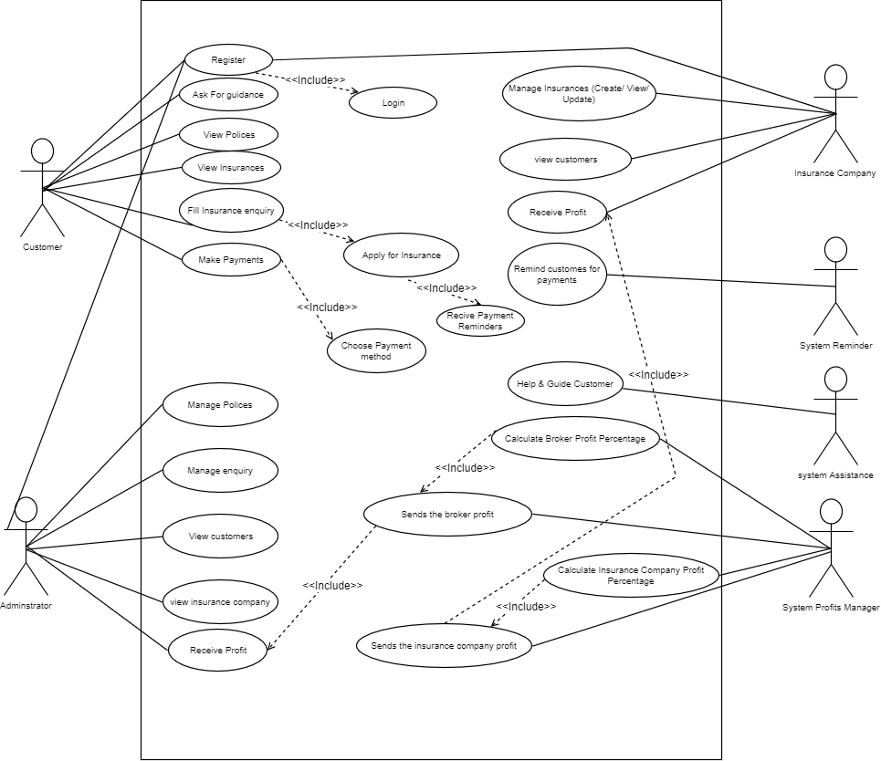***Overall Use-Case Diagram***

1. ***Detailed Use Cases***
2. ***Administrator detailed description:  
    (Ahmad Thabet)***

|  |  |
| --- | --- |
| ***Actor*** | ***Administrator*** |
| ***Description*** | *The Administrator could manage inquires and policies*  *and could also check his profits amount "profits calculated by System profits manager".* |
| ***Pre-conditions*** | *The Administrator could login to system and receive profits or mange system* |
| ***Sequence/Flow of Events*** | 1. *Log-in to system* 2. *check inquires list* 3. *edit inquires [if needed]* 4. *push edited inquire to system database* 5. *log-out* |
| ***Data*** | *Name, Email, phone number, visa card/bank account* |
| ***Stimulus/Trigger*** | *The Administrator could manage inquires* |
| ***Post-conditions/***  ***Response*** | *The Administrator must have admin-type access, and all his information stored in database.* |
| ***Comments*** | *No comments* |

***2- Ask for guide/help detailed description: (*Sanaa Bader**)

|  |  |
| --- | --- |
| ***Actor*** | ***Customer*** |
| ***Description*** | *The customer asks for help/guide when he find some trouble using the system by sending a request to the assistance of the system  asking about his issue* |
| ***Pre-conditions*** | *The customer log in to the website and ask for a help/guide.* |
| ***Sequence/Flow of Events*** | *1.Customer ask/request for help/guide by sending a message*  *2. Assistance response immediately to the request*  *3. Assistance sends a message for the customer to choose type of help the customer is looking for.* |
| ***Data*** | *Name , type of help* |
| ***Stimulus/Trigger*** | *The customer send a message* |
| ***Post-conditions/***  ***Response*** | *The system stores the question in a database.* |
| ***Comments*** | *No comments* |

***3- Receive notifications/ email/ sms detailed description: (*Eman Ghazawneh**)

|  |  |
| --- | --- |
| ***Actor*** | ***Customer*** |
| ***Description*** | *The customer gets a notification/ email/ sms that tells him to pay before the payment end date.* |
| ***Pre-conditions*** | *Have account on the system, and apply for insurance.* |
| ***Sequence/Flow of Events*** | *1-The system send a notification/Email/ sms for the customer on his phone to remind him to pay*  *2-the customer open the website and log in.*  *3- He pays for the insurance.* |
| ***Data*** | *Email, Phone number, Visa card number, amount of payment, payment status, type of insurance.* |
| ***Stimulus/Trigger*** | *Customer press confirm payment button* |
| ***Post-conditions/***  ***Response*** | *The system updates customer’s payment status in the database.* |
| ***Comments*** | *Have account on the system* |

***4- Apply for insurance detailed description: (*Maryam Shaheen**)

|  |  |
| --- | --- |
| ***Actor*** | ***Customer*** |
| ***Description*** | *The customer should fill the insurance enquiry when he wants to apply for insurance by filling his information.* |
| ***Pre-conditions*** | *The customer shall login to the website and view the insurances available, click on the insurance that he wants, and fill his information.* |
| ***Sequence/Flow of Events*** | *1.Customer logs in*  *2.customer views the insurances*  *3.customer chooses the best insurance*  *4. Customer fills his info.*  *5. and Apply for the insurance by clicking on submit*  *6. chose the type of payment*  *7. pay, or pay later (system reminder will remind him to pay two weeks before its finished)* |
| ***Data*** | *Name, Email, phone number, car type, visa card/bank account, address.* |
| ***Stimulus/Trigger*** | *The Customer may click insure car button.* |
| ***Post-conditions/***  ***Response*** | *The system stores customer’s info and payment status in a database.* |
| ***Comments*** | *No comments* |

***5- Receive Profit detailed description: (*Nourhan Abu Sharbak**)

|  |  |
| --- | --- |
| ***Actor*** | ***Insurance Company*** |
| ***Description*** | *The insurance company, that has an account in the system, receives the company profit, from the system profit manager* |
| ***Pre-conditions*** | *Have account on the system, provide insurances for customers, and have at least one customer applied for one of its insurances.* |
| ***Sequence/Flow of Events*** | 1. *the customer pays his insurance payments* 2. *the system profit manager calculates the company profit* 3. *The system profit manager sends a notification/ Email/ SMS for the insurance company of the customer current payment status and the amount of profit it gained.* |
| ***Data*** | *Name, Email, phone number, visa card/bank account* |
| ***Stimulus/Trigger*** | *System profit manager should calculate and send the profit* |
| ***Post-conditions/***  ***Response*** | *The system profit manager updates company profits status in the database.* |
| ***Comments*** | *No comments* |

1. ***Activity Diagrams***

***Over All Activity Diagram***

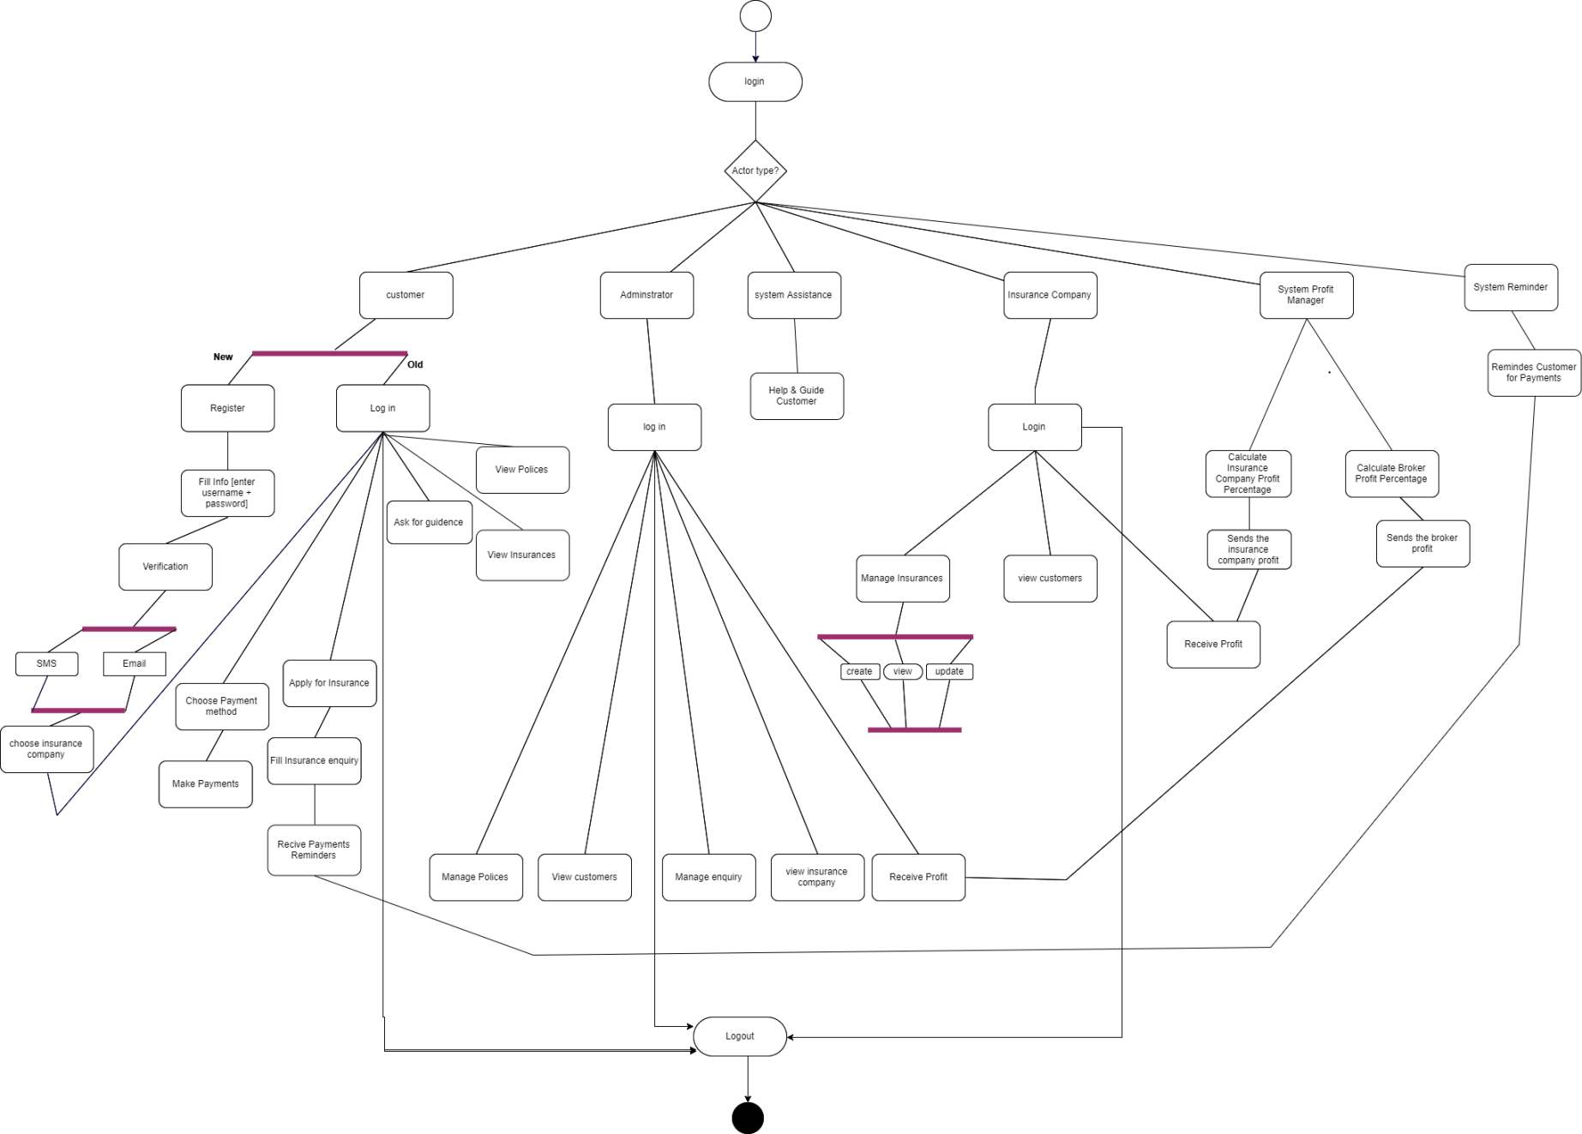

***Administrator Activity Diagram:   
(Ahmad Thabet)***

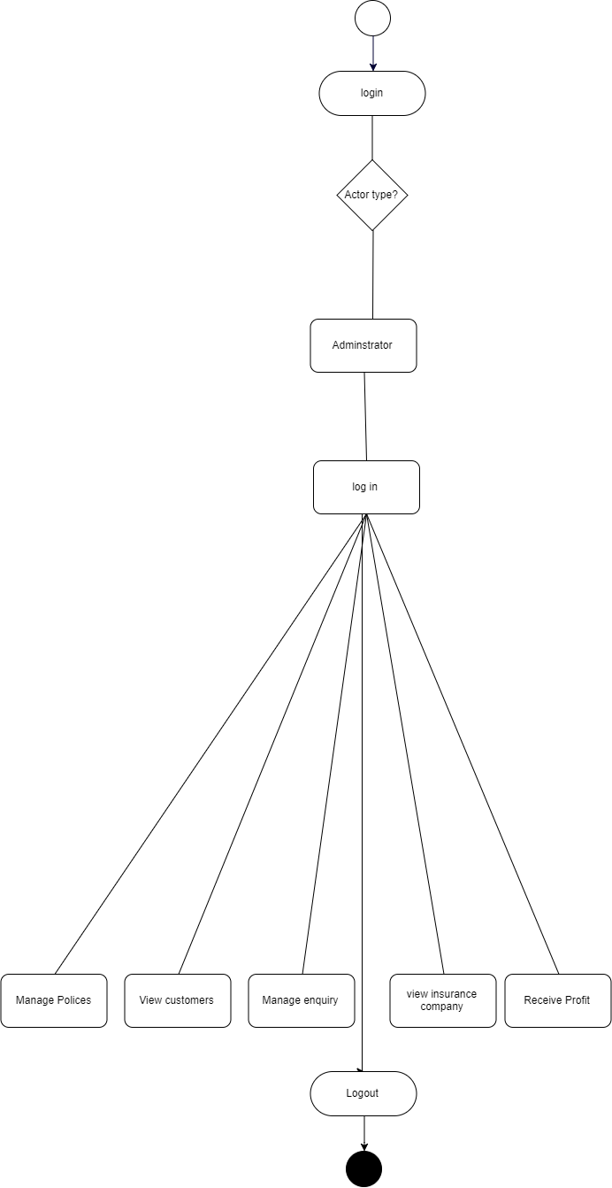

1. ***Customer Activity Diagram:  
   (*Nourhan Abu Sharbak)**

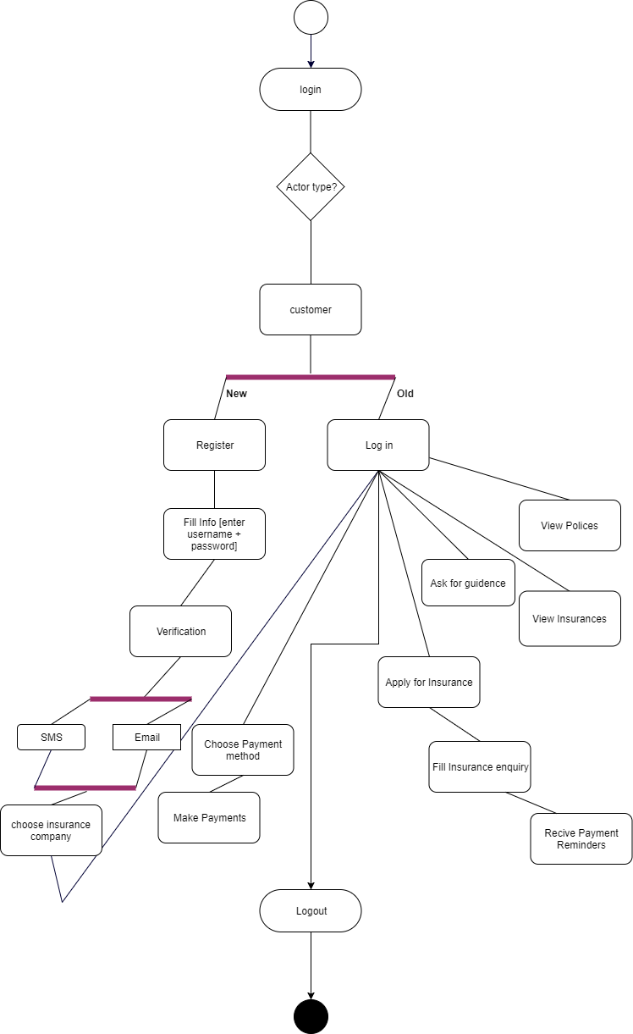

1. ***Insurance company Activity Diagram:  
   (Maryam Shaheen)***

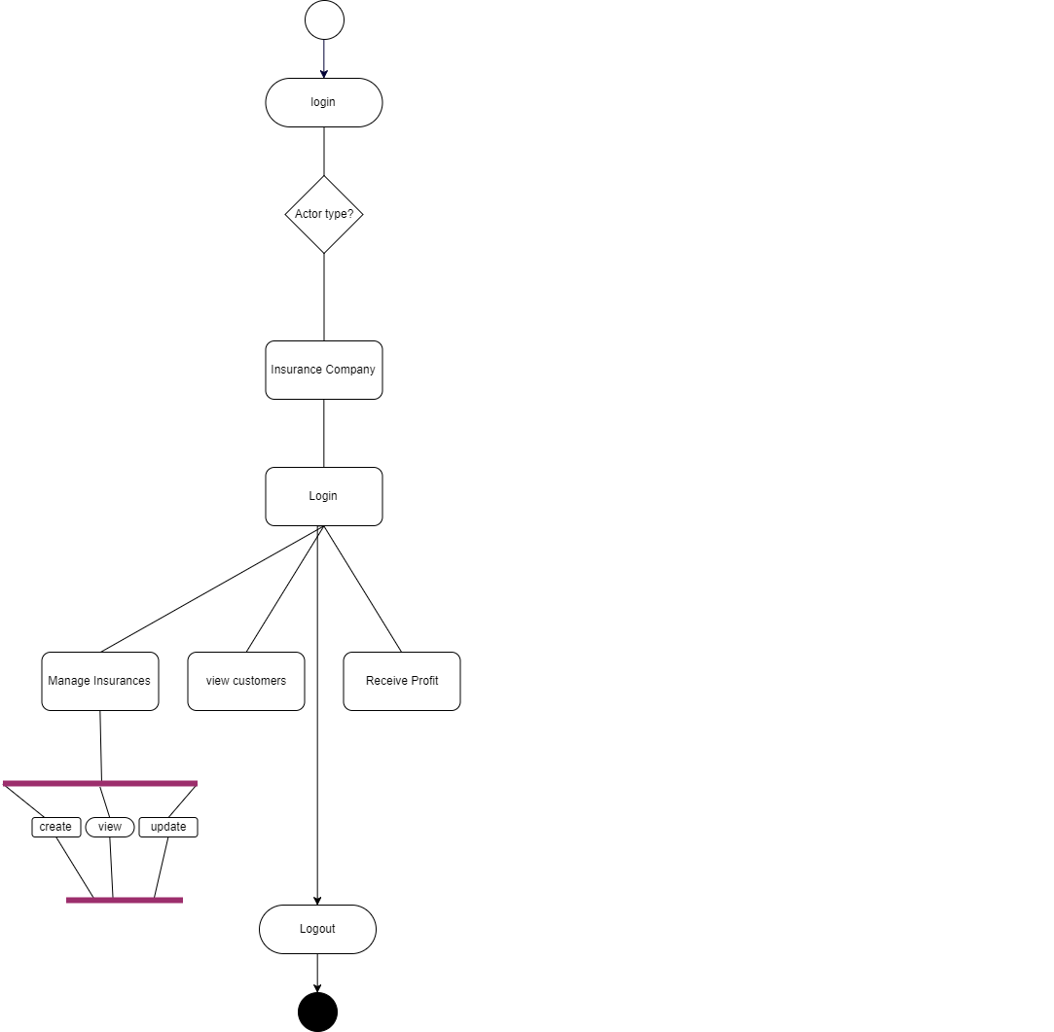

1. ***System Reminder Activity Diagram:  
   (Eman Ghazawneh)***

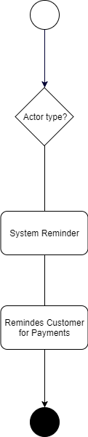

1. ***System Assistance Activity Diagram:  
   (Sanaa Bader)***

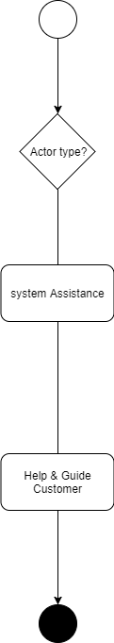

1. ***System Profits Manager Activity Diagram:  
   (Maryam Shaheen)***

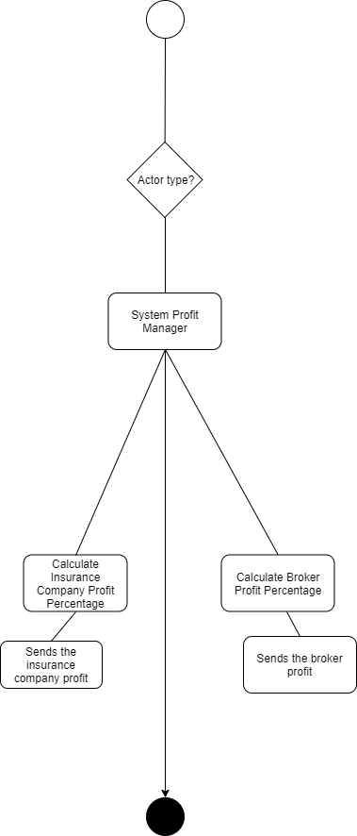

***Chapter 3***

***[System Modeling  
 &  
 Analysis](#TableOfContents)***

1. ***Class Model Analysis (By Sanaa & Maryam)***

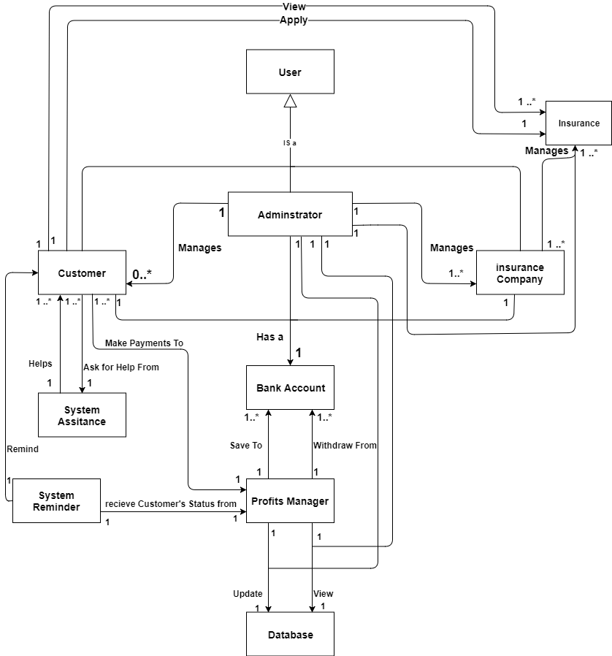

1. ***Detailed Class Model (By Sanaa & Maryam)***

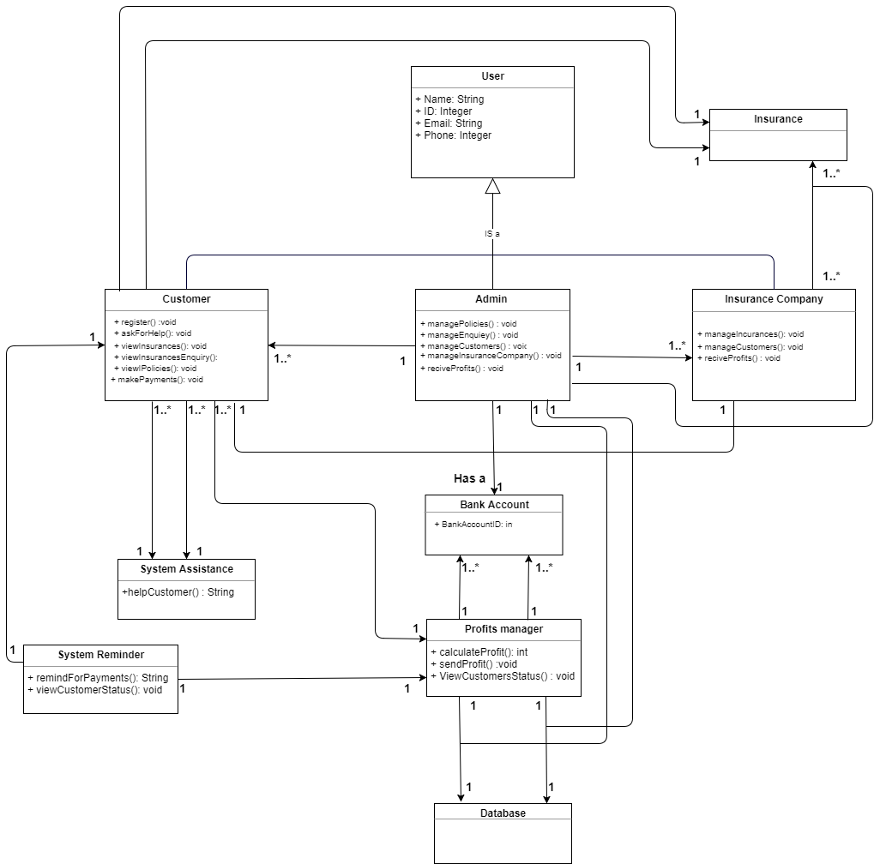

1. ***Classes Descriptions***

***System Assistance****: assistance responsible for help and guide the user/customer of the system in any issue.*

***System Reminder****: This class represents someone who reminds the customer of the deadline for payments.*

***User****: this class represents each user can register and use the system, where has 3 types of users (Customer/ administrator/ insurance Company)*

***Insurance Company****: This class represents someone who registers on the system, manage customers, manage payments, also he/she can manage policies, and change his password and profile settings after logging in.*

***Insurance****: is an object obtained from the insurance company, and can be managed by the insurance company and the administrator.*

***Administrator****: This class represents the Administrator of the system, it has all of his information, and he is allowed to manage stuff such as, enquiries and policies in addition to receive profits.*

***Customer****: This class represents someone who registers on the system, see and ask for car assurance, search for policies and view them, also he/she can ask for guidance for how to use the system, change his password and profile settings after logging in. And after choosing assurance, he can pay cash or by visa card, also he can communicate with the assurance company.*

***Profits Manager****: this class represents a system profits manager who calculates the profit for each insurance Company and the administrator, and then sends the profits to their bank accounts, that are stored in the database.*

***Database****: this class represents the database that stores each user information (customer/ administrator/ and the insurance company) also can be updated or edited by the administrator or the profits manager only.*

***Bank Account****: this class represents each user bank information (customer/ administrator/ and the insurance company), where each one have a bank account id number.*

1. ***Object Diagram (By Nourhan)***

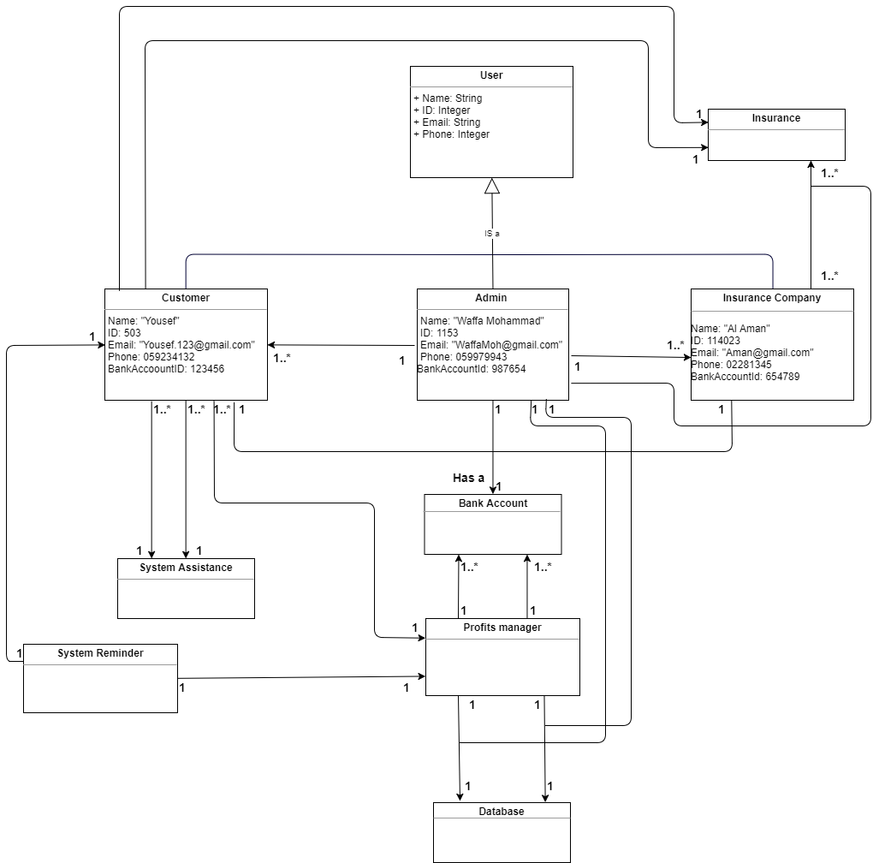

1. ***Sequence Diagrams***

***1- Admin view and edit inquiries sequence diagram  
 (by Ahamad)***

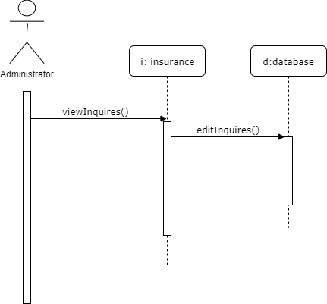

***2- Customer applying for insurance sequence diagram (By Maryam)***

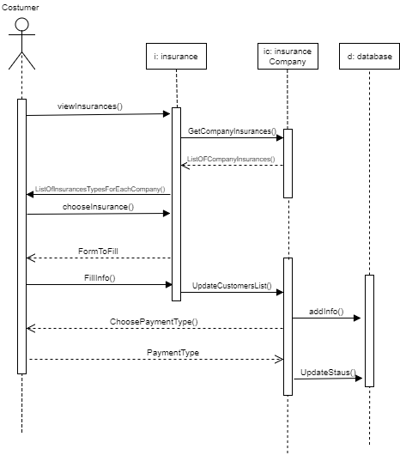

1. ***Customer asking for assistance sequence diagram (By Sanaa)***

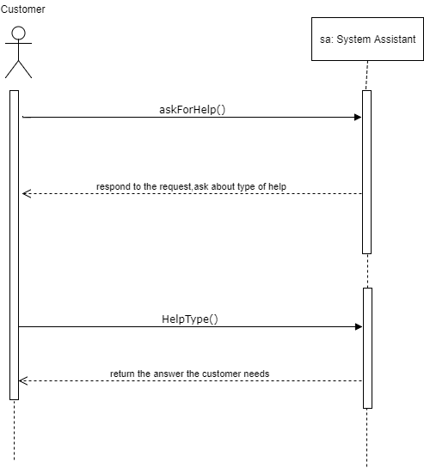

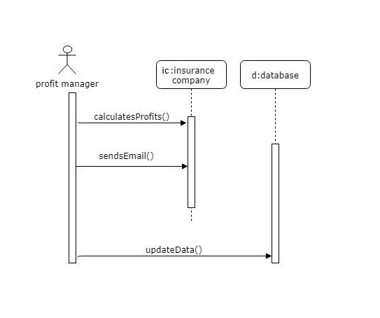***4- Profit manager for insurance company sequence diagram (By Nourhan)***

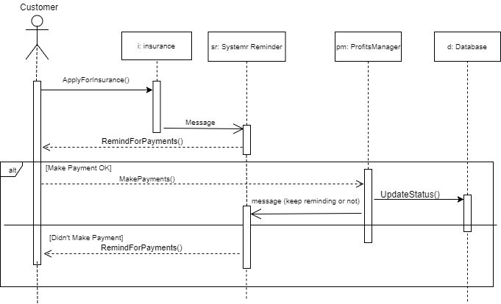***5- System reminder sequence diagram (By Eman)***

1. ***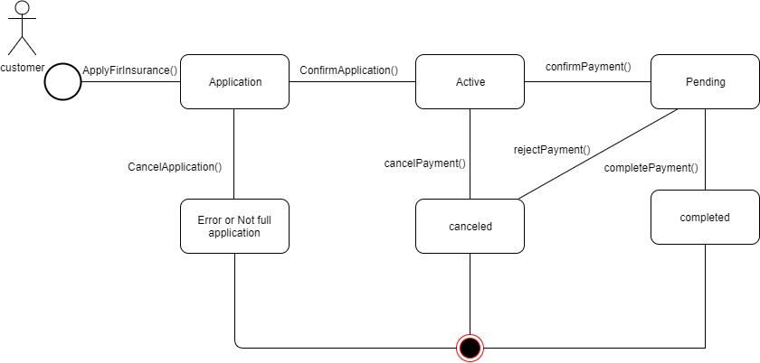******State Diagram*** ***(By Ahmad)***

***Chapter 4***

***System Design***

1. ***Design Goals Descriptions (By Eman)***

***General Goals:***

1. *High cohesion: Classes that interact to perform a certain function are placed together in one component that provides the service of said function.*
2. *Low coupling: If a class has interactions that relate to different components, copies of that class are made and distributed among the components so as to lower the rate of interaction between them*

***Specific Goals:***

1. *User friendliness: Achieved by providing the customer with several user interfaces.*

1. ***Component Diagram (by Maryam)***

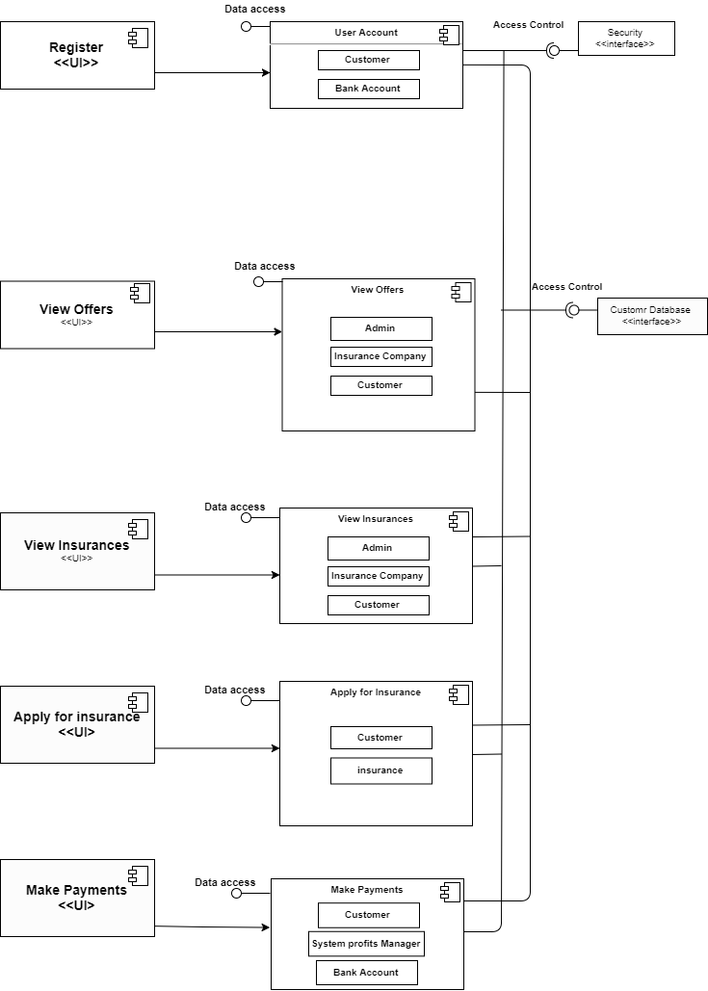

1. ***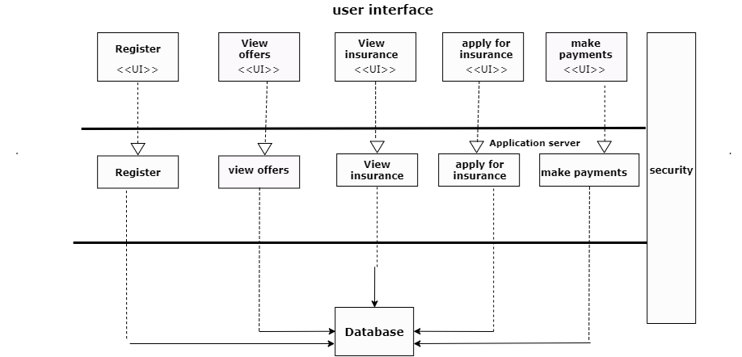******Overall Architecture Diagram*** ***(By Nourhan)***

1. ***Deployment Diagram (By Sanaa)***

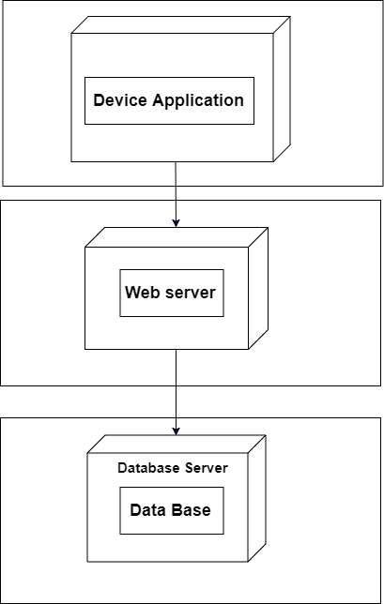

***Chapter 5***

***[Assessment   
&   
Effort Estimation](#TableOfContents)***

|  |  |
| --- | --- |
| **Customer Group No.** | **Developer Group No.** |
| **G1** | **G1** |

* 1. ***Assessment***

* 1. ***User Requirement Approval Phase***

|  |  |  |
| --- | --- | --- |
| **1-Are these items included or submitted to in the approval report? -delete YES or No as appropriate.** | | |
| **Yes** | The requirement statement/Business description – which you supplied to them. | |
| **Yes** | USER Requirements. | |
| **Yes** | SYSTEM Requirements | |
| **Yes** | The negotiated COST of project completion. | |
| **Yes** | The negotiated TIMESCALE (delivery time) of project completion. | |
| **2- Do you Approve the USER and SYSTEM requirements? -delete YES or No as appropriate.** | | |
| **Yes** | Yes, USER requirements are complete and meet my business needs. | |
| **Yes** | Yes, SYSTEM requirements are complete and meet my business needs. | |
| **NO** | No, requirements are not complete- some requirements are missing and are listed below in 3.1. | |
| **NO** | No, requirements are not complete- some requirements are not correctly identified and are listed below in 3.2. | |
| **3- Assessment of the cooperation with your developer group** | | |
| 3.1- Have your respective developer group written the USER and SYSTEM requirement with valid characteristics? If No, list the numbers of requirements that you think are not VALID. | | |
| **Requirements are complete.** | | |
| 3.2- Have your developer group put enough effort to understand your business and identify both USER and SYSTEM requirements correctly? If yes, write how well you think they understood your business. If no, write what they failed at to understand your business. | | |
| **Requirements are complete.** | | |
| 3.3- Have your developer group been collaborative enough in responding to your discussion? Write a statement on their collaboration, on: how helpful in listening to your suggestions, contacting you to discuss, meeting you to discuss and suggesting ways to improve the efficiency of your business. | | |
| **Yes, they were collaborative and available in every meeting, and also they were helpful in listening to our suggestions, they also give us an opinion to improve our business.** | | |
| **4- Assessment of your COST and delivery TIME negotiation with your developer group** | | |
| 4.1- Have the negotiation with your developer group been easy to reach an agreement on a suitable cost and time? If no, write what were the difficulties. If yes, write what particularly was easy to reach an agreement. | | |
| **Yes, their price and period of time were good and made sense to us, so we accepted it very fast and easily.** | | |
| 4.2- What were the negotiated COST and EFFORT/TIME relative to your expected ones? | | |
| AGREED COST: **$4704** | | AGREED TIME: **7 weeks.**  AGREED Delivery date: **18-June-2018** |

|  |  |  |  |
| --- | --- | --- | --- |
| **1- Assessment of Requirement discovery techniques and ability** | | | |
| 1.1- Have your customer group provided you with CLEAR answers to your queries about their business needs in terms of USER Requirements? If yes, how clear were their answers to help you identify USER & SYSTEM requirements. If no, write what issues were not clear (or ambiguous). | | | |
| **Yes, they were very clear in their business description, and they clarified each requirement.** | | | |
| 1.2- Have you found any particular aspect difficult to analyses or understand out of your customer’s business USER & SYSTEM Requirements needs? If yes, describe what aspects. If no, write what aspects were hardest to understand. | | | |
| **No, all aspects were clear enough to understand and analyses** | | | |
| **2- Assessment of the cooperation with your customer group** | | | |
| 2.1- Have your customer group provided you with clear answers and enough details to help you create requirements with valid characteristics? If yes, write how clear were their responses. If no, write examples of some issues they were not clear at. | | | |
| **yes, always available to give feedback and help with any idea**  **weekly meeting to discuss what the things we’ve done** | | | |
| 2.2- How prompt (or fast) was your customer group in responding to your queries? If slow, write how long they took to respond. If fast, write how effective they were in responses | | | |
| **fast and responsive, we used to get the response within 24 hours** | | | |
| 2.3- Have your respective developer group been collaborative enough in discussion? Write a statement on their collaboration, in terms of, for example, being difficult, helpful, non-responsive, not interested. | | | |
| **very helpful and kind to deal with** | | | |
| **3- Assessment of your COST and delivery TIME negotiation with your customer group** | | | |
| 3.1- Have the negotiation with your customer group been easy to reach an agreement on a suitable cost and time? If no, write what were the difficulties. If yes, write how easy was to reach an agreement. | | | |
| **it was easy, we first discussed about the time then the cost**  **they preferred short period with higher cost** | | | |
| 3.2- What were the negotiated COST and EFFORT/TIME relative to your estimated ones?- Write these down as noted below (Please keep your detailed calculation, you will be asked to submit them later, part of your next project report) | | | |
| **close enough to each other , and acceptable by both sides** | | | |
| Minimum effort: **15 p/w**  Minimum scheduled time: **15.5 week** | Maximum effort**: 25 p/w**  Maximum scheduled time: **32.5 week** | | Minimum Cost: **$15015**  Maximum Cost: **$17745** |
| AGREED COST: **$15 000** | | AGREED TIME: **4 months**  AGREED delivery date:**18/8/2018** | |

* 1. ***Requirements Analysis Phase***

|  |  |
| --- | --- |
| **1-Are the following items included in the report?-delete YES or No as appropriate** | |
| **Yes** | ACTOR’s analysis and their description. |
| **Yes** | USE-CASE diagram(s). [One overall system use case - and up to 3 multi-level use case diagrams, if needed]. |
| **Yes** | USE-CASES and their detailed description [up to 4 use cases, one each] |
| **Yes** | ACTIVITY diagram (s): One main activity diagram to show a business process, and up to four instance activity diagrams of key use-cases, one each, preferably of the scenarios in detailed before, showing its normal, alternative and error flows. |
| **2- Do you Approve the requirement Analysis report? - -delete YES or No as appropriate** | |
| **Yes** | Yes, ACTORS and their description are complete, meaningful and meet my business needs. |
| **Yes** | Yes, USE CASES are complete- meaningful and meet my business (USER) requirement. |
| **Yes** | Yes, ACTIVITIES are complete- meaningful and represent my business processes. |
| **No** | No, ACTORS and their description are not complete- some are not correctly analyzed and are listed below in 3.1 |
| **No** | No, USE CASES are not complete- some are not correctly analyzed and are listed below in 3.1 |
| **No** | No, ACTIVITIES are not complete- some are not correctly analyzed and are listed below in 3.2 |
| **3- Assessment of the cooperation with your developer group** | |
| 3.1- Have your respective developer group analysed the requirements to fit your business needs? If yes, list what key requirements have correctly been analysed. If not, write what requirements have NOT correctly been analysed. | |
| **Yes, The customer group agreed about the price, and we discussed the details of the payment method.** | |
| 3.2- Have your respective developer group analysed the requirements correctly in terms of your business understanding and have they used the correct UML notation for you to understand? If yes, write how well you think they understood your business and UML notations. If not, write where they have not analysed your business correctly or not conformed to UML. | |
| **Yes , Developer group understands well the notations of the UML , and the analysis of the requirements**  **Developer group provide detailed UML diagrams and analysis, with a clear implementation for relations between attributes and entities of the diagrams.** | |
| 3.3- Have your respective developer group been collaborative enough in responding to your discussion? Write a statement on their collaboration, on: helpful in listening to your suggestions, contacting you to discuss, meeting you to discuss and suggesting ways to improve the efficiency of your business. | |
| **We were in touch with the developer group in each step , we meeting more than one time to discuss more details of the system and requirement analysis ,they were very cooperative and helpful in providing more suggestions to improve efficiency and effective of the business .** | |

|  |
| --- |
| **1- Assessment of your Requirement Analysis techniques and ability** |
| 1.1- Have your customer group provided you with CLEAR answers to your queries about their business requirements in terms of functional needs of the system? If yes, how clear were their answers to help you analyse their requirements and business processes into USE CASES and ACTIVITIES. If no, write what issues where not clear (or ambiguous). |
| **Yes, our customer group always provide us clear answers to our queries, and there answers always give us a very good feedback to complete in the system process.** |
| 1.2- Have you found any particular aspect difficult to analyse or understand out of your customer’s business processes and Requirements? If yes, describe what aspects. If no, write what aspects were hardest to understand. |
| **actually, we didn’t face any problem to analysis our customer’s business process** |
| **2- Assessment of your cooperation and collaboration abilities with your customer group** |
| 2.1- Have your customer group been responsive to your queries related to what they want to get done on their business understanding details? If yes, write how clear were their responses. If no, write examples of some issues they were not clear at. |
| **Yes, our customer group gave us a good requirement to understand and they detailed it, they were very friendly.** |
| 2.2- How prompt (or fast) was your customer group in responding to your queries? If slow, write how long they took to respond. If fast, write how effective they were in responses |
| **Actually , we always keep in touch with them ,in different ways , such as class meeting, we also talk to them in social media, there’s always at least member of them answer very quickly to our queries.** |
| 2.3- Have your respective customer group been collaborative enough in discussion? Write a statement on their collaboration, in terms of, for example, being difficult, helpful, non-responsive, not interested. If they were difficult what technique did you use to overcome their difficulty |
| **There is friendship between us and we have no difficulty in understanding with them, they are very helpful, responsive and interested.** |

* 1. ***System Modeling and Design Phase***

|  |  |
| --- | --- |
| **1-Are these item included in the report, check the boxes below if YES.** | |
| **System Modelling** | |
| ✓ | System CLASS Diagram, and brief description of classes |
| ✓ | OBJECT Diagram |
| ✓ | SEQUENCE Diagram; two sequence diagrams for two different use cases |
| ✓ | STATE diagram: one state diagram, of an object that has a state. If none exists, describe why. |
| **System Design** | |
| ✓ | An architectural design– component diagram |
| ✓ | Description of chosen Design Goals, and describe how they will be addressed, justification for choosing architecture style. |
| ✓ | COMPONENT Diagram; Describe how and where in the component Chosen Design goals have been addressed. |
| ✓ | DEPLOYMENT Diagram: mapping Software components on hardware nodes. |
| **2- Do you Approve the System (Analysis) Model report?** | |
| ✗ | Yes, the presented system model/Design is complete and meets my business needs. |
| ✓ | No, the presented system model/Design is not complete- some issues are not addressed and are listed below in 3.1 |
| ✓ | No, the presented system model/Design is not complete - some issues are not correctly modelled and listed below in 3.2 |
| **3- Assessment of the cooperation with your developer group** | |
| 3.1- Have your respective developer group presented System model/Design that answers your business needs and rules? If yes, list what key issues have been addressed. If not, write what issues have NOT been addressed. | |
| **They didn’t present it in the lecture so we didn’t see their work** | |
| 3.2- Have your respective developer group presented a system model/Design CORRECTLY in terms of your business rules and have they used the correct UML notation for you to understand? If yes, write how you think they met your business needs in their solution. If not, write what issues they have not analysed CORRECTLY or UML notation errors. | |
| **Their work wasn’t sent to us** | |
| 3.3- Have your respective developer group modified your System Analysis/Model/Design according to your feedback on the Requirement analysis/ document. If yes, write which changes you asked them to modify. If not, write which changes they did not attempt. | |
| **Their work wasn’t sent to us** | |
| 3.3- Have your respective developer group been collaborative enough in responding your discussion? Write a statement on their collaboration. | |
| **Their work wasn’t sent to us** | |

|  |
| --- |
| **1- Assessment of your analysis techniques and ability** |
| 1.1- Have your respective customer provided you with CLEAR answers to your queries about their business? If yes, how clear were the answers to help you conduct the system analysis? If no, write what issues where not clear or ambiguous. |
| **Yes, they answered all of our answers and they’ve been very clear, but they never give us feedback.** |
| 1.2- Have you found any particular aspect difficult to analyse or understand out of your customer’s business? If yes, describe some of these issues. If no, write what issues were hardest to understand. |
| **No. the business was clear, at first it was difficult, but we managed to understand it and ask them some questions.** |
| **2- Assessment of the cooperation with your developer group** |
| 2.1- Have your customer group been responsive to your queries related to FUNCTIONAL and NON-FUNCTIONAL needs? If yes, write how clear these responses were. If no, write example of some issues they were not clear at. |
| **Yes, they were responsive** |
| 2.2- How prompt was your respective customer group in responding to your queries? If slow, write how long they took to respond. If fast, write how effective they were in responses |
| **Normal, not to slow neither too fast** |
| 2.3- Have your respective developer group been collaborative enough in discussion? Write a statement on their collaboration, in terms of, for example, being difficult, helpful, non-responsive, not interested. |
| **Helpful** |

***5.2*** ***Effort/Time Estimation & Calculation***

***pw****= person week;* ***pm****= person month;* ***w****= week;* ***m****= month*

***effort****= the effort required for a person employed all month/week long*

***Schedule time*** *= time needed to complete including based on working days only (including holidays etc.)*

|  |  |  |  |
| --- | --- | --- | --- |
| ***UR*** | ***Estimated Effort*** | ***Estimated No. of Developers*** | ***Total Effort*** |
| *UR1- Database security* | *2 pw* | *2* | *2*2=4* |
| *UR2- Friendly system Design* | *1pw* | *2* | *1*1=2* |
| *UR3- Services for the user* | *1 pw* | *2* | *1*2=2* |
| *UR4- Sign Up/ Sign In* | *1 pw* | *2* | *1*2=2* |
| *UR-5 financial records for the user* | *1 pw* | *2* | *1*2=2* |
| *UR-6 Payment methods* | *1 pw* | *1* | *1*1=1* |
| *UR-7 Notifications/ payments deadlines/ sales/ offers* | *1 pw* | *2* | *1*2=2* |
| *UR-8 Communicating with the company* | *1 pw* | *2* | *1*2=2* |
| *UR-9 Assistance/ guidance for the user* | *1 pw* | *3* | *1*3=3* |
| *UR-10 Admin functionalities* | *2 pw* | *2* | *2*2=4* |
| *Total effort average* | *12 pw* | *13/5 =2.6* | *25* |
| *Schedule time 30%* | *12*1.30 =15.5 w (min time to complete)* |  | *25* 1.3 = 32.5w (max time to complete)* |
| *Cost* |  | *AVG salary = 420$* | *420* 32.5 w =$13,650* |
| *Profit Margin (min=10%, max=30%)* |  | *min cost →*  *max cost →* | *13650*1.10 = $15,015*  *13650 *1 .30 = $17,745* |

***Schedule Time:***

*Min: 12*1.30 =15.5 w*

*Max: 25* 1.3 = 32.5w*

***Profit margin***

*Min → 10% 🡪 min cost →13650*1.10 = $15,015*

*Max → 30% 🡪 max cost → 13650 *1 .30 = $17,745*

***We agreed on $15000 as an offer.***

***Appendix***

1. ***Group Meetings (By Nourhan)***

|  |  |  |  |
| --- | --- | --- | --- |
| ***Results/Decisions taken*** | ***Purpose*** | ***Attendance*** | ***Date and***  ***location*** |
| Business selection | Phase One- Task 1.2 | All attended | **5.3.2018 (online)** |
| Business description outline/briefing | Phase One- Task 1.3 | All attended | **20.3.2018**  **(at campus)** |
| Draft of User requirements. | Phase Two-Task 2.1 | All attended | **27.3.2018**  **(at campus )** |
| Draft System requirements | Phase Two-Task 2.1 | All attended | **29.3.2018**  **(online)** |
| Final User and System Requirements | Phase Two- Task 2.2 | All attended | **1.4.2018**  **(online)** |
| Draft Effort and time estimation | Phase Two- task 2.4 | All attended | **4.4.2018**  **(online)** |
| Final Effort and time estimation | Phase Two- task 2.4 | All attended | **6.4.2018 (online)** |
| Complete Assessment forms | User Requirements Approval Assessment | All attended | **17.4.2018**  **(online)** |
| Draft Scenario Analysis | Phase Three-Task 3.1 | All attended | **18.4.2018**  **(online)** |
| Final Scenario Analysis | Phase three-Task 3.1 | All attended | **22.4.2018**  **(online)** |
| Draft  actors and use case Model Analysis | Phase three-Task 3.2 | All attended | **23.4.2018**  **(at campus )** |
| final actors and use case Model Analysis  +  write a detailed description of 5 use cases | Phase three-Task 3.2 +Task3.3 | All attended | **25.4.2018**  **(at campus)** |
| Draft Activity Model/Diagram Analysis | Phase three-Task 3.3 | All attended | **25.4.2018**  **(online)** |
| Final  Activity Model/Diagram Analysis | Phase three-Task 3.3 | All attended | **1.5.2018**  **(online)** |
| Detailed use cases | Phase three-Task 3.3.2 | All attended | **2.5.2018**  **(online)** |
| prepare for the presentation | Presentation for phase three | All attended | **5.5.2018**  **(at campus )** |
| Draft System Class modelling and Analysis | phase four-task 4.1 | All attended | **9.5.2018**  **(online)** |
| Final System Class modelling and Analysis  +Draft DETAILED CLASS model  + OBJECT diagram + Draft System Sequence & State modelling and Analysis | phase four-task 4.1 +Task4.1.2 +Task4.2 | All attended | **14.5.2018**  **(online)** |
| Final   DETAILED CLASS model/Diagram  + OBJECT diagram  +Final System Sequence & State modelling and Analysis | phase four-task 4.1.2 + Task4.2 | All attended | **16.5.2018**  **(at campus )** |
| Complete Assessment forms | Requirements Analysis Assessment | All attended | **19.5.2018 (online)** |
| Draft Design Goals + Architecture diagram+ Component diagram+ deployment diagram | phase four- Task 4.3 | All attended | **20.5.2018**  **(online)** |
| Final Design Goals + Architecture diagram+ Component diagram+ deployment diagram | phase four- Task 4.3 | All attended | **21.5.2018**  **(at campus )** |
| Finish PowerPoint  for final presentation | Final presentation | All attended | **22.5.2018**  **(at campus )** |
| Finish final report | Final report | All attended | **27.5.2018**  **(online)** |

1. ***Meetings With Customer Group (By Nourhan)***

|  |  |  |  |
| --- | --- | --- | --- |
| ***Results/Decisions taken*** | ***Purpose*** | ***Attendance*** | ***Date and***  ***location*** |
| Business description outline/briefing | Phase One- Task 1.3 | 2 attendances from G2  3 attendances from G9  All attended from G1 | **20.3.2018**  **(at campus)** |
| Draft of User requirements. | Phase Two-Task 2.1 | 2 attendances from G2  3 attendances from G9  All attended from G1 | **27.3.2018**  **(at campus )** |
| Draft System requirements | Phase Two-Task 2.1 | 2 attendances from G2  3 attendances from G9  All attended from G1 | **29.3.2018**  **(online)** |
| User and System Requirements Approval | Phase Two- Task 2.3 | All attended | **5.4.2018**  **(during lecture)** |
| Draft Effort and time estimation Approval | Phase Two- task 2.4 | All attended | **4.4.2018**  **(online)** |
| Final Effort and time estimation Approval | Phase Two- task 2.4 | All attended | **6.4.2018 (online)** |
| Draft Scenario Analysis Approval | Phase Three-Task 3.1 | All attended | **18.4.2018**  **(online)** |
| Final Scenario Analysis Approval | Phase three-Task 3.1 | All attended | **22.4.2018**  **(online)** |
| Draft  actors and use case Model Analysis Approval | Phase three-Task 3.2 | All attended | **23.4.2018**  **(at campus )** |
| final actors and use case Model Analysis  +  write a detailed description of 5 use cases  Approvals | Phase three-Task 3.2 +Task3.3 | All attended | **25.4.2018**  **(at campus)** |
| Draft Activity Model/Diagram Analysis Approval | Phase three-Task 3.3 | All attended | **25.4.2018**  **(online)** |
| Final  Activity Model/Diagram Analysis Approval | Phase three-Task 3.3 | All attended | **1.5.2018**  **(online)** |
| Detailed use cases Approval | Phase three-Task 3.3.2 | All attended | **2.5.2018**  **(online)** |
| Draft System Class modelling and Analysis Approval | phase four-task 4.1 | All attended | **9.5.2018**  **(online)** |
| Final System Class modelling and Analysis  +Draft DETAILED CLASS model  + OBJECT diagram + Draft System Sequence & State modelling and Analysis  Approvals | phase four-task 4.1 +Task4.1.2 +Task4.2 | All attended | **14.5.2018**  **(online)** |
| Final   DETAILED CLASS model/Diagram  + OBJECT diagram  +Final System Sequence & State modelling and Analysis  Approvals | phase four-task 4.1.2 + Task4.2 | All attended | **16.5.2018**  **(at campus )** |
| Draft Design Goals + Architecture diagram+ Component diagram+ deployment diagram  Approvals | phase four- Task 4.3 | All attended | **20.5.2018**  **(online)** |
| Final Design Goals + Architecture diagram+ Component diagram+ deployment diagram  Approvals | phase four- Task 4.3 | All attended | **21.5.2018**  **(at campus )** |