



**Computer Science Department**

**Second Semester 2017/2018**

**Instructor: Adel Taweel**

**Comp433 – Software Engineering**

**Project-Phase One**

**Group Formation and Project Planning**

**Students:**

**Maryam Shaheen #1140427**

**Nourhan Abu Sharbak #1150640**

**Eman Ghazawneh #1152278**

**Ahmad Thabet #1150312**

**Sanaa Bader #1151763**

Table of Contents

Project planning and managemen...................................................................3   
1.1 Group name & Logo...................................................................................3  
1.2 Group roles………………………………................................................................4  
1.3 Project management strategy ...................................................................4

1. Project planning and management

1.1 Group Name: problem.seen

Logo:

Why this name?  
→ The team noticed that Dr. Adel insisted on the idea of problem awareness by saying: “if you can’t see the problem, then you can’t solve it” so we decided to take the responsibility and start seeing problems to solve them, and we are sure by the end of this course we will be able to See problems, engineer them, Solve them, and Evaluate them, Inshallah ;)!

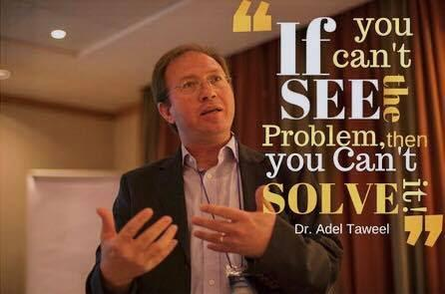



1.2 Group Members:

Manager: Maryam Shaheen

Secretary: Nourhan Abu Sharbak

Technical architect: Eman Ghazawneh

Programmer: Ahmad Thabet

Tester: Sanaa Bader

1.3 Project management strategy:

Most of the team’s meetings will be conducted online via Facebook Messenger, WhatsApp, UberConference (When Document/Screen Sharing is needed), or Skype.

However, every two weeks, the team will meet on Wednesday afternoons in many places made for group working such as (Umake Center and Avenue) or on Tuesday following the lecture in the Campus. The decision to meet twice a week was due to conflicting schedules and was taken to ensure the participation of every team member. When it came to decision making, a team member or two would propose an idea or solution and the team would vote on whether or not to adopt this decision.