7/27/2021

Introduction to computer

Section1

Mohammed Assi

1200975

7/28/2021 1:54 PM

Table of Contents

Chapter1: Red II

Chapter2: Nursing. III

Chapter3: My lab experience. IV

#### Table of figures

Figure 1 III

Figure 2 III

##### Bibliography

Assi, M. (2021). *Mohammed Assi-1200975.* Ramallah.

# Chapter1: Red

After surviving an assault from a squad of hit men, retired CIA agent Frank Moses (Bruce Willis) reassembles his old team for an all-out war. Frank reunites with old Joe (Morgan Freeman), crazy Marvin (John Malkovich) and wily Victoria (Helen Mirren) to uncover a massive conspiracy that threatens their lives. Only their expert training will allow them to survive a near-impossible mission- breaking into CIA headquarters. The secrets these four know made them on the wanted list now and they are targeted for liquidation.

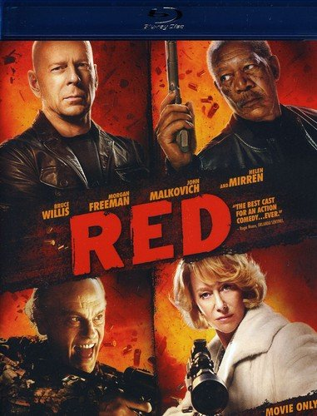

Figure1 Figure2

Figure 1

Figure 2

[Red film](https://cima4u.ws:2053/%D9%85%D8%B4%D8%A7%D9%87%D8%AF%D8%A9-%D9%81%D9%8A%D9%84%D9%85-red-2010-%D9%85%D8%AA%D8%B1%D8%AC%D9%85/)

## Chapter2: Nursing.

~~Nursing is a microcosm of medicine.~~ The specialization is wonderful and interesting if the person has a passion for learning and studying about the human body and everything related to it.

SmartArt

Shape

[1] Footnote.

### Chapter3: My lab experience.

List of two things I like in the lab: -

I like the way of explanation, and we apply what is explained.

I love the doctor.

Screenshot from my ITC: -



Equation: -

$$\frac{-b±\sqrt{b^{2}-4ac}}{2a}$$

First book.

1. Nursing needs someone who is responsible, ambitious, and loves to help.