

***Introduction to Computer***

***Last Assignment***

***Dr : Refat Othman***

***Abeer Murrar***

***1151337***

**Using SPSS Program do the following for the questionnaire below:**

1. Define the required variables and choose the most suitable feature for each .*Notice that you must be in the variable view.*

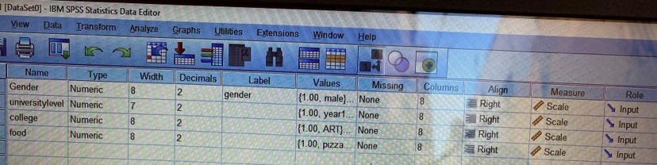

2. Assume that the people who answered the questionnaire were as shown in the table below. Enter these answers into your SPSS file. *Notice that you must be in the data view!*

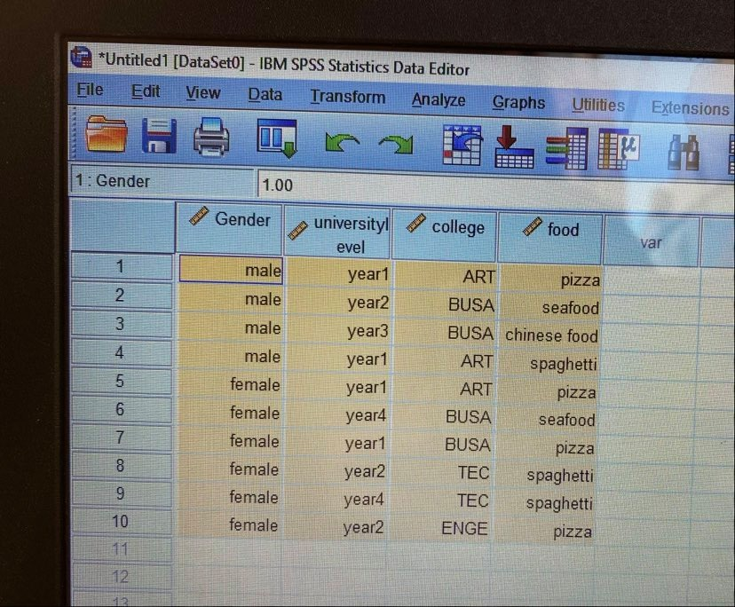

4. Show the mean, maximum and minimum **College,Food** using discriptives.

|  |  |  |  |  |
| --- | --- | --- | --- | --- |
| **Descriptive Statistics** | | | | |
|  | N | Minimum | Maximum | Mean |
| college | 10 | 1.00 | 4.00 | 2.3000 |
| food | 10 | 1.00 | 4.00 | 2.0000 |
| Valid N (listwise) | 10 |  |  |  |

5. Draw a bar chart and frequency table for the College, Year.

**Frequency Table**

|  |  |  |  |  |  |
| --- | --- | --- | --- | --- | --- |
| **college** | | | | | |
|  | | Frequency | Percent | Valid Percent | Cumulative Percent |
| Valid | ART | 3 | 30.0 | 30.0 | 30.0 |
| TEC | 2 | 20.0 | 20.0 | 50.0 |
| BUSA | 4 | 40.0 | 40.0 | 90.0 |
| ENGE | 1 | 10.0 | 10.0 | 100.0 |
| Total | 10 | 100.0 | 100.0 |  |

|  |  |  |  |  |  |
| --- | --- | --- | --- | --- | --- |
| **universitylevel** | | | | | |
|  | | Frequency | Percent | Valid Percent | Cumulative Percent |
| Valid | year1 | 4 | 40.0 | 40.0 | 40.0 |
| year2 | 3 | 30.0 | 30.0 | 70.0 |
| year3 | 1 | 10.0 | 10.0 | 80.0 |
| year4 | 2 | 20.0 | 20.0 | 100.0 |
| Total | 10 | 100.0 | 100.0 |  |

**Bar Chart**

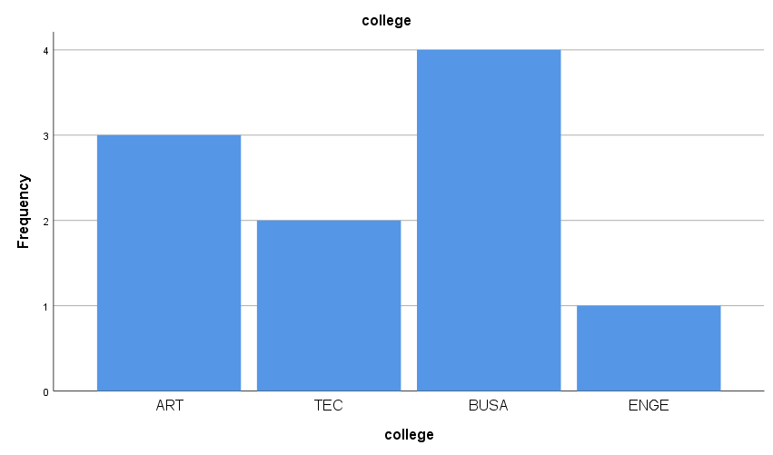

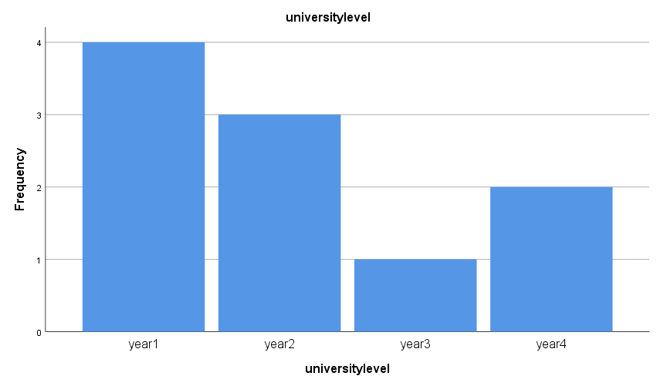

7. Split your data according to **gender**.

SORT CASES BY Gender.

SPLIT FILE SEPARATE BY Gender.

8. **Repeat question 4 after you did the split.**

**gender = male**

|  |  |  |  |  |
| --- | --- | --- | --- | --- |
| **Descriptive Statisticsa** | | | | |
|  | N | Minimum | Maximum | Mean |
| college | 4 | 1.00 | 3.00 | 2.0000 |
| food | 4 | 1.00 | 4.00 | 2.5000 |
| Valid N (listwise) | 4 |  |  |  |
| a. gender = male | | | | |

**gender = female**

|  |  |  |  |  |
| --- | --- | --- | --- | --- |
| **Descriptive Statisticsa** | | | | |
|  | N | Minimum | Maximum | Mean |
| college | 6 | 1.00 | 4.00 | 2.5000 |
| food | 6 | 1.00 | 3.00 | 1.6667 |
| Valid N (listwise) | 6 |  |  |  |
| a. gender = female | | | | |

9. Repeat question 5 after you did the split

**gender = male**

**Frequency Table**

|  |  |  |  |  |  |
| --- | --- | --- | --- | --- | --- |
| **collegea** | | | | | |
|  | | Frequency | Percent | Valid Percent | Cumulative Percent |
| Valid | ART | 2 | 50.0 | 50.0 | 50.0 |
| BUSA | 2 | 50.0 | 50.0 | 100.0 |
| Total | 4 | 100.0 | 100.0 |  |
| a. gender = male | | | | | |

|  |  |  |  |  |  |
| --- | --- | --- | --- | --- | --- |
| **universitylevela** | | | | | |
|  | | Frequency | Percent | Valid Percent | Cumulative Percent |
| Valid | year1 | 2 | 50.0 | 50.0 | 50.0 |
| year2 | 1 | 25.0 | 25.0 | 75.0 |
| year3 | 1 | 25.0 | 25.0 | 100.0 |
| Total | 4 | 100.0 | 100.0 |  |
| a. gender = male | | | | | |

**Bar Chart**

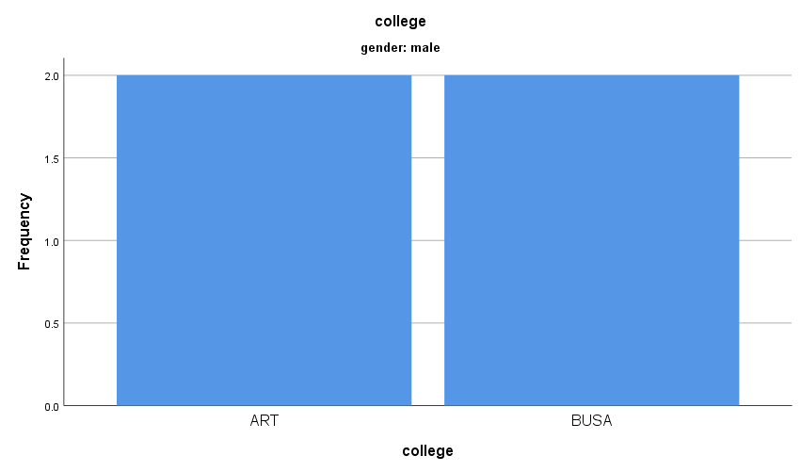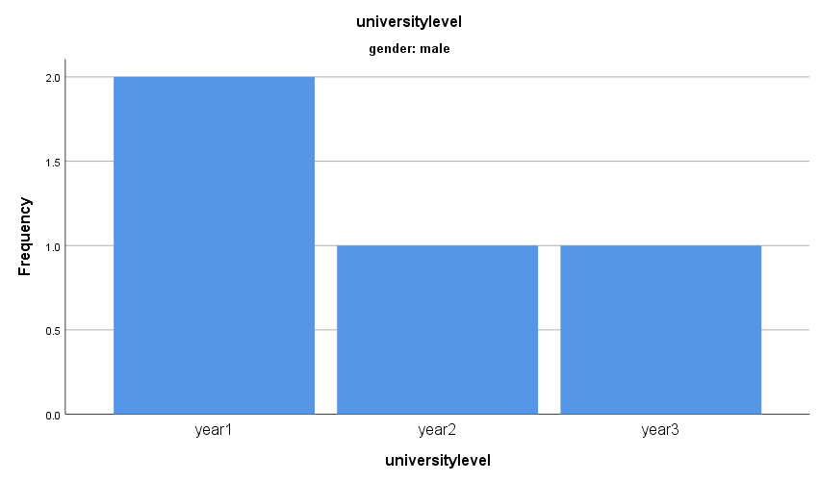

**gender = female**

**Frequency Table**

|  |  |  |  |  |  |
| --- | --- | --- | --- | --- | --- |
| **collegea** | | | | | |
|  | | Frequency | Percent | Valid Percent | Cumulative Percent |
| Valid | ART | 1 | 16.7 | 16.7 | 16.7 |
| TEC | 2 | 33.3 | 33.3 | 50.0 |
| BUSA | 2 | 33.3 | 33.3 | 83.3 |
| ENGE | 1 | 16.7 | 16.7 | 100.0 |
| Total | 6 | 100.0 | 100.0 |  |
| a. gender = female | | | | | |

|  |  |  |  |  |  |
| --- | --- | --- | --- | --- | --- |
| **universitylevela** | | | | | |
|  | | Frequency | Percent | Valid Percent | Cumulative Percent |
| Valid | year1 | 2 | 33.3 | 33.3 | 33.3 |
| year2 | 2 | 33.3 | 33.3 | 66.7 |
| year4 | 2 | 33.3 | 33.3 | 100.0 |
| Total | 6 | 100.0 | 100.0 |  |
| a. gender = female | | | | | |

**Bar Chart**

