

Computer Science Department- Faculty of Engineering and Technology
Health Informatics - Comp 2322

Instructor: Murad Njoum

Based on the previous data set, answer the following questions:
- Find the minimum and maximum weight 43 / 160
- Find the average age 43.87
- Represent the bar chart for quality of sleep group
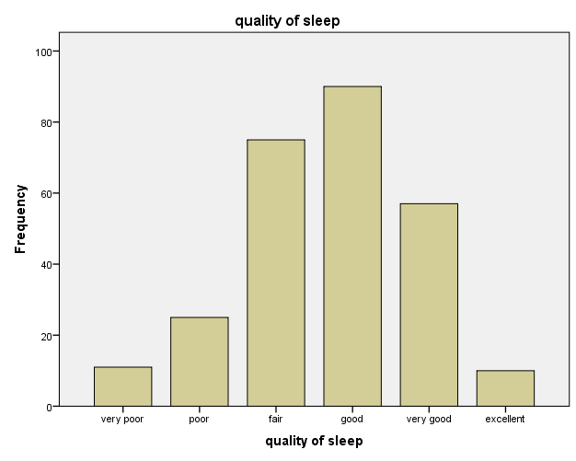
- Find the average number of females does not smoke and drink caffeine more than 5 cups.
45
- Find the maximum male age whose does not smoke and has not sleep while drive.
70
- Find the minimum weight with quality sleep “Excellent “and has stop breathing problem.
48
- Find number of females has not breathing problem.
2
- Using Bar chart Represent mean value of weight with waking at night for male and for female.
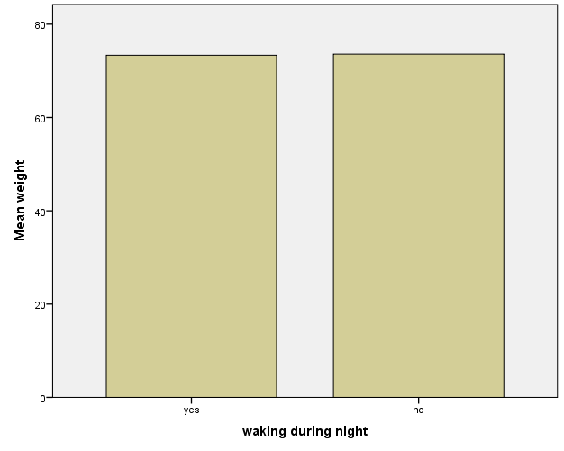
- Find the maximum age female, she has been divorced and take medicine to help her for sleep
42
- Find number of sleeper light male who has smoked and slept more than 7 hours a weekend.
2

