

**Computer Science Department**

**Second Semester 2017/2018**

**Comp332 – Human Computer Interaction.**

**Instructor: Mamoun Nawahdah  
  
Asignmen#1  
Understandable and Confusing Design**

**Name: Maryam Shaheen**

**ID#: 1140427**

Take a photo **of two designs** you think are **understandable** and another **two** that you think are **confusing**.

 • What do you think makes the designs understandable or confusing?

• For each, determine the following: affordance, signifier, mapping (if any), and feedback (if any).

**Confusing design #1**

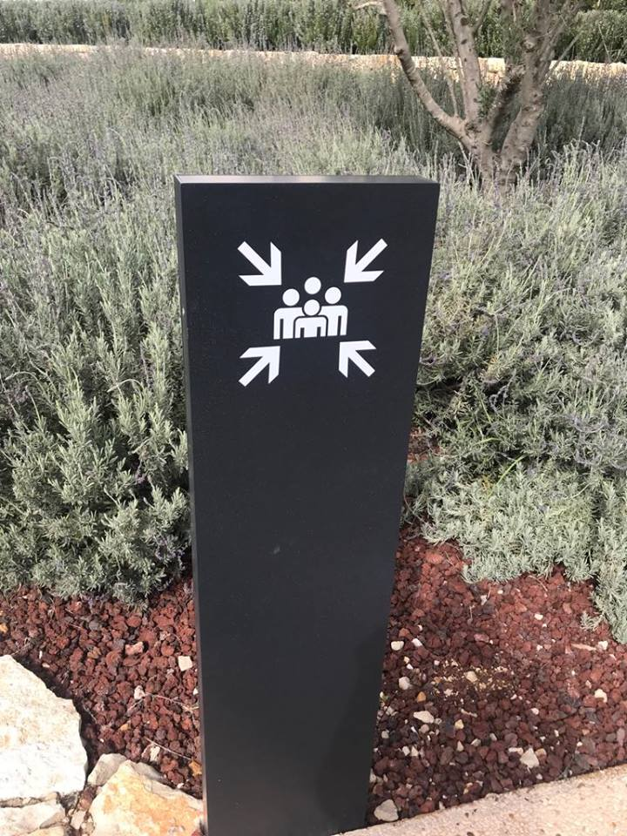

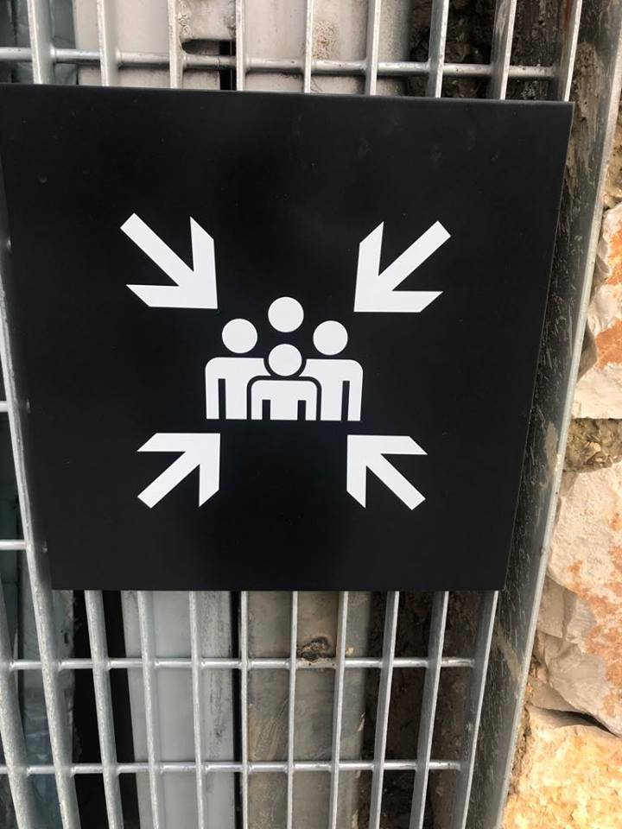

I found this sign in the Palestinian museum, in BZU and it was very confusing, what does that mean?   
**1-** In my opinion this sign **for someone who has no background about signs, It’s not affording me anything...**

**2-** It’s obvious that **there’s no mapping** in the sign (No Text)

**3- the user can’t give any feedback!**

**4- it's not signified**: the main thing that forced me to think about this sign for this assignment is because it stuck in my head since one year ago, but I still remember that it was confusing for me, so I made a Poll in the students group to see what they think about it, and the responses were as following:  
- Is crowding allowed in the outside museum space?  
- Have adults to be with kids? And the arrows are for more attention?   
- Or maybe, visitors have to stay in a group not separated since there are group tours in the museum??  
- is entry limited?   
-is it only for families?  
 It’s really **confusing**…

After “Search by Image” in Google the results were shocking!

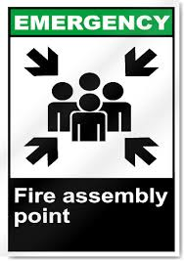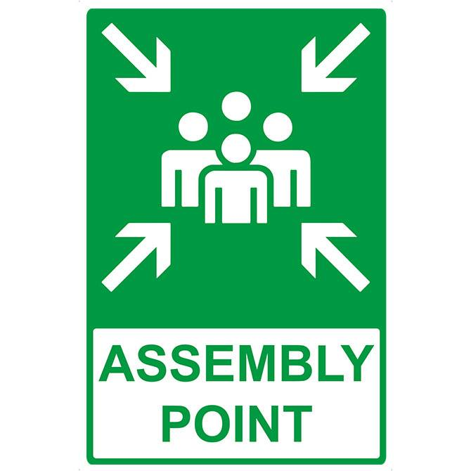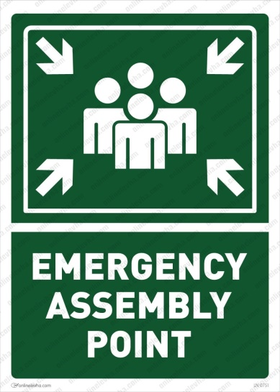

**Confusing design #2**

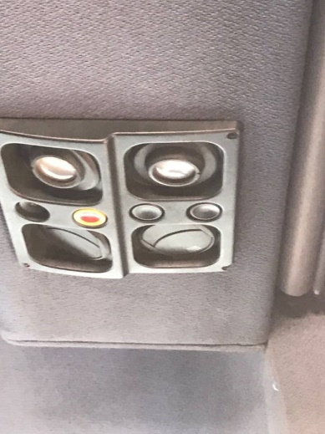Bus bell to stop the driver! Which one is the bell button?

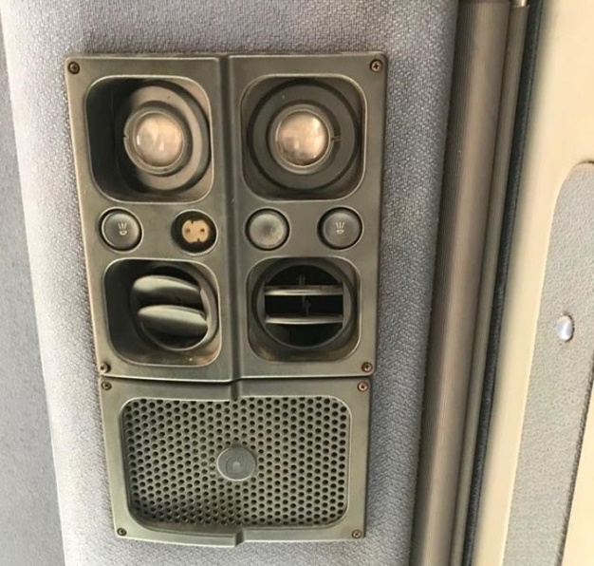 Most likely it’s broken so the user can’t notice the red color

**1-** It’s **affording** the user, but after trying the four buttons and wasting time

**2-** It’s obvious that **there is a confusing mapping** in the left and right buttons ( they’re for the lightning) but they look like speakers, so maybe they’re for bell voice?

**3- The user can’t give any feedback!**

**4- It’s not signified** for first time user and fresh students.

**Confusing design#3**

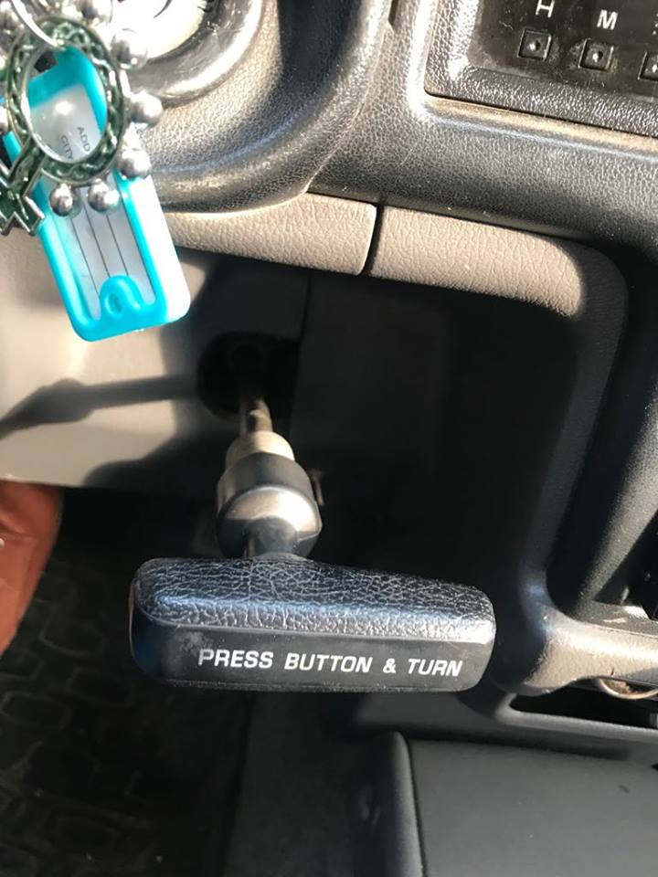 Hand-break under the steering wheel!

**1-** It’s **affording**, but the user may get confused and change the gear instead of pulling the hand-break.

**2-** It’s obvious that **there is mapping** ( Text ) but the user still don’t know to which side shall he turn it?

**3- The user can’t give any feedback!**

**4- It’s not signified** for first time user, and for me every time :’)

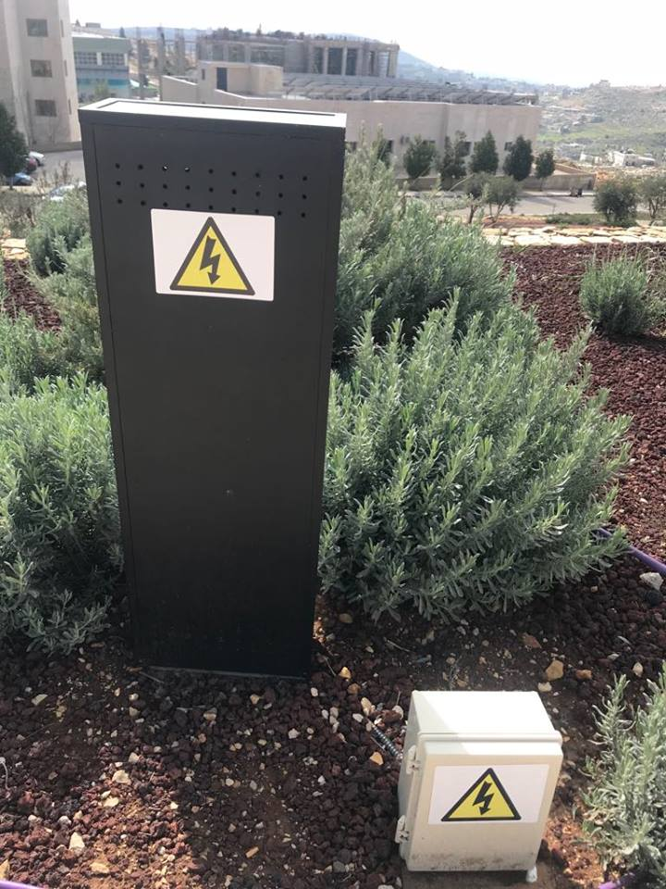**Understandable design #1**

Danger!, Electricity!

**1-** It’s **affording** the user to be safe and staying away from danger

**2- There is mapping** (electricity symbol)

**3- The user can’t give any feedback,** and I think it’s not needed.

**4- It’s signified**

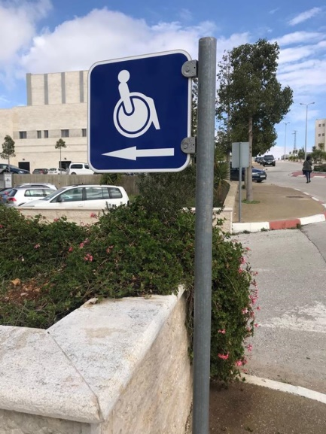**Understandable design #2**

**1-** It’s **affording** the user that there’s Special Needs parking to the left.

**2- There is mapping** (Special Need symbol, arrow symbol)

**3- The user can’t give any feedback,** and I think it’s not needed.

**4- It’s signified**