

**Faculty of Engineering and Technology**

**Department of Computer Science**

**Comp332**

**Human Computer Interaction**

**Study of new design of ritaj web page**

**Student’s names: Ahmad Salah, Mohammad Ameera**

**Student’s id’s: 1130083, 1122211**

**Abstract**

Our study centered on establishing alternative web page of ritaj – which is web page of Birzeit university - and see whether this idea will be accepted by Birzeit University students or not and will it be able to solve the problems in the ritaj web page . Through the study that we used two types of gathering data and made the calculations using SPSS program we were able to detect that there is acceptance by Birzeit university students to the new design of ritaj web site.

**INTRODUCTION**

Ritaj site is a site used by Birzeit University students, but this site suffers from several problems, including problems in show links and information, when a student opens a page Ritaj he will find a large amount of links and information on it, so that make student confusing, our idea to improve the site Ritaj by hiding links in a combo box and have a specific address on each combo box so that links appear when the student click on it’s title.

**LITERATURE REVIEW**

For long complained of Birzeit University students from Page Ritaj , that is the site have several problems and need amendments and when we have created an alternative web page of site Ritaj to solve one of these problems, we presented the new page on a sample of Commerce fourth-year students at Birzeit University that combines Business specialization and involves both male and female, and there number is 21 students, we have showed them the new page and made them answer questionnaires and we made a written interview with them .

**RESEARCH METHODOLOGY**

We selected a sample of students witch include students of the Faculty of Commerce fourth year specialization Business Administration males and females.

And we show them the old design and new design of ritaj web site.

**Old design:**

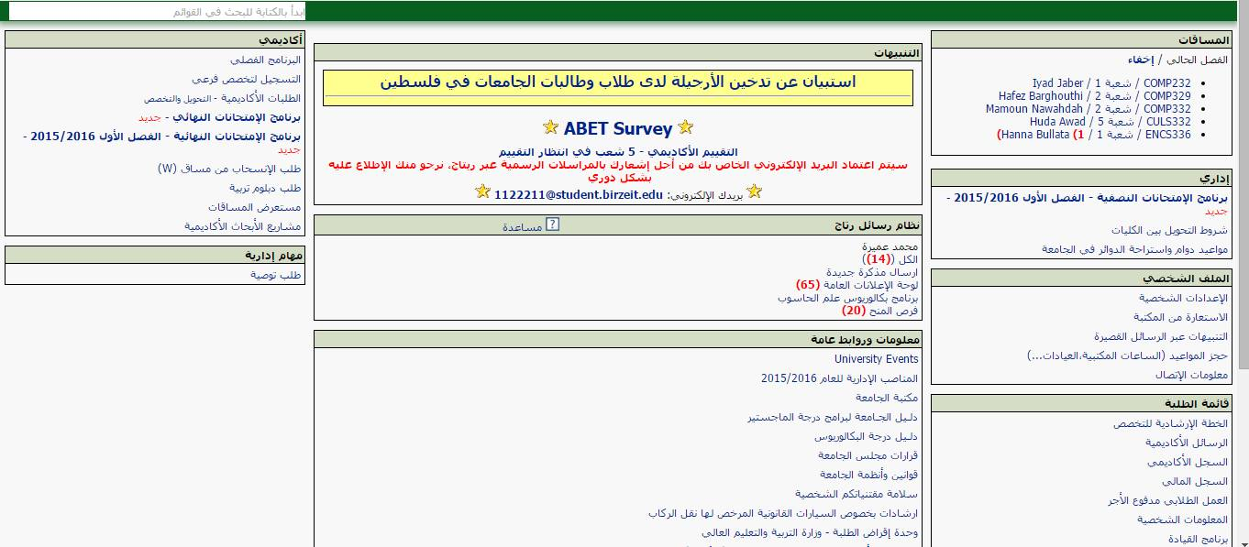

**New design:**

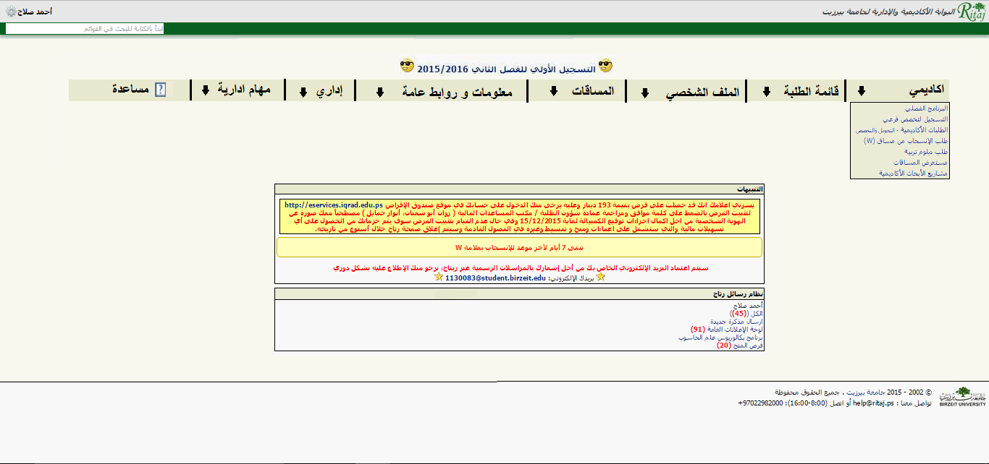

We have prepared two types of methods of gathering information the first one we made a questionnaire and the second one we made an interview with the students and recorded it on pepper.

We have selected a sample of 21 males’ student and 12 female’s student and they were randomly selected.

After we collect the data we have analyzed it using SPSS program. The test that we used was the ANOVA test.

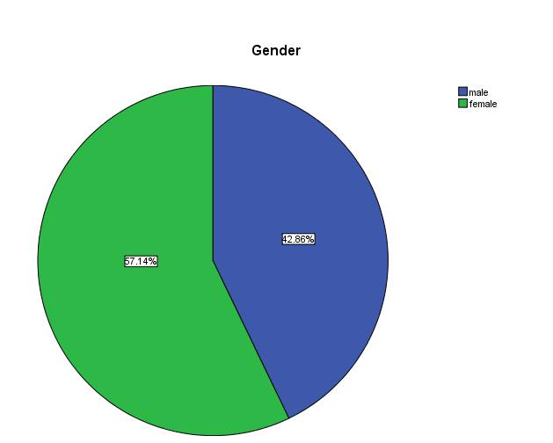

**RESULTS AND DISCUSSION**

Through the answers on the questionnaires and the interview with the students we came to result that the hypotheses that we have set is correct and acceptable which is that there is a difference between the old design of the Ritaj web page and the new design, the new design has defeat the old one, the new design took the largest votes the mean of the sample votes was (5.47 / 7) for the new design, the old design mean of sample votes was (3.61 / 7).

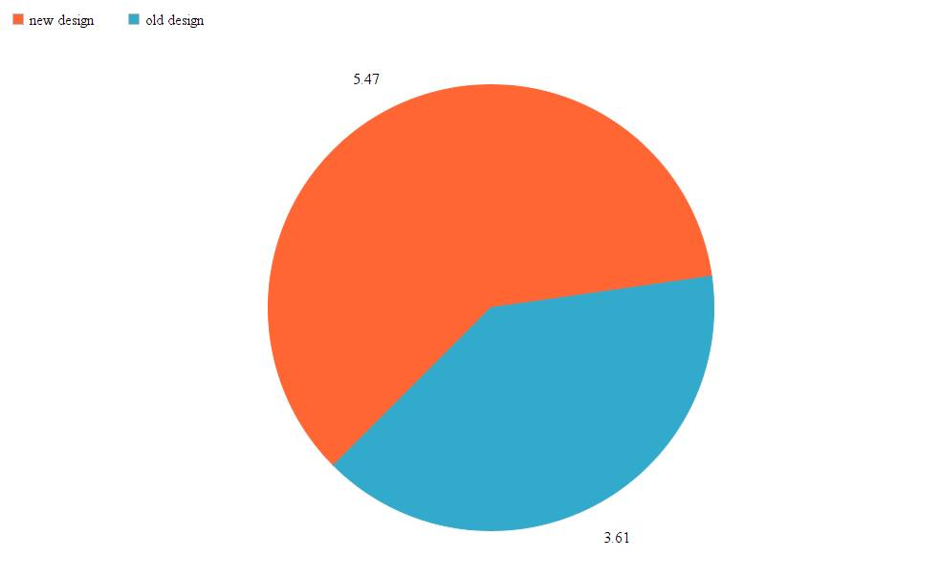

That’s means that there is an acceptance from the students to the new design of page ritaj.

After analyzing the data we did not find any significant differences between conditions, so the new design significant equal to 0.144 and the old design is equal to 0.578.

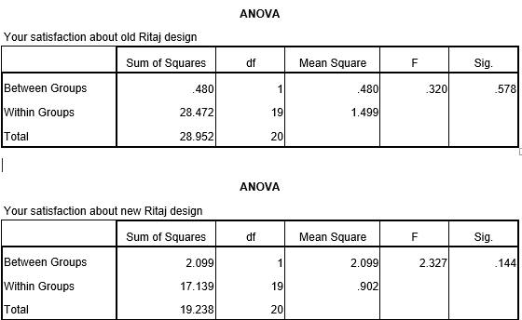

**CONCLUSION**

Conclusion After the study, we conclusion that the web page of ritaj site contains several problems and to fix these problems, or at least one of them we have created a new Web page for ritaj site to solve the existence problem witch is the large number of information and links displayed on the home page of the site and that caused several problems for students of psychological pressure and the difficulty of access to information in the site ritaj.

We have selected a sample of 21 students from the Faculty of Commerce, fourth year specialization business administration.

The way we used was questionnaires and interviews to gather the Data.

The research result was there is acceptance of the Birzeit University students to the new design of ritaj web page.