

Yusuf Ahmad Alghanim Library Website

A study about design problem in Yusuf Ahmad Alghanim Library Website

Faculty of Engineering and Technology Department of Computer Science

Ahmad Salah, Nidal Assi, Somoud Diab 1130083, 1132065, 1110708

**Abstract-** Our study centered on establishing alternative web page of Yusuf Ahmad Alghanim Library, which is a site used by student and employees in Birzeit university community to search about books, see new event and new book. - and see whether this idea will be accepted by Birzeit University students or not and will it be able to solve the problems in the Library web page. Through the study that we used two types of gathering data and made the calculations using SPSS program we were able to detect that there is acceptance by Birzeit university students to the new design of Yusuf Ahmad Alghanim Library web site.



*Figure 1 Yusuf Ahmad Alghanim Library Website logo*

**Introduction-** Yusuf Ahmad Alghanim Library site is a site used by Birzeit University students, but this site suffers from several problems, including the order in the site: every topic not order good, all the menu without border and attention, it must have colored because the user need a lot time to find items looking for, so that make student confusing, our idea

to improve the site by put Similar lists in subject matter must be arranged next to each other and Every menu must to be in border and color constant.

**Literature review-** For long complained of Birzeit University students from Yusuf Ahmad Alghanim Library page , that is the site have several problems and need amendments, when we have created an alternative web page of Yusuf Ahmad Alghanim Library site to solve one of these problems, we presented the new page on a sample of Commerce fourth-year students at Birzeit University that combines Business specialization and involves both male and female, and there number is 42 students, we have showed them the new page and made them answer questionnaires and we made a written interview with them.

**Research methodology-** We selected a sample of student’s which include students of the Faculty of Commerce fourth year specialization Business Administration males and females. And we show them the first design and the second design of Yusuf Ahmad Alghanim Library website.

# First design

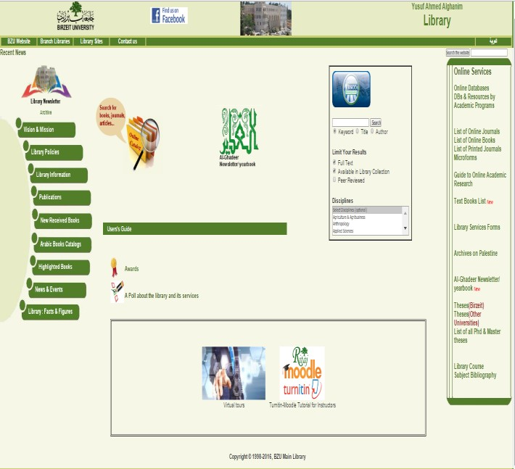

*Figure 2: First design of Yusuf Ahmad Alghanim Library Website*

# Second design

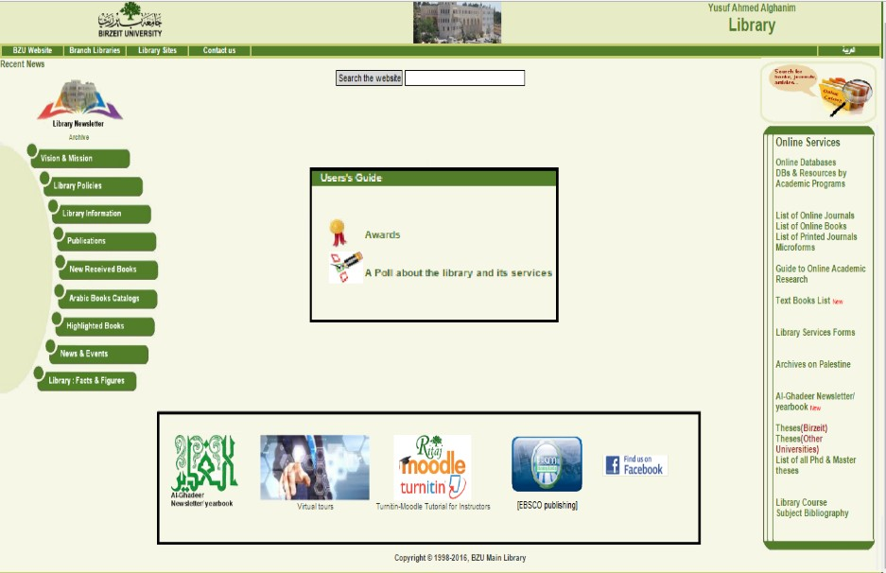

*Figure 3: Second design of Yusuf Ahmad Alghanim Library Website*

Thank you for using [www.freepdfconvert.com](http://www.freepdfconvert.com/) service!

Only two pages are converted. Please Sign Up to convert all pages. <https://www.freepdfconvert.com/membership>