## **Computer Science Department**

## **Second Semester 2017/2018**

## **Instructor: Mamoun Nawahdah**

## **Comp332 – Human Computer Interaction**

## **Final Project - Phase #1**

## **Team Leader: Maryam Shaheen #1140427**

## **Team Members: - Eman Ghazawneh #1152278**

## **- Sondos Sarraj #1140275**

## 

***Introduction to the problem***

*During our studying years, we faced problems with many applications and websites we were using. One of them is* ***MATLAB alternative Online Website (OCTAVE)*** *Link:* [*https://octave-online.net/*](https://octave-online.net/)

***What is OCTAVE?****Octave is one of the major free alternatives to MATLAB, It’s a software featuring a high-level programming language, primarily intended for numerical computations. Octave helps in solving linear and nonlinear problems numerically, and for performing other numerical experiments using a language that is mostly compatible with MATLAB. It may also be used as a batch-oriented language. Since it is part of the GNU Project, it is free software under the terms of the GNU General Public License. (Wikipedia)*

***The problem***

*The GUI is not following the standards of a good design nor an interactive design:*

*Not following the terms of a* ***usable product (eee):***

* *Not easy to learn*
* *Not effective to use*
* *Not enjoyable*

*Your first look to the screen will find nothing can help using the website, just a huge space with red and white colors.*

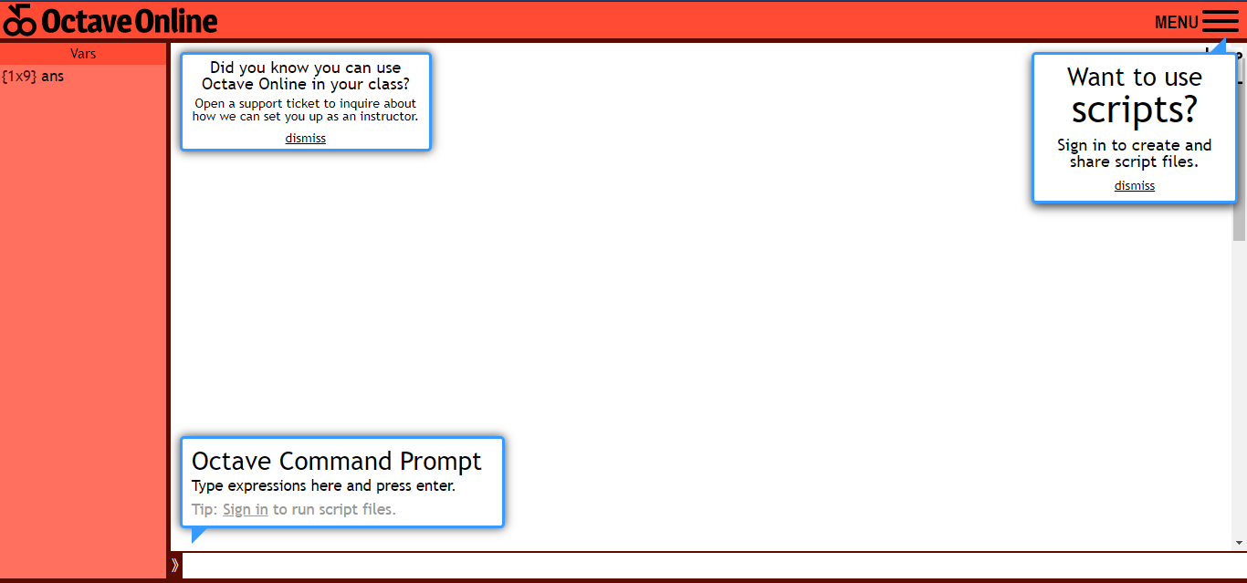

* *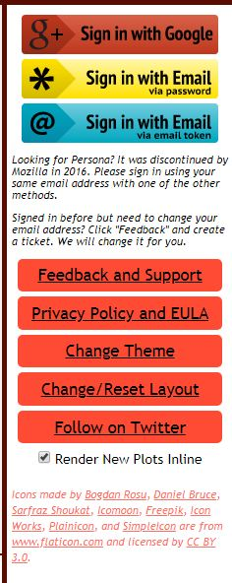No tips how to use it.*
* *No buttons for commands*
* *Hidden Functions :*

*- There is no list for the name of functions that you can use or need*

*- You can’t know how the syntax of the function is*

* *No Mapping for the menu*

*And after logging in with email, the interface changes to the following:*

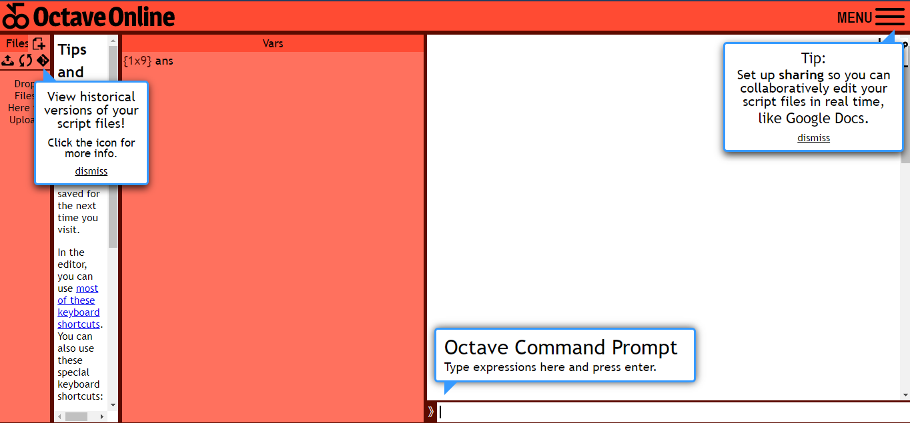

*More tips, but viewed in an annoying way…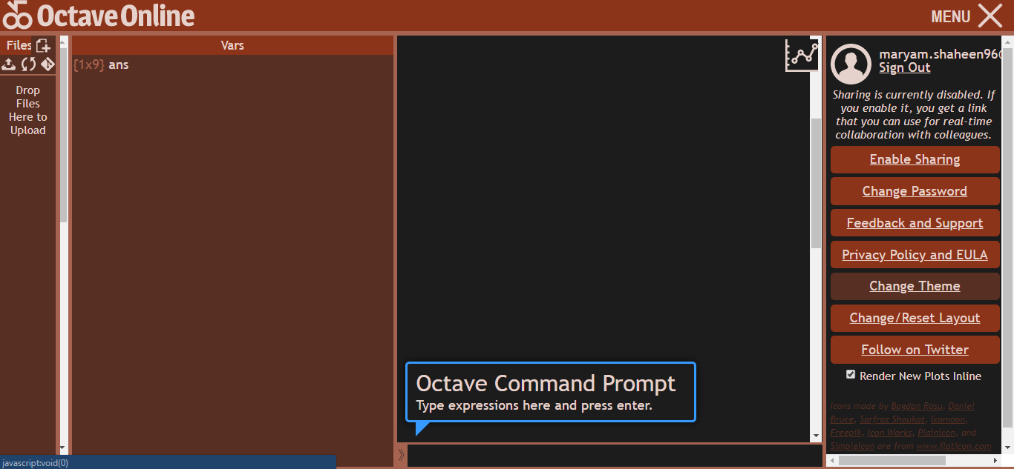*

*Oh look, user can change colors from bad to worse!*

***Conclusion:***

*1- Bad features   
2- Missing Conventional Menu   
3- Hidden Functions*

*4- No tips how to use*

*5- No buttons, submitting the code with Enter key on keyboard is something that is neither conventional nor clear to know that.*

*6- Bad Colors & GUI  
7- Not friendly to the user*

*8- Bad user experience (very confusing)*

*9- User should reload it many times*

*10- No mapping (ex. Menu, answer)*

***Cognition Reflection (from Cognitive Process)***

***1-Attention:***

*There is nothing can attract the user such as ( buttons, icons, colors ..) where it could lead him/her to use the system.*

***2- Perception and recognition:***

*There is few precognitive functionalities* ***after logging in the system only****, such as (Create file and upload file only).*

***3- Memory:***

*It’s hard for the user to memorize how to use the system again, and how to remember which functions to use.*

***4- Learning:***

*There is no clear source for learning how to write the syntax or use the system, therefore few of people can deal with it and try to learn how to use it from other resources. .*

***5- Reading, Speaking, and Listening.***

*-Readings: there are few instructions, that the user can read, but in our opinion, the notes are very basic and useless.  
-Speaking/ listening: there are no sounds/ voices*

***6- Problem- solving, planning, reasoning, and decision-making.***

*Problem-solving: Yes it solves numerical and non-numerical equations.  
Decision-making: the user can take decisions; there are no annoying or strict orders to do.*

***Persona***

