## **Computer Science Department**

## **Second Semester 2017/2018**

## **Instructor: Mamoun Nawahdah**

## **Comp332 – Human Computer Interaction**

## **Final Project - Phase #2**

## **Team Leader: Maryam Shaheen #1140427**

## **Team Members: Eman Ghazawneh #1152278**

## **Sondos Sarraj #1140275**

## 

***Abstract:*** *Our aim in this phase is to find a solution to the problem that was described in phase#1   
for reminding; our problem was the UX in the alternative program of MatLab (Octave Online) →* [*https://octave-online.net*](https://octave-online.net)

***Solution:***

*Our proposed solution is justified by the cognitive aspects, and emotional interaction aspects* ***only****.*

1. ***Cognition Reflection (from Cognitive Process)***

***1-Attention:****Our solution contains new colors, buttons, and icons; to attract the user.*

***2- Perception and recognition:****Our solution is to add more perception and**cognitive functions, in both cases (logged in/ not logged in).*

***3- Memory:****Our solution contains more common functions and buttons that most users are familiar with.*

***4- Learning:****Our solution will contain auto complete for the functions (as a clear learning resource), therefore users won’t face problems with learning how to use the system. Also we provided a new functions list that is added on the top left.*

***5- Reading, Speaking, and Listening.****-Readings: In our solution we added removable notes, and a reference link for tips that leads to another page, because in the old design, the notes were static, and annoying and patronizing.**-Speaking/ listening: our solution suggests adding action sounds, such as clicking on buttons sounds.*

***6- Problem-solving, planning, reasoning and decision-making.****No problem here, therefore; our solution doesn’t suggest any changes in these aspects.*

* ***Note:*** *the program we chose to redesign doesn’t need any Social Interaction.*

1. ***Emotional Interaction***

*In this section, let us tell you the emotional experience that most of numerical course student’s been through…*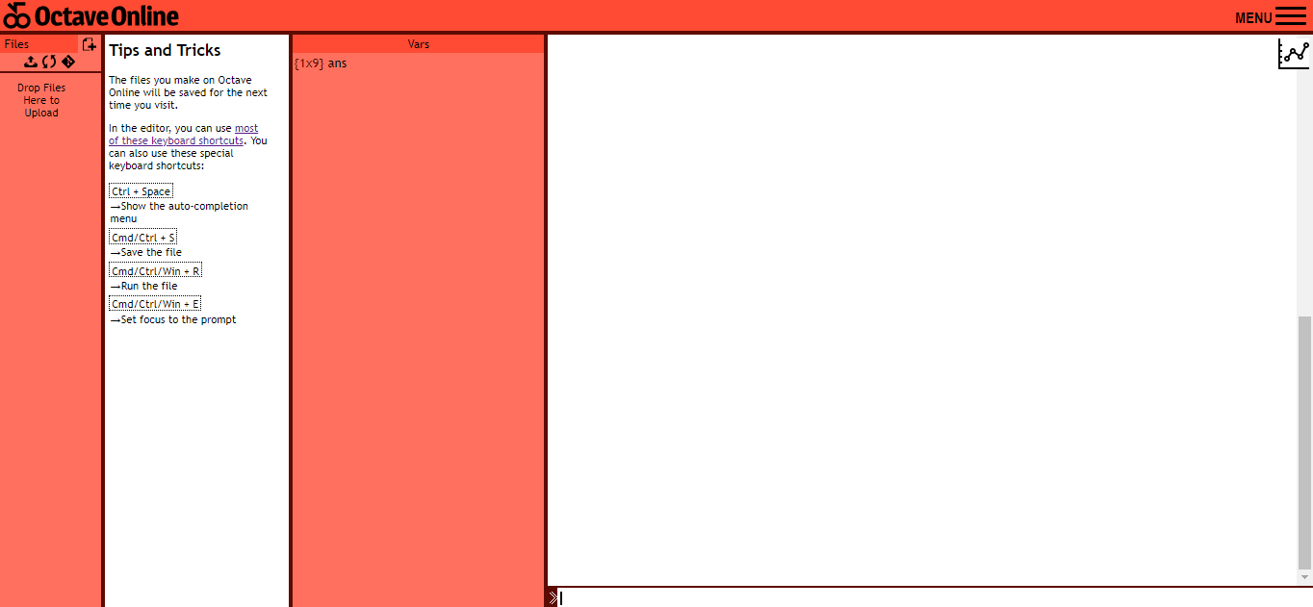

*First, the interface is unfamiliar to the users, therefore most of them felt uncomfortable to use it, so we* ***suggested*** *a more* ***common interface****. By changing columns locations and removing the static notes section.*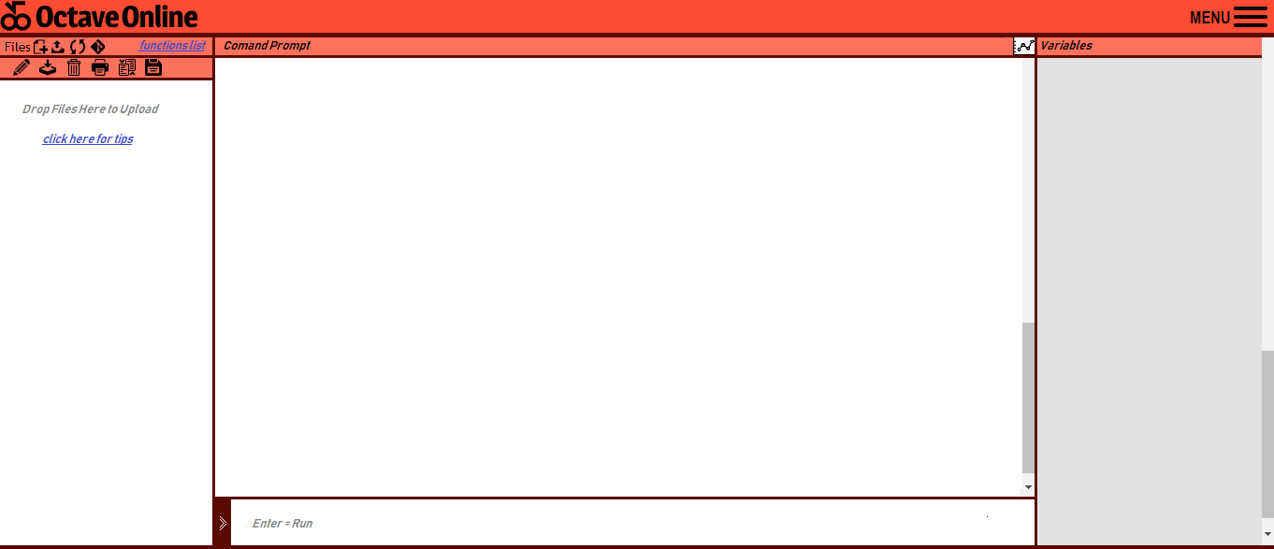

* *Command Prompt in center as most of coding programs.*
* *More functionalities in the toolbar with clear and familiar icons.*
* *Variables used in the program are to the left, and the word is fully written unlike the old version that was written as (Vars) only.*
* *Functions section is thicker now with bigger font, and a default text is added as an instruction of how to run the function that will be written.*

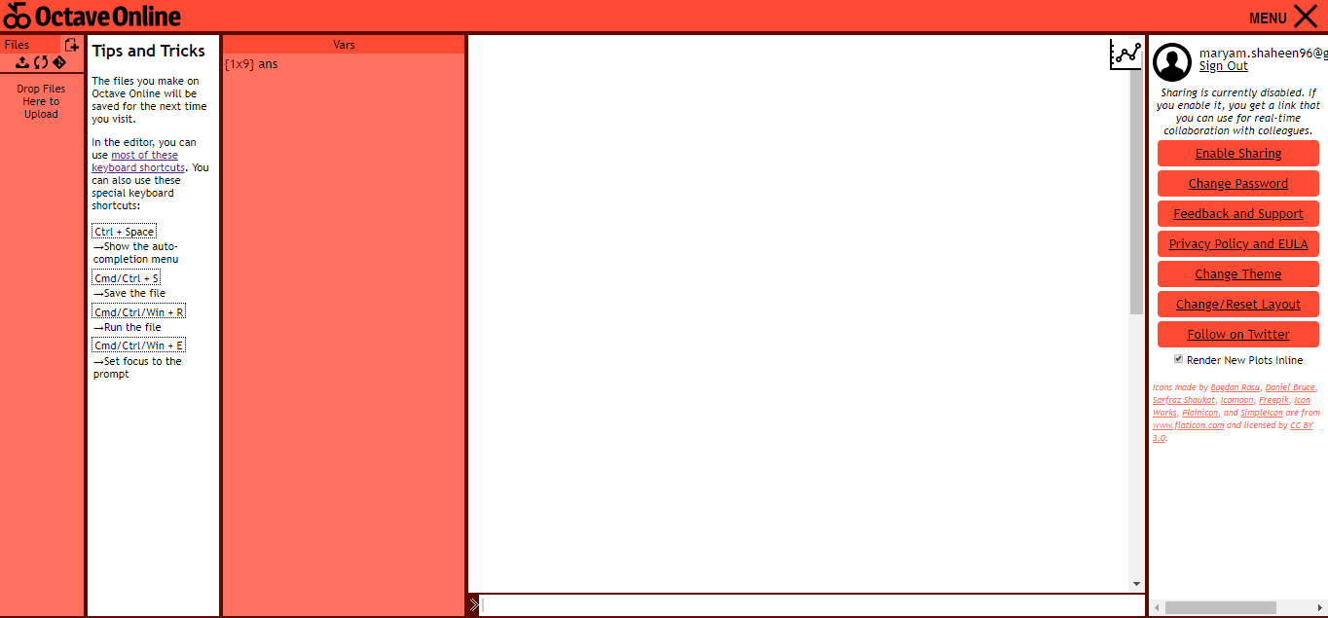

*The menu bar is not as how it was expected to be, and the users felt the most shock when they tried to change the theme because there is no clear clue of what is the other theme color would be, to find out the terrible color! As shown in the next two screenshots.*

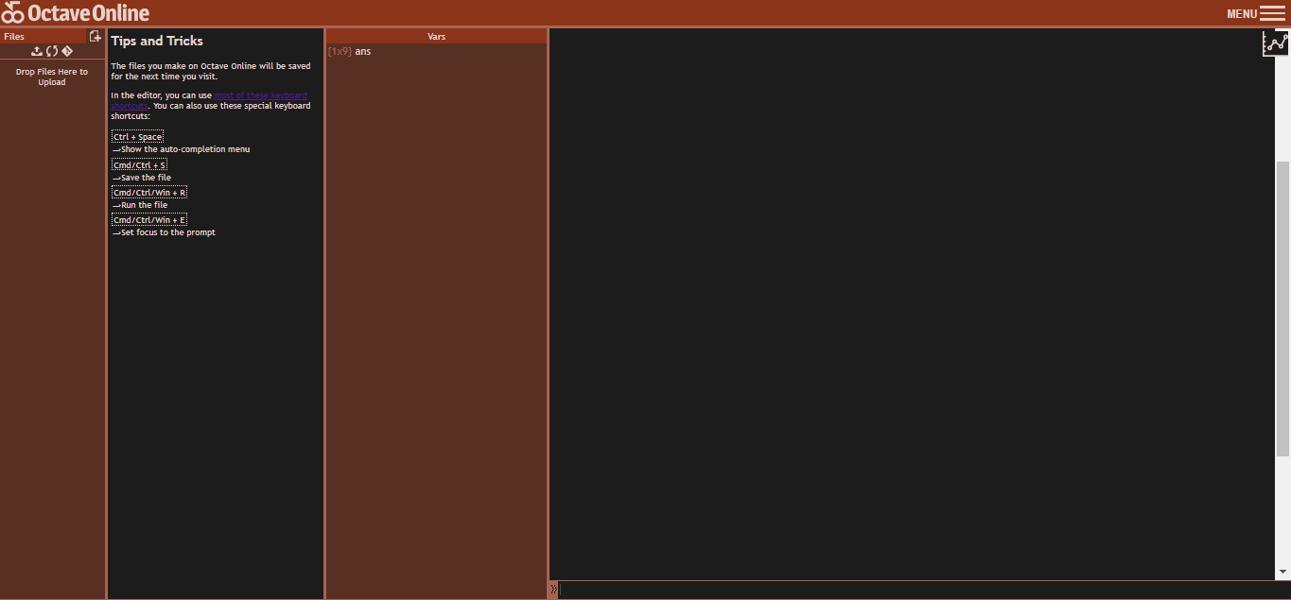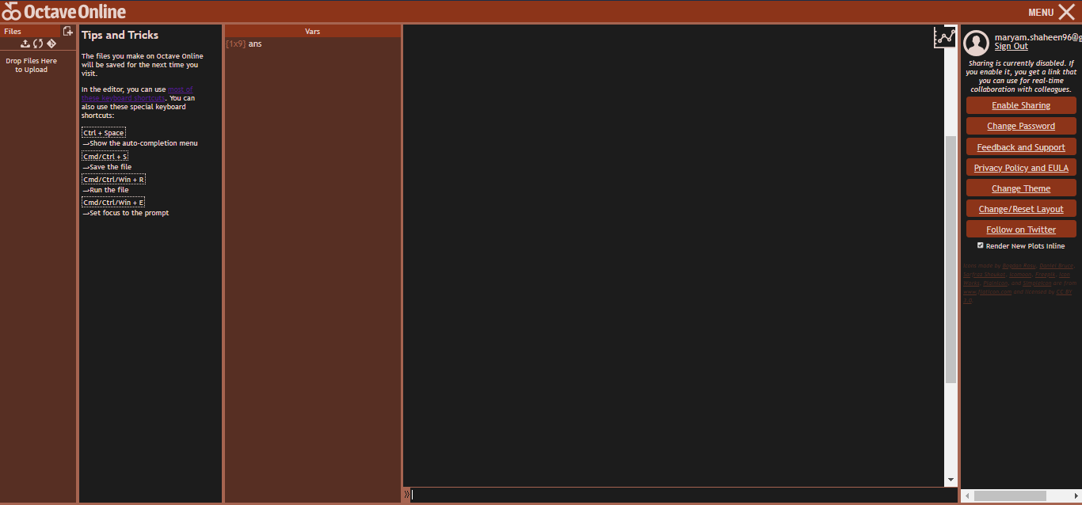

*So our solution suggests clear examples of how the theme colors could be, and more options to choose.*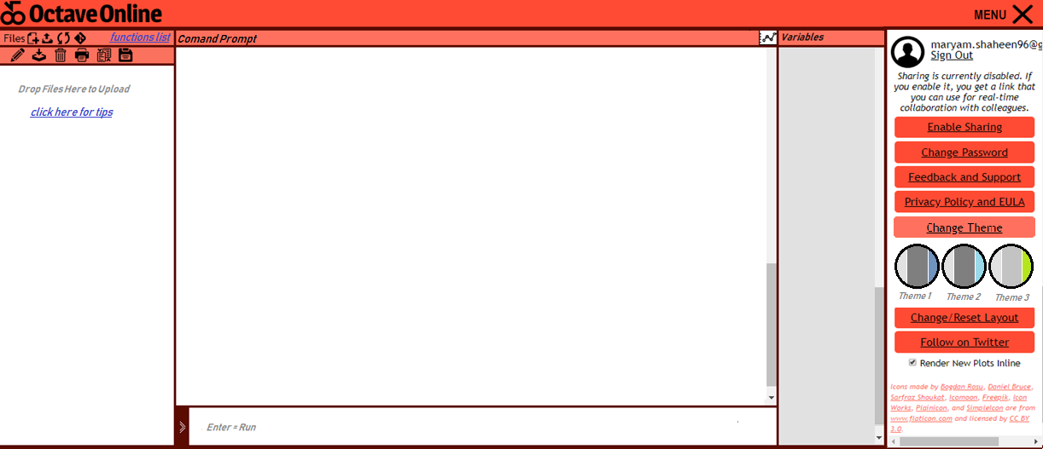

As an applicable example; we tried to change the theme color as theme 2, *As shown in the next two screenshots.*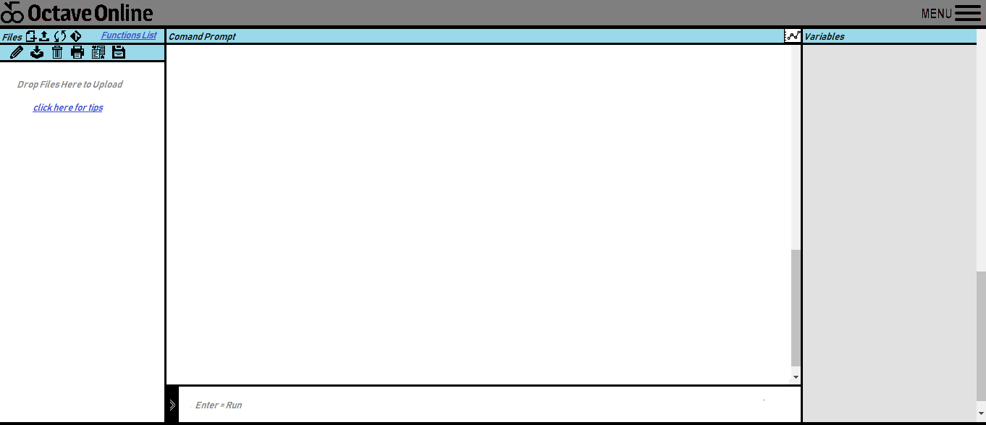

And we showed the option “to get back to the original color” in the theme options.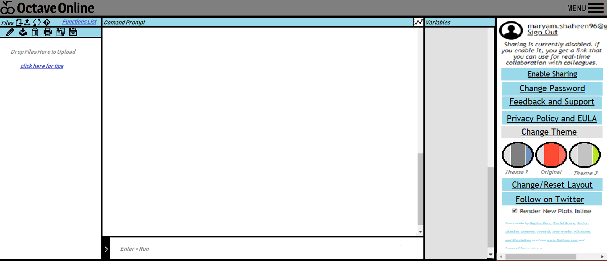

Note: The pictures are attached in the .rar file to make sure that you can see them clearly, also try to enter to the website through the link provided in the second page, and see your own UX with the old design.  
We hope our solution was covering the material you asked for.