

Faculty of Engineering and Technology   
Department of Computer Science

Comp332  
Human Computer Interaction

A study about design problem in Octave Online; the alternative of matLab Software in Birzeit University society

Maryam Shaheen, Student ID# 1140427  
Sondos Sarraj, Student ID# 1140275  
Eman Ghazawneh, Student ID# 1152278

Instructor: Dr. Mamoun Nawahdah

## 

## Table of Content

1. Abstract …………………………………………………………..………. 3
2. Introduction ………………………………………………………….… 4
3. Research methodology ………………………………….…….........7
4. Results ……………………………………………………………….…… 9
5. Conclusion …………………………………………………………..……10

Abstract~

*In Birzeit University,* students with majors in Engineering, Technology, and Science in general, take numerical and mathematical courses that require some calculations, and function invoking through a specific software that meant for that, *MatLab* software is the main software that was developed for these purposes, but the problem is that it’s not available for all students, since it takes time to download and activate, also it has licenses that not everyone can get, therefore some developers created an alternative online software (website) that can be used instead of MatLab, and its name is Octave *Online*, to be reachable any time and for all students/ teachers/ researchers… etc. And here is where the students started facing some bad designs and not good user experience; therefore we decided to make a study, which focuses on this alternative software’s design and colors.

And our *Null hypothesis* says:

There is no significant difference between Octave Online users over their subjective satisfaction in terms of the interface color.

*We used Microsoft office Excel data analysis tool for one-way ANOVA test.*

*And the results were, exactly as how we expected them to be, where we rejected our null hypothesis.*

Introduction~

*Octave Online* is a site used by scientific students from Birzeit University, but this site suffers from several problems, including the page sections and ordering in a non-usual way. The site doesn’t give any feedback or autocomplete for helping the user how to choose a function, there is no mapping between the menu elements, and it does not include sufficient information inside it, and in our opinion a studying website must have more information because the user can’t know where to go and what to do where it leads students to be confused, our idea is to provide a choice to change the interface color in order to attract users, and provide them a good experience, so they can use it comfortably .

Problem Statement~

Our problem points on the interface of the Octave website, that it was very frustrating and not understandable enough how to use.

We suggested many solutions but focused on *COLOR* in this research.

Suggested Solution~

Our proposed solution is justified by the cognitive aspects, and emotional interaction aspects, see next two pages..

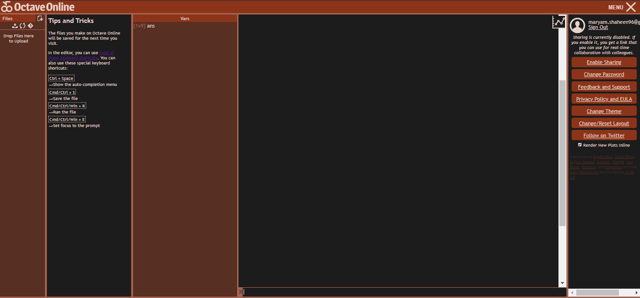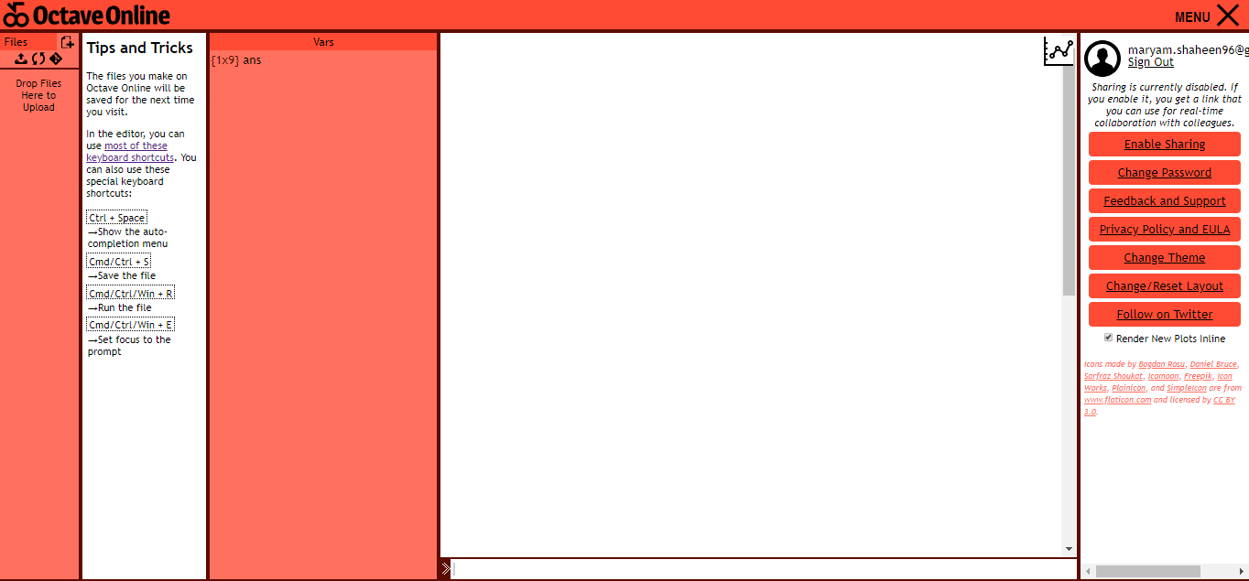

Design 1 (Original)

Design 2 (Original theme 2)

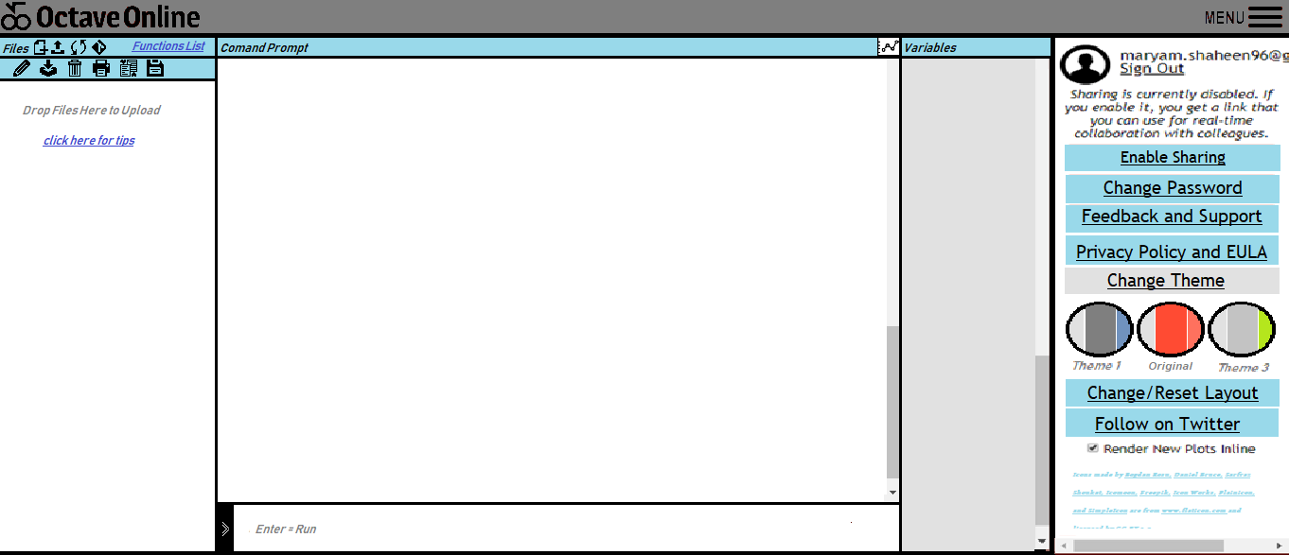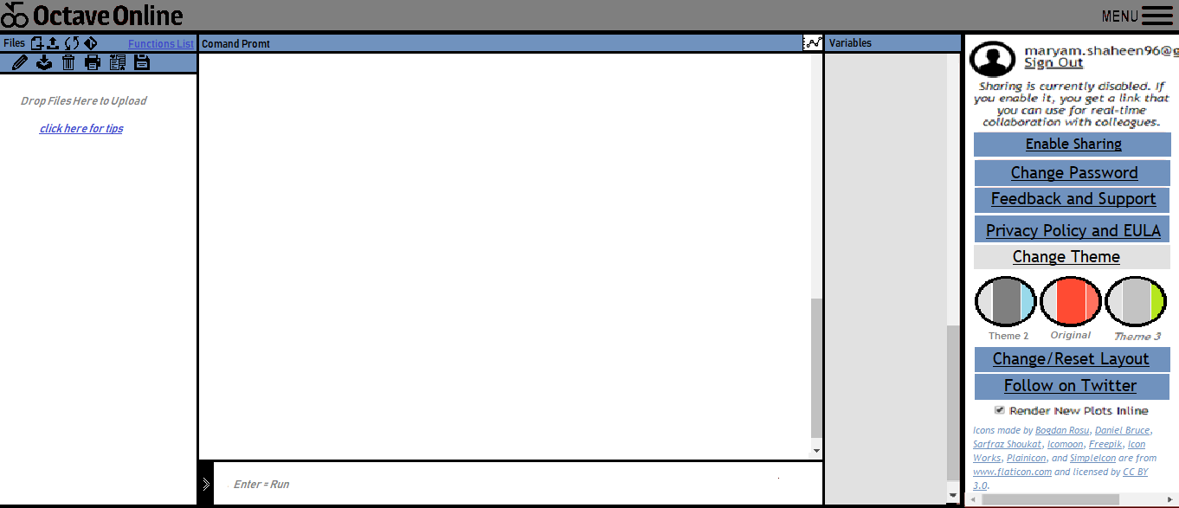

Design 3 (our design)

Design 4 (our design)

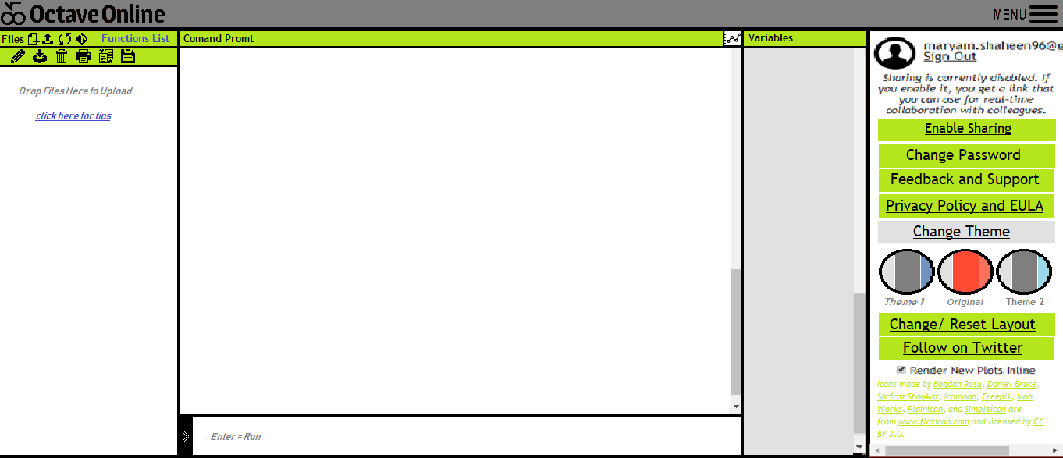

Design 5 (our design)

Research methodology~

We selected a sample of students with majors in Engineering, Technology, and Science in general, males and females, to fill a questioner that aims to see their satisfaction in terms of the colors of the alternative designs that we created.

A null hypothesis was set in the beginning that says:

There is no significant difference between Octave Online users over their subjective satisfaction in terms of the interface color.

Grouping: between groups

Independent variable(s): 1. Variable, (Color).

Condition(s): 5 conditions,

1. Desgin#1 (Original) 2. Theme#2 (Original Theme)

3. Theme #3. 4. Theme #4. 5. Theme #5.

Dependent variable(s): 1. Variable, (Subjective satisfaction).

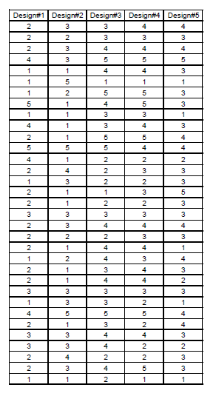Subjects: 33 subjects.

Data collection techniques: Questionnaire

Questionnaire questions:

How satisfy are you with this design in terms of its color?

Data analysis technique: One-way ANOVA test

Questionnaire in the link:

<https://goo.gl/forms/IiqkeMt5xKzAhiZS2>

After all these details, and data was collected as numbers that represents their satisfaction over five different colors, and we analyzed the data using Microsoft Excel data analysis tool, our test was the one way ANOVA, and the results are as shown below…

*Collected data are found on the left in figure1

Figure 1

Results~

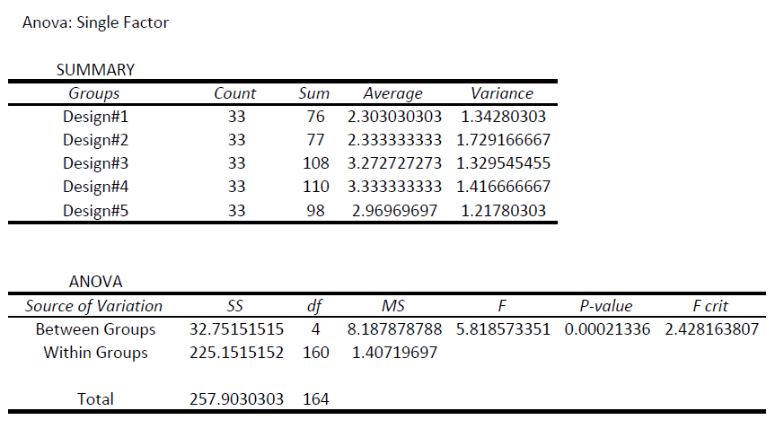Results by the Microsoft Excel data analysis tool are as following:

Box Plot:

Figure 4

Figure 3

Figure 2

Conclusion~

By comparing the P-value (0.00021) with alfa (0.05) we find that

P-Value is < less than alfa, therefore we say, that we have to reject the null hypothesis, which says: There is no significant difference between Octave Online users over their subjective satisfaction in terms of the interface color.

To conclude, that users actually were affected by the colors and the designs we provided as an alternative of the existing software.