

**Computer Science Department**

**Web Application and Technologies (COMP 334)**

**Second Semester 2015/2016**

**Assignment 1: HTML & CSS *Due Date 23/03/2016***

This assignment involves the creation of some HTML pages. You are forbidden to use any HTML editor for this assignment. You should do the entire thing by editing HTML files using a text editor.

**General Requirements**

All your web pages and CSS code must validate correctly and all your formatting should be done using CSS, either inline or as a separate file. You will lose marks for putting (too much) formatting into your HTML. In particular, you should avoid using anything other than the class, id, name, value, and href attributes. *All hyperlinks and references within your documents must be*

* General Cascading Style Sheets: You MUST apply **EXTERNAL** CSS where appropriate.

**Placement of Assignment Files**

You must submit your files to CS Host please see the instructions below. You should have a main directory that contains a file called index.html which contains links to the different parts of the assignment.

**The questions**

Description:

For the first part of the assignment, you will make a main web and subordinate web pages that convey some background information about you. In doing so, you will demonstrate your understanding of the following HTML constructs and features:

* Basic formatting
* CSS
* Images
* Lists
* Links
* Tables

These pages should have

* 1. A photograph for you and your address
  2. A brief biography that includes subsections on Education, Employment History and any other relevant information
  3. A list of awards and/or distinctions that you have earned.
  4. A list of places that you have visited/ or would you like to visit.

Each of the above items should be a level-1 heading and there should be a navigation bar that allows you to jump from the top of the page to any of these sections. All of this should be implemented in HTML/CSS *without using tables*. The design, layout and color scheme of the page is left up to you.

**Requirements:**

Create a home page using frames and linked documents to display the following information:

1. The **main page** should contain 3 frames called **"head"**, **"nav"** and **"disp", you must use <div> and csss to format this page**.  The header frame should extend horizontally across the top of the entire page.  The navigation frame and the display frames should run vertically below the header frame.  The navigation frame should be on the left side and be 15% of the width of the screen.  The display frame should consume the remainder of the screen.
2. The **header frame** should contain your name in a large font, A photograph for you and your address
3. The **navigation frame** should display links to the following pages.  When the links are activated, the selected page should become visible in the display frame.  The header and navigation frames should not change. The **navigation frame** should display links to the following pages.  When the links are activated, the selected page should become visible in the display frame.  The header and navigation frames should not change.
   1. Education
      * Name of the institute, the dates of entrance and leaving, the degree you have get, link to the institute webpage if available.
   2. Employment
      * Name of the institute, the dates of entrance and leaving, the position, link to the institute webpage if available.
   3. Awards
   4. Name of the award, when you have get it and what is the work you have done to get it. Link to the institute that support the award.
   5. Visited places
      * List of the places that you have visited, when, the main activity you have done. Provide at least one photo about the place. Which should be clickable, when you click on it it must take you to the place web page.
4. **Schedule:** The schedule page should display the your course schedule using a complex table. For those semester where you are not sure which classes you will be taking, make your best guess.
   1. There should be a title and brief description at the top of the page.
   2. The first row of the table should include the **column headings**.  The column headings should be bolded.
   3. The first column should show the **year** in the program (i.e. first year, second year).  Each year row should span all the semester and course rows.
   4. The second column should indicate the **semester** (1st, 2nd, summer).  Each semester row should span the course rows included in the semester.
   5. The third column is the **course id** column.  Each entry in this column should display the course number (e.g. COMP230).
   6. The fourth column should contain the **course title** (e.g. Computer and Programming).
   7. The last column should display the number of **credit hours** for each course.
   8. At the bottom of the table should be a **total row** showing the total credits required for the program.  The word "Total" should span the first four columns.  The total value should appear in the credits column.
5. The **display frame** should be used to display the results of the links chosen from the navigation frame.  Upon initial load, this frame may be blank.

**CSS Requirements:**

The following **formatting** conditions must be met:

* **Common formatting**
  + All the HTML files should depict a consistent presentation format. The following conditions apply to all pages.
  + The text used in headers should be within the same general font family (i.e. Serif or Sans-Serif). Header text should use a consistent color scheme.
  + The text used in paragraphs and in other non-heading areas should use a font family that is different than that used by the header text.
  + When using any of the <bold>, <strong> or <em> elements for inline formatting, one or more of the default formatting characteristics must overridden using CSS rules.
  + All fonts should use relative size units. Borders, margins and padding may use either relative or fixed size units as appropriate.
  + All clickable images should be surrounded by Green border, Blue when hovering.
  + All visited links should be Yellow.
* **Header section**
  + Your name should be displayed in a reverse color scheme from the other headers in the other web pages (e.g. white on a dark background).
* **Navigation section**
  + The links in the navigation page should use large margins and/or padding to simulate the look and feel of navigation buttons.
  + There should be no underline on the link text.
  + The link text colors should remain the same before and after visiting the link.
  + The colors of the link should reverse when the cursor hovers over the link text.
  + In the work experience section you should highlight the text of your job title.
  + The list used in the education section should be displayed without any kind of bullet symbol. And the text of the university name should be highlighted in some fashion.
  + The section that describes the activities you have done in the visited city should be use a special font, color and background color to make the section stand out.
* **Schedule**
  + The header rows should use a light colored text on a dark background.
  + The header columns and the footer row should use a bold font in the normal color scheme.
  + The text in a data cells should use a font that is unique to the table.
  + The Course ID and Course Title for your current courses should use a CSS class called **current** and be displayed in a highlight color and normal background color.

Dear Class

In coordination with the computer center, a web server has been set up for you to host your project on, it is called cshost. Every one of you has an account, the server url is studentswebprojects.ritaj.ps YOUR domain is web-yourID-.studentswebprojects.ritaj.ps for example if your ID is 112233 then your domain is web112233.studentswebprojects.ritaj.ps

your username is web-yourID-.studentswebprojects.ritaj.ps , for the example above the user name is web112233.studentswebprojects.ritaj.ps

password is web-yourID.

Password is web112233

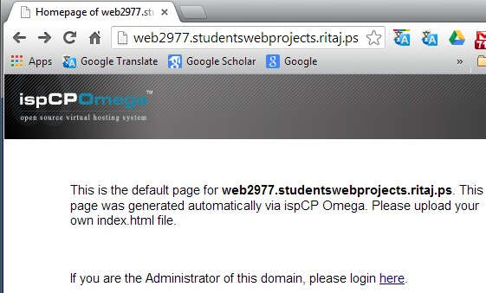

Type your domain at the address bar

Click here to setup your account