

**Computer Science Department**

**Second Semester 2017/2018**

**Instructor: Abdallah karakra**

**Comp334 – WEB APPLICATION AND TECHNOLOGY**

**HomeWork#1**

**Name: Maryam Shaheen**

**ID#: 1140427**

Represent and clarify each of the following:

<a> it’s a tag that defines a hyperlink, which is used to link from one page to another.  
The most important attribute of the **<a>** element is the **href** attribute, which indicates the link's destination.

**Example:**

**Code:**

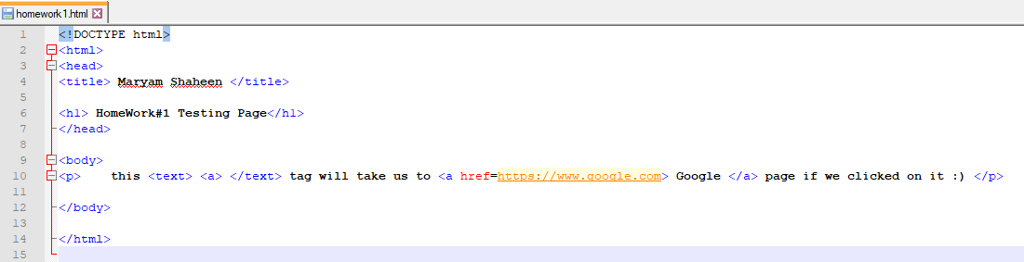

**How it Look Like:**

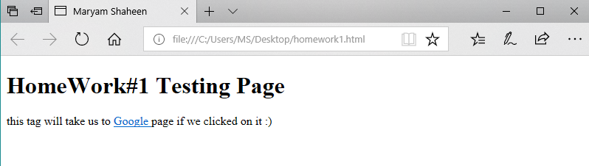

<b> this is a text formatting tag that makes it **Bold text**

**Example:**

**Code:**

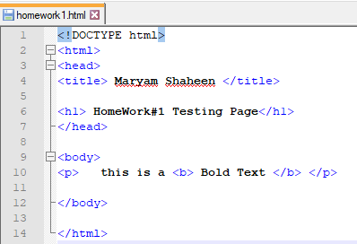

**How it looks like:**

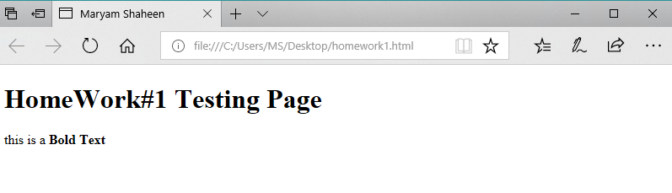

<br> this tag inserts a single line break.

And the **<br>** tag is an empty tag which means that it has no end tag.

**Example:**

**Code:**

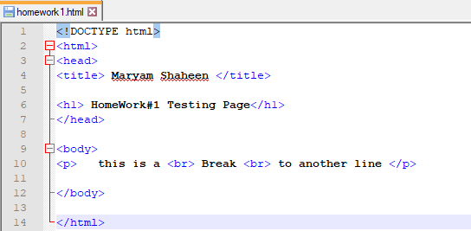

**How it looks like:**

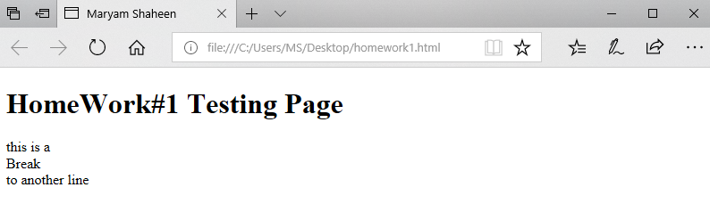

<cite> this tag defines the title of a work (e.g. a book, a song, a movie, a TV show, a painting, a sculpture, etc.).

**Example:**

**Code:**

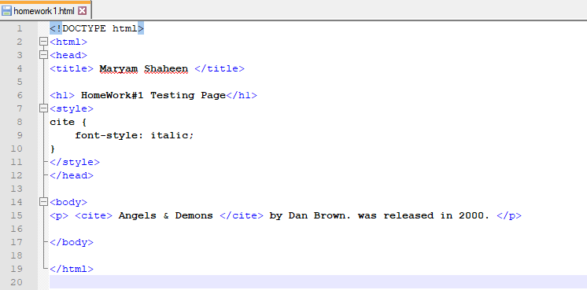

**How it looks like:**

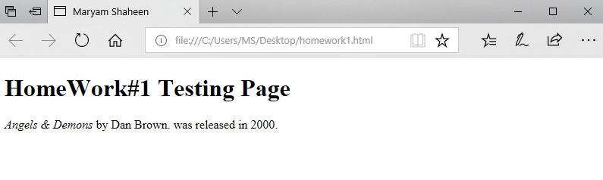

<code> this tag is a phrase tag. It defines a piece of computer code.

**Example:**

**Code:**

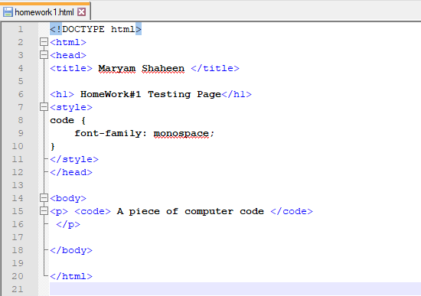

**How it looks like:**

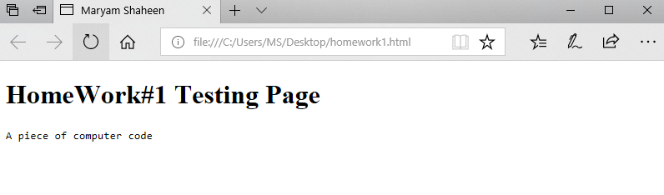

<em> this tag is a phrase tag. It renders as emphasized text.

**Example:**

**Code:**

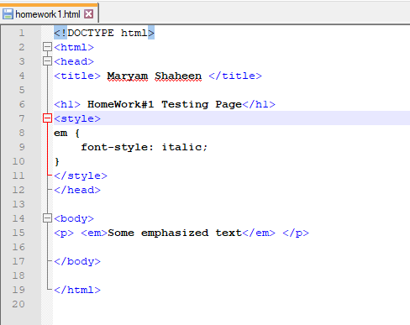

**How it looks like:**

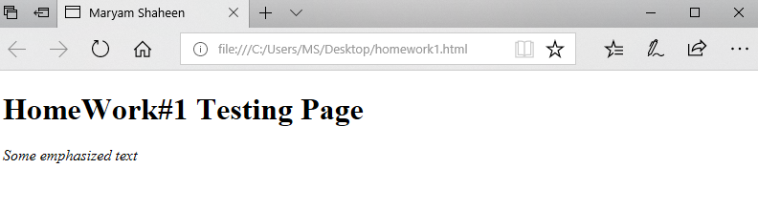

<mark> this tag defines marked text.

**Example:**

**Code:**

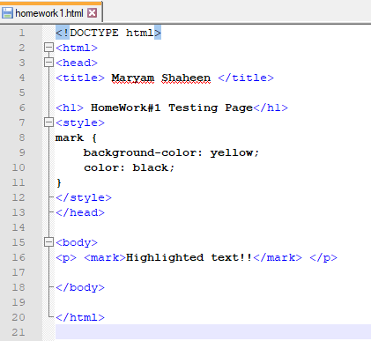

**How it looks like:**

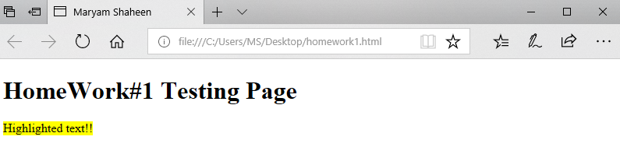

<small> this tag defines smaller text (and other side comments).

**Example:**

**Code:**

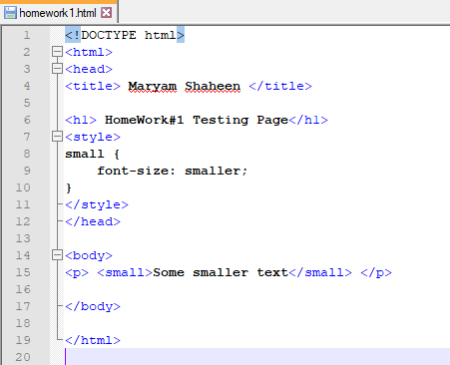

**How it looks like:**

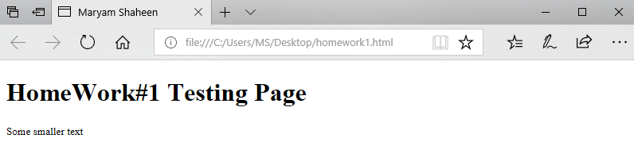

<span> this tag is used to group inline-elements in a document, And provides no visual change by itself, Also provides a way to add a hook to a part of a text or a part of a document.

**Example:**

**Code:**

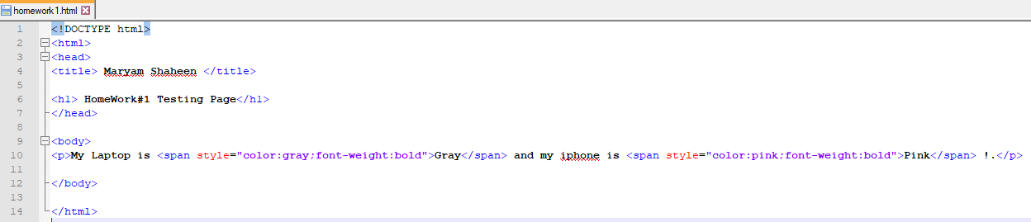

**How it looks like:**

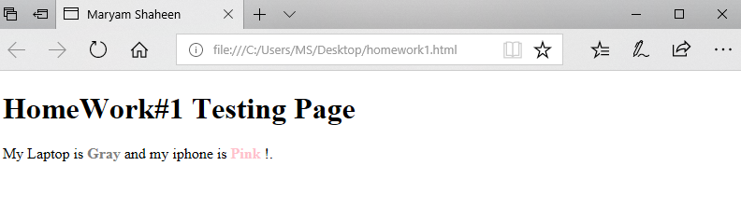

<strong> this tag is a phrase tag. It defines important text.

**Example:**

**Code:**

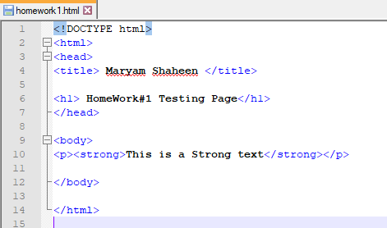

**How it looks like:**

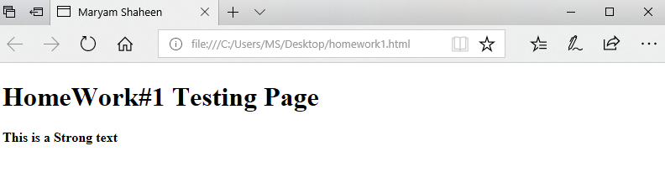

<time> this tag defines a human-readable date/time.  
Also this element can also be used to encode dates and times in a machine-readable way so that user agents can offer to add birthday reminders or scheduled events to the user's calendar, and search engines can produce smarter search results.

**Example:**

**Code:**

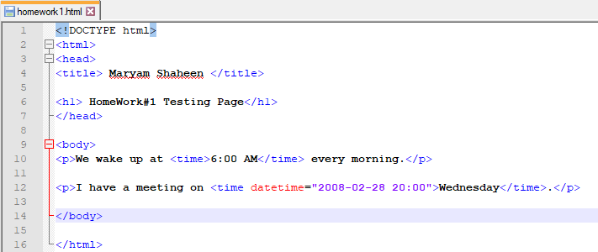

**How it looks like:**

