**[WEB APPLICATION AND TECHNOLOGY](http://comp334.studentswebprojects.ritaj.ps/index.html" \o "BZU)**

**Student manual**

Contents

Open your account and change your password 3

FTP User 4

FileZilla 5

# Open your account and change your password

Every one of you has an account, the server url is [studentswebprojects.ritaj.ps](http://www.studentswebprojects.ritaj.ps) your **domain** is [web-yourID-.studentswebprojects.ritaj.ps](http://www.web-yourID-.studentswebprojects.ritaj.ps) , your **username** is web-yourID-.studentswebprojects.ritaj.ps and your **password** is web-yourID .

**Ex**: If your ID is 8888888 then:

|  |  |
| --- | --- |
| Domain | [web8888888.studentswebprojects.ritaj.ps](http://www.web8888888.studentswebprojects.ritaj.ps) |
| Username | web88888888.studentswebprojects.ritaj.ps |
| Password | web8888888 |

At first try to log to your account through <http://admin.studentswebprojects.ritaj.ps3> and enter your username and your password as shown in the following screen capture:

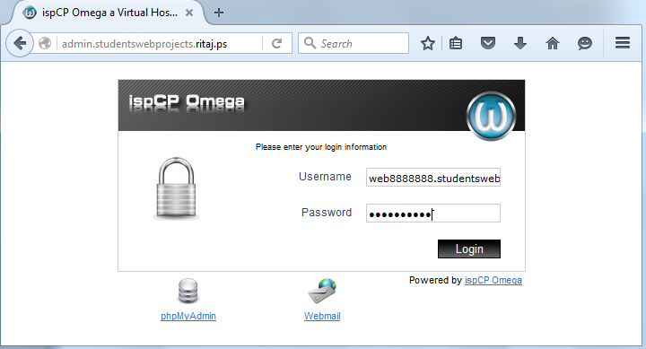

After that your account was accessed successfully, you should change your password through **Change password** as shown in the following screen capture:

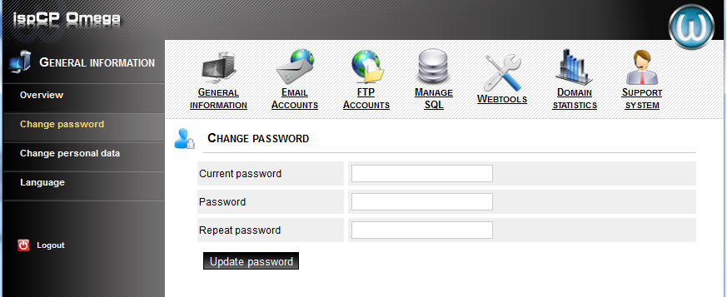

# FTP User

To be enable the transfer of files with a host computer by using FTP services, you should **Add FTP user** from **FTP Accounts**

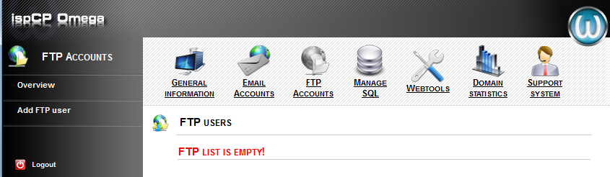

Fill the required field as the following:

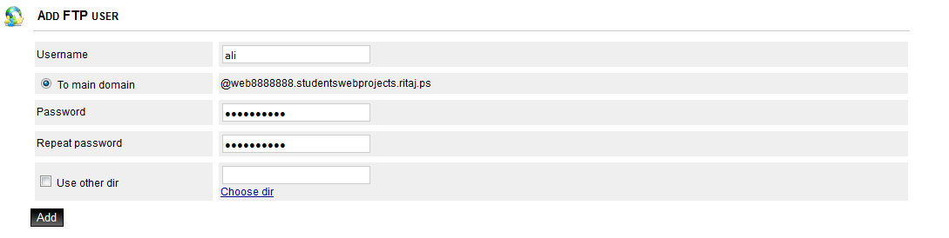

# FileZilla

To get your hands on your website files remotely is far from complicated you can use **FileZilla** ([Download From Here](https://filezilla-project.org/download.php?type=client)), after download, install and open it, let us connect to your ftp account using FileZilla.

At First, set your FTP connection:

1. Go to **Edit** > **Settings**

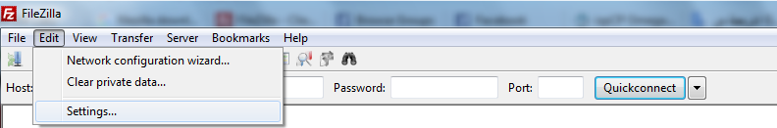

1. Change **Transfer Mode** from **Passive** to **Active**

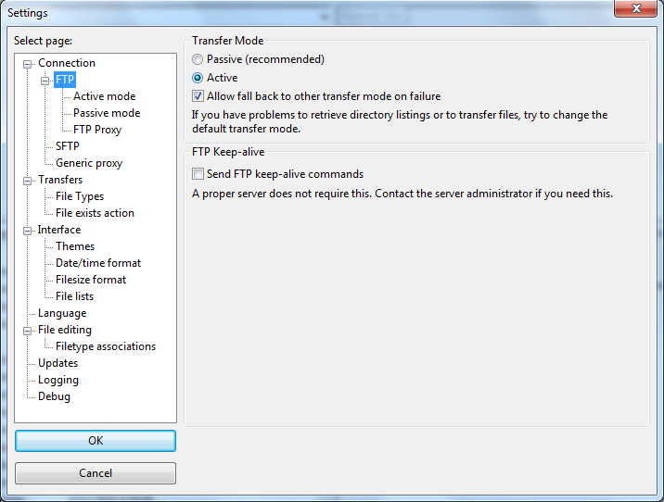

Secondly, connect to FTP account by fill **Host**, **Username** and **Password** then click **Quickconnect** as the following table:

|  |  |
| --- | --- |
| Host | Your domain |
| Username | Your FTP user Username @ Your domain |
| Password | Your FTP user Password |

For more detail see the following screen capture:



Now, you can initiate the file transfer simply by dragging and dropping the required files to the correct location. To upload to the server, you would drag files from your computer and drop them in the **remote site** pane.

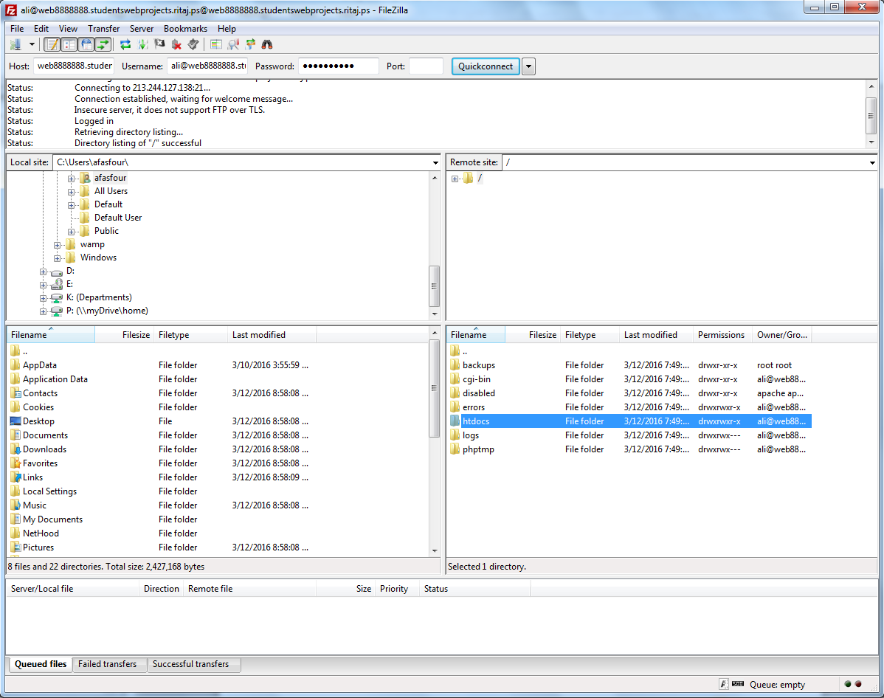

**remote site pane**: You use this pane to browse to the location you wish to upload files to, or alternatively to where the files you wish to download are located. If you are using FTP to upload your web page files then ensure you are uploading to the [public_html] folder before uploading your web pages.

Let us upload first file by FileZilla:

1. I create new HTML file and give it name “**index.html**” and contain the following script:

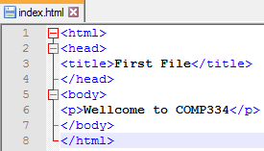

1. Drag “index.html” file and drop into **htdocs** folder as shown in the following screen capture:

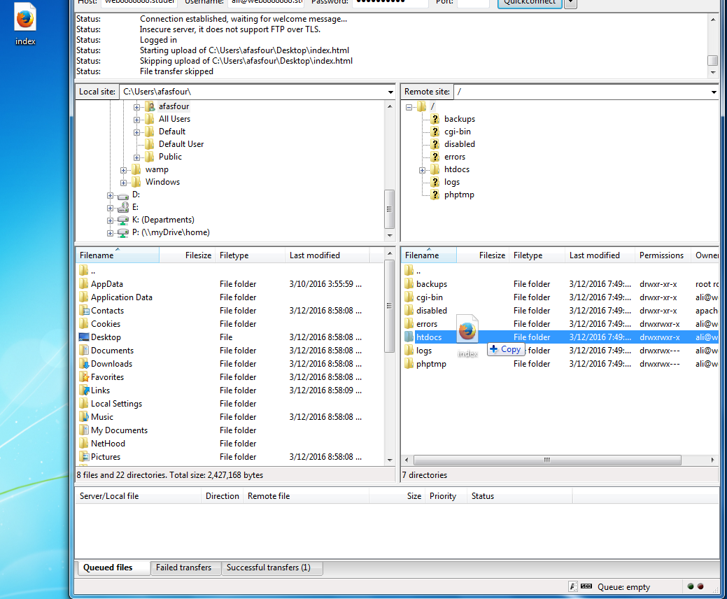

1. Now open your domain through Web browser, you can see your uploaded file, as shown in the following figure:

