

**Experiment.No.4**

**Digital Circuit Implements Using Breadboard**

**Student’s names: Ahmad Salah**

**Student’s id’s: 1130083**

**1) Table of content:**

|  |  |
| --- | --- |
| **Page Number** | **Description** |
| **1** | **Cover page** |
| **2** | **Table of content** |
| **3** | **Abstract** |
| **4** | **Theory** |
| **6** | **Procedure** |
| **13** | **Conclusion** |

**2) Abstract:**

**In This Experiment We will use New Things Like Breadboard and we will use it to implement basic logic gates using its chips , and building digital circuit using a digital design kit , and we will use IC Tester to check the chip Work good or not .**

**3) Theory:**

**3.1) AND logic gate:**

**The AND gate performs a logical multiplication, thus, the output is high when both the inputs are high, and the output is low when any or both of the outputs are low.**

**[ 1 && 1 🡪 1 : (otherwise) 0 ]**

**3.2) OR logic gate:**

**The OR gate performs an addition, thus, the output is high when any one of the inputs is high, and the output is low level when both the inputs are low.**

**[ 0 || 0 🡪 0 : (otherwise) 1 ]**

**3.3) NOT logic gate:**

**The NOT gate is called an inverter, that’s because the output is high when the input is low, and the output is low when the input is high.**

**[ 0 🡪 1 , 1 🡪 0]**

**3.4) NAND logic gate:**

**The NAND gate performs NOT gate after AND gate, thus, the output is low when both of the inputs are high, and the output is high when any or both of the inputs are high.**

**[ !(1 & 1) 🡪 0 : (otherwise) 1 ]**

**3.5) NOR logic gate:**

**The NOR gate performs NOT gate after OR gate, thus, the output is low when any one of the inputs is high, and the output is high when both the inputs are low.**

**[ 0 || 0 🡪 1 : (otherwise) 0 ]**

**3.6) XOR logic gate:**

**The XOR gate is exclusive OR gate where the output is high if and only if one of the two inputs is high, otherwise, the input is low, if there is more than two inputs, the output is high when the number of inputs with high level is odd.**

**[ 1 XOR 0 🡪 1 : (otherwise) 0 ]**

**4) procedure:**

**All the logic gates can be implemented on the breadboard, and in order for the gates to work it should be connected to ground and it should be connected to a power source, in this experiment the power source that is used is +5V, all the chips that we are using have inputs and outputs, if the inputs is connected in the place of the outputs, the chi would be destroyed.**

**4.1) AND logic gate:**

**In 7408 chip which is AND Logic gate , there are four And basic gates, each one has 2 inputs and one output .**

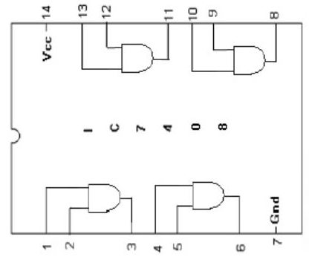

**AND Chip 7408**

|  |  |  |  |
| --- | --- | --- | --- |
| **Input1** | **Input2** |  | **Output** |
| **0** | **0** | **0** |
| **0** | **1** | **0** |
| **1** | **0** | **0** |
| **1** | **1** | **1** |

**AND logic truth table**

**4.2) OR logic gate:**

**In 7432 chip which is OR Logic gate , there are four Or basic gates, each one has 2 inputs and one output .**

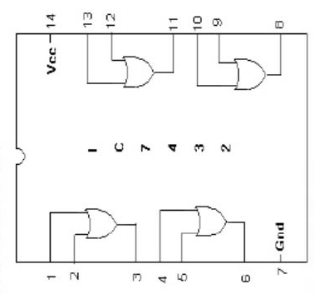

**OR chip 7432**

|  |  |  |  |
| --- | --- | --- | --- |
| **Input1** | **Input2** |  | **Output** |
| **0** | **0** | **0** |
| **0** | **1** | **1** |
| **1** | **0** | **1** |
| **1** | **1** | **1** |

**OR logic truth table**

**4.3) NOT logic gate:**

**In 7404 chip which is Invertor Logic gate , there are six not basic gates, each one has 1 input and one output .**

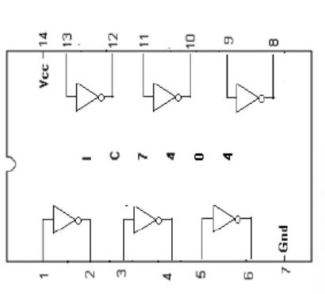

**NOT chip 7404**

|  |  |  |
| --- | --- | --- |
| **Input1** |  | **output** |
| **0** | **1** |
| **1** | **0** |

**NOT logic truth table**

**4.4) NAND logic gate:**

**In 7400 chip which is NAND Logic gate , there are four NAND basic gates, each one has 2 inputs and one output .**

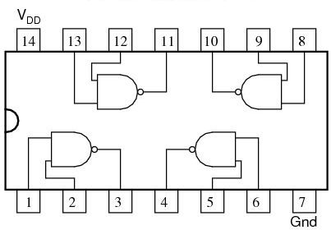

**NAN chip 7400**

|  |  |  |  |
| --- | --- | --- | --- |
| **Input1** | **Input2** |  | **Output** |
| **0** | **0** | **1** |
| **0** | **1** | **1** |
| **1** | **0** | **1** |
| **1** | **1** | **0** |

**NAND logic truth table**

**4.5) NOR logic gate:**

**In 7402 chip which is NOR Logic gate , there are four Nor basic gates, each one has 2 inputs and one output .**

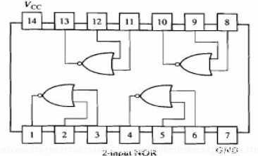

**NOR chip 7402**

|  |  |  |  |
| --- | --- | --- | --- |
| **Input1** | **Input2** |  | **Output** |
| **0** | **0** | **1** |
| **0** | **1** | **0** |
| **1** | **0** | **0** |
| **1** | **1** | **0** |

**NOR truth table**

**4.6) XOR logic gate:**

**In 7486 chip which is XOR Logic gate , there are four XOR basic gates, each one has 2 inputs and one output .**

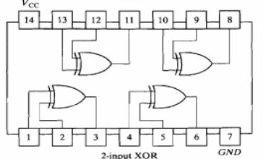

**XOR chip 7486**

|  |  |  |  |
| --- | --- | --- | --- |
| **Input1** | **Input2** |  | **Output** |
| **0** | **0** | **0** |
| **0** | **1** | **1** |
| **1** | **0** | **1** |
| **1** | **1** | **0** |

**XOR logic truth table**

**4.7) 2 to 4 Decoder:**

**This decoder converts each output to other output where every input has its special output, and this one gives one active digit for each value.**

|  |  |  |  |  |  |  |
| --- | --- | --- | --- | --- | --- | --- |
| **B** | **A** |  | **F1** | **F2** | **F3** | **F4** |
| **0** | **0** | **0** | **1** | **1** | **1** |
| **0** | **1** | **1** | **0** | **1** | **1** |
| **1** | **0** | **1** | **1** | **0** | **1** |
| **1** | **1** | **1** | **1** | **1** | **0** |

**2 to 4 Decoder truth table**

**5) Conclusion:**

**The implementation of all the gates, encoder, multiplexer, and full-adder on breadboard gave us the chance to learn exactly how it works, and where the inputs get in from and where the outputs get out from, so the work on breadboard was extremely hard and we faced a lot of troubles to during implementing these stuff. One of the problems, that the chip that we were using was broken so the output was wrong, what lead us to rebuild the full-adder, and other trouble with the wires, that we don’t have suitable wires for the experiment that we had to attach wires with cables so we can connect then to the device.**