

**Experiment.No.6**

**Sequential Logic Circuits using Breadboard and IC’s**

**Student’s names: Ahmad Salah**

**Student’s id’s: 1130083**

**1) Table of content:**

|  |  |
| --- | --- |
| **Page Number** | **Description** |
| **1** | **Cover page** |
| **2** | **Table of content** |
| **3** | **Abstract** |
| **4** | **Theory** |
| **6** | **Procedure** |
| **10** | **Tasks** |
| **13** | **Conclusion** |

**2) Abstract:**

**This experiment talks about decoder and its connection to BCD counters, the BCD counter is being used in almost every counter that counts from 0-9, that’s because it resets automatically to 0 after it reaches 9. To implement this BCD counter a digital display, 7 resistors, decoder, and BCD counter will be used, and that’s by connecting the outputs of the counter and make them as inputs for the decoder, first we will check that the digital display is working right by connecting only the decoder, taking in consideration that LT is connected to ground, and RBI, BI are connected to 5+V, so we can check all the 7 segments.**

**3)Theory:**

**3.1) Seven-Segment Display:**

**The Seven-Segment Display is used to show the result of chips that are connected to it, in this experiment it will be connected to decoder, which has LT pin and RBI pin and RBO(BI) pin, each pin has its own function:-**

**LT is an active low pin, also called lamp-test feature it used for checking if the 7 segments are working perfect and all should be turned on, if we put LT high then it will be used for normal operation.**

**RBI is an active low pin, also called a ripple blanking input. It used for hiding the 0 output, but if its high then it will show the 0 output on display.**

**RBO(BI) : (Bi)is an active low pin ,also called a blanking input, can be used as input to turn off all segments, (RBO) is an active low pin , also called ripple blanking output , we use it with RPI when it activated and the input of DCBA is 0000 , this allow us to drive the input to another 7 segment display**

**3.2)** **Implementing one decade counter:**

**The 7490 is a decade counter, meaning it is able to count from 0 to 9 cyclically, and that is its natural mode. That is, QA, QB, QC and QD are 4 bits in a binary number, and these pins cycle through 0 to 9**

**4) Procedure:**

**4.1.1) Testing lamps in the display:**

**To build this structure we used decoder (7447 chip) and a digital display, both of them should be placed on the breadboard, then we connected them using 7 resistors, a-a, b-b, c-c, …etc, after that we connected the third pin from each side of the lamp to the ground, then we connected pin 4(BI) and pin 5(RBI) to +5V, and pin 3(LT) to ground, as the design shows below, this structure makes the 7 segments turned on.**

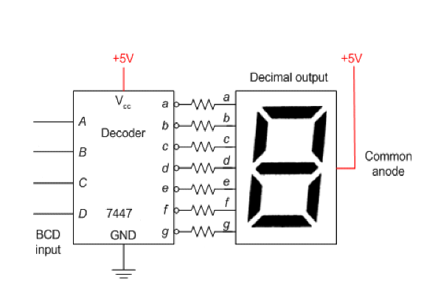

**4.1.2) Blanking all segments:**

**To blank the 7 segments we connected pin 4(BI) to ground, after that we connected pins (1,2,6,7) which represent inputs for the decoder to the switches, by changing the switches the number on the digital display, but because the decoder is active low, the number is shown by the low switches.**

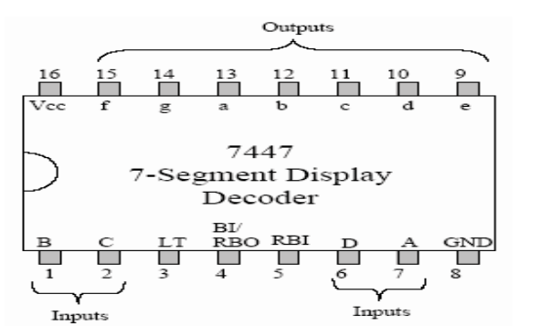

**4.2)** **Implementing one decade counter:**

**To implement this counter (7490 chip) we kept the same previous structure but we disconnected the inputs from the switches and connected them to the counter, each pin connected with one pin from the outputs of the counter chip, QA to A, QB TO B, and so on, then we connected clock to the input A in the counter “as it shown below”, and the output from the first flip flop is connected to the input B so the counter works as ripple counter. With every clock pulse it adds one to the output, which is shown on the digital display. And to make the chip works as counter we connected R0(2) and R9(2) to low and we kept the others disconnected because the value of any of them doesn’t matter.**

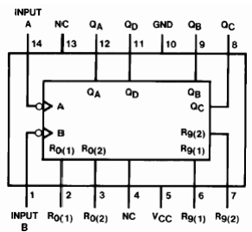

|  |  |  |
| --- | --- | --- |
| **J** |  | **D1** |
| **C:\Users\User\Desktop\Capture.PNG** | **0** |
| **C:\Users\User\Desktop\Capture.PNG** | **1** |
| **C:\Users\User\Desktop\Capture.PNG** | **2** |
| **C:\Users\User\Desktop\Capture.PNG** | **3** |
| **C:\Users\User\Desktop\Capture.PNG** | **4** |
| **C:\Users\User\Desktop\Capture.PNG** | **5** |
| **C:\Users\User\Desktop\Capture.PNG** | **6** |
| **C:\Users\User\Desktop\Capture.PNG** | **7** |
| **C:\Users\User\Desktop\Capture.PNG** | **8** |
| **C:\Users\User\Desktop\Capture.PNG** | **9** |
| **C:\Users\User\Desktop\Capture.PNG** | **0** |
| **C:\Users\User\Desktop\Capture.PNG** | **1** |
| **C:\Users\User\Desktop\Capture.PNG** | **2** |
| **C:\Users\User\Desktop\Capture.PNG** | **3** |

**5) Tasks**

**5.1) Two-decade counter that counts from 00 to 99:**

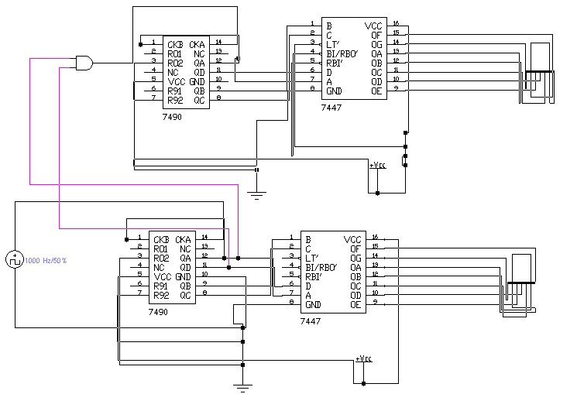

**5.2) Add additional input to your design that can be used to reset the counter:**

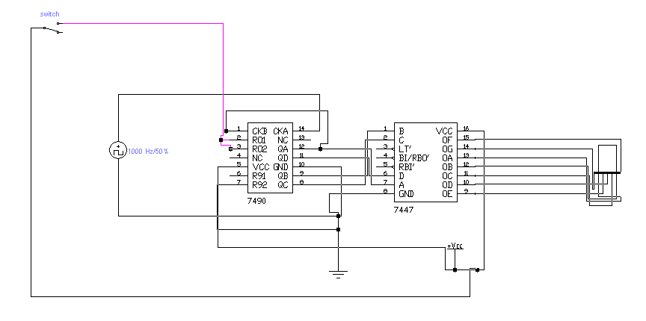

**5.3) Two-decade counter that counts from 00 to 59:**

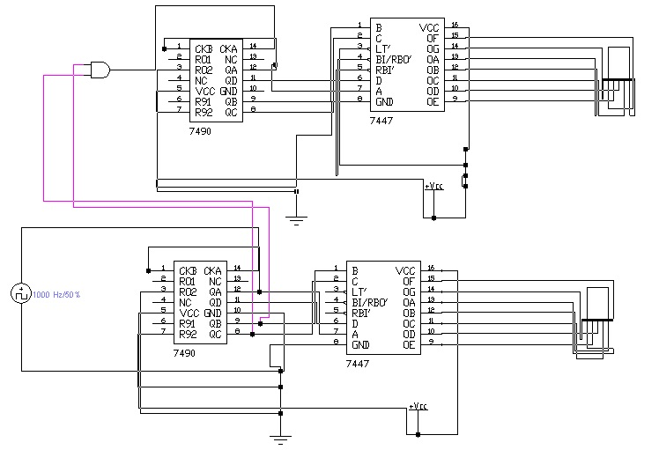

**6) Conclusion:**

**This experiment was interesting because it improved our understanding to the decoders and BCD counters and how they work, and it gave us example how the resistors are very useful, and how it can be used. That’s besides the new way of thinking that we were taught in the tasks, overall this experiment was helpful and we learned a lot from it.**