

**Experiment.No.9**

**A simple security system using FPGA**

**Student’s names: Ahmad Salah**

**Student’s id’s: 1130083**

**1) Abstract:**

**This report talks about how to build different digital components using Quartus, and it shows us how to use multi simple designs to construct a really useful devise such that in this case a security system, and it aims to make us more familiar with FPGA.**

**2) Table of contents:**

|  |  |
| --- | --- |
| **Page Number** | **Description** |
| **1** | **Cover page** |
| **2** | **Abstract** |
| **3** | **Table of content** |
| **4** | **Procedure** |
| **9** | **Conclusion** |

**3) Procedure:**

**3.1) 8x3 Priority Encoder**

**The priority encoder is used by the user to choose what value to view on a 7-segment display (values range from 0 to 7 in decimal). As it show the simulation below.**

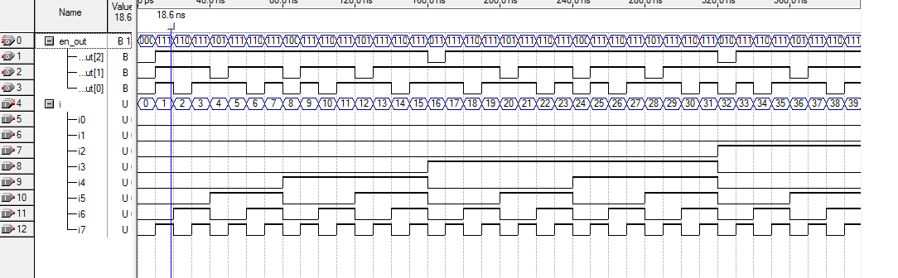

**3.2) 2x4 Decoder**

**The decoder is used to let the user select which memory system is active thus, which 7-segment display to use.as it shows below the output of the 2x4 Decoder .**

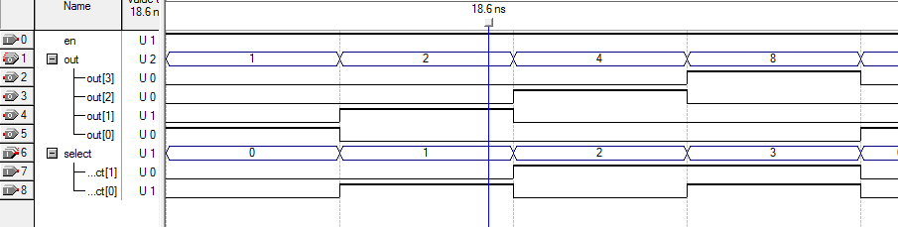

**3.3) Memory System:**

**The memory system is used to keep the selected value by the user to select another 7-segment. Each memory system is consisting of seven D- flip flops and 2x1 MUXs. When the Enable pin =0, the output of each DFF becomes its input at every clock cycle, when the Enable pin becomes 1 the data coming from the 7-segment driver is then stored in the each DFF. The output of each DFF is sent as a data bus to a 7-segment display. For each 7-segment display we need a memory system block.**

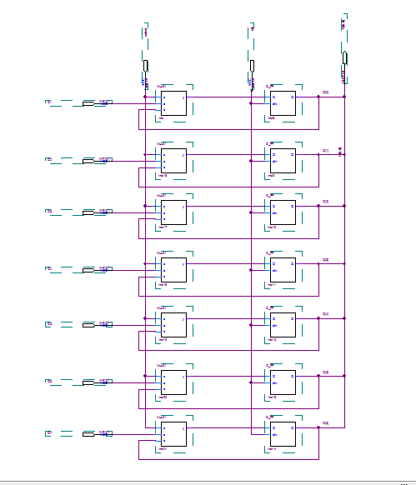

**3.4) Comparator**

**The purpose of the comparator is to lock/unlock our security system. The input of each 7-segment display is connected also to a comparator, every comparator has a build in value (reference) which is compared with the value of the 7-segment display, if both are equal then the output of the comparator is 1 else the output will be 0. For example, if one of the comparators has a reference value = 5 then its output will be 1 if and only if the input is equal to=7'b0100100.**

**We wrote in the code of the comparator the reference we want:**

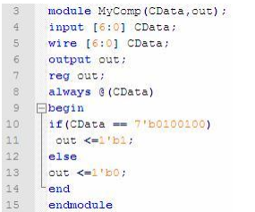

**After writing the code for each part of the system and simulate it, the next step is to make symbol of every digital design, after we created the symbols the only thing is left to do is connect all the parts together so the system is ready to be simulated then moved to Cyclone II, so it can be used on the hardware.**

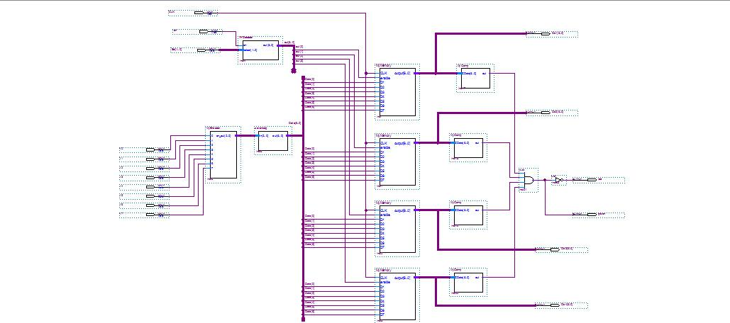

**4) Conclusion:**

**We noticed that dealing with software is much better than hardware, since we done some changes of our circuit by changing the software but if we use the hardware we must do a big change in the hardware design. We learn how to put some of the digital components to build useful systems.**