q``

**Faculty of Engineering and Technology**

**Department of Electrical and Computer Engineering**

**ENCS 211**

**Digital Electronics and Computer Organization Lab**

**Experiment No. 11**

**Introduction** **to** **DEBUG** **Program**

**Objective:**

The main objective of this lab is to get you familiarized with DOS DEBUG program.

**Procedure:**

**PART** **I:** **Immediate** **Operands**

To open the DOS prompt use start 🡪 run 🡪 type “cmd” and then Enter.

Activate the DEBUG program by typing DEBUG at the DOS prompt.

**Activity** **1.1:** Enter the following program instructions in assembly code at the offset memory location 100h by typing **A** **100** at the DEBUG program prompt then press Enter-key.

**MOV** **AX,** **2864** **ADD** **AX,** **3749** **MOV** **BX,** **AX** **SUB** **BX,** **2805** **NOP**

**Activity** **1.2:** Use DEBUG command **U** to unassemble the instructions in Activity 1.1, i.e. convert them to machine code.

What is the machine code corresponding to each assembly code instruction?

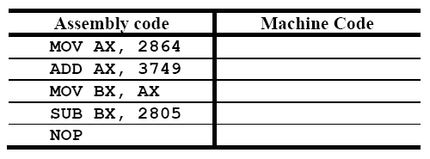

**Activity** **1.3:** How many bytes are needed to represent each instruction in binary?

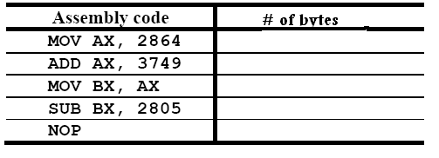

**Activity** **1.4:** **How** is the (immediate) data **2864** stored at memory offset **101h**?

**Activity** **1.5:** What are the contents of **CS**, **IP**, **AX**, and **BX**? Use DEBUG command **R** to display this information?

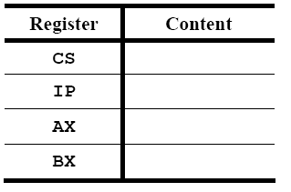

**Activity** **1.6:** Predict the contents of the following registers after execution of each instruction: **CS**, **IP**, **AX**, and **BX**.

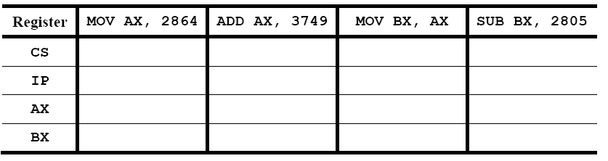

**Activity** **1.7:** Use the T command to execute the program. Determine the content of the above registers after executing each instruction. Explain any discrepancies?

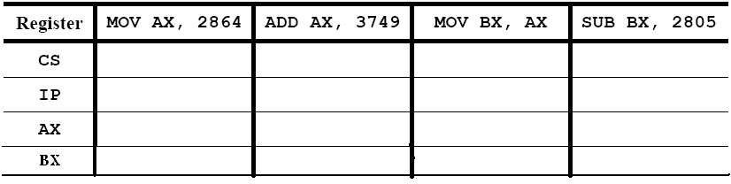**Activity** **1.8:** Explain why the content of IP changes after each instruction is executed.

**Activity** **1.9:** What is the offset address of the second **MOV** instruction? What is its physical address?

**PART** **2:** **Memory** **Addressing**

**Activity** **2.1:** Enter the following data at the offset memory location **200h** using DEBUG command **E.**

**E** **DS:** **200** **1B** **9F**

**E** **DS:** **202** **36** **4A** **00** **00** **E** **DS:** **206** **2A** **2A** **2A**

**Activity** **2.2:** Enter the following program instructions in machine code at the offset memory location **100h** using DEBUG command **E.**

**E** **CS:** **100** **A1** **00** **02**

**E** **CS:** **103** **8B** **1E** **02** **02** **E** **CS:** **107** **01** **C3**

**E** **CS:** **109** **89** **1E** **04** **02** **E** **CS:** **10D** **90**

**Activity** **2.3:** What is the assembly code corresponding to each machine code Instructions?

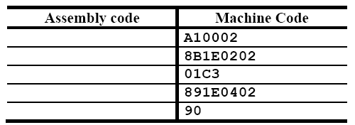

**Activity** **2.4:** What is the 8-bit data value stored at DS: 0200 after the data in Activity 2.1has been entered? (Note that the data value is a byte).

**Activity** **2.5:** What is the 16-bit data value stored at DS: 0200 after the data in Activity 2.1 has been entered?

**Activity** **2.6:** Predict the data value stored at DS: 0204 AFTER the code in Activity 2.2 is executed? (Note that the data value is a byte).

**Activity** **2.7:** Execute the program, and then determine the content of **AX** after the instruction **A10002** is executed?

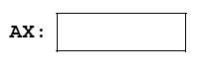**Activity** **2.8:** What is the content (data value) of memory at offset address 0204 after each instruction?

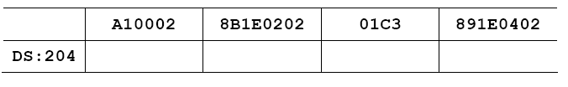

**PART** **3:** **Entering** **assembly** **code** **in** **DEBUG**

**Activity** **3.1:** Enter the following assembly code using the DEBUG command **A** at **CS** offset address **100h**:

**MOV** **CL,** **42** **MOV** **DL,** **2A** **ADD** **CL,** **DL** **NOP**

**Activity** **3.2:** Execute the program using the **T** command. Determine the content of **CL**, **DL**, and **IP** after execution of each instruction?

* 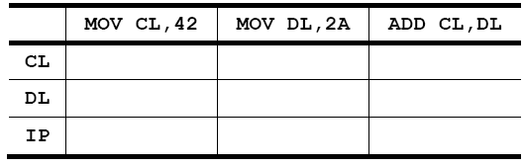THE END -