

**Faculty of Engineering and Technology**

**Department of Electrical and Computer Engineering**

**ENCS 211**

**Digital Electronics and Computer Organization Lab**

**Experiment No. 3**

**Encoders, Decoders, Multiplexers and**

**Demultiplexers**

**3.1 OBJECTIVES**

• To understand the operating principles of Encoders/Decoders

• To understand the operating principles of Multiplexers/Demultiplexers

• To construct encoders and decoders using basic gates and IC.

• To construct multiplexers and demultiplexers using basic gates and IC

**3.2 EQUIPMENT REQUIRED**

1. KL-22001 Basic Electricity Circuit Lab

2. KL-26002 Combinational Logic Circuit Experiment Module (2)

3. KL-26003 Combinational Logic Circuit Experiment Module (3)

4. KL-26004 Combinational Logic Circuit Experiment Module (4)

5. Multimeter.

**3.3 LABORATORY REGULATIONS AND SAFETY RULES**

The following Regulations and Safety Rules must be observed in the laboratory:

1. It is the duty of all concerned who use any electrical laboratory to take all reasonable steps to safeguard the HEALTH and SAFETY of themselves and all other users and visitors.
2. Be sure that all equipment is properly working before using them for laboratory exercises. Any defective equipment must be reported immediately to the Lab. Instructors or Lab. Technical Staff.
3. Students are allowed to use only the equipment provided in the experiment manual or equipment used for senior project laboratory.
4. Power supply terminals connected to any circuit are only energized with the presence of the Instructor or Lab. Staff.
5. Students should keep a safe distance from the circuit breakers, electric circuits or any moving parts during the experiment.
6. Avoid any part of your body to be connected to the energized circuit and ground.
7. Switch off the equipment and disconnect the power supplies from the circuit before leaving the laboratory.
8. Observe cleanliness and proper laboratory housekeeping of the equipment and other related accessories.
9. Double check your circuit connections before switching “ON” the power supply.
10. Make sure that the last connection to be made in your circuit is the power supply and first thing to be disconnected is also the power supply.
11. Equipment should not be removed, transferred to any location without permission from the laboratory staff.
12. Software installation in any computer laboratory is not allowed without the permission from the Laboratory Staff.
13. Computer games are strictly prohibited in the computer laboratory.
14. Students are not allowed to use any equipment without proper orientation and actual hands on equipment operation.
15. Smoking and drinking in the laboratory are not permitted.

**3.4 PRE-LAB**

**1.** Prepare all sections and Hand out all the required designs to your teaching assistant.

**2.** Design a circuit which uses an SN74151 to implement a sum-of-products expression, as follows:

**(a)** Convert the following expression into summation form (i.e. F(A,B,C)= ∑(…)):



**(b)** Sketch on figure.1 the input connections necessary to implement the function in (a).

**Figure.1: 8-to-1 Multiplexer**

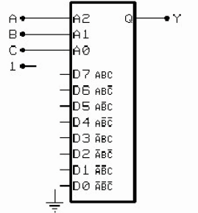

**3.** Design a circuit which uses an SN74138 demultiplexer to implement a sum- of-products expression, as follows:

1. Convert the following expression into summation form (i.e. F(A,B,C)= ∑(…)):



**(b)** The demultiplexer output is selected, and will go low, by the address on inputs A, B, and C when the IC is enabled. Therefore, we can create the output function Y by summing together the outputs indicated by the summation form of the expression. Since the outputs of the demultiplexer are active-low, this is done with a NAND gate. Connect each of the TRUE minterm outputs of the demultiplexer in Figure.2 (indicated by the summation equation) to an input of the NAND gate. Connect all unused NAND inputs to logic 1.

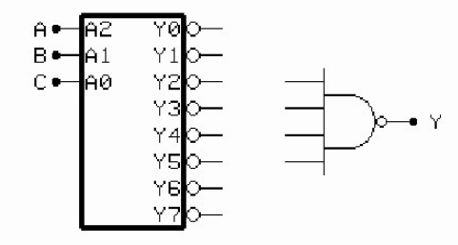

**Figure.2: 3-to-8 Demultiplexer**

**3.5 PROCEDURE:**

**A. Constructing 4-to-2-Line Encoder with Basic Gates**

1. Set the KL-26003 Module on the KL-22001 Basic Electricity Circuit Lab, and locate block a. Complete the connections by referring to the wiring diagram in Figure 3.

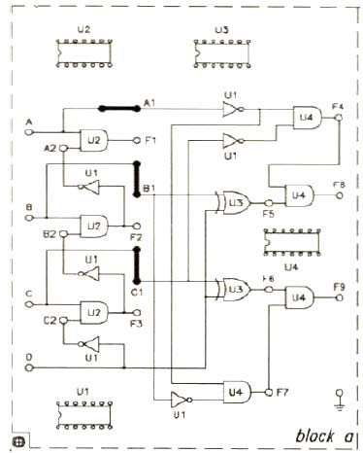

**Figure.3: wiring diagram of 4-to-2 line Encoder**

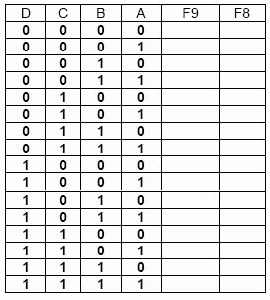

**Table.1**

2. Apply +5 VDC from the Fixed Power on KL-22001 Lab to KL-26003 Module.

3. Connect inputs A-D to Data Switches SW0-SW3 respectively; outputs F8 and F9 to Logic Indicator L0 and L1.

4. Follow the input sequences for D, C, B, A in Table. 1 (above) and record the output states.

**B. Constructing 10-to-4-Line Encoder with TTL IC**

Set the KL-26004 Module on the KL-22001 Basic Electricity Circuit Lab, and locate block a. The 74147 (U7l) decimal to BCD priority encoder in Figure.4 will be used in the following steps.

1. Apply +5 VDC from Fixed Power to KL-26004.

2. Connect inputs A1-A8 to SW0-SW7, A9 to D7. Connect outputs A-D to Logic indicators L1-L4. Follow the input sequences given in Table.2 and record output states.

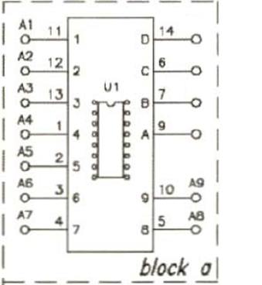

**Figure.4: (74147) BCD Priority Encoder**

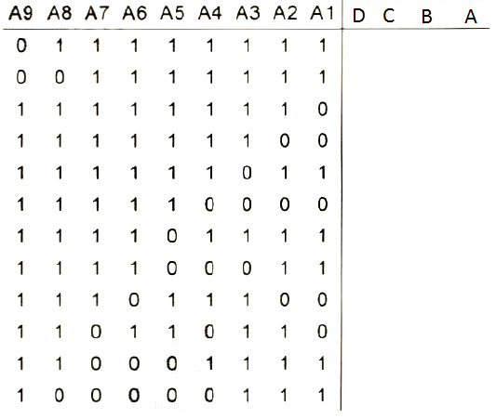

**Table.2**

**C. Constructing 2-to4-Line Decoder with Basic Gates**

1. Set the KL-26003 Module on the KL-22001 Basic Electricity Circuit Lab, and locate block C. Apply +5 VDC from the Fixed Power on KL-22001 Lab to KL-26003 Module.

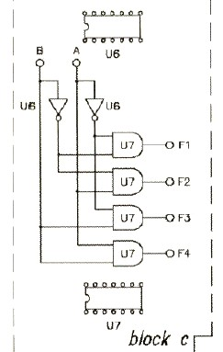

**Figure.5: 2-to-4 Decoder (KL-26003 block C)**

2. Connect inputs A and B to Data Switches SW0 and SW1. Connect outputs F1-F4 to Logic Indicators L0-L3 respectively.

3. Follow the input sequences for A and B in Table.3 and record output states

**Table.3**

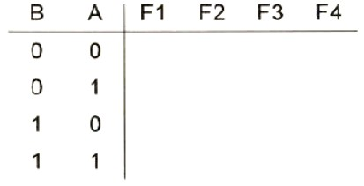

**D. Constructing 4-to-10-Line Decoder with TTL IC**

1. Set the KL-26002 module on the Kl-22001 Basic Electricity Circuit Lab, and locate block c. U10, 7442 4-to-10-line (or BCD to Decimal) decoder will be used in the following steps.

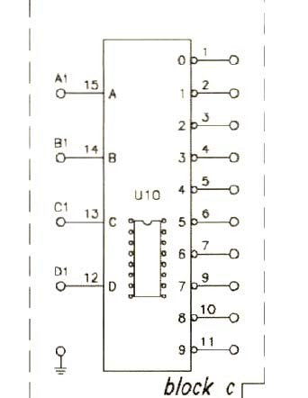

**Figure.6: 4-to-10 line Decoder**

2. Connect inputs A1, B1, C1, D1 to the Data Switches SW0, SW1, SW2, and SW3, respectively. Connect outputs 0-9 to Logic Indicator L0-L9.

3. Follow the input sequences for D, C, B, A in Table.4 and record output states.

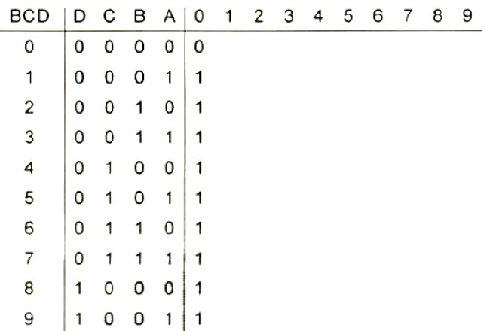

**Table.4**

**E. Constructing 2-to-1-Line Multiplexer with basic Gates**

1. Set the KL-26004 Module on the KL-22001 Basic Electricity Circuit Lab, and locate block e. Apply +5 VDC from the Fixed Power on KL-22001 Lab to KL- 26004 Module.

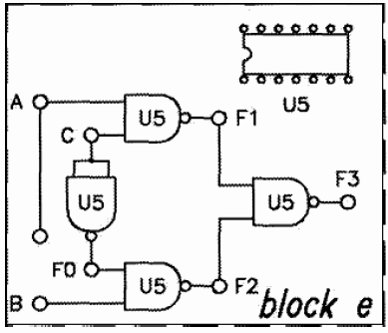

**Figure.7: 2-to-1 Multiplexer**

2. Connect inputs A, B to Data Switches SW0, SW1; selector C to SW2. Connect output F3 to Logic Indicator L0.

3. Follow the input sequences in Table.5 and record states of F3. Which input (A or B) determines the output when C=0?

Which input (A or B) determines the output when C=1?

**Table.5**

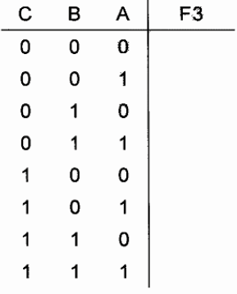

**F. Constructing 8-to-1-Line Multiplexer with IC**

1. Set the KL-26004 Module on the KL-22001 Basic Electricity Circuit Lab, and locate block f. Apply +5VDC from the Fixed Power on KL-22001 Lab to KL-26004 Module.

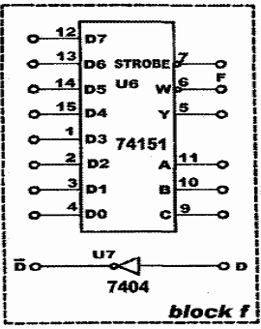

**Figure.8: 8-to-1 MUX (KL-26004 block f)**

2. Refer to the data sheet for specifications of U6 (74151).

When CBA ="000", data at D0 is sent to output *Y.* When CBA ="010", data at D2 is sendt to output Y. When CBA ="111", data at D7 is sent to output Y.

The IC will function properly only when STROBE ="0". Y will remain “0” when STOROBE=”1”.

3. Connect inputs D0~D7 to Data Switches D0~D7; input C, B, A to Data Switches SW2, SW1, SW0. Connect STROBE to Data Switch SW3. Connect output Y and F to Logic Indicators L0 and L1, respectively. Set SW3 to "0". Follow the input sequences in Table.6, switch D0~D7 and record output states. Determine on which input among D0~D7 does Y depend on.

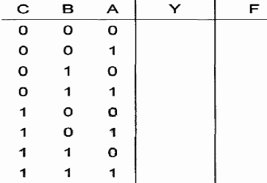

**Table.6**

**G. Using Multiplexer to Create a Logic Function**

1. Set the KL-26004 Module on the KL-22001 Basic Electricity Circuit Lab, and locate block f. Apply +5 VDC from the Fixed Power on KL-22001 Lab to KL-26004 Module

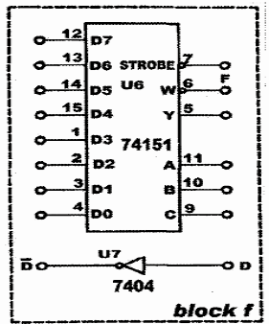

**Figure.9: Wiring diagram (KL-26004 block f)**

2. Sketch on (**Figure.9**) the input connections necessary to implement the function

**F (A, B, C, D) =∑ (0,2,4,5,7,8,10,11,15)**

4. Implement the circuit you designed above on the KL-26004 kit, block f.

5. Connect inputs D, C, B, A to Data Switches SW3, SW2, SW1, SW0 respectively. Connect output Y to Logic Indicator L0. Record output states in Table 7.

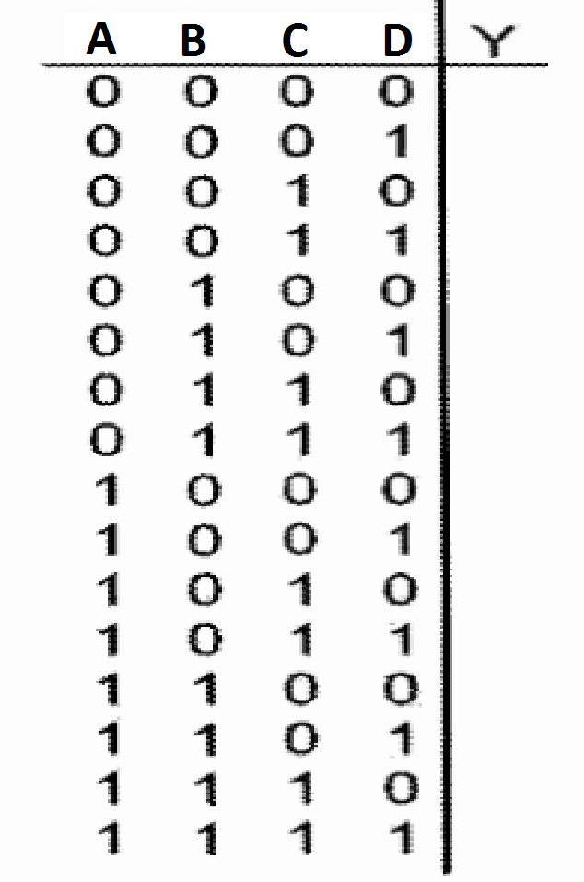

**Table.7**

**H. Constructing 1-to-2-Line Demultiplexer with Basic Logic Gates**

**1.** Set the KL-26004 Module on the KL-22001 Basic Electricity Circuit Lab, and locate block e. Complete the connection by referring to the wiring diagram in Figure.10. Apply +5VDC from the Fixed Power on KL-22001 Lab to KL-26004 Module.

**Figure.10: 1-to-2 Demultiplexer**

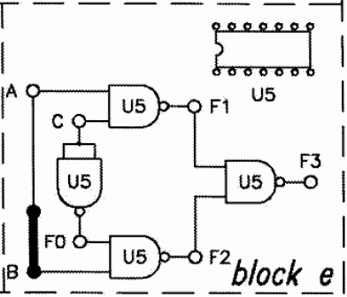

2. Connect A to Data Switch SW0; C to SW3; F1 and F2 to Logic Indicators L0 and L1 respectively.

3. Set C to "1", change A and observe outputs F1 and F2. _____

4. Set C to "1", change A and observe outputs F1 and F2. _

**I. Constructing 1-to-8-Line Demultiplexer with CMOS IC**

1. Set the KL-26004 Module on the KL-22001 Basic Electricity Circuit Lab, and locate block b as shown in Fig 11. Apply +5VDC from the Fixed Power on KL-22001 Lab to KL-26004 Module. U2 (4051) will be used in the experiment.

**Figure.11: 1-to-8 Demultiplexer**

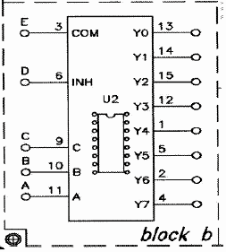

2. Connect E and D to Data Switches D0 and D1, respectively. Connect input A to SW0, B to SW1, C to SW2; outputs Y0~Y7 to Logic Indicators L0~L7, respectively.

3. Set D=”0”, apply the sequence 1-0-1-0 to the Common Input E and observe output Y0~Y7.Do the outputs change as the input sequence is? .

4. Set D="1", apply the input sequence 1-0-1-0 to the Common Input E and observe outputs Y0~Y7.

Do the outputs change as the input sequence is applied?

Which state of D changes the outputs?

5. Set D="0". Using the same sequence for E (1-0-1-0), follow the sequence for A, B and C given in Table.12. Record output states.

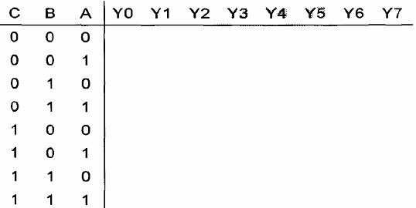

**Table.8**

**3.6 POST-LAB PROBLEM**

Solve the following problem in your report.

Design a Majority Circuit; a circuit that takes 4 inputs and 1 output, its output equals 1 when 3 or 4 of the inputs are 1. ***You can only use two 4×1 multiplexers.***