

**Faculty of Engineering and Technology**

**Department of Electrical and Computer Engineering**

**ENCS 211**

**Digital Electronics and Computer Organization Lab**

**Experiment No. 4**

**Digital Circuit Implementation using Breadboard**

**4.1 OBJECTIVES**

The objective of this laboratory experiment is to introduce you to simple digital devices and their operations. You will also be introduced to the process of building digital circuits using a digital design kit.

**4.2 EQUIPMENT REQUIRED**

**1.** KL-22001 Basic Electricity Circuit Lab

**2.** Breadboard

**3.** IC 7404 (inverter), IC 7408 (2-input AND), IC 7432 (2-input OR), IC 7400(2- input NAND) and IC 7486 (2-input XOR)

**4.3 LABORATORY REGULATIONS AND SAFETY RULES**

The following Regulations and Safety Rules must be observed in the laboratory:

1. It is the duty of all concerned who use any electrical laboratory to take all reasonable steps to safeguard the HEALTH and SAFETY of themselves and all other users and visitors.
2. Be sure that all equipment is properly working before using them for laboratory exercises. Any defective equipment must be reported immediately to the Lab. Instructors or Lab. Technical Staff.
3. Students are allowed to use only the equipment provided in the experiment manual or equipment used for senior project laboratory.
4. Power supply terminals connected to any circuit are only energized with the presence of the Instructor or Lab. Staff.
5. Students should keep a safe distance from the circuit breakers, electric circuits or any moving parts during the experiment.
6. Avoid any part of your body to be connected to the energized circuit and ground.
7. Switch off the equipment and disconnect the power supplies from the circuit before leaving the laboratory.
8. Observe cleanliness and proper laboratory housekeeping of the equipment and other related accessories.
9. Double check your circuit connections before switching “ON” the power supply.
10. Make sure that the last connection to be made in your circuit is the power supply and first thing to be disconnected is also the power supply.
11. Equipment should not be removed, transferred to any location without permission from the laboratory staff.
12. Software installation in any computer laboratory is not allowed without the permission from the Laboratory Staff.
13. Computer games are strictly prohibited in the computer laboratory.
14. Students are not allowed to use any equipment without proper orientation and actual hands on equipment operation.
15. Smoking and drinking in the laboratory are not permitted.

**4.4 PRE-LAB**

1. Review how the breadboard works and the way components, including chips are connected to the breadboard. You can watch the following videos for that:

<https://www.youtube.com/watch?v=gwcVr5VfXwA>

2. Learn how to identify the pins of a chip. You may find the following presentation useful:

<https://www.youtube.com/watch?v=Y9vsZTpnDDI>

3. Design and Implement a Full Adder using the gates on the chips. Your final circuit must include the IC’s, their pin numbers, and the connections between the pins.

4. Design and Implement a 4x1 multiplexer using the gates on the chips. Your final circuit must include the IC’s, their pin numbers, and the connections between the pins.

5. Design and Implement a 2-4 “active-low” decoder using the gates on the chips. Your final circuit must include the IC’s, their pin numbers, and the connections between the pins.

Figure 4.1 shows some digital gates with identification numbers and pin assignment.

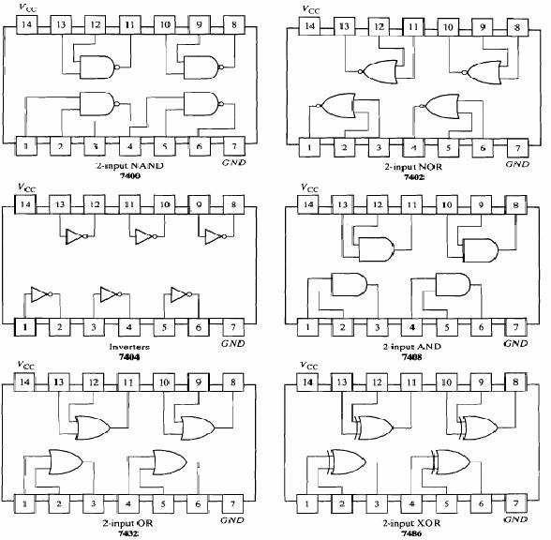

Figure 4.1: DIGITAL GATES IN IC PACKAGES

**4.5 PROCEDURE**

**4.5.1 Verification of basic logic gates**

In this task you are to verify the operations of some of the IC chips.

**1.** Place each chip shown in Figure 4.1 on the breadboard in such a way that its pins are not short-circuited. Make sure power is off while you place IC’s and wires.

**2.** Connect GND and +5V for each chip you want to check. Connect the gate inputs to the dip switches and the gate output to any LED. Determine the output for each possible input combination and compare your results with the expected Truth Tables.

3. Verify the function of the 7404 (inverter) chip by observing how the output changes in response to input changes.

4. Verify the function of the 7408 (2-input AND) chip by observing how the output changes in response to input changes.

5. Verify the function of the 7432 (2-input OR) chip by observing how the output changes in response to input changes.

6. Verify the function of the 7400 (2-input NAND) chip by observing how the output changes in response to input changes.

**6a. how does the gate act if one of its two input is held at “1”?**

**6b. how does the gate act if its two input are connected together?**

7. Verify the function of the 7486 (2-input XOR) chip by observing how the output changes in response to input changes.

**7a. how does the gate act if one of its two input is held at “1”?**

**7b. how does the gate act if one of its two input is held at “0”?**

**4.5.2 Full-Adder, Multiplexer, and Decoder Implementations**

Use any needed gates shown in figure 4.1 to implement the full adder, the 4x1 multiplexer, and the decoder that you designed in the pre-lab.