

**Faculty of Engineering and Technology**

**Department of Electrical and Computer Engineering**

**ENCS 211**

**Digital Electronics and Computer Organization Lab**

**Experiment No. 6**

**Sequential Logic Circuits using Breadboard and IC’s**

**6.1 Objectives:**

1. To learn how to use some integrated circuits (ICs) such as counters (IC7490) and 7-segment display driver/decoder (IC7447).
2. To understand the function of the 7-segment display and how to find its pin assignment.
3. To build one, two or more decade counters with 7-segment displays.

**6.2 Introduction**

**6.2.1 Seven-Segment Display**

The seven-segment LED (Light Emitting Diode) display is a common device in consumer electronics, from calculators to clocks to microwave ovens. In this lab, you will learn the basic principles of operation of the seven-segment display and the process of converting BCD values to the proper signals to drive this display.

The display has seven separate bar-shaped LED's arranged as shown in figure.1. In addition, many seven-segment displays have one (or two) circular LED used as a decimal point.

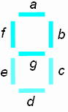

**Figure.1:** seven-segment display

Inside the seven-segment display, one end of each LED is connected to a common point. This common point is tied either to ground or to the positive supply, depending on the specific device. If your seven-segment display is designed to have the common connection tied to the positive supply, +5V, it is called a **common anode** configuration as shown in figure.2 To turn on these LED segments, the inputs must be ***logic low***.

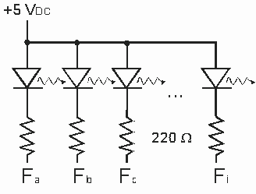 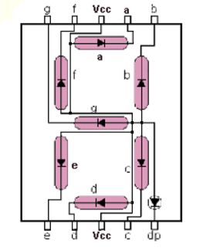

**Figure.2**: common anode display

If your seven-segment display is designed to have the common connection tied to the ground, 0V, it is called a **common cathode** configuration as shown in figure.3. To turn on these LED segments, the inputs must be ***logic* *high.***

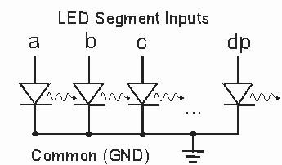 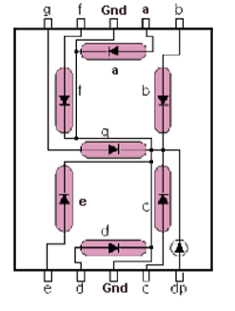

**Figure.3**: common cathode display

In both common-anode and common cathode configurations, current-limiting resistors are used to lower the amount of current that the driver sends into the LED’s. This achieves two goals:

1. Prevent over-current which may burn the LED’s.
2. Control the brightness of the LED’s.

**6.2.2 BCD-to-seven-segment decoder**

A BCD-to-seven-segment decoder is a logic circuit that allows the display of a binary coded decimal on a seven-segment display.

In this lab the IC type 7447 decoder will be used. The 7447 pin assignment is shown in Figure.4. Its pin description is shown in Table.1

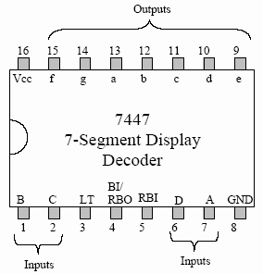

**Figure.4:** 7447 pin assignment

|  |  |
| --- | --- |
| **Pin name** | **Description** |
| **A, B, C, D**  **a, b, c, d, e, f, g RBI BI/RBO**  **LT** | BCD inputs; D is the most significant input  (DCBA)  Decoder output (Active Low)  Ripple Blanking Input (Active Low)  Blanking Input (Active Low)/or Ripple Blanking  Output (Active Low)  Lamp Test input (Active Low) |

**Table.1:** 7447 pin description

**LT** is a lamp-test feature, active low. This line should be high for normal operation and, when pulled low, all 7-segments will be turned on so you can see all the 'lamps' are good.

**RBI** is the ripple blanking input, also active low. It allows you to hide a ‘0’. When this line is high, and there's a 0 at the inputs, a '0' will be displayed on the display. When the line is low with a 0 at the inputs, nothing will be displayed.

**BI/RBO** can be used as input or output. **BI**, or blanking input, active low, is used to turn off all the segments. **RBO**, or ripple blanking output, active low, is used with RBI. When RBI activated and the input of DCBA is 0000, RBO will be active to indicate that the segments are blanked. This allows you to drive the RBI input of another 7-segment display.

For **normal operation without blanking**, the three inputs: LT, RBI, and BI/RBO should be connected to +5V.

**6.2.3 Counter**

In this lab the IC type 7490 counter will be used. The 7490 pin assignment is shown in Figure.5 and its logic diagram is shown in Figure.6.

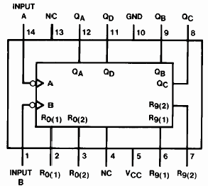

**Figure.5:** 7490 counter pin assignment

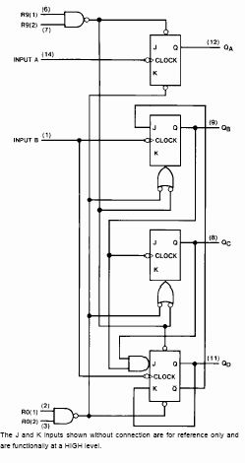

**Figure.6:** 7490 counter logic diagram

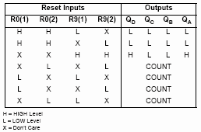**Table.2:** Reset/count function table

**6.3 Pre Lab:**

1. What is the appropriate display type (common anode/common cathode) that must be used with 7447 display decoder? Why?
2. **We would like to limit the current in the LED segments to 10mA.** Assuming that the turn-on voltage for the LED’s is 1.7v, what is the proper value of the resistors to be connected between the 7447 decoder and the 7-segment display?
3. **Assume that the resistors provided in the lab are 220Ω. What would the current flowing into the LED’s be?**
4. **Design a decade counter circuit using the 7490 counter, the 7447 decoder, and a 7-segment display. Show the pin numbers on the IC’s in your design.**

**6.4 Procedure**

**6.4.1 Seven- Segment display**

**a. Testing lamps in the display**

1. Place the display and the 7447 chips on the breadboard.

2. Implement the circuit shown in Figure.7.

3. Connect pin 4 and pin 5 of the 7447 decoder to the +5V

1. Connect pin 3 (LT) of the 7447 decoder to the ground. All 7 segments must be turned on. This to verify that all segments in the display are working correctly.

**b. Blanking all segments**

1. Connect pin 4 (BI) of the decoder to the ground. All 7 segments must be turned off.
2. Keep this circuit connected. You may use it as part of the next step.

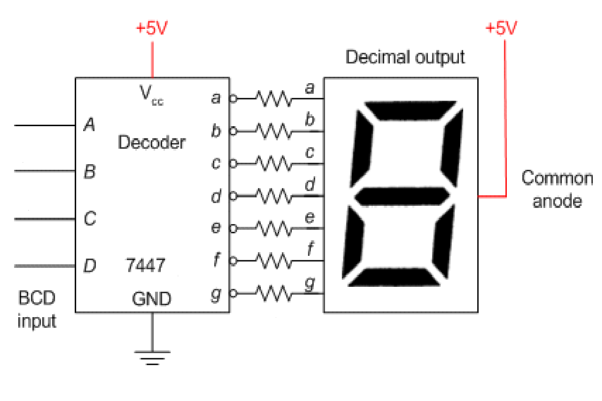

**Figure.7:** display-decoder connection

**6.4.2. Implementing one decade counter**

In this part, you will build a counter that counts from 0 to 9

1. Connect the circuit that you designed in part 4 of the pre-lab. Show the design and the connected circuit to the instructor before turning on the power.
2. Apply clock pulses to pin 14 of the 7490 counter using Pulser switch SWA.
3. Observe the counting sequence on the display D1 and complete Table.3
4. Now, apply clock pulses to pin 14 from “pulse generator” of the KL-22001 Basic circuit lab. Observe the count sequence.

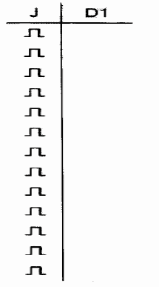

**Table.3**

**Task 1:**

Design a two-decade counter that counts from 00 to 99. Attach your design schematic with the experiment report.

**Task2:**

Add additional input to your design that can be used to reset the counter. Attach your design schematic with the experiment report.

**Task3:**

Modify the counter in Task1 to count to 59 (without Reset). Attach your design schematic with the experiment report.