

**Faculty of Engineering and Technology**

**Department of Electrical and Computer Engineering**

**ENCS 211**

**Digital Electronics and Computer Organization Lab**

**Experiment No. 7**

**Introduction to QUARTUSII Software**

**7.1 Objective:**

Quartus II software is dedicated to program PLDs or FPGAs, in this experiment; we will study the schematic capture and HDL on Quartus II and then download simple examples on the FPGA using the Kit DE1.

**7.2 Pre-lab:**

* **Read :**
* **This tutorial :**
* ftp://ftp.altera.com/up/pub/Altera_Material/10.1/Tutorials/Schematic/Quartus_II_Introduction.pdf
* Look inside this page for more examples
* <http://www.fpga4fun.com/SPI.html>
* Watch these videos:
* <https://www.youtube.com/watch?v=oVvmeyVMtEI>
* <https://www.youtube.com/watch?v=7TMgEherFW4>
* Learning more:
  + https://www.youtube.com/watch?v=gUsHwi4M4xE

**Note: Student Should start the experiment/SW without TA help**

* Prepare needed info to build this by end of the experiment :
* Using Quartus II, create a schematic file for the function F=AB+C’D and simulate it.
* Using Quartus II, create Verilog file for full Adder and simulate it.

**7.3 Procedure:**

**Part 1: schematic capture:**

The aim of this part is to design the combinational function: F=ABC+A’D

• Run the QUARTUSII software: double click on the QUARTUS II item in the desktop.

• Define the project : fileÆnew project wizardÆthen press next

• Follow the windows as shown below:

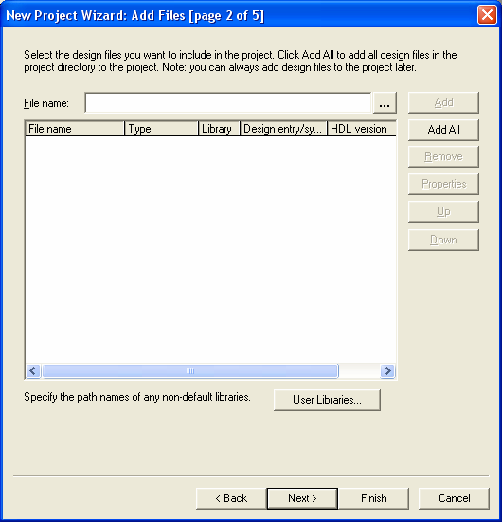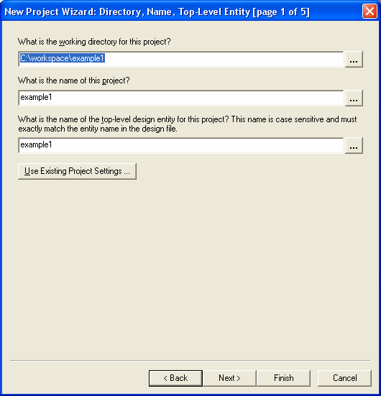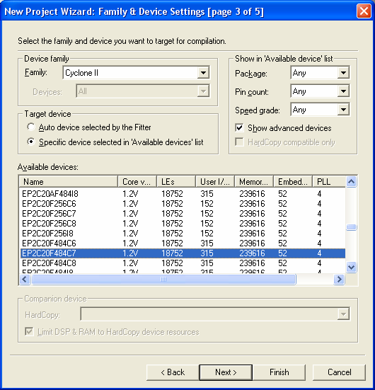

• Change the working directory to indicate your folder that will contain your project.

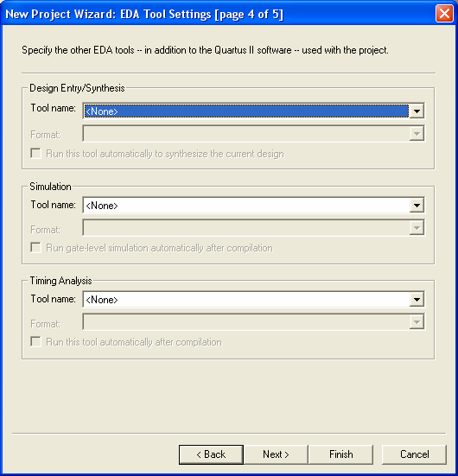

• Then name this project and the top level design entity, you must notice that the name of the project and the high level design entity must have the same name as the module in your program (in the case of HDL programming), then press next.

• If you have already files to add, you can add them here, otherwise (if you want to build the design now) press next.

• The next window give us a chance to use a specific device (which we will use later), choose the

Family cyclone II and the device EP2C20F484C7

• Since our project is simple, and no need to add any other Tools, we just press next.

• After that the following window appears:

• Finally press finish.

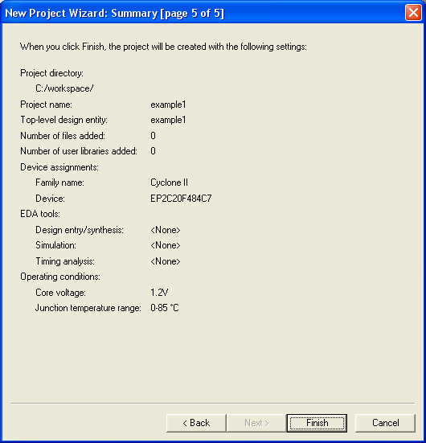

Now we will build our function a schematic file: File Æ new

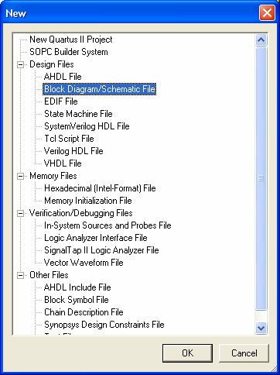

To enter components of our design double click anywhere on the schematic window, or select the symbol tool

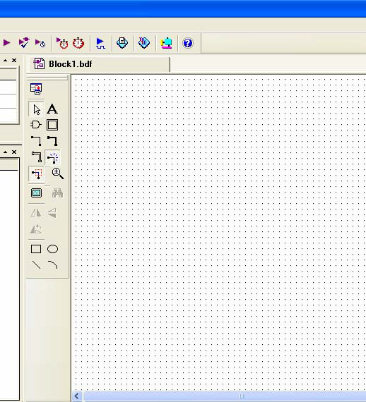

(The little and gate ) as shown in the figure:

This opens the symbol window in which available libraries ,including the standard QUARTUSII library, open this library by clicking on the little plus sign next to it , then select primitives , and then select logic

,then select the gate you want in your implementation

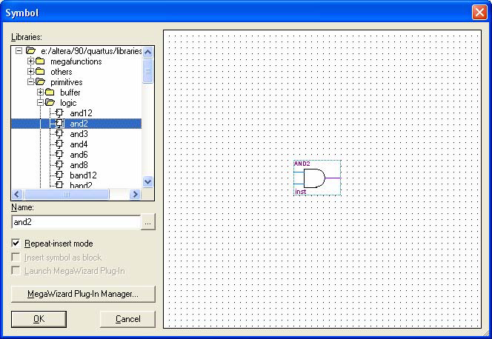

You have to define the inputs and outputs of your implementation, and you do so by opening the symbol windowÆprimitiveÆpin, the following figure shows all the design components that must now be connected:

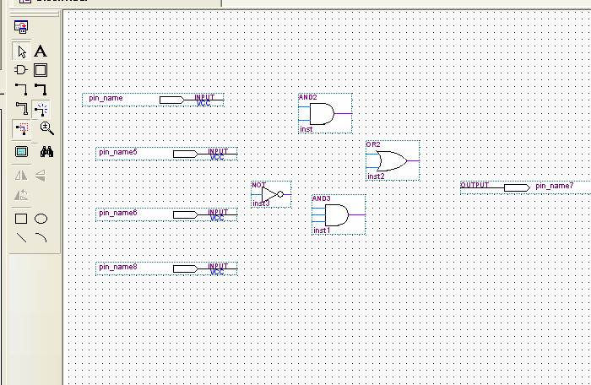

o

• To connect the components of the previous figure , select the 90

thin line with the dots on its ends on the

tool bar, this makes your cursor a wiring tool that can be used to connect you circuit. When done, disable the wiring tool by clicking the arrow on the tool bar.

• Rename input and output ports to the variable names of our design ,to name a pin, either double click it to open its pin properties window, or right –click it , and select properties from the pull-down menu that shows up.

• Save your design , and make sure it is named the same as your project, the following figure shows the completed block diagram of our design.

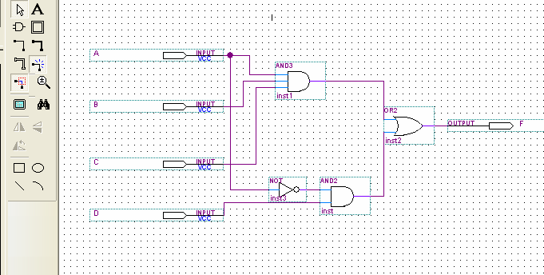

**Compilation**

After that we compile our design by either clicking on processingÆstart compilation or click on .



If there are errors fix them before proceeding.

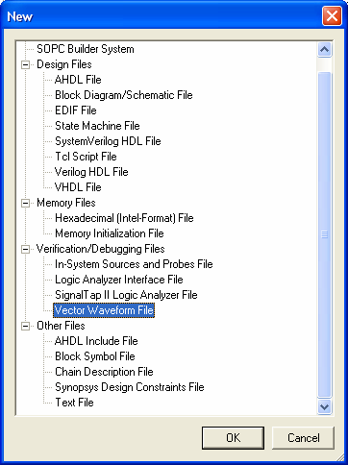

**Simulation**

If there are no errors, File Æ new , select Vector waveform File

Then right-click on the leftmost side of the window (under Name), then click insert node or bus, as shown below

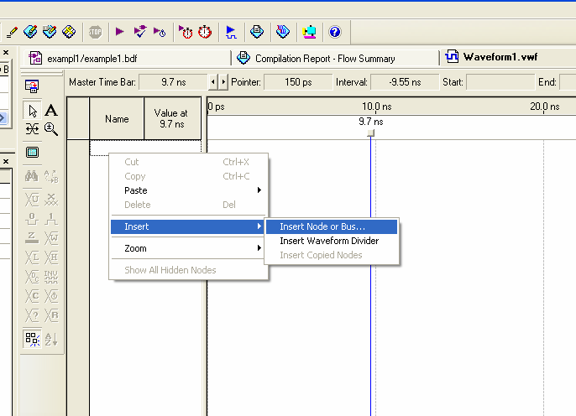

Click on **Node Finder** and then on List (using the Filter pins: all)

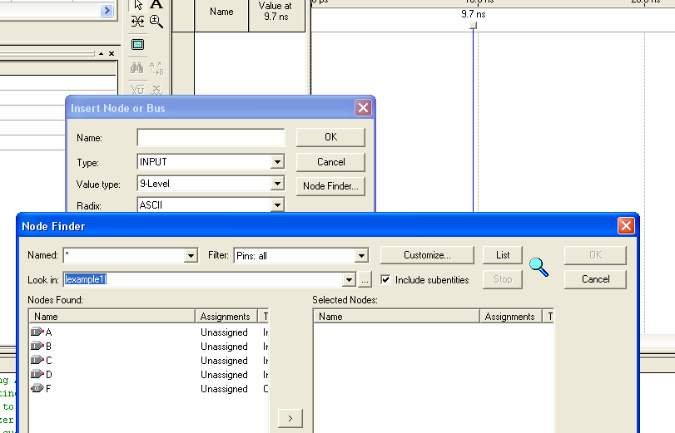

• Select all inputs and the output by clicking on (>>) (you can select one by one).

• You can select the intervals when you want the inputs to be one or zero , either by shadowing the interval ,then press the one level in the tool bar, or by write clicking the name , then select valueÆcount value, the change the start value, the end value , and the radix as shown in the following figure:

• Now save the file with the same name as your project and in the same folder.

• Simulate your file either by clicking processesÆstart simulation or click on.



**Routing the Project on the FPGA:**

After verifying that the design works as expected we can install the cod on the hardware (FPGA).

• Double check that the selected device is the one available on the Kit DE1. This can be done using AssignmentsÆ Device

• We need 4 Inputs and one output , so we can use 4 switches and a LED . We have to use the user manual of DE1 to figure out the location of the switches and the LEDs . the Table below show the location of the switches

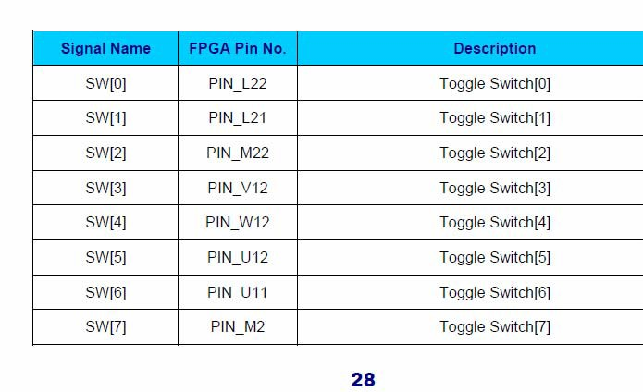

Assign PINs for the Inputs and Outputs. You can assign by right click the pin then choose

• LocateÆlocate in assignment editor

• Select Pin in the category and select a switch for input.

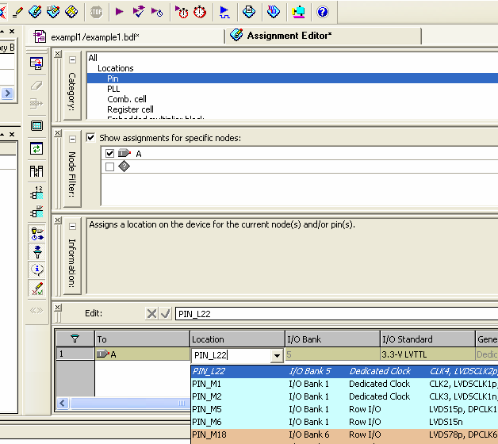

The Figure below shows the circuit with PIN assignments.

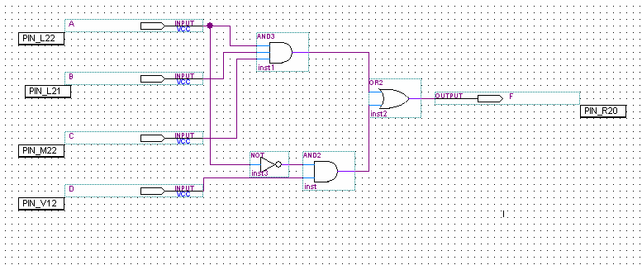

**Re-compile** the Project so that the new changes in the PINs take place. Download the Program on the FPGA ToolsÆ Programmer

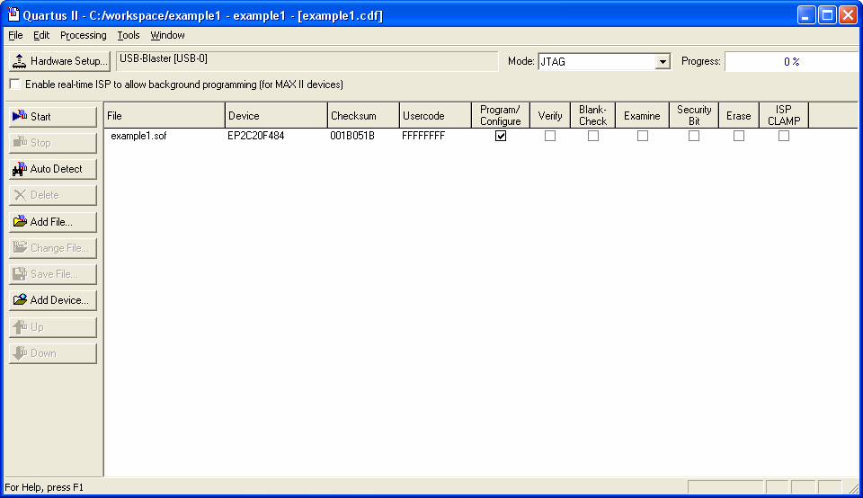

Make sure that the currently selected hardware is USB-Blaster, and then click **Start. (Show the results to the instructor)**

***Part2: Verilog***

***Adder subtractor:***

A and B are bytes. The circuit provides A + B when X = 0, and A - B if X = 1.

1. Create a new project as in part1

2. Make new verilog file: File --> New --> "Verilog HDL file"

3. Study, write, and compile and simulate the following program.

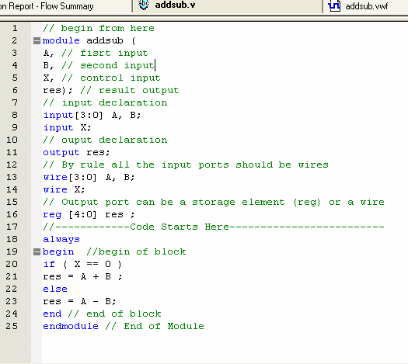

Modify the program to work as follows:

A and B are bytes. The circuit provides zero output when X=0, A + B when X = 1, and A

- B if X = 2, A*B when X=3, .

**(Simulate it and show the results to the instructor)**

**Seven segment display decoder (driver):**

Make sure that you have the file sevenseg.v in the same directory you work and it is compiled

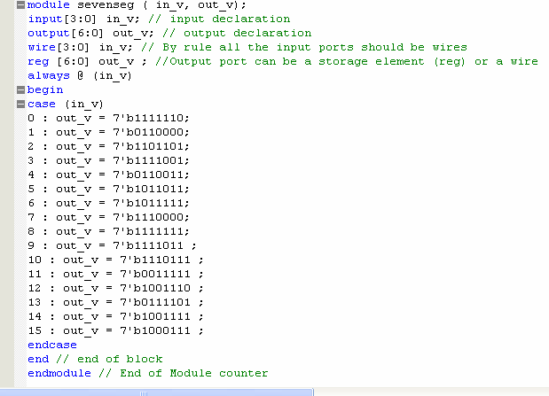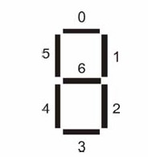

Correctly, and then create symbol by FileÆcreate/updateÆcreate symbol files for current file

Now create a new project and a schematic file. Insert the created symbol in this file

Knowing that the seven-segment displays are active- low. Modify the above code and then

1-Assign four switches as input

2- Assign one of the sevens segments to the output

Re-compile and then rout it on the FPGA **(show the results to the instructor)**

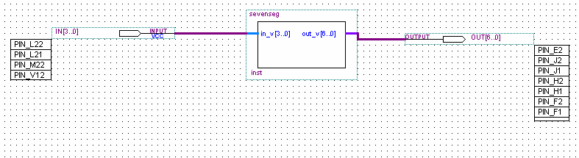

Keep the working code; you will need it in the next experiment.