Islam Jihad 1191375

Q2 a-

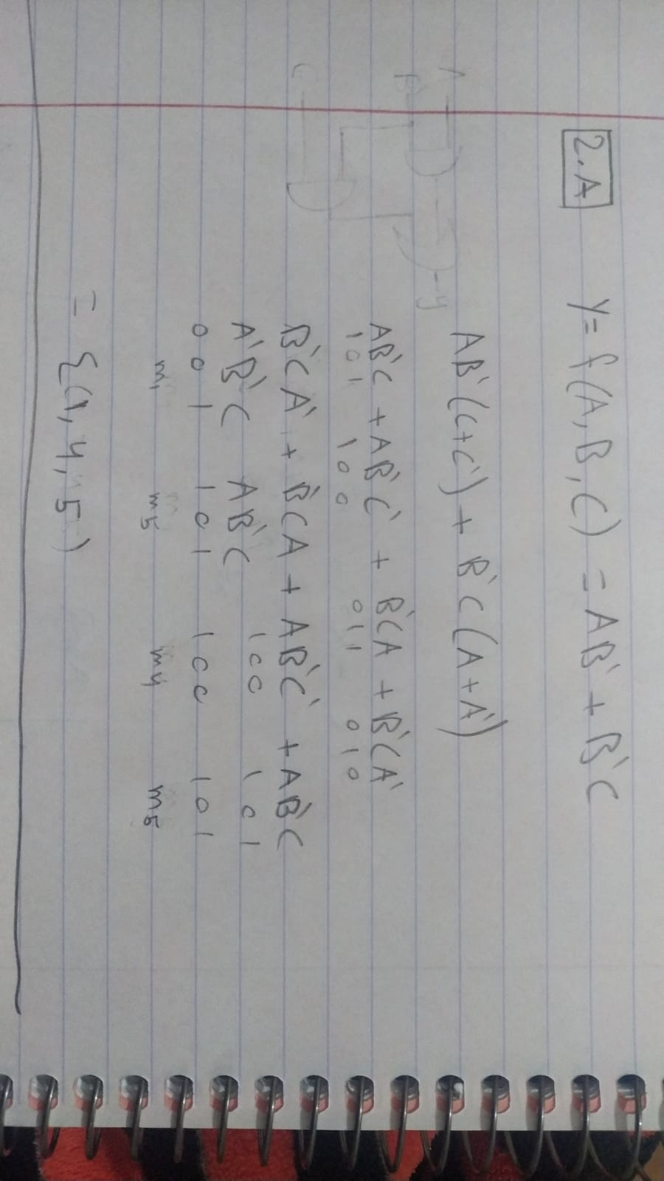

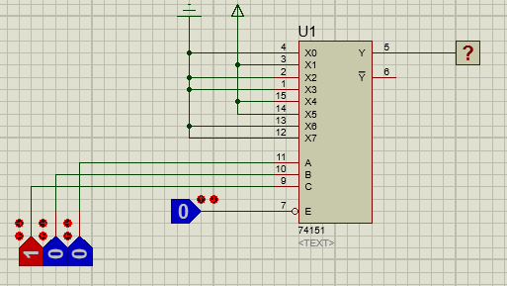

b-

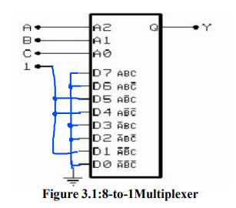

Q3 a-

Y = A'BC + BC'

Y = A'BC + (A+A')BC'

Y = A'BC + ABC' + A'BC'

Y = 011 + 110 + 010

Y = ∑(2,3,6)

b-

thhis is the troth table of 3-8 multiblexer which shows how to connect the IC with inpusts and outputs

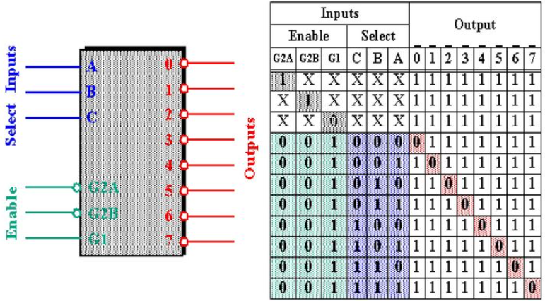

Here is the cercuit

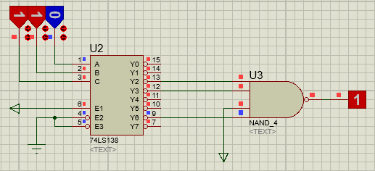

First we use the E1 enable only, then every input give one output and from the equation if the output was 2, 3 or 6 the output will give 1 ( but it work onactive low so it give a qustion mark sign) and this work by using NAND gate.