Design and Implement a Full Adder using the gates on the chips. Your final circuit must include the IC’s, their pin numbers, and the connections between the pins.



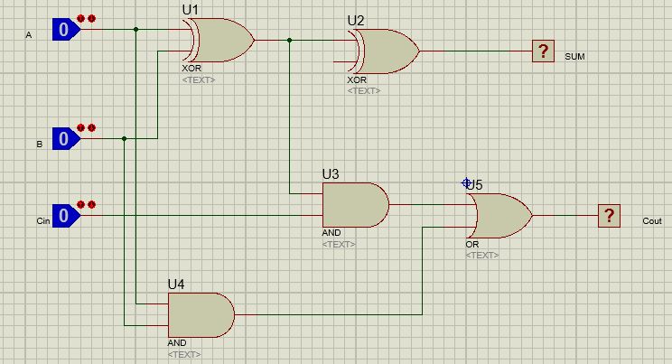

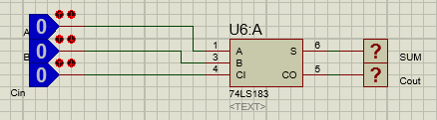

Design and Implement a 4x1 multiplexer using the gates on the chips. Your final circuit must include the IC’s, their pin numbers, and the connections between the pins.

