

DIGITAL ELECTRONICS AND COMPUTER ORGANIZATION LABORATORY

Dr. Anjad Badran

Experiment No. 2 - Comparators, Adders and Subtractors

Section 11

Islam Jihad Joma 1191375

T. Enas Jawabrah

21-3-2021

**Abstract**

In this experiment we have to learn how to use Quartus program, how to use HDL on Quartus and build 4- bits adder and 4 bits coparator and 2x1 multiplixer, we have to design them using Quartus by making codes, we have to simulate them by simulation butto.

**Table of content:**

1. **Abstract ----------------------------------------------------------------------------------------------------------------- 2**
2. **Theory ------------------------------------------------------------------------------------------------------------------ 4**
3. **Procedure & Discussion ---------------------------------------------------------------------------------------------5**

**- Part 1 : 4-Bit Full Adder using Quartus II ----------------------------------------------------------------------- 5**

**- Part 2 : 4-Bit Comparator using Quartus II -------------------------------------------------------------------- 6**

**- Part 3 : 2X1 MUX using Quartus II ------------------------------------------------------------------------------- 7**

**- Part 4 : run all together using Quartus II ----------------------------------------------------------------------- 8**

**5- Conclusion --------------------------------------------------------------------------------------------------------------8**

1. **References -------------------------------------------------------------------------------------------------------------9**

**Introduction (Theory)**

**We have to create this figure** 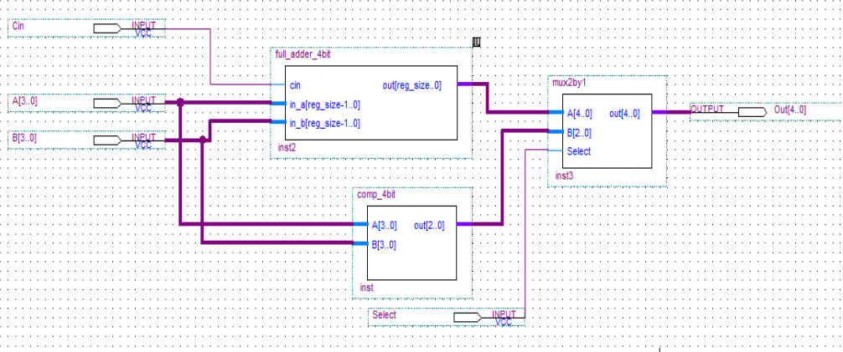

**Figure8.2**

**As a code using Quartus HDL language that helps us to create and then semulate it**

**In Quartus there is 3 types in writing the code;**

**Gate-Level Modeling : using instantiation of primitive gate and user defined modules .**

**Data-Flow Modeling : using continues assignment statements with keyword assign**

**Behavioral Modeling : using procedural assignment statements with keyword always .**

**We need to create 1- bit adder so we can create the 4- bits adder as we need too for 4-bits comparator that compare between 4 digits 2 numbers, and we need a multiplixer as to contain the two blockes to work together. We need to semulate it and save the semulation too, and other coding stuff.**

**Procedure (Discussion & Results)**

**Part 1 : 4-Bit Full Adder using HDL and Quartus II**

**We need first to create 1- bit adder which is made of XOR gates and or gate**

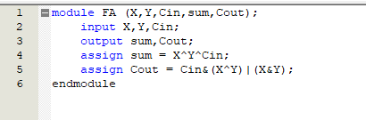

**And it accepts 3 inputs X<Y and the Cin from th previus one, and give us output of sum and the carry ( Cout )**

**Then I called the function 4 times to create 4-bits adder and coonected them with each other(the output Cout from the previus function is a Cin for thenext function and so on..)**

**And I got this code**

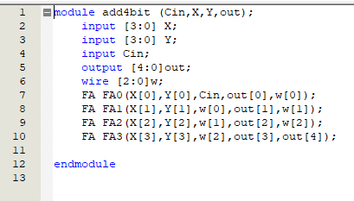

**I mareged the Cout and the sum and make them one number made of 5 bits as the teacher asked.**

**Then I semulated it and got a true results and I’ll share a picture for a part of the semulation**

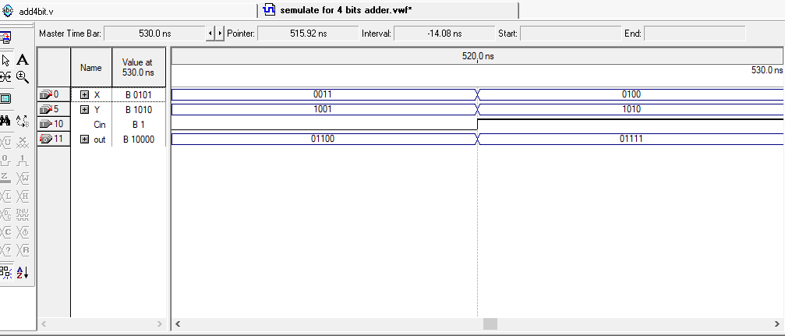

**- Part 2 : 4-Bit Comparator using Quartus II**

**To create the comparator of 4 bits firsts it’s made of inputs(X,Y) and the output as 3 bits, if the middle number is 1 and the rest is zeros then that’s means the 2 numbers are equals(010) but if the outbut was like (100) that’s means the first number is bigger, and if (001) means the second number is bigger. Here is the code:**

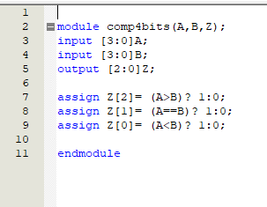

**And here is the semulation:**

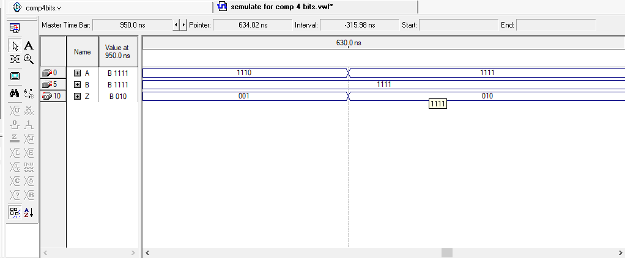

**And all the results were true**

**- Part 3 : 2X1 MUX using Quartus II**

**We have to made this part to connect the 2 parts together as it’s needed so I wrote the code as this:**

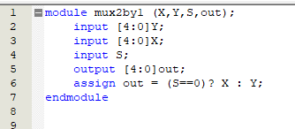

**And the semulation was like this**

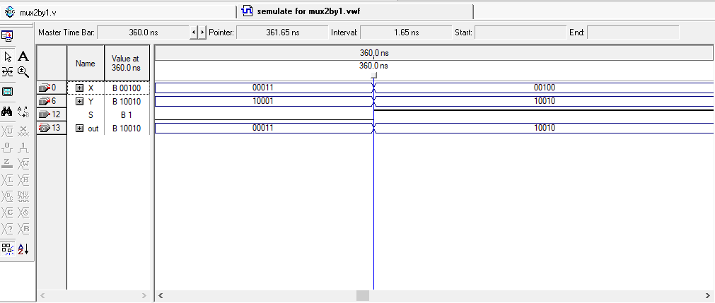 **and the results were true for all tries**

**- Part 4 : run all together using Quartus II**

**Here I called all the 3 functions and make the outputs for some of them an inputs for others to run the program once using it**

**Here is the code**

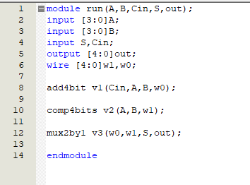

**And the semulation was as following:**

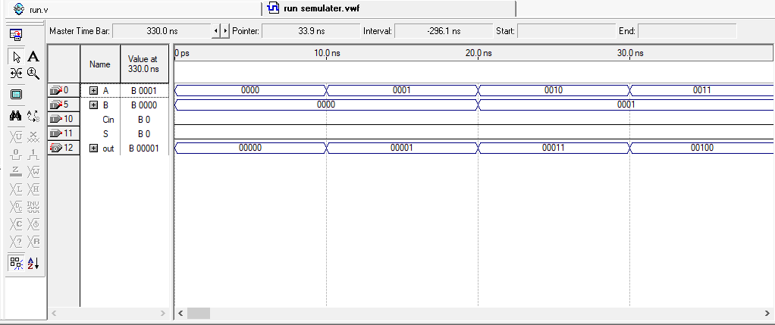

**And all the semulation result were true and correct.**

**Conclusion**

**Intthis expirement I became famelier with Quartus and HDL built the 4-bits adder and 4-bits comparator and and the multiplixer and how to connect them to gother. And I have verified the correctness of my work by using the semulation button for every single code. Now I can create more and more codes with this program.**

**And here is a diagram for all the work made by me shows all the blocks and how they got connected togother:**

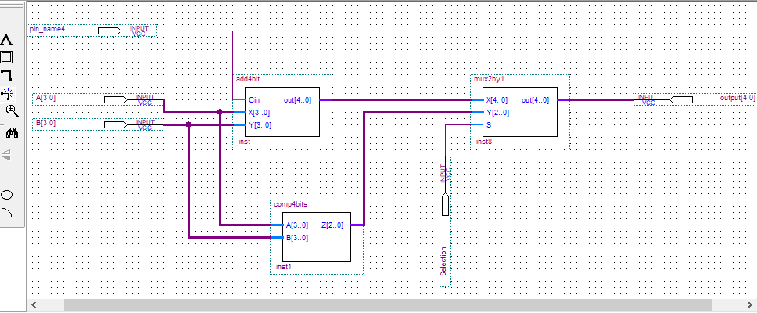

**References**

**In this expirement I didn’t get help from outside the ALL Experimets PDF, only my own work.**

**Appendix**

**I didn’t get help from outside the ALL Experimets PDF, only my own work.**