**Theory :**

In some circuits we need to save or use previous result , in such circuits we use type of circuit called sequential circuit , these circuits contain from combination circuit & memory element , the output in these circuit depends on the input and previous result.

**Latch:**

1. **RS Latch:**

circuits its timing to change the output not controlled , to solve these problem we using controlling input which allow to change in the output only if its value is 1.

1. **D Latch:**

Circuits its output value is the same as the input value and change at the clock level ,it built by developed the RS Latch.

**Flip Flops:**

Memory element that storage binary information , it built using two D-Latch connecting together . There are three types of flip flops :

1. **D Flip Flop**

The output is the same value of its input

1. **JK Flip Flop**

The output has 4-case when JK =00 no change in output ,JK=11 complement the previous output , JK =10 set the value to 1 and the last when JK =01 reset put the value to be 0.

1. **T Flip Flop**

The output not change when the input is 0 and the complement when the input is 1.

**Counter :**

Sequential circuit that use to count from zero to specific number , it contain from many of flip flop depends on the limit of the number. There are two types of counter : synchronous all flip flop have the same clock ,ripple in this kind there are delay on the output because the change don’t happen on the same time.

**Register :**

Sequential circuit that hold n-bit of information , it contains from n-flip flop , the change in the value can be in serial input that need many of clock or parallel load which need only to one clock.

**Procedure :**

**1.Latch :**

**A. Constructing RS latch with basic logic gates**

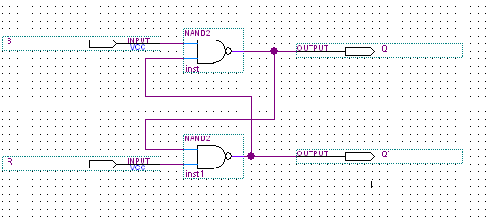

Fig (1):RS latch

|  |  |
| --- | --- |
| S R | Q Q' |
| 0 0 | 1 1 |
| 0 1 | 1 0 |
| 1 0 | 0 1 |
| 1 1 | 0 1 |

Table(1):truth table of active low RS latch

**B. Constructing RS latch with control input**

The circuit below in fig 2 was connected . with +5v on CK2 and the output shown in table 2.

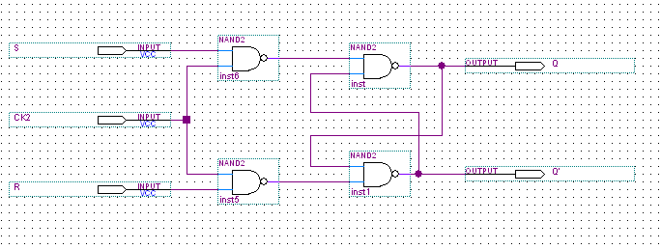

Fig (2):RS latch with control input

|  |  |
| --- | --- |
| S R | Q Q' |
| 0 0 | 1 0 |
| 0 1 | 0 1 |
| 1 0 | 1 0 |
| 1 1 | 1 1 |

Table(2)

**C . Constructing D latch with RS latch**

These connection in fig (3) change the RS latch to D latch was tested and had the result in table (3).

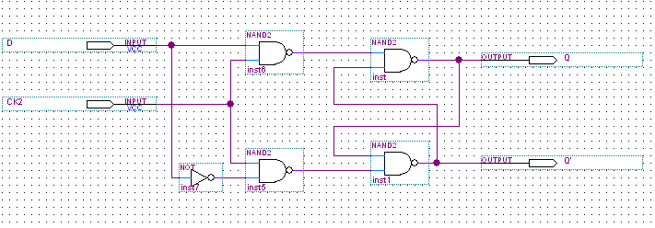

Fig(3): D latch using RS latch

|  |  |
| --- | --- |
| CK2 D | Q Q' |
| 0 0 | 0 1 |
| 0 1 | 0 1 |
| 1 0 | 0 1 |
| 1 1 | 1 0 |

Table (3):truth table for D latch circuit

**D . Constructing JK latch with RS latch**

RS latch also used to constructed JK latch as in fig (4) with CK2 is 1.

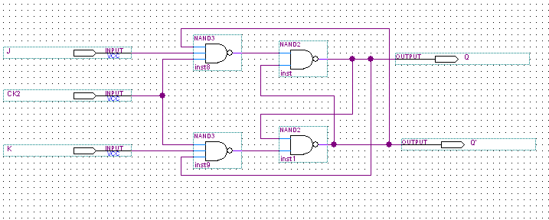

Fig(4):JK latch using RS latch

|  |  |
| --- | --- |
| J K | Q Q' |
| 0 0 | 1 0 |
| 0 1 | 0 1 |
| 1 0 | 1 0 |
| 1 1 | 0 1 |

Table(4)

**E . Constructing JK flip flop with master-slave RS latch**

In these circuit we had two RS latch one is called master the other called the slave as shown in fig (5).

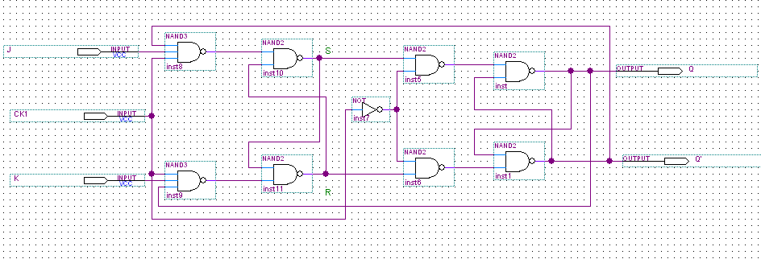

Fig (5):JK latch

|  |  |
| --- | --- |
| K J | S R Q Q' -> S R Q Q' |
| 0 0 | 1 0 1 0 -> 0 1 0 1 |
| 0 1 | 0 1 1 0 -> 1 0 0 1 |
| 1 0 | 1 0 0 1 -> 0 1 1 0 |
| 1 1 | 0 1 1 0 -> 1 0 0 1 |
| 1 1 | 1 0 0 1 -> 0 1 1 0 |

Table (5)

**Counter :**

1. **2-bit synchronous counter:**

We built it by using two JK flip flop as in fig (6) ,and was countered from zero to three as shown in table (6).

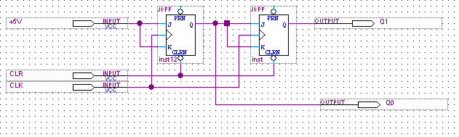

Fig (6):2-bit synchronous counter

|  |  |
| --- | --- |
| CLK | Q1 Q0 |
| 1 | 0 0 |
| 1 | 0 1 |
| 1 | 1 0 |
| 1 | 1 1 |
| 1 | 0 0 |
| 1 | 0 1 |
| 1 | 1 0 |
| 1 | 1 1 |

Table (6)

**B . 3-bit ripple counter:**

This kind of counter had delay in time because the changed didn’t happen on the same time the counter in fig 7 count from zero to seven.

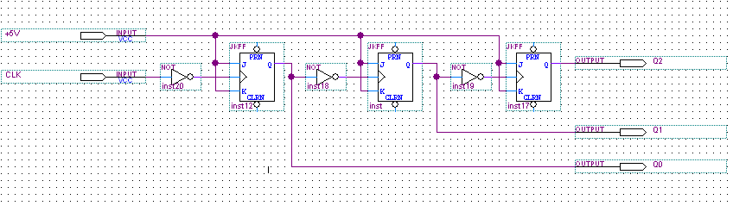

Fig(7):3-bit ripple counter

|  |  |
| --- | --- |
| CLK | Q2 Q1 Q0 |
| 1 | 0 0 0 |
| 1 | 0 0 1 |
| 1 | 0 1 0 |
| 1 | 0 1 1 |
| 1 | 1 0 0 |
| 1 | 1 0 1 |
| 1 | 1 1 0 |
| 1 | 1 1 1 |

Table (7)

**Conclusion:**

In these experiment we learned a new kind of circuit which was the sequential circuit how it worked and many application on it like counter and register . also we learned the differences between the latch and flip flop and how we can built flip flop using latch . In addition we learned how register work and how can we built it ,finally the differences between ripple and synchronous counter and the way that change from one type to another .

**TASKS:**

**TASK1**:

How we get Serial shift-leftusing IC7495? what the connections we have to make?

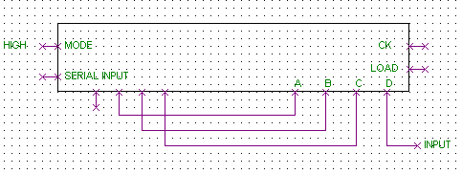

Fig (8):serial shift left

**Task2:**

Modify the circuit in Figure.18 in the lab manual to be 3-bit Synchronous Counter.

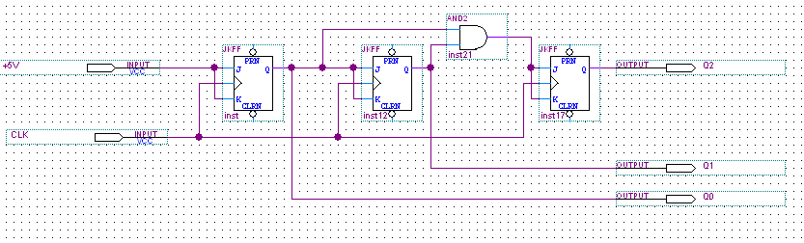

Fig(9):3-bit synchronous counter

**Task3:**

change the connection of counter in Figure.19 in lab manual to count from:

1. 0-5

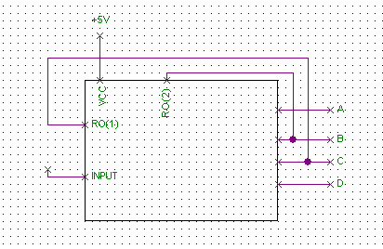

Fig(10) :0-5 counter

2.0-4

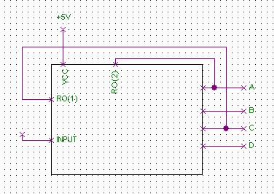

Fig(11):0-4 counter