

Mechanical Engineering Department

**DIGITAL LABORATORY**

ENCS 211

**EXPERIMENT # 2**

**Comparators, Adders and Subtractors**

**Pre-Lap**

**INSTRUCTOR**: Dr. Hanna Bullata

Student name: Khalid Mohammad Sbaih

ID no. : 1090128

**Sec: two**

* **Half-Adder:**
* Truth Table :



* Boolean Function:

Sum = XY

Carry = X'Y + XY'

* Design :

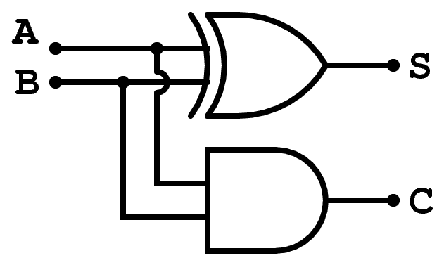

* **Full Adder :**
* Truth Table
* Boolean Function :

Sum= X'Y'Cin + X'YCin ' + XY'Cin ' + XYCin

C_out = XY + XCin +YCin = XY + XY'Cin + X'YCin

* Design :

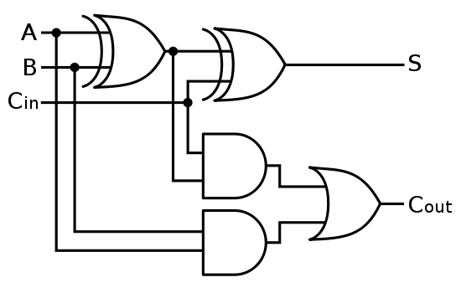

* **Half Subtractor :**
* Truth Table



* Boolean Function

D = XY' + X'Y (X(XOR)Y)

B = X'Y

* Design

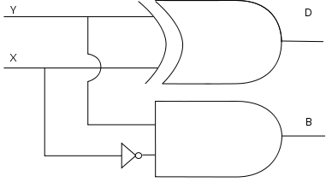

* **Full-Subtractor :**
* Truth Table :



* Boolean Function :

D = Bin XOR (A XOR B)

Bout = Bin (A XOR B)' + A'B

* Design :

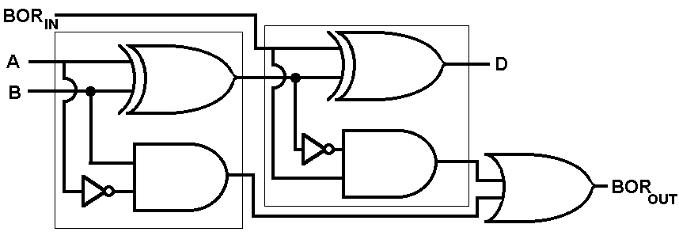

* **Three bit comparator:**

The basic comparator is the comparator that compares between two numbers, each number contains one digit. The design of a basic comparator is shown in fig.

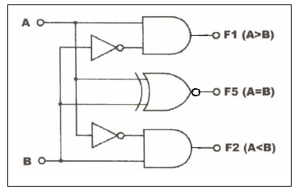

Three bit comparator consists of three basic comparators and five AND gates and one OR gate the design of it is shown in fig

