

Mechanical Engineering Department

**DIGITAL LABORATORY**

ENCS 211

**EXPERIMENT # 4**

**Digital Circuit Implementations Using Breadboard**

**Pre-Lap**

**INSTRUCTOR**: Dr. Hanna Bullata

Student name: Khalid Mohammad Sbaih

ID no. : 1090128

**Sec: two**

1. Design and Implement a Full Adder using the gates on the chips

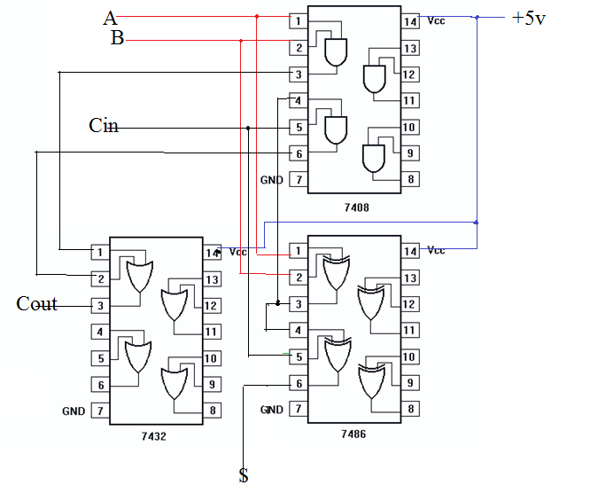

1. Design and Implement a 4x1 multiplexer using the gates on the chips



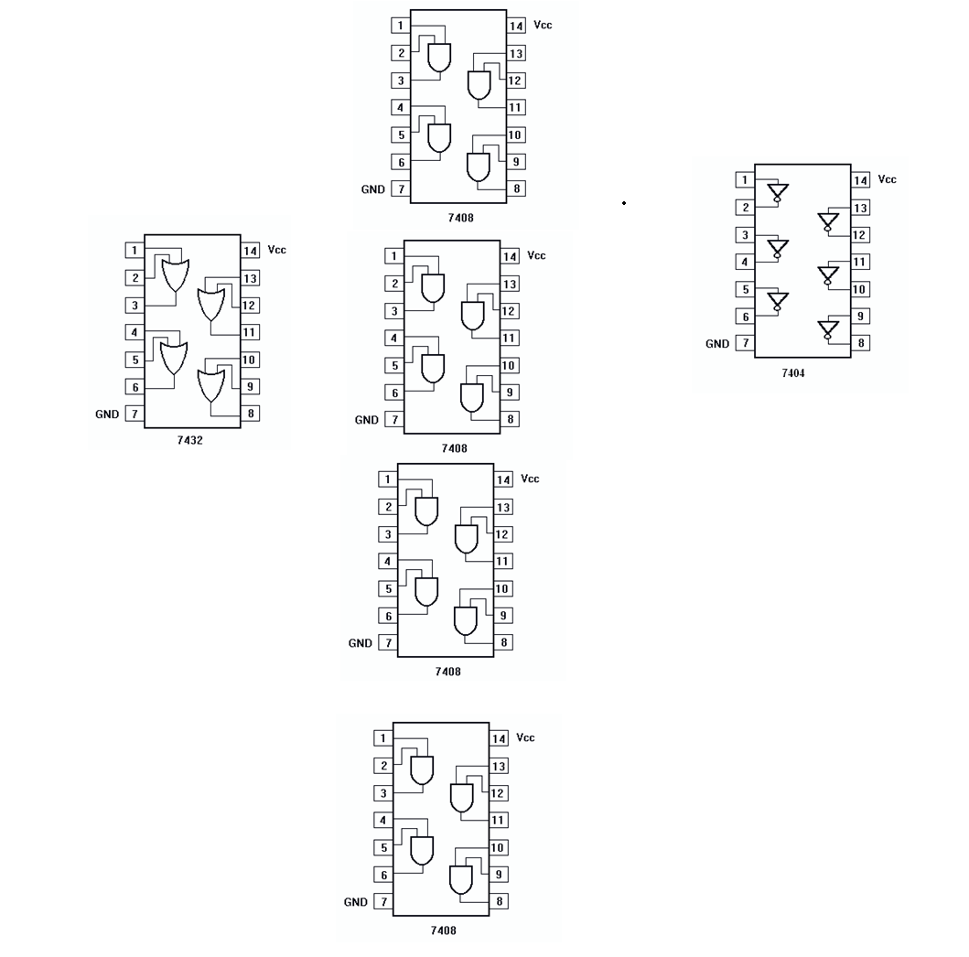

1. Design and Implement a 2-4 “active-low” decoder using the gates on the chips



