

Mechanical Engineering Department

**DIGITAL LABORATORY**

ENCS 211

**EXPERIMENT # 2**

**Comparators, Adders and Subtractors**

**Report**

**INSTRUCTOR**: Dr. Hanna Bullata

Student name: Khalid Mohammad Sbaih

ID no. : 1090128

**Sec: two**

* **Abstract :**

This experiment aims to introduce comparator, full and half adder and Subtractor circuits to us, by constructing comparator circuit, we were able to compare between two numbers with 4 bits and we saw that on the board, the full adder circuit combined with the Subtractor circuit were constructed, and gave us a true results almost.

The objectives of this experiment were to get us familiar to with the functionality of the digital adder and subtractor circuits, and comparator function.

* **Table of content :**
* Introduction …………………………………………………. [4]
* Apparatus ………………………………….. [5]
* Procedure and discussion …................................................. [5-8]

* Conclusion …………………………………………………. [9]
* References ……………………………………………….... [9]
* **Introduction :**

Logic circuit for digital system may be combinational or sequential.

Adders and Comparators, this is what we want to learn in this experiment

This type of circuits called combinational circuit such as half adder and full adder and four-bit parallel adder and the basic and complex comparators; at these circuits, the output is determined directly from the input regardless of previous input.

**The half Adder:** is a combinational circuit that performs the addition of two bits, the circuit is need two binary inputs and two outputs which produce the sum and carry.

**The full Adder:** it is a combinational circuit consisting of three inputs and two outputs. Two of the inputs represent the two significant bits to be added and the third input is the carry.

**The 4-bit Adder:**  is a digital circuit produces the arithmetic sum of two binary numbers in parallel. It consists of three full adders connected with one-half adders, with the output carry from each adder in the chain.

**Basic Comparator:** A combination circuit compares two numbers A&B  
In addition, determines the relative magnitudes, the output (A>B, A<B, A=B).  
To compare if A>B or A<B or A=B we check the relative magnitudes of pairs of significant digits starting from the most significant position so if they are equal we compare the next lower significant, and we do this until a pair of unequal digits is reach.

* **Apparatus** **:**

1. KL-22001 Basic Circuit Lab.
2. KL-26001 Combinational Logic Circuit Experiment Module (1).
3. KL-26002 Combinational Logic Circuit Experiment Module (2)
4. KL-26005 Combinational Logic Circuit Experiment Module (5)

* **Procedure and Discussion:**

1. **The half adder:**

1. Construct a half adder on the Digital logic system as shown in fig. (2.1). Use the Switch register to obtain bits A1 and B1 Connect the adder output S1 and the carry C1 to the indicator lamps.

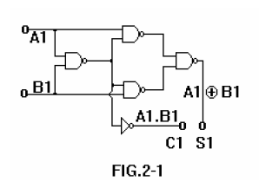

2. Vary the positions of the switches A1 and B1 and check according to the truth table

In fig. (2.2).

Therefore, we got the Boolean function:

S= A'B+AB'

C=AB

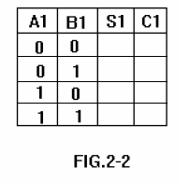

1. **The full adder**

1- Construct a full adder on the digital logic system as in fig. (2.3). Use the additional

Switch to generate the carry Ck-1 Connect the adder output SK to the indicator

Lamps.

The figure of full adder is:

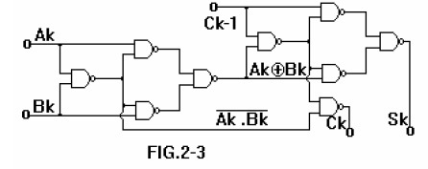

2- Check operation of the adder according to the truth table in fig. (2.4).

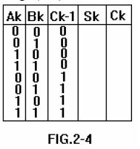

The Boolean functions were:

S =A'B' CK-1+ A` B CK-1` + A B` CK-1` + A B CK-1

C = A B + A CK-1 + B CK-1

3. Design a full adder using half adders only.

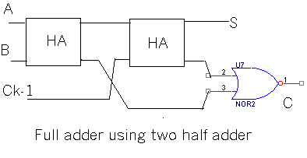

**c) The 4-Bit Adder**

Construct a 4-Bit parallel adder as shown in Fig. (2.6) A1…A4 is a binary number;

B1…B4 is the second binary number.

Connect the curry output C4 to lamp L4 Check the operation of the adder by

Performing a number of tests. Add the numbers shown in fig. (2-7) and record the

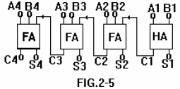

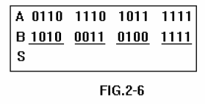

**d) Basic Comparator**

1. Connect the one-bit basic comparator as shown in fig. 2-7. Connect the outputs of

Functions F1, F2 and F3 to the indicator lamps.

**The basic comparator is:**

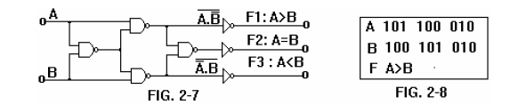

2. Vary the positions of the switches and check the truth table for each function.

|  |  |  |  |  |
| --- | --- | --- | --- | --- |
| A | B | F1 | F2 | F3 |
| 0 | 0 | 0 | 1 | 0 |
| 0 | 1 | 0 | 0 | 1 |
| 1 | 0 | 1 | 0 | 0 |
| 1 | 1 | 0 | 1 | 0 |

**e) Two-bit Comparator:**

In this comparator, we compare two bits with another two bits and the design of two-bit comparator by using only basic comparator is as follow:

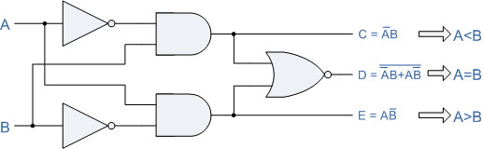

The result as follow:

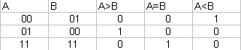

* **Conclusion :**

We noticed that from our experiment that the results were accurate. No unexpected values recorded in this experiment.

At this experiment, we checked variety of circuits such as half adder and full adder and the comparator and we took useful information about them.

* **References :**
* <http://www.personal.psu.edu/cwb5096/Old%20Site/index_files/cmpenlab4.htm>
* <http://www.utdallas.edu/~dodge/EE2310/lab2.pdf>