Shoa'a Mare'e 1090734
Prelab Exp. No.2

Half-Adder :

- Truth table

- Boolean Function

Sum = XY
Carry = X'Y + XY'

- Design
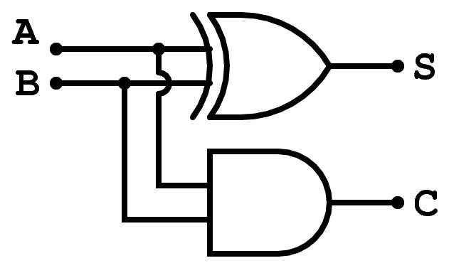

Full-Adder :

- Truth Table

- Boolean Function

Sum= X'Y'Cin + X'YCin ' + XY'Cin ' + XYCin

C_out = XY + XCin +YCin = XY + XY'Cin + X'YCin

- Design

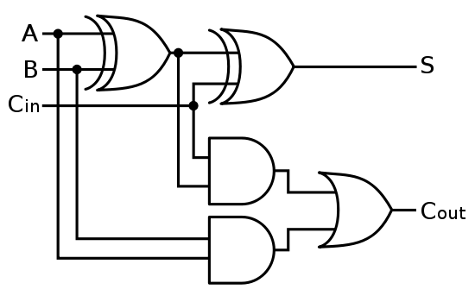

Half- Subtracter :

- Truth Table

- Boolean Function

D = XY' + X'Y (X(XOR)Y)

B = X'Y

- Design

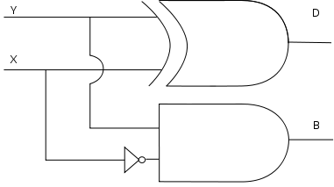

Full-Subtracter :

- Truth Table :

- Boolean Function :

D = Bin XOR (A XOR B)
Bout = Bin (A XOR B)' + A'B

- Design :

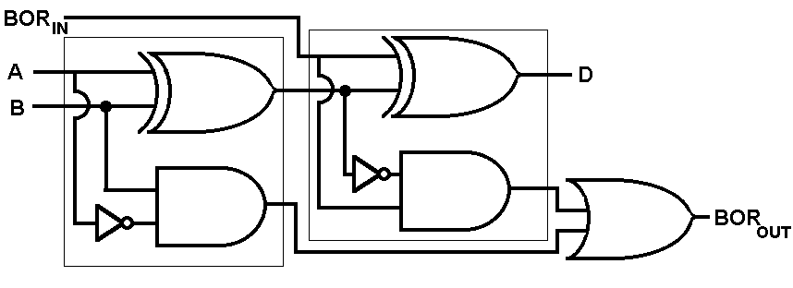

2.1 Three bit comparator :

The basic comparator is the comparator that compares between two numbers , each number contains one digit . The design of a basic comparator is shown in fig.

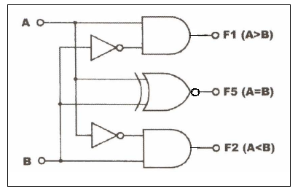
Three bit comparator consists of three basic comparators and five AND gates and one OR gate the design of it is shown in fig
