Report #3

ENCS 211

Experiment # 9

A simple Security System Using FGPA

Student Name : Khalid Manasra - 1090374

Partner Name : Isra Anabtawi - 1090910

### Abstract:

We want to learn from this experiment how to build a security System by put some digital components we have studied and build in previous lab sessions together to build the system.

And also to become more familiar with using the FGPA.

## Apparatus:

• A Desk\Lab top with Quartus II (7.2 +) and USB driver installed.

• Altera DE1 system with its datasheets. (For FPGA pins map).

## Procedure:

1. **8x3 Priority Encoder:**

The Code:

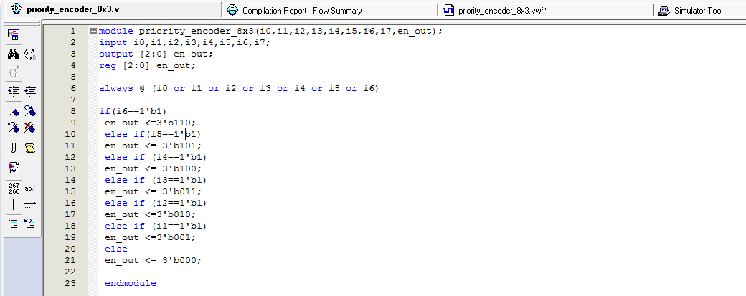

The Simulation:

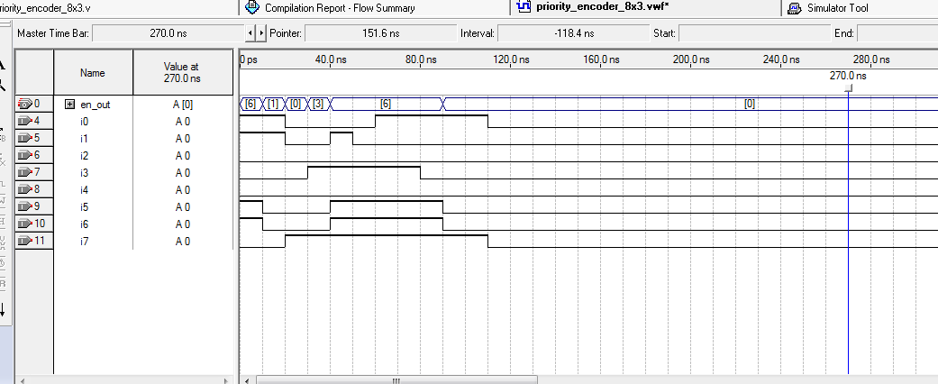

The Block Diagram:

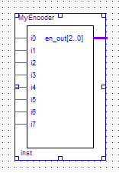

1. **2x4 Decoder:**

The Code :

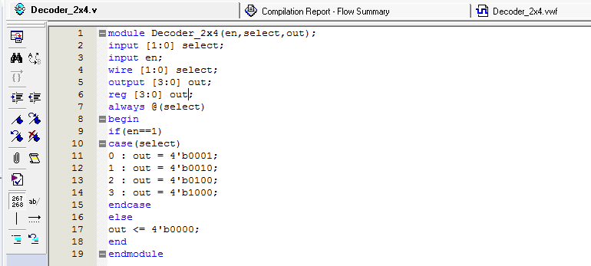

The simulation :

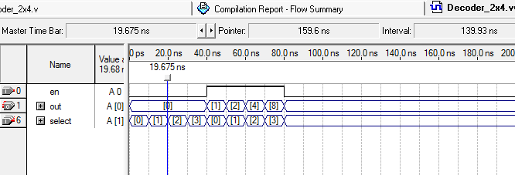

The Block diagram:

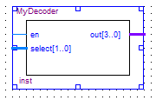

1. **7-segement driver:**

The Code :

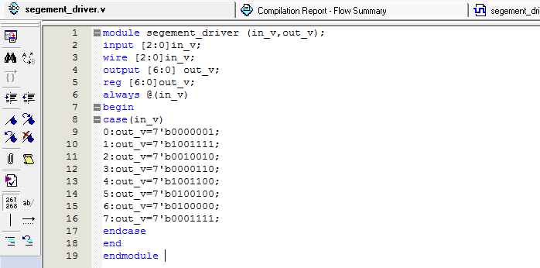

The simulation :

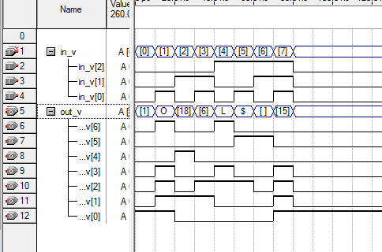

The Block Diagram :

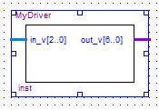

1. **2*1 Mux:**

The Code:

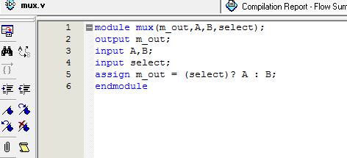

The Simulation :

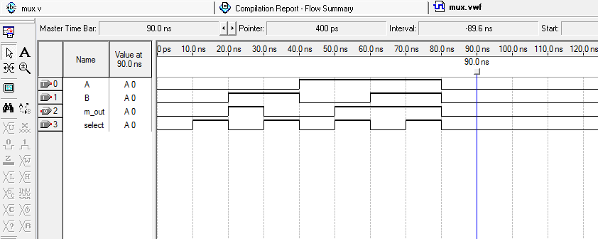

The Block Diagram :

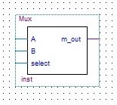

1. Comparator:

The Code:

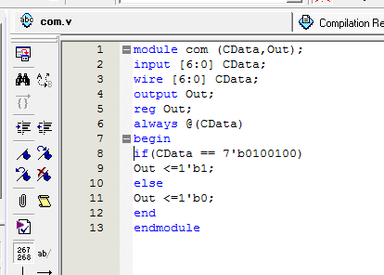

The simulation :

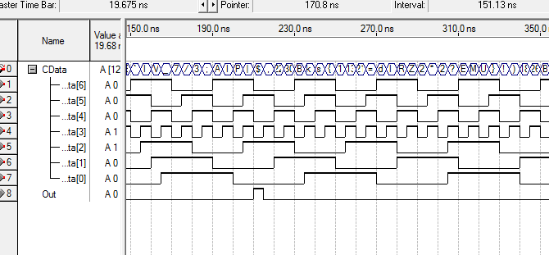

The Block Diagram:

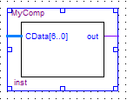

1. The DFF:

The Code :

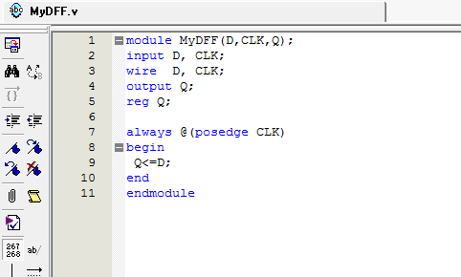

The simulation:

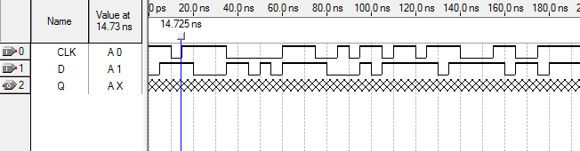

The Block Diagram:

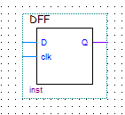

Then we used the DFF and the 2*1 Mux to implement the memory as the following Diagram:



Then we use the last diagram as Block (memory) to implement the Security System :

