

Computer Engineering Department
ENCS 312
Experiment: 5

Sequential Logic Circuits

May Shunnar 1060372
Ahmed Shawqi 1060889

Date: 26/9/2009

Objective:
The aim of the experiment is to understand the differences between combinational and sequential logic circuits; and the applications of various memory units. And to study the operating principles and applications of various flip-flops. Another aim is to understand the operating principles of counters and how to construct counters with JK flip-flops. And to study asynchronous and synchronous counters.

APPARATUS
1. KL-22001 Basic Electricity Circuit Lab
2. KL-26006 sequence Logic Circuit Experiment Module (1)
3. KL-26007 sequence Logic Circuit Experiment Module (2)
4. Oscilloscope.

Procedure:
Flip-Flops
- Constructing RS Flip-Flop with Basic Logic Gates.

First the the KL-26006 Module was set on the KL-22001 Basic Electricity Circuit Lab and block (c) was located . And avoltage of +5 and +12 VDC was applied from the Fixed Power on KL-26001 Module.
The inputs A3, A4 was connected to Data Switches SW1 and SW2, respectively. And outputs F6 and F7 to logic Indicators L1, L2.
FIG1: NAND RS flip-flop

The input sequences in Table 1 was followed and the outputs was observed as shown in table(1).

State | A4 | A3 | F6 | F7
 | (sw2) | (SW1) | (L1) | (L2)
0 | 0 | 0 | 1 | 1
1 | 0 | 1 | 0 | 1
2 | 1 | 0 | 1 | 0
3 | 1 | 1 | 1 | 0
Table(1)

Then R = A4 , S = A3 , Q = f7 , Q' = f6

The connections was completed by referring to wiring diagram shown in Fig(2).
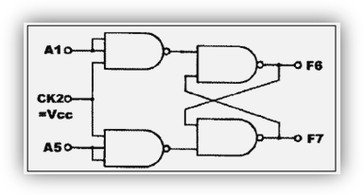
Fig 2

The CK2 was connected to +5V & the inputs A1 and A5 to Data Switches SW1and SW2, respectively.
And table (2)

State | A5 | A1 | F6 | F7
0 | 0 | 0 | 0 | 1
1 | 0 | 1 | 1 | 0
2 | 1 | 0 | 0 | 1
3 | 1 | 1 | 1 | 1
Table(2)

B. Constructing D Flip-Flop with RS Flip-Flop.
the connections was completed by referring to wiring diagram shown in Fig(3)
.
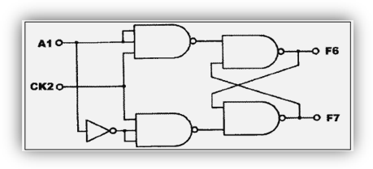
Fig. 3

Then A1 was connected to SW1, CK2 to the A output of Pulsar Switch SWA and F6 to Logic Indicator L1.
And the output states was recorded and labeled as in table(3).

CLK | A1 | F6
0 | 0 | 0
0 | 1 | 0
П | 0 | 0
П | 1 | 1
Table(3)

C. constructing JK Flip-Flop with RS Flip-Flop
Here the connection was completed by referring to the JK flip-flop circuit in Fig(4) then CK2 was connected to the A output of Pulsar Switch SWA, A1 to Data Switch SW1, and F6 to Logic Indicator L1.
Fig(4)

And table(4) was completed as bellow.

CLK | A5 | A1 | F6
П | 0 | 0 | 0
П | 0 | 1 | 1
П | 1 | 0 | 0
П | 1 | 1 | 0
Table(4)

D. constructing Master-Slave JK Flip-Flop with RS Flip-Flop
The connection was completed by referring to the the master-slave JK flip-flop circuit in Fig(5).

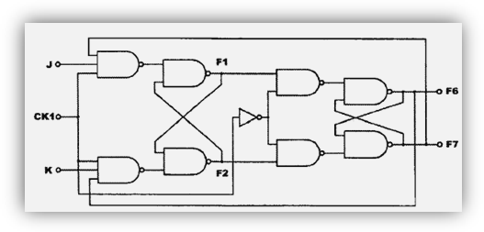

Fig (5)

Then CK1 was connected to the A output of Pulsar Switch SWA, J and K to Data Switches SW0 and SW1. F1, F2, F6, F7 to Logic Indicators L0, L1, L2, and L3 Respectively.
And the data was labeled in table
CLK | K | J | F1 | F2 | F6 | F7 | → | F1 | F2 F6 | F7
П | 0 | 0 | 0 | 0 | 0 | 1 |  | 0 | 0 0 | 1
П | 0 | 1 | 0 | 0 | 0 | 1 |  | 1 | 0 1 | 0
П | 1 | 0 | 1 | 0 | 1 | 0 |  | 0 | 0 0 | 1
П | 1 | 1 | 0 | 0 | 0 | 1 |  | 1 | 0 1 | 0
П | 1 | 1 | 1 | 0 | 1 | 0 |  | 0 | 0 0 | 1
Table(5)

E. Constructing Shift Register with D Flip-Flops
Here the the KL-26006 Module was set on the KL-22001 Basic Electricity Circuit Lab and block (a) was located .A +5VDC and +12VDC was applied from the Fixed Power on KL-22001 lab to KL-26006 Module. Then the B(clear) was connected to SW0; A(I/P) to SW1; CK to SWA output; F1,F2,F3,F4 to L1,L2,L3,L4 respectively the SW0 was set to "1" to clear D flip-flop, and then to "0". And SW1 was set to "1". And a four clock pulses was applied to CK using Pulsar Switch SWA. And the indications after each pulse was applied was observed and recorded as in table(6)

CLK | F1 | F2 | F3 | F4
1 | 1 | 0 | 0 | 0
2 | 1 | 1 | 0 | 0
3 | 1 | 1 | 1 | 0
4 | 1 | 1 | 1 | 1
Table(6)

SW0 was set to “1” to clear D flip-flops, and then to “0”. And SW1 was set to “1” and
Returned to “0” after one clock pulse is applied. Then three clock Pulses was applied to CK using Pulsar Switch SWA

CLK | F1 | F2 | F3 | F4
1 | 1 | 0 | 0 | 0
2 | 0 | 1 | 0 | 0
3 | 0 | 0 | 1 | 0
4 | 0 | 0 | 0 | 1
Table(7)

F. Preset Left/Right Shift Register
Here the KL-26006 Module was sert on the KL-22001 Basic Electricity Circuit Lab, and block b was located. A +5VDC was applied from the Fixed Power on KL-2201 Lab to KL-26006 Module.
And the following connections was completed:
Inputs A, B, C, and D to SW0, SW1, SW2, and SW3
Outputs F1, F2, F3, F4 to L4, L3, L2, L1
D1 (LOAD) to SWA A output
C1 (CK) to SWB B output
B1 (Serial input) to SW7
A1 (MODE) to SW6
And the input sequence for A1 and B1 was followed and the outputs was observed and recorded in the table bellow.

INPUT |  |  | OUTPUT
C1 | B1 | A1 | F1 | F2 | F3 | F4
П | 1 | 0 | 1 | 0 | 0 | 0
П | 1 | 0 | 1 | 1 | 0 | 0
П | 1 | 0 | 1 | 1 | 1 | 0
П | 1 | 0 | 1 | 1 | 1 | 1
П | 1 | 0 | 1 | 1 | 1 | 1
П | 0 | 0 | 0 | 1 | 1 | 1
П | 0 | 0 | 0 | 0 | 1 | 1
П | 0 | 0 | 0 | 0 | 0 | 1
П | 0 | 0 | 0 | 0 | 0 | 0
П | 0 | 0 | 0 | 0 | 0 | 0
Table(8)
Then A1 and B1 was set to “1” and the outputs was observed as in table(9).

INPUT |  |  | OUTPUT
C1 | D | C B A | F1 | F2 | F3 | F4
П | 0 | 0 1 0 | 0 | 1 | 0 | 0
П | 1 | 0 1 0 | 0 | 1 | 0 | 1
П | 1 | 1 1 0 | 0 | 1 | 1 | 1
П | 0 | 1 1 1 | 1 | 1 | 1 | 0
П | 0 | 1 1 0 | 0 | 1 | 1 | 0
Table(9)

Counters
A-Construct Divide-by-8 Counter with JK Flip-Flops
Here the KL-26007 Module was set on the KL-22001 Basic Electricity Circuit Lab, and block c was located. And the connections was completed by referring to the wiring diagram in Fig(6). A +5VDC was applied from the Fixed Power on KL 22001 Lab to KL-26007 Module. Then the CK input was connected to the A output of Pulser Switch SW. And the outputs Q1, Q2, and Q3 to Logic Indicators L5, L6, and L7, respectively.
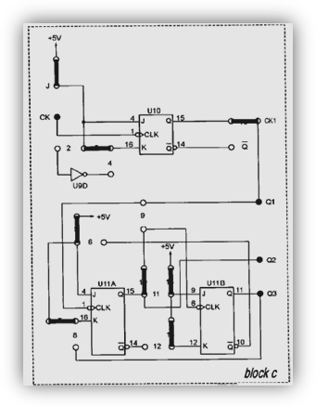
Fig (6)
A clock pulses was applied to CK input using Pulsar switch SWA. The outputs was as shown in table(10).
CLK | Q3  L5 | Q2  L6 | Q1  L7
П | 1 | 0 | 0
П | 1 | 0 | 1
П | 1 | 1 | 0
П | 1 | 1 | 1
П | 0 | 0 | 0
П | 0 | 0 | 1
П | 0 | 1 | 0
П | 0 | 1 | 1
П | 1 | 0 | 0
П | 1 | 0 | 1
П | 1 | 1 | 0
Table(10)

B-Constructing Synchronous Counter with JK Flip-Flops
Then the KL-26007 Module was set on the KL-22001 basic Electricity Circuit Lab, and block c was located. And the connections was completed by referring to the wiring diagram in Fig(7). A +5VDC was applied from the Fixed Power on KL-22001 Lab to KL-26007Module.

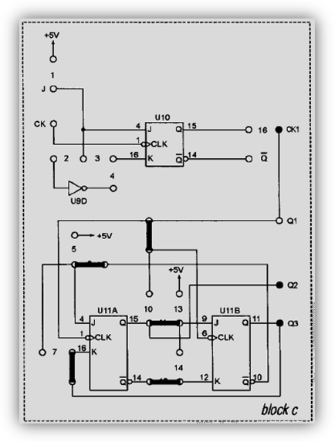
Fig (7)
The CK1 input was connected to the A output of Pulser Switch SWA. And the outputs Q2 and Q3 to Logic Indicators L6 and L7, respectively. A clock pulses was applied to CK1 input using Pulser switch SWA. And the outputs Q2 and Q3 was Observed and recorded as in table(11)

CLK | Q3  L6 | Q2  L7
П | 1 | 1
П | 1 | 0
П | 0 | 0
П | 0 | 1
П | 1 | 1
П | 1 | 0
П | 0 | 0
Table(11)

C. Constructing Divide-by-8 Counter with 7490
First we were needed to plug the KL-26007 module with the +5v power supply form KL-22001 and complete the connections by referring to the wiring diagram in Fig 17.
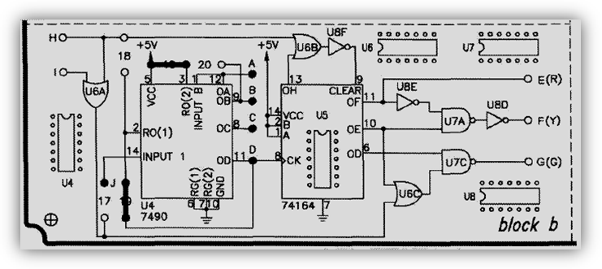
Fig (8)

The J input was connected to the A output of Pulsar Switch SWA then A clock pulses was applied to J input using Pulsar switch SWA. And the outputs was Observed and recorded in table(12).

CLK | A  L5 | B  L6 | C  L7 | D  L8
П | 1 | 0 | 0 | 0
П | 0 | 1 | 0 | 0
П | 1 | 1 | 0 | 0
П | 0 | 0 | 1 | 0
П | 1 | 1 | 1 | 0
П | 0 | 1 | 1 | 0
П | 1 | 0 | 0 | 0
П | 0 | 0 | 0 | 0
П | 1 | 1 | 0 | 0
П | 0 | 1 | 0 | 0
Table(12)

D. Constructing BCD Counter with 7490
Here the KL-26007 module was pluged in with the +5v power supply form KL-22001 and the connections was completed by referring to the wiring diagram in Fig(9).
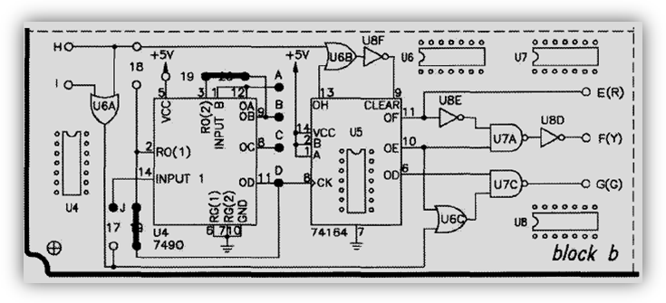
Fig(9)
And the J input was connected to the A output of Pulsar Switch SWA. Then A clock pulses was applied to J input using Pulsar switch SWA. And the outputs was observed and recorded in table(13)
J | D1
П | 0
П | 1
П | 2
П | 3
П | 4
П | 5
П | 6
П | 7
П | 8
П | 9

Table(13)

Problem:
A | B | A+ | B+
0 | 0 | 0 | 1
0 | 1 | 1 | 0
1 | 0 | 1 | 1

A+ = AB’ B+ = A’B’

Conclusion:
We clearly observe that our results are the same as the theoretical ones. We note that the characteristic of flip flop is applied in the table of present and next state.
This table summarizes the Main Results:
Flip-Flop | Characteristic Equation
D | Q_{next} = Q
T | Q_{next} = TQ' + T'Q
JK | Q_{next} =JQ' + K'Q

A counter is a device which essentially counts stores the number of times an event or process has occurred which controlled by control signal.
As flip-flops are implemented electronically, they require power and ground connections.
Finally our experiment was successful and proves its theory.

