B i r z e i t U n i v e r s i t y

Faculty of Information Technology

Computer Systems Engineering

Department

Digital Lab ENCS211

PRE LAB EXP3

**Daoud Shaheen 1090395**

**Instructor:Aziz Qarosh**

**PRE-LAB 4**

1. Design and Implement a Full Adder using the gates on the chips

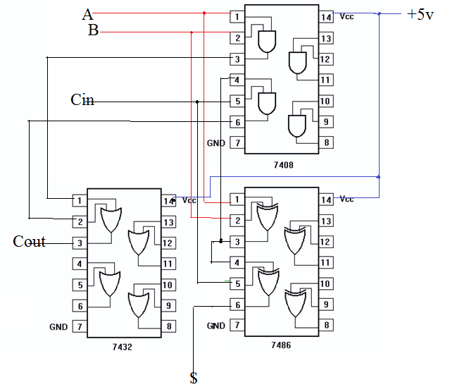

1. Design and Implement a 4x1 multiplexer using the gates on the chips



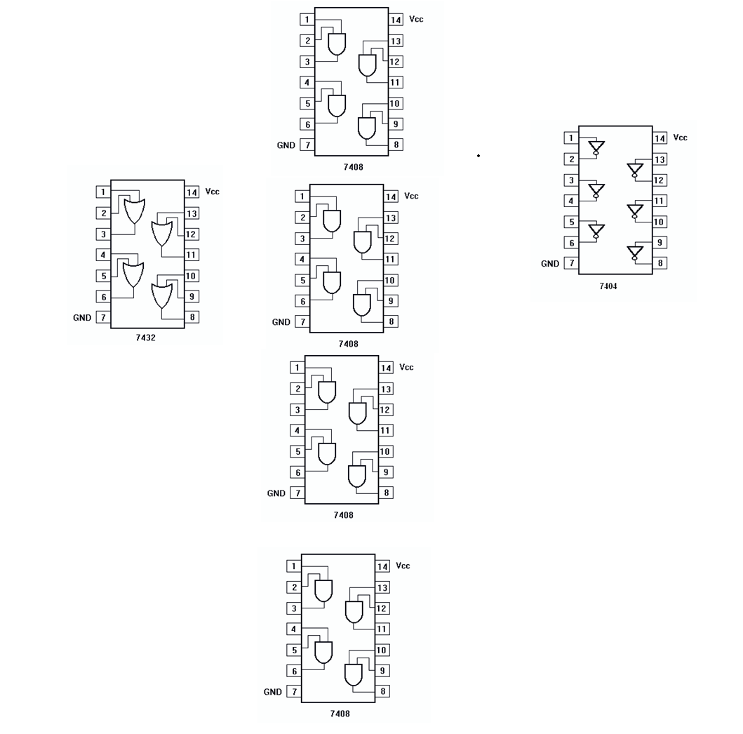

1. Design and Implement a 2-4 “active-low” decoder using the gates on the chips



