Question 1:

Design, construct, and test a circuit which uses an SN74151 to implement a sum-of-products

expression.

**(a)** Convert the following expression into summation form (i.e. F(A,B,C)= Σ(…)):

Y=F(A,B,C) = AB' +B'C

=AB'(C+C')+B'C(A+A')

=AB'C+AB'C'+A'B'C

=m5+m4+m1 = Σ(1,4,5)

(b) Sketch on figure.6 the input connections necessary to implement the function in **a**

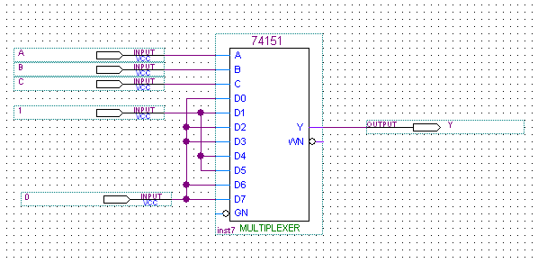

Figure 6:8-to-1 Multiplexer

(c) Refer to function in (a) to fill in the table bellow (table.1)

|  |  |
| --- | --- |
| OUTPUT | INPUT |
| Y Y' | A B C |
| 0 1 | L L L |
| 1 0 | L L H |
| 0 1 | L H L |
| 0 1 | L H H |
| 1 0 | H L L |
| 1 0 | H L H |
| 0 1 | H H L |
| 0 1 | H H H |

TABLE 1

QUESTION 2:

Design, construct, and test a circuit which uses an SN74138 demultiplexer to implement a sum of-products expression.

**(a)** Convert the following expression into summation form (i.e. F(A,B,C)= Σ(…)):

Y= F(A,B,C) =A'BC+BC'

=A'BC+BC'(A+A')

=A'BC+ABC'+A'BC'

= m3+m6+m2 = Σ(2,3,6)

(b) Sketch on figure.7 the input connections necessary to implement the function in **a**

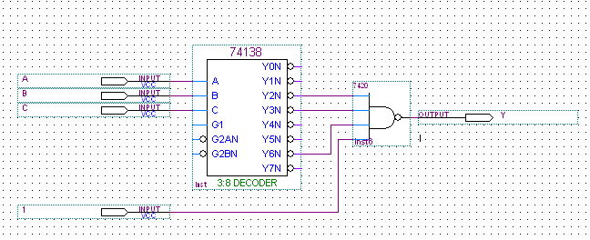

Figure 7 :3-to-8 DeMUX